**CHAPTER ONE**

**INTRODUCTION**

* 1. **Background of the study**

The most significant force in creating the environment and controlling the climate is water. It is one among the most significant substances that has a significant impact on human existence. The physical, chemical and biological aspects of water are frequently used to characterize its quality. Rapid industrialization and the uncontrolled use of chemical fertilizers and pesticides in agriculture are polluting the aquatic environment in a variety of ways, causing water quality to deteriorate and aquatic biota to deplete. Humans are infected with water-borne illnesses as a result of their usage of polluted water. As a result, it's important to check the water's quality on a frequent basis. Temperature, pH, turbidity, salinity, nitrates and phosphates are just few of the parameters that are needed to be measured. The aquatic macro invertebrates have been evaluated (Gorde & Jadhav, 2013).

Any aquaculture system must have good water quality. It has a significant impact on fish health and any decline in water quality leads to illnesses and stress in fish (Arulampalam et al., 1998). According to Joseph et al., (1993), each water quality component interacts with and affects the other factors, often in subtle ways. Fish must have adequate water quality to survive and flourish since their entire life cycle is entirely dependent on the environment (Bolorunduro and Abdullah, 1996).

Since farmed fish are extremely sensitive to changes in factors including poisonous chemicals, pH, temperature and presence of gas, water quality control is essential in aquaculture. For the fish to maintain their best health, production and quality, the water quality must be consistently examined and managed. As fish use the water to live in, eat from, reproduce, grow and excrete waste into, the quality of the water in fish ponds can swiftly deteriorate. Numerous physico-chemical factors affect how good the quality of water supply is. The size and source of any pollutant load must be determined by assessment and monitoring of these factors (Thirupathaiah et al., 2012). Monitoring and assessment of water quality parameters are the key elements for the sustainable development of water resources of any country. The various components of the water also known as water quality parameters are highly dynamic in space and time. Quantification of water quality parameters using traditional methods provides limited, point-based information which is not sufficient for assessing spatio-temporal variations in these parameters. Satellite-based remote sensing has proven its usefulness in effective mapping/retrieval and monitoring of water quality parameters such as precipitation, interception, soil moisture, surface runoff, water level, river flow, evapotranspiration, change in terrestrial water storage, etc. This review paper highlights the major work done in India for the estimation of water quality parameters using remote sensing. The basics of retrieval techniques, their applications in India, their validation, and their limitations are discussed in this paper. The progress of each technique from conventional optical remote sensing-based to advance microwave remote sensing-based water quality parameters estimation has been presented. The integration of remote sensing derived water quality parameters in water balance and land surface model is also presented. Compliance with regulatory issues, trend detection, model validation and evaluation of the efficiency of adopted policies are all reasons why marine water quality monitoring is done (Dadhich et al., 2018).

Natural disasters and an increase in human interference are to blame for this coast's declining ecological value and environmental quality. Due to an increase in tourists and solid waste, the water quality in the coastal region is deteriorating daily. Waste thrown by tourists on the beach or into the water could also be harmful to the coral environment. Therefore, to keep the water quality and its standard, the coastal ecology needs to be carefully protected.

As temperature can impact fish behavior, feeding, growth, and reproduction, temperature control is crucial for fish welfare. Depending on whether the fish are from cold or warm water, different average temperature ranges are needed for their best growth. Particularly in recirculating aquaculture systems, plankton, fish feces, uneaten feed, or clay particles suspended in the water can all be an issue. As they can contain up to 70% of the nitrogen load in the system and might irritate the fish's gills, fish waste particles can be a significant contributor to poor water quality. For every pound of fish produced, one pound of waste is typically created. Clay or soil particles can impede light penetration and hinder photosynthesis by causing turbidity.  Nitrogen, ammonia, oxygen and carbon dioxide are the most prevalent dissolved gases. Both parts per million (ppm) and milligrams per liter (mg/L), which are used to quantify concentrations, are equivalent units. The crucial chemical parameter in aquaculture is dissolved oxygen (DO), by far. More fish kills occur as a direct result of low dissolved oxygen levels than all other issues combined. Fish also need oxygen to breathe to maintain life. The fish's size, eating rate, activity level, and temperature all affect how much oxygen it takes in. Striped bass were shown to ingest 0.012–0.020 pounds per pound of fish each day when grown at 77ºF, according to Lewis et al., (1981).

The physical, chemical, and biological processes that interact in coastal ecosystems maintain higher levels of diversity and richness. Therefore, in order to maintain biodiversity in Bangladesh's coastal region, it is crucial to measure water quality parameters with seasonal variation. Despite the fact that these assessments covered the whole Cox's Bazar Coast, there is little data on the water quality parameter. In order to determine the ecological quality of the researched area and to describe the seasonal change of each parameters that will help to identify the healthy ecosystem where fish activities are accessible, the current assessment is being conducted to evaluate the hydrological parameters.

**1.2 Significance of the Study**

* There is a significant variation in the mean levels of water quality parameters of coastal water over season.
* This study was to enable the people of Bangladesh to be aware of the levels of the water quality parameters of coastal water as this would control the risks of their exposure to the hazardous characteristics in the water
* The mean levels of water quality parameters of coastal water during the dry and wet season are significantly different from one another.

**1.3 Purpose of the Study**

This chapter aims to determine the current state of knowledge on river pollution management by discussing relevant water quality parameters and their significance in relation to river pollution assessment. It also reviews available policy instruments for river pollution management to better understand their implications.

**1.4 Research Objectives**

1. To determine the water quality properties of coastal water of Bakkhali river estuary and Rezukhal estuary.
2. To compare the levels of water quality parameters of coastal water from season to season.
3. To determine correlation among different water quality parameters.

**1.5 Research Questions**

a) How do water quality parameters influence coastal environment with seasonal variation?

b) What influence does seasonal variation in water quality parameters have on coastal biodiversity?

**CHAPTER TWO**

**REVIEW OF LITERATURE**

The principles, design, and data analysis processes for monitoring marine water quality are discussed in this article. There's also a quick rundown of regional marine conventions from around the world. However, it is important to notice that regarding water quality as far as Africa is concerned, studies on nutrients export from rice fields are scarce and almost little have been done in Benin. More recently, one study has been conducted by Bossa et al., (2012) who investigate the effects of crop patterns and management scenarios on nitrogen (N) and phosphorus (P) loads to surface water and groundwater in the Donga-Pont catchment a tributary of the Ouémé catchment. From this work, it has been found that decreases in sediment and nutrient loads were induced by reductions in rainfall; and that the effects of decline in rainfall were counteracted by the effects of land use changes. As conclusion, the results indicate potential relationships between agriculture and water quality (Bossa et al., 2012).

Eutrophication is mainly caused by excessive inputs of P and N and has many negative effects on aquatic ecosystems. More explicitly, nitrate is transported in surface runoff, groundwater flow and lateral soil flow, whereas organic N is assumed to be transported with sediment; and the major form of P from paddy fields is sediment-bound (Somura et al., 2012). At the end, it should be possible to describe how and define at which extent rice intensification could impact the hydrological behavior of inland valleys by investigating the major hydrological processes, their spatial and temporal variability that affect the generation of stream flow; and analyzing the resulting changes of nitrogen concentration in water discharge from the watershed.

To determine the impact of dumpsite contamination of groundwater quality, Patil et al. (2013) conducted physical, chemical, and bacteriological analyses of water samples from seven bore wells located near a landfill site in Turmuri, Belgaum. During the research period, seven bore wells were chosen at distances of 500, 750, and 1000 meters from the landfill. pH, total dissolved solids (TDS), total hardness, nitrate, most probable number (MPN), and heavy metals like as lead were all tested using normal laboratory protocols during the research period. In February and March, the pH ranged from 6.01 to 7.3, indicating an acidic character, but in April and May, all of the wells were within the standards. The pH levels of water in wells within 500-700 meters are polluted.

According to Rashid et al., (2013), reduced pH has negative effects on water quality and calcifying organisms. The study focused on the negative effects of ocean acidification on the environment of the Bay of Bengal and related physicochemical water parameters. The average pH of seawater was 7.75 on average but had decreased by 0.2 units.

Shamsuzzaman and Islam (2018) talked about how the degradation of the "Coastal and Marine" environment along Bangladesh's coast was caused by both natural and human influences being aware of how badly the environment is being damaged.

According to the contamination index, Mallic et al., (2016) reported on the sediment and water quality of the Karnafully River. As a consequence of the investigation, the pattern of water chemistry and sediment properties was shown to change, having an impact on growing pollution.

According to Islam et al., (2017), the factors affecting water quality in various seasons are connected to salinity and human activity in the pre-monsoon, precipitation-induced surface runoff in the monsoon, and erosion and oxidation in the post-monsoon.

According to Rashedul and Zafar (2018), sediment pH and water pH were positively correlated, whereas sediment salinity and water salinity exhibited an inverse association. This outcome concentrates on a baseline data for creating an index association with the water and sediment of the coastal zone in Bangladeshi territory.

According to Hena et al., (2012) the ecology of this estuary is suffering from ongoing environmental disturbances such pollution, urban runoff, and sedimentation. The primary location where Cox's Bazar's municipal trash is discharged is the Bakkhali River.

The majority of the native effluents originates in Cox’s Bazar city and eventually goes through a network of canals before entering the Bakkhali River. Cox's Bazar lacks any prospective industrial areas; hence the main sources of pollution in this estuary river are household and municipal trash as well as discharges from small businesses. The boat repair sector, which is another source of pollutants for the water and sediments, is primarily responsible for waste discharge and chemical spills (Jahan et al., 2019).

**2.1 Physico-Chemical Water Quality Parameters**

**2.1.1 Temperature:**

Temperature plays a vital role in multifarious process of waterbodies which result in affecting the physical, chemical, biological and as well as bio-geochemical cycle processes of waterbodies (ANZECC, 1992). Productivity of a waterbody is very much dependent on temperature as little fluctuation in temperature can lead to abrupt changes in aquatic lives. Fish development is lowered at temperatures above or below the optimum, and deaths may happen at high temperatures (Joseph et al., 1993). Warm water fish cultivation is good for water temperatures between 26.06 and 31.97ºC, according to Boyd (1982). According to research, the optimal temperature range for tropical fish production is between 25ºC and 32 °C (Bolorunduro and Abdullah, 1996). In the cage culture of tilapia in Malaysia's Tasik Kenyir reservoir, Siti-zahrah et al., (2008) observed that water temperatures above 30oC induce a significant death rate. The average temperature of Thailand's tilapia cage culture was 21.38oC, according to Mondal et al., (2010).The average temperature in the year 2010 according to Zanatta et al. High temperature can trigger eutrophication and unwanted growth of wastewater microbes (Metcalf and Eddy, 1991). Determination of temperature should be done “In-situ” otherwise the sample water will reach the same temperature as surrounding. If in-situ is not possible then it should be determined on spot (Hutton, 1983).

**2.1.2 Salinity:**

Salinity refers to the amount of dissolved salts particles in water. Different forms of lives can withstand different levels of salinity; organisms exist from weakly mineralized water to granite floors filled with snowmelt (Khlebovich and Aladin, 2010). Salt concentration and composition vary from one waterbody to another which is why freshwater and seawater organisms are adapted differently for survival. Slight changes in water salinity can cause death of several aquatic organisms. Salinity fluctuation can result in creating biological dead zones by controlling the water mixing.

**2.1.3 Dissolved Oxygen:**

Oxygen gets dissolved in water from atmosphere and plant which serves as an essential component for the survival of the aquatic organisms. Saturation of dissolved oxygen varies season to season or even within a 24-hour time period. Determination of DO not only gives idea about productivity of a waterbody but also level of pollution present in the environment. Lower saturation of DO creates various diseases in aquatic life especially in fish due to reduced assimilation of food (Tom, 1998). Again, exposure to hyperoxia creates bubble in blood and block capillaries, in sub-acute cases, bubbles are visible between fin rays primarily in dorsal and caudal fins (Florida Lake Watch, 2004).

The levels of pollution in water bodies are indicated by the DO readings (Amankwa ah et al., 2014). The fundamental reason for the reduced DO at some aquaculture locations is that microbes consume DO during the degradation of organic waste (Yee et al., 2012). According to Mallasen et al., (2012), 4.0 mg/l of oxygen is the crucial threshold for tropical fish development, and it was never below that level. The formation of ammonia and other pollutants as well as issues with DO depletion at night can be brought on by rapid plankton development. According to Nsonga (2014), the optimal DO level for warm water fishes is 6.5 mg/l or more than 5 mg/l.

**2.1.4 pH:**

pH is referred as ‘the negative of the logarithm to the base 10 of the hydrogen ion concentration’ (Chapman and Kimstach, 1992). Changes in pH of natural waterbody can occur due to many reasons which vary from natural processes to chemical causes. Both high and low pH can affect aquatic animals in drastic ways. High pH indicates the water being more alkaline thus resulting in reducing availability of phosphate, sulphate, iron and manganese. On the other hand, low pH creates acidic environment and reduce the availability of calcium and magnesium (Gambrell and Patrick, 1988).

**2.1.5 Alkalinity:**

Alkalinity plays a vital role to determine water quality as it helps to measure water’s buffering capacity or ability to resist changes in pH. It is a chemical way of measuring water's ability to neutralize acids. Major form of alkalinity is bicarbonate ion in natural waters which originates from atmospheric Carbon dioxide and the weathering of carbonate minerals in rocks and soil. In chemical language alkalinity is the amount of irritable bases in water which is expressed as milligrams per liter of equivalent calcium carbonate (Amin, 2020).

**2.1.6 Total Dissolved Solids:**

The main sources of TDS in receiving waters include point sources of water pollution discharged from industrial or sewage treatment plants, clay-rich mountain waters, agricultural and residential (urban) runoff and leaching of soil contamination (Islam et al., 2016). Increasing salinity, altering the ionic makeup of the water and the toxicity of certain ions are all effects of total dissolved solids toxicity. It has been established that increases in salt alter biotic ecosystems, reduce biodiversity, drive out less resilient species, and have acute or long-lasting consequences during particular life stages (Weber-Scannell and Duffy, 2007).

**2.1.7 Transparency:**

A first-order indicator of water quality is water transparency (also known as water clarity). It has to do with how light reaches and weakens undersea ecosystems, which is crucial for understanding water ecology, environmental changes, and biogeochemical processes including phytoplankton photosynthesis and development, heat transmission in the upper water layer, sediment movement, and re-suspension. Actually, chlorophyll*-a* (Chl-a), total suspended matter (TSM), and colored dissolved organic matter (CDOM) concentrations all affect how transparent water is, with an usually negative relationship between them. Therefore, understanding water transparency could be useful information for researching changes in the marine ecology and aquatic environment (Bai et al., 2020).

**CHAPTER THREE**

**MATERIALS AND METHODS**

**3.1 Study Area**

Cox’s Bazar coasts were selected for the year-round research work of determining the seasonal variability of water quality parameters. Two suitable stations were preferred for sample collection. One station was in Bakkhali river estuary and another one was in Rezukhal estuary at the south- eastern coast of the Bay of Bengal. (Figure 1)

The study area consists of two different locations in the Cox’s Bazar coast.

(S1) Bakkhali river estuary (Lat. 21ᵒ47'15" N and Lon. 91ᵒ95'04" E), and

(S2) Rezukhal estuary (Lat. 21°29'52.77"N and Lon. 92°03'50.48"E).

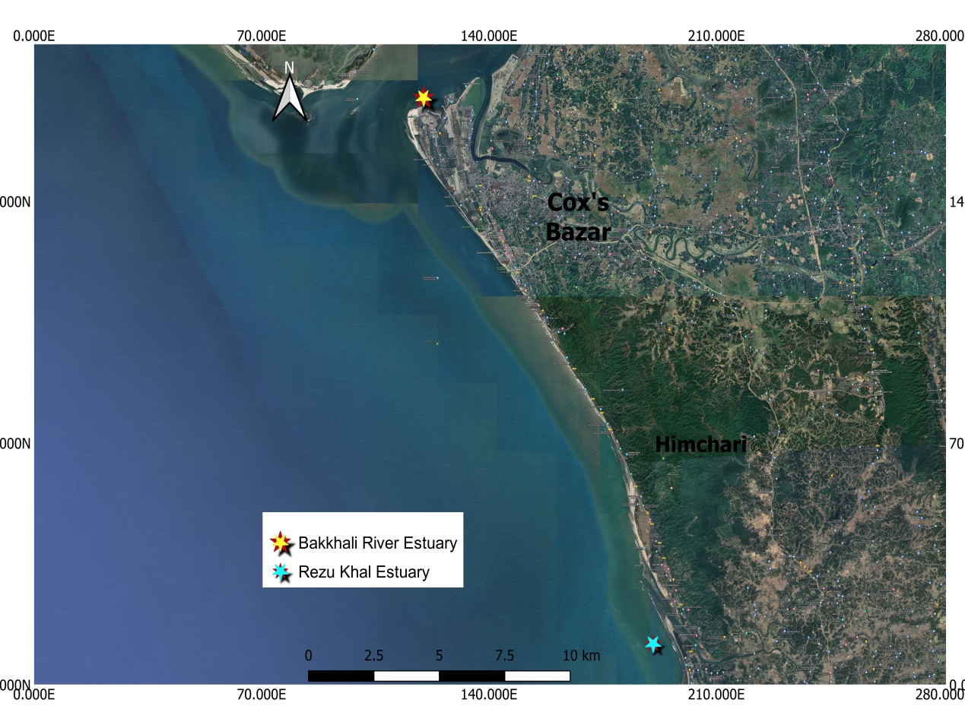

Figure 1: Map of study area (Bakkhali river estuary and Rezukhal estuary region)

**3.2 Sampling and Studied Parameters**

**3.2.1 Research procedure:**

**Table:1**

|  |  |  |
| --- | --- | --- |
| **SI. No** | **Step** | **Description of the work** |
| 01 | Selection of study area | Two suitable stations were selected for collection of blue button in Cox’s Bazar coasts by QGIS Software. |
| 02 | Sample Collection | Water samples for physico-chemical parameters were collected from each sampling station with water sampler bottle during morning hours. The hydrological parameters (Temperature, Transparency, pH, DO etc.) were measured on spot and water sample was transported in the laboratory for further analysis. |
| 03 | Laboratory Analysis | DO, Salinity, Alkalinity, TDS measured in the lab by using renowned method which is practiced in Aquatic Ecology lab (CVASU). |
| 04 | Summarizing the data and Analysis | Collected data was summarized and analysis of the data was done by using Microsoft Excel, SPSS software and ANOVA test. |
| 05 | Final reporting | Results of the research with a proposed strategic plan were submitted to the authority. |

**3.2.2 Preparation for Sample Collection**

Equipment were carried to the sampling stations to collect samples and further activities such as pH meter, DO meter, sampling jar, sampling bottle and ethanol etc.

**3.2.3 Sample Collection**

Water samples for assessing the physio-chemical parameters were collected from both of the selected stations. Sampling was done once in a month from March 2020 to October 2021. Some physico-chemical parameters such as temperature, DO, salinity and pH were estimated on spot as these parameters tend to change with time. The water sampler bottles were cleaned properly before sample collection. For laboratory analysis, water samples were brought to the Aquatic Ecology laboratory with proper labeling and preserved carefully.

**3.2.4 Analysis of Physico-Chemical** **Water Quality Parameters**

The seasonal variability of thephysico-chemical water quality parameters were assessed by following standard methods (APHA, 2005). Parameters such as temperature, DO, pH, salinity, TDS, transparency were determined using Celsius thermometer, Digital DO meter (Model: DO200A), Hannah pen pH meter (Model: pH100A), Refractometer (Model: ATC), TDS meter (Model: sensION ECM) and Secchi disk accordingly. Alkalinity was determined by titrimetric method in the Aquatic ecology laboratory in Chattogram Veterinary and Animal Sciences University.

**3.2.4.1 Temperature**

Water sample was taken from the corresponding stations in a water sampler bottle and temperature was measured by using Celsius thermometer on spot immediately after sample was brought to surface.

**3.2.4.2 Salinity**

Refractometer (ATC COMINHKPR124469) was used to determine salinity of the selected stations. Before measuring salinity, it was calibrated to get accurate results. Few drops of sample water were provided on the main prism and after 45 seconds readings were obtained by looking through the eyepiece in the direction of a light source.

**3.2.4.3 Dissolved Oxygen**

To determine DO concentration of the two stations digital DO meter (HANNA HI2004-01 edgeDO) was used. Measurement was done in-vitro condition so that no fluctuations occur in the value.

**3.2.4.4 pH**

Hannah pen pH meter (HI2211 model) is an ideal material to determine pH on spot. This tool was used to determine the pH value of the two stations at each month.

**3.2.4.5 Alkalinity**

In the laboratory, alkalinity was determined using titrimetric method in which phenolphthalein was used as indicator and sample was titrated against 0.02N sulphuric acid. Indicator was added one drop at a time to the water sample bottle and shook properly. If the sample turned pink in color, 0.2N concentrated Sulfuric acid were used to titrate the sample until turns colorless. The number of drops of acid = Phenolphthalein alkalinity in grains per gallon calcium carbonate (${ CaCO}_{3}$). The colorless sample resembles zero phenolphthalein indication; hence Bromcresol Green-Methyl Red Indicator Powder Pillow was added and mixed aptly. Until the sample was in pink color, drops were added.

**Calculation:**

Alkalinity (mg/l) as ${ CaCO}_{3}$ = (ml of titrant× N of acid used× 50× 1000/ ml of sample)

**3.2.4.6 Total Dissolved Solids**

TDS was determined using TDS meter (HACH sensION+EC71) to conduct this study. In order to analyze seasonal variation in TDS value, data were collected every month on the spot.

**3.2.4.7 Transparency**

Water transparency is the determination of productivity in water. A standard secchi disk was used for measuring of transparency.

**3.3 Seasonal Discretion:** In present study, the study period was seasonally allocated in the following:

✓ **Pre-Monsoon:** March, April, May

✓ **Monsoon:** June, July, August

✓ **Post Monsoon:** September, October, November

✓ **Winter:** December, January, February

**3.4 Data analysis and interpretation**

Monthly variation was observed in the parameters and demonstration of results was done using Microsoft Excel (Version-16). Investigated data were analyzed by using SPSS (version-25) and compared with previously completed studies and shown correlation among water quality parameters.

**3.5 Photo Gallery**

|  |  |  |
| --- | --- | --- |
| Plates No. | Photos |  |
| 01 | C:\Users\RAFI-PC\Desktop\RAFI\photo gallery\IMG_2212.jpeg | DO meter (HANNA HI2004-01 edgeDO) |
| 02 | C:\Users\RAFI-PC\Desktop\RAFI\photo gallery\IMG_2211.jpeg | TDS meter (HACH sensION+EC71) |
| 03 |  | pH meter (HI2211) |
| 04 | C:\Users\RAFI-PC\Desktop\RAFI\photo gallery\IMG_2219.jpeg | Refractometer (ATCCOMINHKPR124469) |
| 05 | C:\Users\RAFI-PC\Desktop\RAFI\photo gallery\IMG_2210.jpeg | Titration of Alkalinity |
| 06 | C:\Users\RAFI-PC\Desktop\RAFI\photo gallery\IMG_2199.jpeg | Assessing of DO |
| 07 | C:\Users\RAFI-PC\Desktop\RAFI\photo gallery\IMG_2203.jpeg | Assessing of pH |
| 08 | C:\Users\RAFI-PC\Desktop\RAFI\photo gallery\IMG_2208.jpeg | Titrating for Alkalinity |
| 09 | C:\Users\RAFI-PC\Desktop\RAFI\photo gallery\IMG_2206.jpeg | Assessing of Salinity |
| 10 | C:\Users\RAFI-PC\Desktop\RAFI\photo gallery\IMG_2204.jpeg | Assessing of TDS |
| 11 | C:\Users\RAFI-PC\Downloads\IMG-2214.jpg | Lab analysis |

**CHAPTER FOUR**

**RESULTS**

**4.1 Water Quality Parameter**

Different water quality parameters like temperature, pH, dissolved oxygen, total dissolved solids, salinity, alkalinity and transparency were investigated during this study which are outlined below using different graphs and diagrams-

**Monthly Water Quality Parameters**

**4.1.1 Temperature**

In the selected months, the mean temperature recorded was (25.35±5.16) 0C monthly. The maximum temperature was recorded 32.07ºC and minimum temperature was recorded 14.8ºC in Bakkhali river estuary, maximum temperature was recorded 30.80ºC and minimum temperature was recorded 15.40ºC in Rezukhal estuary Figure 2.

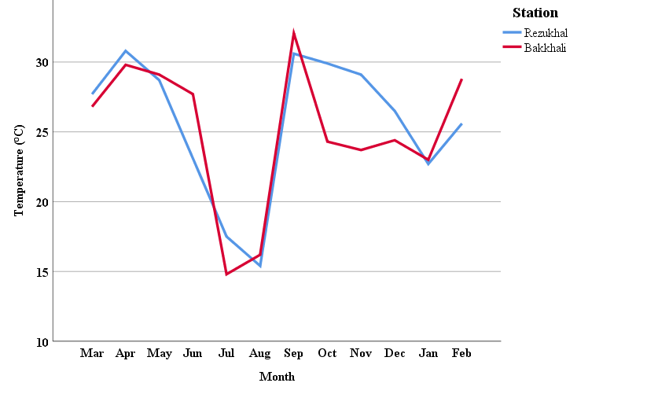

Figure 2: Monthly variations of temperature in two sampling area

**4.1.2 Salinity**

The mean value of salinity was observed as (23.7208±4.27) mg/l with the maximum 30.1 mg/l and minimum 18.2 mg/l value was recorded in Bakkhali and maximum 29.7 mg/l and minimum 18.5 mg/l value was recorded in Rezukhal respectively. The variations of Salinity of two stations have been shown in following figure 3.

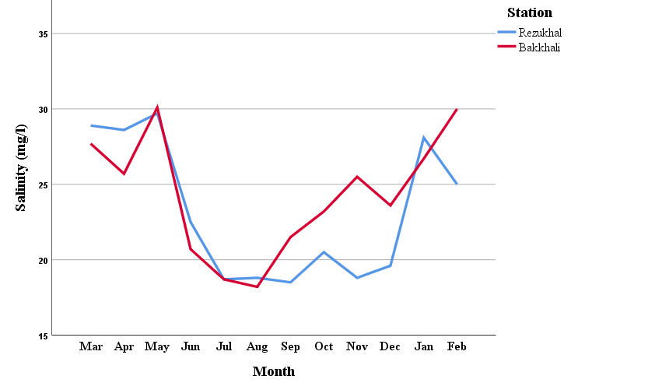

Figure 3: Monthly variations of salinity in two sampling area

**4.1.3 Dissolved Oxygen**

In the present study the mean value of DO content was recorded (6.40±1.05) mg/l in Cox’s Bazar coast. The minimum and maximum value of dissolved oxygen was recorded 4.2 mg/l and 7.7 mg/l in Bakkhali, the minimum and maximum value of dissolved oxygen was recorded 4.8 mg/l and 7.9 mg/l in Rezukhal respectively. Monthly variations of DO have been shown in following Figure 4.

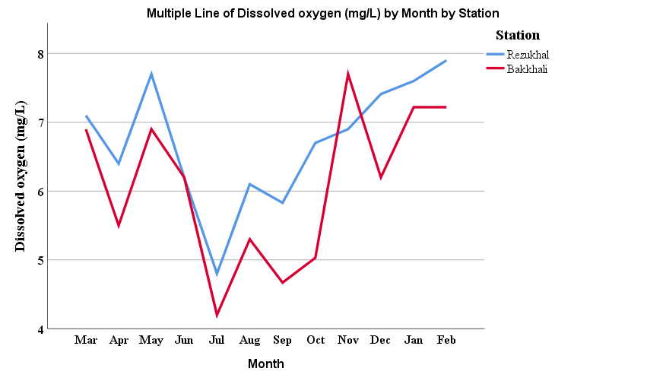

Figure 4: Monthly variations of dissolved oxygen in two sampling area

**4.1.4 pH**

The mean value of pH recorded in the selected months was (7.44±0.8). The minimum and maximum value of pH was recorded 6.1 and 8.1 in Bakkhali, the minimum and maximum value of pH was recorded 6.2 and 8.5 in Rezukhal respectively (Figure 5).

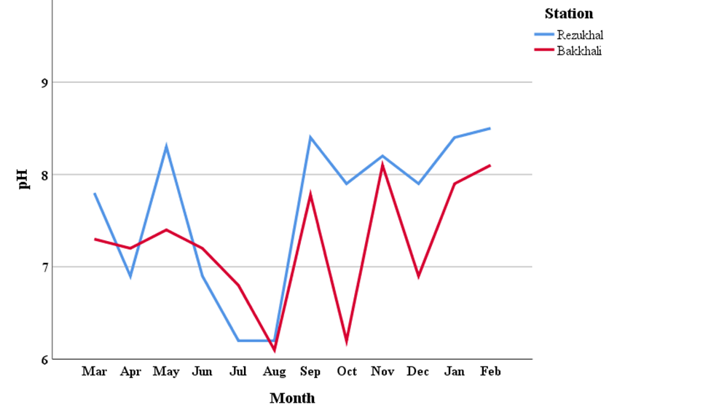

Figure 5: Monthly variations of pH in two sampling area

**4.1.5 Alkalinity**

The minimum and maximum value of alkalinity was recorded 108 ppm and 280 ppm in Bakkhali, the minimum and maximum value of alkalinity was recorded 165 ppm and 289 ppm in Rezukhal respectively(Figure 6). The mean value of alkalinity was (196.25±50.81) ppm.

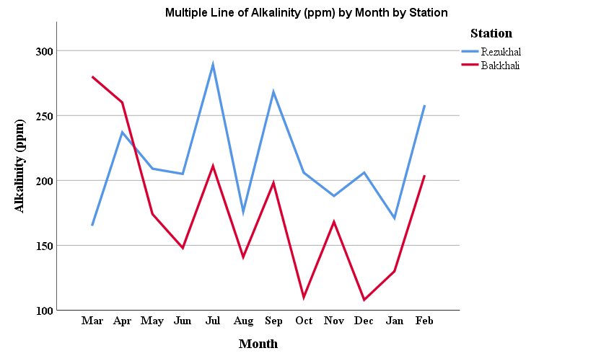

Figure 6: Monthly variations of alkalinity in two sampling area

**4.1.6 Total Dissolved Solid**

In the selected months, the mean value was (486.04±67.78) ppm monthly. The minimum and maximum value of TDS was recorded 399 ppm and 569 ppm in Bakkhali, the minimum and maximum value of TDS was recorded 417 ppm and 622 ppm in Rezukhal respectively (Figure 7).

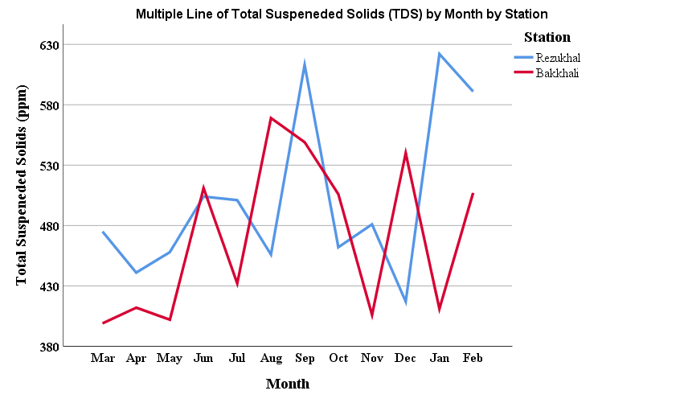

Figure 7: Monthly variations of TDS in two sampling area

**4.1.7 Transparency**

In the selected months, the mean value reported was (47.50±13.03) cm monthly. The minimum and maximum value of transparency was recorded 26 cm and 71 cm in Bakkhali, the minimum and maximum value of transparency was recorded 29 cm and 63 cm in Rezukhal respectively (Figure 8).

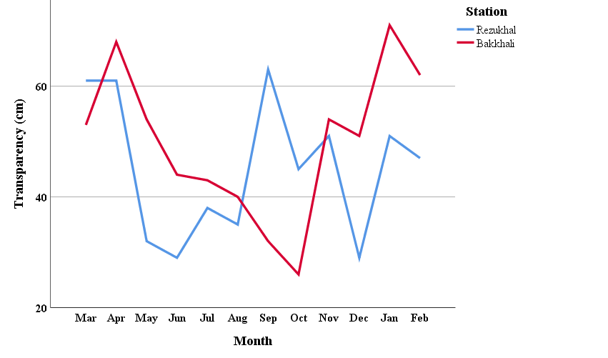

Figure 8: Monthly variations of transparency in two sampling area

**4.2 Station-wise Variable**

**4.2.1 Salinity**

The mean value of water salinity were observed (23.14 ± 4.60) mg/l in Rezukhal and (24.50±5.61) mg/l in Bakkhali (Table 2) and no significant relation (P > .05) was found in terms of station with salinity. Average value of salinity of two stations has been shown in figure 9.

**4.2.2 pH**

The mean value of water pH was recorded (7.32± 0.57) in Rezukhal and (7.86±0.63) in Bakkhali (Table 2) and no significant relation was found in terms of station. Average value of pH of two stations has been shown in figure 9.

**4.2.3 Dissolved Oxygen**

The average value of water DO was obtained (5.71± 1.08) mg/l in Rezukhal and (6.81±1.09) mg/l in Bakkhali (Table 2) and no significant variation was observed in two stations. Average value of DO of two stations has been shown in figure 9.

**4.2.4 Temperature**

The mean value of water temperature content was occupied (25.54±5.19) 0C in Rezukhal and (25.69±6.20) 0C in Bakkhali (Table 2) and had no significant relation. Average value of temperature of two stations has been shown in figure 9.

**4.2.5 TDS**

The average value of water TDS content was occupied (540.58±43.46) mg/l in Rezukhal and (574.80±80.64) mg/l in Bakkhali (Table 2) and no significant relation was found in two stations. Average value of TDS of two stations has been shown in figure 9.

**4.2.6 Transparency**

The average value of water transparency content was found (46.17±7.70) cm in Rezukhal and (51.92±10.66) cm in Bakkhali (Table 2) and no significant variation was observed. Average value of transparency of two stations has been shown in figure 9.

**4.2.7 Alkalinity**

The average value of water alkalinity content was observed (223±53.33) mg/l in Rezukhal and (206.50±62.70) mg/l in Bakkhali (Table 2) and had no significant variation in there. Average value of alkalinity of two stations has been shown in figure 9.

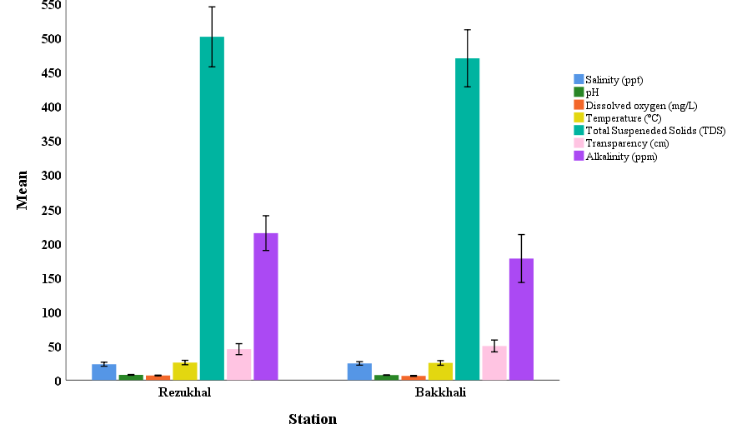

Figure 9: Station-wise variable of parameters in two sampling area

**Table 2:** The average value of water quality parameters of two sample areas.

|  |  |  |
| --- | --- | --- |
| **Parameter** | **Rezukhal** | **Bakkhali** |
| Salinity (mg/l) | 23.14 ± 4.60 | 24.30±4.02 |
| pH | 7.63± 0.85 | 7.24±0.67 |
| DO (mg/l) | 6.72± 0.91 | 6.07±1.13 |
| Temperature (0C) | 25.63±5.06 | 25.06±5.25 |
| TDS (mg/l) | 501.75±69.03 | 470.33±65.60 |
| Transparency (cm) | 45.17±12.58 | 49.83±13.60 |
| Alkalinity (mg/l) | 214.83±40 | 177.67±55.19 |

**4.3 Seasonal Variability in Physico-chemical Parameters of Water**

**4.3.1 Salinity**

Seasonally observed highest salinity 30.1 mg/l was found in Bakkhali during pre-monsoon and lowest value 18.2 mg/l was found in Bakkhali estuary during monsoon with the mean value of (23.72±4.31) mg/l and seasonally had significant relation (P = 0.000). Then, salinity was showed strong correlation with DO (r = .573) but weak correlation was found with another parameter (Table 3) (figure 17). Seasonal variability of salinity has been shown in the following figure 10.

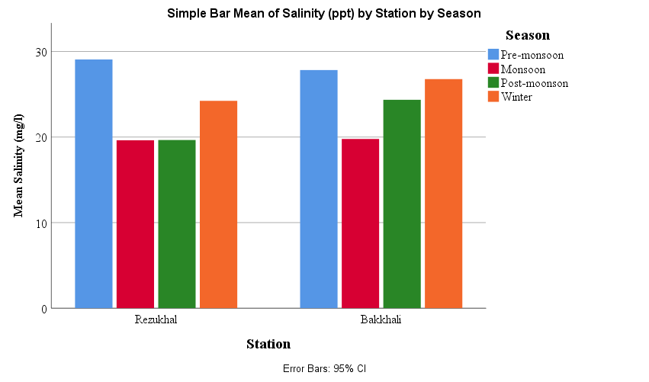

Figure 10: Seasonal variations of Salinity in two sampling area

**4.3.2 pH**

Seasonally the maximum value of pH 8.5 was found in Rezukhal during winter season and minimum value of pH 6.1 was found in Bakkhali estuary during monsoon season with average value of (7.44±0.76) and had no significant relation. But pH had shown high significant (P = .103 < .01) strong relation (r = .693) with DO and (r=.594) with temperature (Table 3) (Figure 17).Seasonal variability of pH has been shown in the following figure 11.

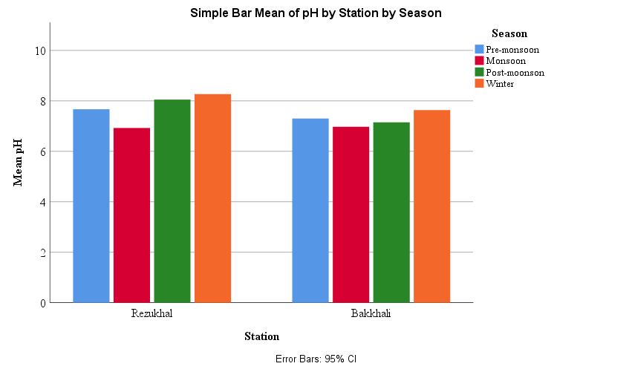

Figure 11: Seasonal variations of pH in two sampling area

**4.3.3 Dissolved Oxygen**

Seasonally observed maximum DO 7.9 mg/l was found in Bakkhali during winter and minimum value 4.20 mg/l was found in Bakkhali during monsoon season with mean of (6.40±1.02) mg/l and seasonally had no significant variation. Moreover, DO had shown high significant (P=.002) moderate relation (r=.333) with temperature and negative relation (r=0.049) with alkalinity (Table 3) (figure 17). The seasonal variation of DO has been shown in the following Figure 12.

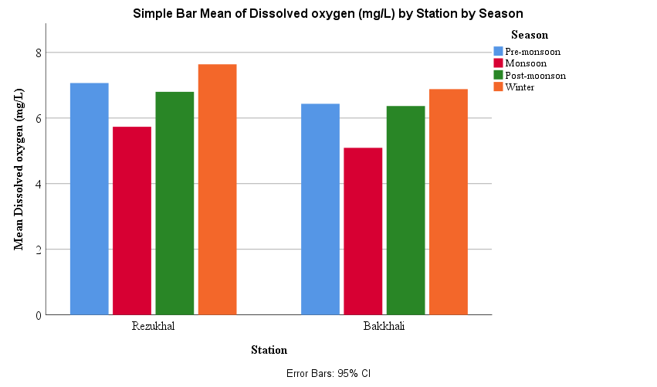

Figure 12: Seasonal variations of DO in two sampling area

**4.3.4 Temperature**

Seasonally highest value of temperature 32.070C & 14.800C lowest value was found in Bakkhali during monsoon season respectively with mean of (25.35±5.16) 0C and seasonally high significant variation (P=0.87) was observed. Besides Temperature had shown negative relation with TDS and moderate relation with transparency(r=0.315) (Table 3) (Figure 17). Seasonal variability of temperature has been shown in the following figure 13.

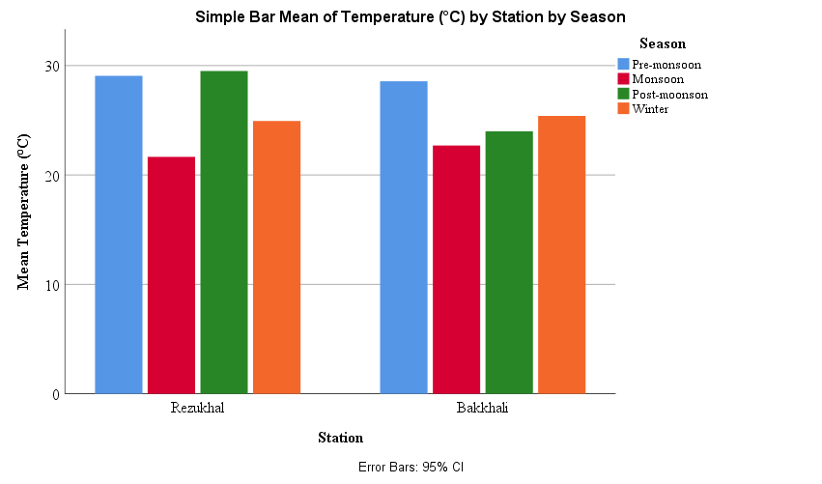

Figure 13: Seasonal variations of Temperature in two sampling area

**4.3.5 Total Dissolved Solid**

The maximum value of TDS 622 mg/l during winter from Rezukhal and minimum value 399 mg/l during pre-monsoon season was recorded from Bakkhali with mean of (486.04.33±67.32) mg/l and seasonally had no significant variation. But TDS had shown negative weak and moderate correlation with other parameters (Table 3) & (Figure 17). Seasonal variability of TDS has been shown in the following figure 14.

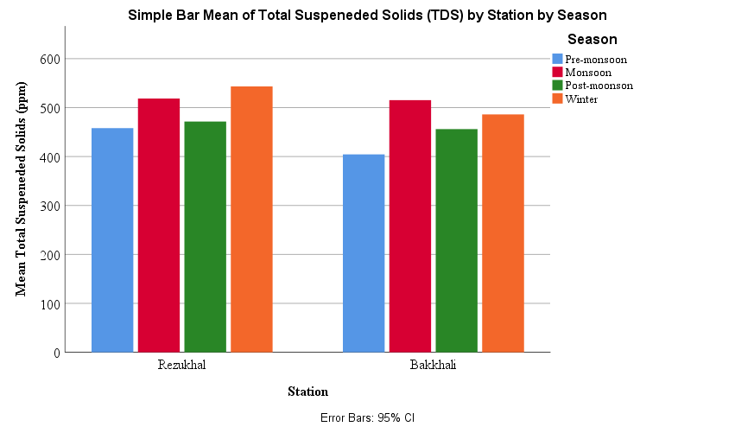

Figure 14: Seasonal variations of TDS in two sampling area

**4.3.6 Transparency**

Seasonally maximum and minimum value like 71 cm during winter season and 26 cm was found in Bakkhali during post-monsoon season and respectively with mean value of (47.5±13.09) cm & no significant variation was observed. Furthermore, positive strong correlation was found with alkalinity (Table 3) & (Figure 17). The variation of transparency has been shown in following figure 15.

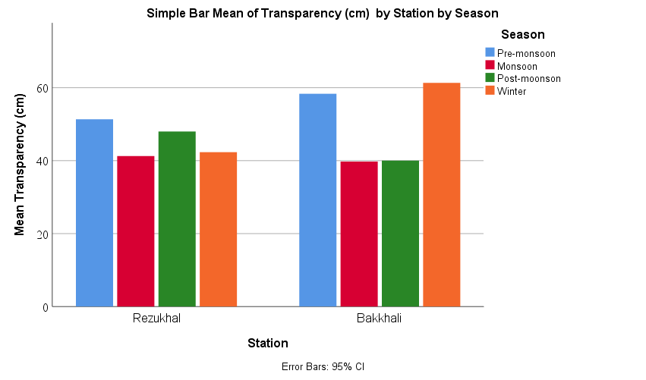

Figure 15: Seasonal variations of Transparency in two sampling area

**4.3.7 Alkalinity**

Seasonally observed highest of alkalinity 289 mg/l was found in Rezukhal during monsoon and lowest value 108 mg/l during winter season from Rezukhal and had no observed significant variation with average value of (196.45±47.50) mg/l. Therefore, alkalinity had shown positive correlation with pH and temperature and (Table 3) & (Figure 17). Seasonal variation of alkalinity has been shown in the following figure 16.

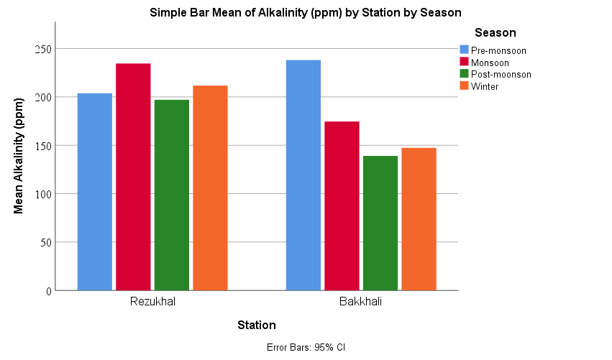

Figure 16: Seasonal variations of Alkalinity in two sampling area

**4.4 Correlation Matrix of Water Parameter:**

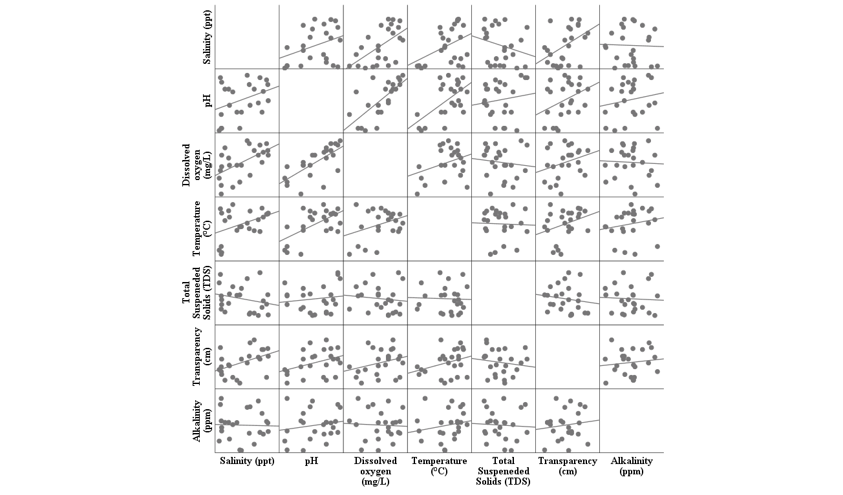

Figure 17: Correlation Matrix of Water Parameter

Table 3: Correlation among Physico-chemical Parameters of water of two sampling areas in Cox’s Bazar Coast. (Pearson Method)

|  |  |  |  |  |  |  |  |  |
| --- | --- | --- | --- | --- | --- | --- | --- | --- |
| **Correlations** | | | | | | | | |
|  | | Salinity (ppt) | pH | Dissolved oxygen (mg/L) | Temperature (°C) | Total Suspeneded Solids (TDS) | Transparency (cm) | Alkalinity (ppm) |
| Salinity (ppt) | Pearson Correlation | 1 | 0.361 | .573\*\* | .415\* | -0.244 | .447\* | -0.031 |
| Sig. (2-tailed) |  | 0.083 | 0.003 | 0.044 | 0.251 | 0.028 | 0.886 |
| N | 24 | 24 | 24 | 24 | 24 | 24 | 24 |
| pH | Pearson Correlation | 0.361 | 1 | .693\*\* | .594\*\* | 0.138 | 0.362 | 0.173 |
| Sig. (2-tailed) | 0.083 |  | 0.000 | 0.002 | 0.520 | 0.082 | 0.418 |
| N | 24 | 24 | 24 | 24 | 24 | 24 | 24 |
| Dissolved oxygen (mg/L) | Pearson Correlation | .573\*\* | .693\*\* | 1 | 0.333 | -0.113 | 0.286 | -0.049 |
| Sig. (2-tailed) | 0.003 | 0.000 |  | 0.112 | 0.599 | 0.175 | 0.822 |
| N | 24 | 24 | 24 | 24 | 24 | 24 | 24 |
| Temperature (°C) | Pearson Correlation | .415\* | .594\*\* | 0.333 | 1 | -0.034 | 0.315 | 0.187 |
| Sig. (2-tailed) | 0.044 | 0.002 | 0.112 |  | 0.874 | 0.134 | 0.382 |
| N | 24 | 24 | 24 | 24 | 24 | 24 | 24 |
| Total Suspeneded Solids (TDS) | Pearson Correlation | -0.244 | 0.138 | -0.113 | -0.034 | 1 | -0.143 | -0.052 |
| Sig. (2-tailed) | 0.251 | 0.520 | 0.599 | 0.874 |  | 0.504 | 0.810 |
| N | 24 | 24 | 24 | 24 | 24 | 24 | 24 |
| Transparency (cm) | Pearson Correlation | .447\* | 0.362 | 0.286 | 0.315 | -0.143 | 1 | 0.127 |
| Sig. (2-tailed) | 0.028 | 0.082 | 0.175 | 0.134 | 0.504 |  | 0.555 |
| N | 24 | 24 | 24 | 24 | 24 | 24 | 24 |
| Alkalinity (ppm) | Pearson Correlation | -0.031 | 0.173 | -0.049 | 0.187 | -0.052 | 0.127 | 1 |
| Sig. (2-tailed) | 0.886 | 0.418 | 0.822 | 0.382 | 0.810 | 0.555 |  |
| N | 24 | 24 | 24 | 24 | 24 | 24 | 24 |
| \*\*. Correlation is significant at the 0.01 level (2-tailed). | | | | | | | | |
| \*. Correlation is significant at the 0.05 level (2-tailed). | | | | | | | | |

**CHAPTER FIVE**

**DISCUSSION**

Water is home to various aquatic organisms. Hence, water quality parameters play a vital role in the aquatic ecosystem. Fluctuations in the parameters can bring drastic changes in the lives of those aquatic organisms. In order to sustain the life of the organisms keeping the water quality in good condition is essential. Environment is an important factor that affects water quality and multifarious physicochemical parameters of the waters are used to determine the effect (Hamuna et al., 2018). A comparative discussion of water quality parameters that was collected from Rejukhal Coast and Bakkhali Channel is given below.

**5.1 Water Quality Parameters**

All the data collected from two stations over ten months have been presented in the result chapter.

**5.1.1 Salinity**

Growth and survivability of aquatic organisms are highly dependent on the water salinity. Each organism is adapted to particular salinity, Salinity directly affects organisms’ metabolism especially osmoregulation process (Holliday, 1969). As a major factor salinity affects the population abundance of organisms in the aquatic environment. In the study the average concentration of salinity (23.72±4.31) mg/l was recoded in Cox’s Bazar coast and the mean value of 23.14 mg/l and 24.30 mg/l was found in Bakkhali and Rezukhal respectively that resembles similarity with the study Parvez et al., (2018). This present study showed that seasonally observed highest salinity 30.1 mg/l was found in Bakkhali during pre-monsoon and lowest value 18.2 mg/L was found in Bakkhali estuary during monsoon. This present study showed that mean salinity value in the Bakkhali Channel was 23.14 mg/L that is similar to the value (range in between 18ppt to 245ppt) found in study conducted by Hasan et al., (2019).

**5.1.2 pH**

In an aqueous solution pH is the measurement of hydrogen ion concentration which is one of the most promising parameters of water quality. A fluctuation in the value of pH affects the aquatic life as well as the whole ecosystem. Different flora and fauna have adapted differently in water with a specific pH. Some experts stated that acid rain induced the recent decrease in amphibian population throughout the globe due to low pH. Moderately acidic pH have the ability to decrease the number of hatched fish eggs as well as can cause irritation in the gill region of fish and damage membrane (Omer, 2019). In the present study the average pH level (7.44±0.76) and the mean value of pH 7.63 and 7.24 were recorded from Bakkhali and Rezukhal respectively and seasonally the maximum value of pH 8.5 was found in Rezukhal during Winter season and minimum value of pH 6.1 was found in Bakkhali estuary during Monsoon season.

A study conducted by Rashed-Un-Nabi et al., (2011) has reported that the mean pH value observed in the Bakkhali Channel was 7.2; during the pre-monsoon season pH value (7.7) was the highest and during the winter season the pH value was lowest (6.3). According to Parvez et al., (2018), range of pH value observed in that station is in between 7-8 which is within the limit recommended (6.5- 9.20) by the World Health Organization (Hossain et al., 2012).

**5.1.3 Dissolved Oxygen**

As a key test of water quality and water pollution Dissolved oxygen (DO) is considered to be one of the most important parameters. Rate of dissolving oxygen in the water is temperature dependent. For example, the saturation concentration at 20°C is about 9 mg/l and at 0°C is 14.6 mg/l. But the actual concentration of DO in the water is largely dependent on pressure, temperature, and salinity of the water (Metcalf et al., 1991). The readings of average DO were (6.40±1.02) mg/l obtained from Cox’s Bazar coast with the average value of DO 6.72 mg/l was found in Bakkhali and 6.07 mg/l was recorded in Rezukhal. In the present study seasonally observed maximum DO 7.9 mg/l was found in Bakkhali during Winter and minimum value 4.20 mg/l was found in Bakkhali during Monsoon season .In the study done by Parvez et al., (2018), it was showed that the DO concentration in the Rejukhal Coast varied from 3 mg/l to 4 mg/l which was below the minimum recommended standard (5 mg/l) set by EPA Redbook (Wang et al., 2015). In order to analyze the suitability of seaweed culture site in the Bakkhali Channel a study was conducted by Hoq et al., (2016), it was presented that DO concentration in that station varied from 5.8 mg/l to 6.8 mg/l; the highest was found in the January month and lowest in the November month.

**5.1.4 Temperature**

One of the most influencing factors of water chemistry parameters is temperature along with dissolve oxygen, pH, nutrient concentration and toxicity of nature and anthropogenic pollutants. These parameters have critical aspect in the fisheries perspective. Raising temperature has direct impacts on inland aquatic ecosystems. Increment in temperature affects water chemistry which indirectly affects the alterations of species composition in the aquatic food chain (Saud et al., 2012). Variations of macro-benthic organism’s abundance and distribution in the waterbody are driven by surface and atmospheric temperature. There is a negative correlation between macro-benthos abundances and temperature changes (Haque et al., 2020). In the present study, average recorded temperature (25.35±5.16)ºC was found in Cox’s Bazar coast and the average temperature was found 25.63°C in Bakkhali and 25.05°C in Rezukhal.

A study conducted in the Rejukhal Coast by Parvez et al., (2020) showed that highest temperature recorded that station was 28°C in the pre-monsoonal season. In this study, seasonally highest value of temperature 32.07°C & 14.80°C lowest value was found in Bakkhali during monsoon season respectively. For fish growth, optimum temperature range should be 22- 31°C. Hence, the water quality of Rejukhal coast is not optimum for fish growth. Another study done by Hasan et al., (2019) prognosticated that, temperature variation in the Bakkhali Channel ranged from 26.44°C in winter to 28.72°C in pre-monsoon. While Raknuzzaman et al., (2018) stated that, temperature in summer was 22ºC and in winter 21ºC.

**5.1.5 Total Dissolved Solids**

Organic matter and inorganic minerals and various kinds salts as well as disassociated electrolytes that make up salinity concentrations are the main ingredients of Total dissolved solids (TDS) (Miranda and Krishnakumar, 2015). Level of TDS reflects the level of pollution occurring in the aquatic system (Jonnalagadda and Mhere, 2001). pH has great impact in the changes of TDS value as fluctuations in the pH value can result in precipitation of suspended solutes (Islam et al., 2018).

In the study of Parvez et al., (2020), the TDS value in the Rejukhal Coast was stated in between 33 to 35 ppm. While in the study, the average value of TDS was (486±67.32) mg/l recorded and the average value of TDS 501.75 mg/l was found in Bakkhali and 470.33 mg/l was found in Rezukhal and the maximum value of TDS 622 mg/l during Winter from Rezukhal and minimum value 399 mg/l during Pre-monsoon season was recorded from Bakkhali.

**5.1.6 Transparency**

Transparency of water is the opposite of water turbidity which is one of the most commonly used indicator of water quality. It also acts as supporting factor for the biological elements in the Water Framework Directive (WFD) (Solimini et al., 2006). Clean water has high transparency value than turbid water hence sunlight penetrates deeper in the clean water. The average value of transparency in the present investigation was (47.05±13.09) cm and the mean value of 45.17 cm was found in Bakkhali and 49.83 cm was found in Rezukhal.

While in this study, seasonally maximum and minimum value like 71 cm during Winter season and 26 cm was found in Bakkhali during Post-monsoon season and respectively. In the Bakkhali Channel the mean value was 45.17 cm which is near similar to the value found in the study done by Hoq et al., (2016) which varied from 64.5 cm to 65.5 cm. In Rejukhal Coast mean transparency value found was 49.83 cm which is above the value found in the study by Parvez et al., (2020). In his study the value was from 21 cm to 45 cm.

**5.1.7 Alkalinity**

As a proper storage of carbon dioxide, bicarbonate plays a vital role that ensures a continuous supply of oxygen for the photosynthesis process. This bicarbonate along with carbonate ion of water is the total alkalinity which used as a tool for the measurement of productivity and conditions of water bodies (Chareontesprasit and Jiwyam, 2001). The average value of alkalinity (196.45±47.50) mg/l was obtained from Cox’s Bazar coast and average value of alkalinity 214.83 mg/l was found in Bakkhali and 177.67 mg/l was in Rezukhal and seasonally observed highest of alkalinity 289 mg/l was found in Rezukhal during Monsoon and lowest value 108 mg/l during Winter season from Rezukhal. The study conducted by Hasan et al., (2019), has stated similar result with this study. In that study the value of alkalinity in the Bakkhali Channel varied from 136 ppm to 168 ppm.

**5.1.8 Limitations:**

1. Investigation of the resources in coastal water body is time consuming and cost intensive.
2. The major limitations of the research work were the unpredictability of the weather, lack of time, transportation problem.

**5.1.9 Suggestions:**

1. In order to protect the coastal ecosystem from several effects, policy makers should be assisted by the study's disclosure of the current status of the physico-chemical parameters.
2. The government could take management policy for maintaining the condition of that ecologically important area and for that reason this research will be helpful.

**CHAPTER SIX**

**CONCLUSIONS**

Good environment is a must to get healthy fish population. Variations in water quality parameters have detrimental impacts of fish population as well as whole aquatic ecosystems. The present investigation is carried out to evaluate seasonal variation of water quality parameters in the Rejukhal Coast and Bakkhali Channel. Major water quality indicators like temperature, dissolved oxygen, pH, salinity, transparency, ammonia and total dissolved solids are being estimated and compared with previous studies to get proper comparative idea. Fluctuations in the parameters can occur for multifarious reasons like change in climate, anthropogenic activities, surface runoff, increase in the load of mud, decomposition rate etc. This study shows that different parameters have different values in different seasons; some increase in pre-monsoonal season and later decrease in post-monsoonal season. Changes in parameters cause changes in the adaptation strategies of organisms.

This study provides good knowledge about water quality parameters of the two stations. Such study is very much crucial and act as first research requirement to increase fish population in any water body. This kind of study helps the management committee to take proper actions and mitigate the detrimental effects of various risks. Nevertheless, further research works are needed to provide more scientific basis to the management actions and policies that will be taken to enhance the condition of Rejukhal Coast and Bakkhali Channel.

**CHAPTER SEVEN**

**RECOMMENDATIONS AND FUTURE PROSPECTIVES**

Fisheries sector is contributing a vital portion in the national economy. Increasing production has becoming a must to get more benefit in terms of economy as well as ecology. Rejukhal Coast and Bakkhali Channel harbor large variety of aquatic organisms specially fish population. This study though revealed seasonal variation of the two stations; there were some limitations. One of the major limitations of this study is lack of time and facilities to evaluate microbial and plastic pollution in those stations. Hence some of the aspects have been mentioned for future study considering the limitations and paramount of those stations.

* Proper steps should be taken to incorporate ad-hoc services along with the cooperation of local communities.
* Enough transportation facilities and other technical support will facilitate the study more.
* Facilities to conduct microbial pollution in those stations will help to analyze the qualitative and quantitative microbial load in the water.
* Proper steps to aware local public and stakeholders will increase the sustainability of the coastal areas where they will be properly become aware of risk and disaster related to climate change and become ready to tackle the post-disaster situations.

**REFERENCES**

Amankwaah D, Cobbina SJ, Tiwaa YA, Bakobie N, Millicent EAB. (2014). Assessment of pond effluent effect on water quality of Asuofia Stream, Ghana. African Journal of Environmental Science and Technology. 8(5): 306-311.

ANZECC (Australian and New Zealand Environment and Conservation Council), (1992). Australian water quality guidelines for fresh and marine waters. ANZECC, Canberra, Australia. [ANZECC & ARMCANZ (2000) guidelines (waterquality.gov.au)](https://www.waterquality.gov.au/anz-guidelines/resources/previous-guidelines/anzecc-armcanz-2000)

APHA, (2005). Standard Methods of Water and Wastewater. 21st Edn., American Public Health Association, Washington DC. ISBN: 0875530478. 2-61.

Arulampalam P, Yusoff FM, Shariff M, Law AT, Srinivasa Rao PS. (1998). Water quality and bacterial populations in a tropical marine cage culture farm. Aquaculture research. 29(9): 617-624.

Bai S, Gao J, Sun D, Tian M. (2020). Monitoring water transparency in shallow and eutrophic lake waters based on GOCI observations. Remote Sensing. 12(1): 163.

Bolorunduro PI and Abdullah AY. (1996). Water quality management in fish culture. Fisheries Series. 3(98): 36.

Bossa YA. (2012). Multi-scale modeling of sediment and nutrient flow dynamics in the Ouémé catchment (Benin)-towards an assessment of global change effects on soil degradation and Water Quality (Doctoral dissertation, Universitäts-und Landesbibliothek Bonn). [Multi-scale modeling of sediment and nutrient flow dynamics in the Ouémé catchment (Benin) - towards an assessment of global change effects on soil degradation and water quality (uni-bonn.de)](https://bonndoc.ulb.uni-bonn.de/xmlui/handle/20.500.11811/5386)

Boyd CE. (1982). Water quality management for pond fish culture. Elsevier Scientific Publishing Co. [Water Quality Management for Pond Fish Culture - Claude E. Boyd - Google Books](https://books.google.com.bd/books/about/Water_quality_management_for_pond_fish_c.html?id=rJbcjoO1Cb4C&redir_esc=y)

Chapman D and Kimstach V. (1992). The Selection of Water Quality Variable In: Water Quality Assessments (Chapman, D. Ed.), Hall, London, 51-119. - References - Scientific Research Publishing (scirp.org)

Chareontesprasit N and Jiwyam W. (2001). An evaluation of Wolffia meal (*Wolffia arrhiza*) in replacing soybean meal in some formulated rations of Nile tilapia (*Oreochromis niloticus* L.). **DOI:** [10.3923/pjbs.2001.618.620](https://dx.doi.org/10.3923/pjbs.2001.618.620)

Florida Lake watch, (2004).The beginners guide for water management oxygen and temperature. Department of Fisheries and Aquatic Sciences Institute of Food and Agricultural sciences. University of Florida, Fist edition.

Gambrell RP and Patrick WH. (1988). The influence of redox potential on the environmental chemistry of contaminants in soils and sediments. The ecology and management of wetlands. 319-333.

Gorde SP and Jadhav MV. (2013). Assessment of water quality parameters: a review. International journal of research and applications 3(6): 2029-2035.

Hamuna B, Suwito TR, Maury HK, Alianto. (2018). Study of seawater quality and pollution index based on physical-chemical parameters in Depapre District waters, Jayapura. Jurnal Ilmu Lingkungan. 16(1): 35-43.

Haque MM, Sharif ASM, Ahmed MK, Anwar F, Rani S, Molla MHR, Khan MI. (2020). Distribution and diversity of macrobenthos in Sangu River, Bangladesh. The Dhaka University Journal of Earth*.* DOI*:* https://doi.org/10.3329/dujees.v9i2.55087

Hasan M, Islam MS, Kabir MH, Hasan J, Hoq ME. (2019). Water quality of Bakkhali River as major water source of Fish Landing Center, Cox's Bazar.Bangladesh Journal of Fisheries*.*31(2): 325-333.

Hena AMK, Kohinoor SMS, Siddique MAM, Ismail J, Idris MH and Amin SMN. (2012). Composition of macrobenthos in the Bakkhali Channel System, Cox’s Bazar with notes on soil parameter. Pakistan Journal of Biological Sciences. 15(13): 641-646.

Holliday FGT. (1969). The Effects of Salinity on the Eggs and Larvae of Teleosts. In Fish physiology (Vol. 1): 293-311. Academic Press.

Hoq ME, Haque MA, Islam MM. (2016). Feasibility of seaweed culture in Inani and Bakkhali coast of Cox’s Bazar, Bangladesh.

Hossain MS, Das NG, Sarker S, Rahaman MZ. (2012). Fish diversity and habitat relationship with environmental variables at Meghna river estuary, Bangladesh. The Egyptian Journal of Aquatic Research 38(3): 213-226.

Hutton LG. (1983). Field Testing of Water in Developing Countries. Water Research Centre, Medmenham. [Field testing of water in developing countries (1983 edition) | Open Library](https://openlibrary.org/books/OL17989243M/Field_testing_of_water_in_developing_countries)

Islam MR, Sarkar MKI, Afrin T, Rahman SS, Talukder RI, Howlader BK, Khaleque MA. (2016). A study on total dissolved solids and hardness level of drinking mineral water in Bangladesh. Journal of the American Chemistry Society. 4(5): 164-169.

Islam, Tarikul & Kibria, Mahbub & Emon, Sonet & Biswas, Suman. (2018). Seasonal Variation of Physico-Chemical Characteristics in the South Eastern Coastal Waters of Cox's Bazar, Bangladesh. (8): 1283-1289.

Jahan SM, Jewel AS, Haque MA, Hasan J, Mita MM, Aktar A, Al-Amin M. (2019). Current status of bacterial contamination in some fish species of Bakkhali River Estuary, Bangladesh. Archives of Agriculture and Environmental Science. 4(1): 96-100.

Jonnalagadda SB and Mhere G. (2001). Water quality of the Odzi River in the eastern highlands of Zimbabwe. Water research. 35(10): 2371-2376.

Joseph KB, Soderberg RW, Terlizzi DE (1993).An introduction to water chemistry in freshwater aquaculture. NRAC Fact Sheet No: 170.

Khlebovich VV and Aladin NV. (2010). The salinity factor in animal life. Herald of the Russian Academy of Sciences. 80(3): 299-304.

Lewis WM, Heidinger RC, Tetslaff BL. (1981). Tank culture of striped bass production manual. Southern Illinois University, Fisheries Research Laboratory, Carbondale. [Tank Culture of Striped Bass | Semantic Scholar](https://www.semanticscholar.org/paper/Tank-Culture-of-Striped-Bass-Lewis-Heidinger/11bf46739c3c38d79d5de5389fbf7a0962b35523)

Mallasen M, De Barros HP, Traficante DP, Camargo ALS. (2012). Influence of a net cage tilapia culture on the water quality of the Nova Avanhandava reservoir, São Paulo State, Brazil. Acta Scientiarum. Biological Sciences. 34(3): 289-296.

Mallick D, Islam SM, Talukder A, Mandol S, Imran M, Biswas S. (2016). Seasonal Variability in Water Chemistry and Sediment Characteristics of Intertidal Zone at Karnafully Estuary, Bangladesh. Pollution. 2(4): 411-423.

Metcalf L, Eddy HP, Tchobanoglous G. (1991). Wastewater engineering: treatment, disposal, and reuse (Vol. 4). New York: McGraw-Hill.

Miranda J and Krishnakumar G. (2015). Microalgal diversity in relation to the physicochemical parameters of some Industrial sites in Mangalore, South India. Environmental monitoring and assessment. 187(11): 1-25.

Mondal MN, Shahin J, Wahab MA, Asaduzzaman M, Yang Y. (2010). Comparison between cage and pond production of Thai Climbing Perch (*Anabas testudineus*) and Tilapia (*Oreochromis niloticus*) under three management systems. Journal of the Bangladesh Agricultural University. 8(452-2016-35693).

Nsonga A. (2014). Indigenous fish species a panacea for cage aquaculture in Zambia: A case for Oreochromis macrochir (Boulenger, 1912) at Kambashi out-grower scheme. International Journal of Fisheries and Aquatic Studies. 2(1): 102-105.

Omer NH. (2019). Water quality parameters. Water quality-science, assessments and policy. 18: 1-34.

Parvez MM, Billah MM, Iqbal MM, Rahman MM, Bhuiyan MKA, Romkey SS, Islam MS. (2018). Fish diversity and water characteristics in the Rejukhal river estuary, Bangladesh. Water conservation & management (WCM). 2(2): 11-19.

Patil C, Narayanakar S, Virupakshi A. (2013). Assessment of groundwater quality around solid waste landfill area-a case study. International Journal of Innovative Research in Science, Engineering and Technology. 2(7): 3131-3136.

Raknuzzaman M, Al Mamun MH, Ahmed MK, Tokumura M, Masunaga S. (2018). Monitoring of seasonal variation of some trace metals concentration in surface water collected from the coastal area of Bangladesh. Journal of Biodiversity Conservation and Bioresource Management. 4(2): 67-80.

Rashed-Un-Nabi M, Al-Mamun MA, Ullah MH, Mustafa MG. (2011). Temporal and spatial distribution of fish and shrimp assemblage in the Bakkhali river estuary of Bangladesh in relation to some water quality parameters. Marine Biology Research. 7(5): 436-452.

Rashedul ACM and Zafar M. (2018). Physico–chemical parameters of water and sediment during spring period in parts off Bay of Bengal, Bangladesh. MOJ Eco Environ Sci*.* 3(3): 150-154.

Rashid T, Hoque S, Akter F. (2013). Ocean Acidification in the Bay of Bengal*.* OpenAccess Scientific Report. 2: 699.

Saud BJ, Bhattacharjya BK, Verma VK, Kumar D, Debnath D, Das M, Sharma AP. (2012). Effect of Climate Change on Aquatic Life with Special Refferencence to North-East Region of India. Environment & Ecology. 30(4A): 1534-1537.

Shamsuzzaman MM and Islam MM. (2018). Analysing the Legal Framework of Marine Living Resource Management in Bangladesh. Marine Policy. 87: 255-262.

Somura H, Takeda I, Arnold JG, Mori Y, Jeong J, Kannan N, Hoffman D. (2012). Impact of suspended sediment and nutrient loading from land uses against water quality in the Hii River basin, Japan. Journal of Hydrology. 450: 25-35.

Siti-Zahrah A, Padilah B, Azila A, Rimatulhana R, Shahidan H. (2008). Multiple streptococcal species infection in cage-cultured red tilapia but showing similar clinical signs. Diseases in Asian Aquaculture VI. Manila: Fish Health Section, Asian Fisheries Society. (2008): 313-320.

Solimini A, Free G, Donohue I, Irvine K, Pusch M, Rossaro B, Cardoso AC. (2006). Using Benthic Macroinvertebrates to assess Ecological Status of Lakes current knowledge and way forward to support WFD Implementation.

Thirupathaiah M, Samatha CH, Sammaiah C. (2012). Analysis of water quality using physico-chemical parameters in lower manair reservoir of Karimnagar district, Andhra Pradesh. International Journal of Environmental Sciences. 3(1): 172.

Tom L. (1998). Nutritional and feeding of fish. Kluwer Academic Publishers. Second edition. https://www.academia.edu/40408955/NUTRITION\_AND\_FEEDING\_OF\_FISH\_Second\_Edition

Wang L, Wang C, Deng D, Zhao X, Zhou Z. (2015). Temporal and spatial variations in phytoplankton: correlations with environmental factors in Shengjin Lake, China. Environmental Science and Pollution Research. 22(18): 14144-14156.

Weber-Scannell PK and Duffy LK. (2007). Effects of total dissolved solids on aquatic organism: a review of literature and recommendation for salmonid species. In American Journal of Environmental Sciences. 3(1-6).

Yee LT, Paka DD, Nyanti L, Ismail N, Emang JJ. (2012). Water quality at Batang Ai hydroelectric reservoir (Sarawak, Malaysia) and implications for aquaculture. International Journal of Applied. 2(6).

**Appendices**

**Appendix-A: Monthly Variable of Water Quality Parameter in Rezukhal and Bakkhali Station**

|  |  |  |  |  |  |  |  |  |
| --- | --- | --- | --- | --- | --- | --- | --- | --- |
| **Salinity (ppt) pH Dissolved oxygen (mg/L) Temperature (°C) Total Suspeneded Solids (TDS) Transparency (cm) Alkalinity (ppm) \* Month** | | | | | | | | |
| Month | | Salinity (ppt) | pH | Dissolved oxygen (mg/L) | Temperature (°C) | Total Suspeneded Solids (TDS) | Transparency (cm) | Alkalinity (ppm) |
| Mar-20 | Mean | 28.3000 | 7.5500 | 7.0000 | 27.2500 | 437.0000 | 57.0000 | 222.5000 |
| Std. Deviation | 0.84853 | 0.35355 | 0.14142 | 0.63640 | 53.74012 | 5.65685 | 81.31728 |
| Minimum | 27.70 | 7.30 | 6.90 | 26.80 | 399.00 | 53.00 | 165.00 |
| Maximum | 28.90 | 7.80 | 7.10 | 27.70 | 475.00 | 61.00 | 280.00 |
| Apr-20 | Mean | 27.1500 | 7.0500 | 5.9500 | 30.3000 | 426.5000 | 64.5000 | 248.5000 |
| Std. Deviation | 2.05061 | 0.21213 | 0.63640 | 0.70711 | 20.50610 | 4.94975 | 16.26346 |
| Minimum | 25.70 | 6.90 | 5.50 | 29.80 | 412.00 | 61.00 | 237.00 |
| Maximum | 28.60 | 7.20 | 6.40 | 30.80 | 441.00 | 68.00 | 260.00 |
| May-20 | Mean | 29.9000 | 7.8500 | 7.3000 | 28.9000 | 430.0000 | 43.0000 | 191.5000 |
| Std. Deviation | 0.28284 | 0.63640 | 0.56569 | 0.28284 | 39.59798 | 15.55635 | 24.74874 |
| Minimum | 29.70 | 7.40 | 6.90 | 28.70 | 402.00 | 32.00 | 174.00 |
| Maximum | 30.10 | 8.30 | 7.70 | 29.10 | 458.00 | 54.00 | 209.00 |
| Jun-20 | Mean | 21.6000 | 7.0500 | 6.2000 | 25.4000 | 507.5000 | 36.5000 | 176.5000 |
| Std. Deviation | 1.27279 | 0.21213 | 0.00000 | 3.25269 | 4.94975 | 10.60660 | 40.30509 |
| Minimum | 20.70 | 6.90 | 6.20 | 23.10 | 504.00 | 29.00 | 148.00 |
| Maximum | 22.50 | 7.20 | 6.20 | 27.70 | 511.00 | 44.00 | 205.00 |
| Jul-20 | Mean | 18.7000 | 6.5000 | 4.5000 | 16.1500 | 466.5000 | 40.5000 | 250.0000 |
| Std. Deviation | 0.00000 | 0.42426 | 0.42426 | 1.90919 | 48.79037 | 3.53553 | 55.15433 |
| Minimum | 18.70 | 6.20 | 4.20 | 14.80 | 432.00 | 38.00 | 211.00 |
| Maximum | 18.70 | 6.80 | 4.80 | 17.50 | 501.00 | 43.00 | 289.00 |
| Aug-20 | Mean | 18.5000 | 6.1500 | 5.7000 | 15.8000 | 512.5000 | 37.5000 | 158.5000 |
| Std. Deviation | 0.42426 | 0.07071 | 0.56569 | 0.56569 | 79.90307 | 3.53553 | 24.74874 |
| Minimum | 18.20 | 6.10 | 5.30 | 15.40 | 456.00 | 35.00 | 141.00 |
| Maximum | 18.80 | 6.20 | 6.10 | 16.20 | 569.00 | 40.00 | 176.00 |
| Sep-20 | Mean | 20.0000 | 8.0900 | 5.2500 | 31.3350 | 581.0000 | 47.5000 | 233.0000 |
| Std. Deviation | 2.12132 | 0.43841 | 0.82024 | 1.03945 | 45.25483 | 21.92031 | 49.49747 |
| Minimum | 18.50 | 7.78 | 4.67 | 30.60 | 549.00 | 32.00 | 198.00 |
| Maximum | 21.50 | 8.40 | 5.83 | 32.07 | 613.00 | 63.00 | 268.00 |
| Oct-20 | Mean | 21.8500 | 7.0500 | 5.8650 | 27.1000 | 484.0000 | 35.5000 | 158.0000 |
| Std. Deviation | 1.90919 | 1.20208 | 1.18087 | 3.95980 | 31.11270 | 13.43503 | 67.88225 |
| Minimum | 20.50 | 6.20 | 5.03 | 24.30 | 462.00 | 26.00 | 110.00 |
| Maximum | 23.20 | 7.90 | 6.70 | 29.90 | 506.00 | 45.00 | 206.00 |
| Nov-20 | Mean | 22.1500 | 8.1500 | 7.3000 | 26.4000 | 443.5000 | 52.5000 | 178.0000 |
| Std. Deviation | 4.73762 | 0.07071 | 0.56569 | 3.81838 | 53.03301 | 2.12132 | 14.14214 |
| Minimum | 18.80 | 8.10 | 6.90 | 23.70 | 406.00 | 51.00 | 168.00 |
| Maximum | 25.50 | 8.20 | 7.70 | 29.10 | 481.00 | 54.00 | 188.00 |
| Dec-20 | Mean | 21.6000 | 7.4000 | 6.8050 | 25.4500 | 478.5000 | 40.0000 | 157.0000 |
| Std. Deviation | 2.82843 | 0.70711 | 0.85560 | 1.48492 | 86.97413 | 15.55635 | 69.29646 |
| Minimum | 19.60 | 6.90 | 6.20 | 24.40 | 417.00 | 29.00 | 108.00 |
| Maximum | 23.60 | 7.90 | 7.41 | 26.50 | 540.00 | 51.00 | 206.00 |
| Jan-21 | Mean | 27.4000 | 8.1500 | 7.4100 | 22.8500 | 516.5000 | 61.0000 | 150.5000 |
| Std. Deviation | 0.98995 | 0.35355 | 0.26870 | 0.21213 | 149.19953 | 14.14214 | 28.99138 |
| Minimum | 26.70 | 7.90 | 7.22 | 22.70 | 411.00 | 51.00 | 130.00 |
| Maximum | 28.10 | 8.40 | 7.60 | 23.00 | 622.00 | 71.00 | 171.00 |
| Feb-22 | Mean | 27.5000 | 8.3000 | 7.5600 | 27.2000 | 549.0000 | 54.5000 | 231.0000 |
| Std. Deviation | 3.53553 | 0.28284 | 0.48083 | 2.26274 | 59.39697 | 10.60660 | 38.18377 |
| Minimum | 25.00 | 8.10 | 7.22 | 25.60 | 507.00 | 47.00 | 204.00 |
| Maximum | 30.00 | 8.50 | 7.90 | 28.80 | 591.00 | 62.00 | 258.00 |
| Total | Mean | 23.7208 | 7.4408 | 6.4033 | 25.3446 | 486.0417 | 47.5000 | 196.2500 |
| Std. Deviation | 4.26757 | 0.77640 | 1.05479 | 5.05059 | 67.78257 | 13.03507 | 50.81702 |
| Minimum | 18.20 | 6.10 | 4.20 | 14.80 | 399.00 | 26.00 | 108.00 |
| Maximum | 30.10 | 8.50 | 7.90 | 32.07 | 622.00 | 71.00 | 289.00 |

**Appendix-B: Water Quality Parameters in the Cox’s Bazar Coast**

|  |  |  |  |  |  |  |  |  |
| --- | --- | --- | --- | --- | --- | --- | --- | --- |
| **Station** | **Month** | **Salinity (PPT)** | **pH** | **Dissolved Oxygen (mg/L)** | **Temperature (°C)** | **TDS (PPM)** | **Transparency (cm)** | **Alkalinity (ppm)** |
| Rezukhal | Mar-20 | 28.9 | 7.8 | 7.1 | 27.7 | 475 | 61 | 165 |
| Rezukhal | Apr-20 | 28.6 | 6.9 | 6.4 | 30.8 | 441 | 61 | 237 |
| Rezukhal | May-20 | 29.7 | 8.3 | 7.7 | 28.7 | 458 | 32 | 209 |
| Rezukhal | Jun-20 | 22.5 | 6.9 | 6.2 | 23.1 | 504 | 29 | 205 |
| Rezukhal | Jul-20 | 18.7 | 6.2 | 4.8 | 17.5 | 501 | 38 | 289 |
| Rezukhal | Aug-20 | 18.8 | 6.2 | 6.1 | 15.4 | 456 | 35 | 176 |
| Rezukhal | Sep-20 | 18.5 | 8.4 | 5.83 | 30.6 | 613 | 63 | 268 |
| Rezukhal | Oct-20 | 20.5 | 7.9 | 6.7 | 29.9 | 462 | 45 | 206 |
| Rezukhal | Nov-20 | 18.8 | 8.2 | 6.9 | 29.1 | 481 | 51 | 188 |
| Rezukhal | Dec-20 | 19.6 | 7.9 | 7.41 | 26.5 | 417 | 29 | 206 |
| Rezukhal | Jan-21 | 28.1 | 8.4 | 7.6 | 22.7 | 622 | 51 | 171 |
| Rezukhal | Feb-21 | 25 | 8.5 | 7.9 | 25.6 | 591 | 47 | 258 |
| Bakkhali | Mar-20 | 27.7 | 7.3 | 6.9 | 26.8 | 399 | 53 | 280 |
| Bakkhali | Apr-20 | 25.7 | 7.2 | 5.5 | 29.8 | 412 | 68 | 260 |
| Bakkhali | May-20 | 30.1 | 7.4 | 6.9 | 29.1 | 402 | 54 | 174 |
| Bakkhali | Jun-20 | 20.7 | 7.2 | 6.2 | 27.7 | 511 | 44 | 148 |
| Bakkhali | Jul-20 | 18.7 | 6.8 | 4.2 | 14.8 | 432 | 43 | 211 |
| Bakkhali | Aug-20 | 18.2 | 6.1 | 5.3 | 16.2 | 569 | 40 | 141 |
| Bakkhali | Sep-20 | 21.5 | 7.78 | 4.67 | 32.07 | 549 | 32 | 198 |
| Bakkhali | Oct-20 | 23.2 | 6.2 | 5.03 | 24.3 | 506 | 26 | 110 |
| Bakkhali | Nov-20 | 25.5 | 8.1 | 7.7 | 23.7 | 406 | 54 | 168 |
| Bakkhali | Dec-20 | 23.6 | 6.9 | 6.2 | 24.4 | 540 | 51 | 108 |
| Bakkhali | Jan-21 | 26.7 | 7.9 | 7.22 | 23 | 411 | 71 | 130 |
| Bakkhali | Feb-21 | 30 | 8.1 | 7.22 | 28.8 | 507 | 62 | 204 |

**Appendix-C: Average Value of Water Quality Parameters in Rezukhal and Bakkhali**

|  |  |  |
| --- | --- | --- |
| **Parameter** | **Rezukhal** | **Bakkhali** |
| Salinity (mg/l) | 23.14 ± 4.60 | 24.30±4.02 |
| pH | 7.63± 0.85 | 7.24±0.67 |
| DO (mg/l) | 6.72± 0.91 | 6.07±1.13 |
| Temperature (0C) | 25.63±5.06 | 25.06±5.25 |
| TDS (mg/l) | 501.75±69.03 | 470.33±65.60 |
| Transparency (cm) | 45.17±12.58 | 49.83±13.60 |
| Alkalinity (mg/l) | 214.83±40 | 177.67±55.19 |

**Appendix-D: Variable of Water Quality Parameter in Rezukhal and Bakkhali Station**

|  |  |  |  |  |  |  |  |  |
| --- | --- | --- | --- | --- | --- | --- | --- | --- |
| **Salinity (ppt) pH Dissolved oxygen (mg/L) Temperature (°C) Total Suspeneded Solids (TDS) Transparency (cm) Alkalinity (ppm) \* Station** | | | | | | | | |
| Station | | Salinity (ppt) | pH | Dissolved oxygen (mg/L) | Temperature (°C) | Total Suspeneded Solids (TDS) | Transparency (cm) | Alkalinity (ppm) |
| Rezukhal | Mean | 23.1417 | 7.6333 | 6.7200 | 25.6333 | 501.7500 | 45.1667 | 214.8333 |
| Std. Deviation | 4.60147 | 0.85529 | 0.90535 | 5.06240 | 69.02849 | 12.58306 | 40.00189 |
| Minimum | 18.50 | 6.20 | 4.80 | 15.40 | 417.00 | 29.00 | 165.00 |
| Maximum | 29.70 | 8.50 | 7.90 | 30.80 | 622.00 | 63.00 | 289.00 |
| Bakkhali | Mean | 24.3000 | 7.2483 | 6.0867 | 25.0558 | 470.3333 | 49.8333 | 177.6667 |
| Std. Deviation | 4.02176 | 0.66935 | 1.13484 | 5.24654 | 65.59980 | 13.60370 | 55.18948 |
| Minimum | 18.20 | 6.10 | 4.20 | 14.80 | 399.00 | 26.00 | 108.00 |
| Maximum | 30.10 | 8.10 | 7.70 | 32.07 | 569.00 | 71.00 | 280.00 |
| Total | Mean | 23.7208 | 7.4408 | 6.4033 | 25.3446 | 486.0417 | 47.5000 | 196.2500 |
| Std. Deviation | 4.26757 | 0.77640 | 1.05479 | 5.05059 | 67.78257 | 13.03507 | 50.81702 |
| Minimum | 18.20 | 6.10 | 4.20 | 14.80 | 399.00 | 26.00 | 108.00 |
| Maximum | 30.10 | 8.50 | 7.90 | 32.07 | 622.00 | 71.00 | 289.00 |

**Apendix-E: Seasonal variable of Water Quality Parameter in Rezukhal and Bakkhali Station**

|  |  |  |  |  |  |  |  |  |
| --- | --- | --- | --- | --- | --- | --- | --- | --- |
| **Salinity (ppt) pH Dissolved oxygen (mg/L) Temperature (°C) Total Suspeneded Solids (TDS) Transparency (cm) Alkalinity (ppm) \* Season** | | | | | | | | |
| Season | | Salinity (ppt) | pH | Dissolved oxygen (mg/L) | Temperature (°C) | Total Suspeneded Solids (TDS) | Transparency (cm) | Alkalinity (ppm) |
| Pre-monsoon | Mean | 28.4500 | 7.4833 | 6.7500 | 28.8167 | 431.1667 | 54.8333 | 220.8333 |
| Std. Deviation | 1.58965 | 0.49565 | 0.74229 | 1.43585 | 31.59378 | 12.44856 | 46.36126 |
| Minimum | 25.70 | 6.90 | 5.50 | 26.80 | 399.00 | 32.00 | 165.00 |
| Maximum | 30.10 | 8.30 | 7.70 | 30.80 | 475.00 | 68.00 | 280.00 |
| Monsoon | Mean | 19.7000 | 6.9475 | 5.4125 | 22.1713 | 516.8750 | 40.5000 | 204.5000 |
| Std. Deviation | 1.62920 | 0.82170 | 0.78345 | 7.15262 | 58.98047 | 10.46081 | 52.50034 |
| Minimum | 18.20 | 6.10 | 4.20 | 14.80 | 432.00 | 29.00 | 141.00 |
| Maximum | 22.50 | 8.40 | 6.20 | 32.07 | 613.00 | 63.00 | 289.00 |
| Post-moonson | Mean | 22.0000 | 7.6000 | 6.5825 | 26.7500 | 463.7500 | 44.0000 | 168.0000 |
| Std. Deviation | 2.95409 | 0.94163 | 1.12156 | 3.20156 | 42.50784 | 12.56981 | 41.66533 |
| Minimum | 18.80 | 6.20 | 5.03 | 23.70 | 406.00 | 26.00 | 110.00 |
| Maximum | 25.50 | 8.20 | 7.70 | 29.90 | 506.00 | 54.00 | 206.00 |
| Winter | Mean | 25.5000 | 7.9500 | 7.2583 | 25.1667 | 514.6667 | 51.8333 | 179.5000 |
| Std. Deviation | 3.66388 | 0.57184 | 0.57870 | 2.30362 | 87.55950 | 14.26067 | 54.95362 |
| Minimum | 19.60 | 6.90 | 6.20 | 22.70 | 411.00 | 29.00 | 108.00 |
| Maximum | 30.00 | 8.50 | 7.90 | 28.80 | 622.00 | 71.00 | 258.00 |
| Total | Mean | 23.7208 | 7.4408 | 6.4033 | 25.3446 | 486.0417 | 47.5000 | 196.2500 |
| Std. Deviation | 4.26757 | 0.77640 | 1.05479 | 5.05059 | 67.78257 | 13.03507 | 50.81702 |
| Minimum | 18.20 | 6.10 | 4.20 | 14.80 | 399.00 | 26.00 | 108.00 |
| Maximum | 30.10 | 8.50 | 7.90 | 32.07 | 622.00 | 71.00 | 289.00 |

**Appendix F: Salinity (mg/L) pH DO (mg/L) Temperature (°C) TDS (MG/L) Transparency (cm) Alkalinity (MG/L) \* Season**

|  |  |  |  |  |  |  |
| --- | --- | --- | --- | --- | --- | --- |
| **ANOVA** | | | | | | |
|  | | Sum of Squares | df | Mean Square | F | Sig. |
| Salinity (ppt) | Between Groups | 294.365 | 3 | 98.122 | 15.761 | 0.000 |
| Within Groups | 124.515 | 20 | 6.226 |  |  |
| Total | 418.880 | 23 |  |  |  |
| pH | Between Groups | 3.615 | 3 | 1.205 | 2.351 | 0.103 |
| Within Groups | 10.250 | 20 | 0.512 |  |  |
| Total | 13.864 | 23 |  |  |  |
| Dissolved oxygen (mg/L) | Between Groups | 13.090 | 3 | 4.363 | 6.981 | 0.002 |
| Within Groups | 12.500 | 20 | 0.625 |  |  |
| Total | 25.589 | 23 |  |  |  |
| Temperature (°C) | Between Groups | 160.983 | 3 | 53.661 | 2.521 | 0.087 |
| Within Groups | 425.712 | 20 | 21.286 |  |  |
| Total | 586.695 | 23 |  |  |  |
| Total Suspeneded Solids (TDS) | Between Groups | 32577.167 | 3 | 10859.056 | 2.971 | 0.056 |
| Within Groups | 73095.792 | 20 | 3654.790 |  |  |
| Total | 105672.958 | 23 |  |  |  |
| Transparency (cm) | Between Groups | 876.333 | 3 | 292.111 | 1.927 | 0.158 |
| Within Groups | 3031.667 | 20 | 151.583 |  |  |
| Total | 3908.000 | 23 |  |  |  |
| Alkalinity (ppm) | Between Groups | 9046.167 | 3 | 3015.389 | 1.198 | 0.336 |
| Within Groups | 50348.333 | 20 | 2517.417 |  |  |
| Total | 59394.500 | 23 |  |  |  |

**Appendix G: Salinity (mg/L) pH DO (mg/L) Temperature (°C) TDS (MG/L) Transparency (cm) Alkalinity (MG/L) \* Station**

|  |  |  |  |  |  |  |
| --- | --- | --- | --- | --- | --- | --- |
| **ANOVA** | | | | | | |
|  | | Sum of Squares | df | Mean Square | F | Sig. |
| Salinity (ppt) | Between Groups | 8.050 | 1 | 8.050 | 0.431 | 0.518 |
| Within Groups | 410.829 | 22 | 18.674 |  |  |
| Total | 418.880 | 23 |  |  |  |
| pH | Between Groups | 0.889 | 1 | 0.889 | 1.508 | 0.232 |
| Within Groups | 12.975 | 22 | 0.590 |  |  |
| Total | 13.864 | 23 |  |  |  |
| Dissolved oxygen (mg/L) | Between Groups | 2.407 | 1 | 2.407 | 2.284 | 0.145 |
| Within Groups | 23.183 | 22 | 1.054 |  |  |
| Total | 25.589 | 23 |  |  |  |
| Temperature (°C) | Between Groups | 2.001 | 1 | 2.001 | 0.075 | 0.786 |
| Within Groups | 584.694 | 22 | 26.577 |  |  |
| Total | 586.695 | 23 |  |  |  |
| Total Suspeneded Solids (TDS) | Between Groups | 5922.042 | 1 | 5922.042 | 1.306 | 0.265 |
| Within Groups | 99750.917 | 22 | 4534.133 |  |  |
| Total | 105672.958 | 23 |  |  |  |
| Transparency (cm) | Between Groups | 130.667 | 1 | 130.667 | 0.761 | 0.392 |
| Within Groups | 3777.333 | 22 | 171.697 |  |  |
| Total | 3908.000 | 23 |  |  |  |
| Alkalinity (ppm) | Between Groups | 8288.167 | 1 | 8288.167 | 3.568 | 0.072 |
| Within Groups | 51106.333 | 22 | 2323.015 |  |  |
| Total | 59394.500 | 23 |  |  |  |

**Appendix H: Correlation among Physico-chemical Parameters of water of two stations in Cox’s Bazar Coast. (Pearson Method)**

|  |  |  |  |  |  |  |  |
| --- | --- | --- | --- | --- | --- | --- | --- |
|  | Salinity | pH | DO | Temperature | TDS | Transparency | Alkanility |
| Salinity | 1 |  |  |  |  |  |  |
| pH | 0.361 | 1 |  |  |  |  |  |
| DO | .573\*\* | .693\*\* | 1 |  |  |  |  |
| Temperature | .415\* | .594\*\* | 0.333 | 1 |  |  |  |
| TDS | -0.244 | 0.138 | -0.113 | -0.034 | 1 |  |  |
| Transparency | .447\* | 0.362 | 0.286 | 0.315 | -0.143 | 1 |  |
| Alkanility | -0.031 | 0.173 | -0.049 | 0.187 | -0.052 | 0.127 | 1 |

**BRIEF BIOGRAPHY OF THE AUTHOR**

This is **Md. Rafiul Jannat**, son of Md. Jamal Uddin and Mahfuza Afroj from Muktagachha Upazila under Mymensingh district of Bangladesh. He passed the Secondary School Certificate Examination in 2012 from Muktagachha R.K. High School, followed by Higher Secondary Certificate Examination in 2014 from Govt. Shahid Smrity College, Mymensingh. He obtained his B. Sc. in Fisheries (Hons.) Degree in 2020 from Faculty of Fisheries, Chattogram Veterinary and Animal Sciences University (CVASU), Chattogram, Bangladesh. Now, he is a candidate for the degree of MS in Fisheries Resource Management under the Department of Fisheries Resource Management, Faculty of Fisheries, (CVASU). He has great interest on scientific research on Fisheries sector.