**Abstract**

The study was conducted at the Upazila Veterinary Hospital, Cox’s bazar during July, August and December, 2012 to find out the clinico-pathological features and prevalence of Peste des petits ruminants (PPR) disease in terms of age, breed, sex, vaccinations, seasons and to observe the response of treatment using parenteral (I/M) oxytetracycline, oral/gut active sulphonamide and parenteral (I/M) sulphonamide. During the course of the study about 182 goats were examined in the hospital of which 87 of different breeds (Black Bangal, Jamunapari and Cross-bred ) were diagnosed with PPR. Diagnosis of PPR was made following the case history, physical examination, clinical examination findings and sometimes supported with hematological examination and postmortem examination results. The results showed that Black Bengal breeds were more prone (51%) to PPR than Jamunapari (47%) and Crossbred goats (43%). Non-vaccinated goats were more susceptible (65%) to PPR than vaccinated goats (26%) (p<0.05). The highest prevalence of PPR was recorded in December month (54%) than July (47%) and August (42%). PPR was proportionately but not significantly higher in female goats (50%) compared with male (47%) (p>0.05). In PPR positive goats the median age was higher (11month) than negative and the median temperature, heart rate and respiratory rate – all also were higher in the PPR-goats. All the haematological parameters except nutrophil counts decreased in PPR-goats. The success rate of recovery from the disease following the parenteral (I/M) use oxytetracycline was higher (55%) compared with the use of sulphonamide - either parenterally (40%) or orally (25%).

**Key words:**PPR, Clinico-pathological features, Prevalence, Haematological parameters, Post-mortem, Breeds of goats

**CHAPTER- I**

**1. INTRODUCTION**

Peste des Petits Ruminants (PPR) is the French name of a Rinderpest-like disease in sheep and goats, first described in Ivory Coast, West Africa in 1942. Many others prefer the appellation of stomatitis-pneumoniaenteritis complex disease, pseudo-rinderpest of small ruminants and kata. But official instances like *Food and Agricultural Organization (*FAO) and *Office International des Epizooties (*OIE*)* use the French name PPR **(Banik *et al.,* 2008).** PPR is an acute, highly contagious viral disease. International oorganizations for aanimal hhealth has identified PPR as a notifiable and economically important transboundary viral disease of sheep and goats associated with high morbidity and mortality **(Balamurugan *et al.,* 2012).** PPR virus is considered a variant of Rinderpest virus, especially adapted for goats and sheep that has lost its virulence for cattle. Because of its transboundary nature, high morbidity and mortality it results in loss of production, abortion, death, limits on export and threat to human food chain. PPR is a target animal disease for poverty alleviation **(FAO, 2009).** PPR virus (PPRV), a ribonucleic acid virus, is belonged to the genus *Morbillivirus* and family *Paramyxoviridae.* The PPRV is an enveloped virus and, like most enveloped viruses, is sensitive to environmental changes. Rapid inactivation of the virus will occur when exposed to conditions outside of the host environment **( Singh *et al.,* 2004).**

Goats are reared by farmers mostly as a subsidiary occupation or by poor people in Bangladesh. Goat is considered as the poor man’s cattle. The total goat population in the world is over 767.90 million of which 109.8 million **(FAO, 2003)** are distributed in India, Pakistan and Bangladesh. The total livestock population of Bangladesh is 47.51 millions of which 20.75 millions are goat **(DLS,March, 2007).** Most goats (90%) reared in Bangladesh are of Black Bengal breed **(Amin *et al.,* 2001)**, reputed for their prolificacy, fertility, early sexual maturity, adaptability to hot humid conditions and superior quality meat and skin **(Devendra and Burns, 1983; Hussain, 1999; Amin *et al.,* 2001).**

PPR is one of the most widespread, infectious and contagious diseases of sheep and goats. For many years, PPR was considered as an African disease localized mainly in western and central Africa **(Losos, 1989).** Initially described in 1942 **(Gargadennec and Lalanne, 1942),**

Introduction

PPR has long been considered as confined to West Africa. More recently, it has become endemic across Sub- Saharan Africa, the Middle East, the Arabian Peninsula, Turkey, Iran, Iraq, Pakistan, India, Bangladesh, Tajikistan and Kazakhstan in Central Asia **(Taylor and Barrett, 2007).** The existence of PPR in goats has been recognized and confirmed in Bangladesh by the World Reference Laboratory, National Reference Laboratory for PPR, Greifswald, as early as 1993 **(Sil *et al.,* 1995).** It was found that the isolates from Bangladesh were closely related to other strains from India and clustered within the Asian group of PPR viruses **(Barrett *et al.,* 1997).** PPRV can infect some other animals particularly, captive wild ungulates from three families: gazelline (Dorcas gazelle), caprine (Nubian ibex and Laristan sheep), Hippotraginae (gemsbox). The American white tailer deer (*Odocoileus virgininanus*) has been infected experimentally **( Saliki, 2008).** Cattle, buffaloes, camels, and pigs are also susceptible to infection, but do not exhibit clinical signs, and are unable to transmit the disease to other animals **(EMPERS, 1999).** Goats and sheep are the natural hosts of PPR, but goats appear to be more susceptible and suffer a more severe clinical disease than sheep. In endemic areas, goats more than 4 months up to 24 months of age are affected **(Samad, 2008).** It has been reported that the Black Bengal goats were more susceptible (67.24%) to PPR than Jamunapari breed (32.76%). Morbidity varies from 40-95% and mortality as high as 80-85% **(Samad, 2000).** Animals become more susceptible to the infection during rainy season as compared to dry season (Samad,1996). The incubation period is 4-5 days, but may range between 6-10 days **(Khan *et al.,* 2005).** The infection is transmitted by close contact between infected and susceptible animals **(Mulindwa *et al.,* 2011).** Experimentally, the virus has been transmitted paranterally through different routes: nasal, oral, subcutaneous, intraocular, intratracheal and intravenous or by contact **(Durtnell, 1972 and Durojaiye, 1980).**

Clinically, it is an acute or sub-acute viral disease of goats which results sudden dullness in infected animals, with high fever and inappetence. One or two days later, congestion of oral, ocular and nasal mucosae leads to serous discharges that later on become more abundant and mucopurulent **(Roeder and Obi, 1999).** Bronchopneumonia, revealed by productive cough and dyspnea, and diarrhea usually appears 3 days after the oral lesions **(Diallo, 2006).** Abortions are often observed, caused by PPRV alone or in combination with other pathogens

Introduction

**(Kulkarni *et al.,* 1996; Abubakar *et al.,* 2008).** At an early stage of infection, virus excretion is massive in the exhaled air. Nasal and ocular discharges, saliva, and feces also contain large amounts of virus **(Abubakar *et al.,* 2012).** Necropsy of diseased goats revealed congested and consolidated pneumonic lungs, generalized enlargement of lymphnodes accompanied with necrosis and congestion of some lymphnodes, atrophied congested spleen and haemorrhagic gastroenteritis **(Khan *et al*., 2005).** Hemorrhagic ulceration is marked in the ileocecal region, colon and rectum where they produce typical “zebra stripes” **(Radostits *et al.,* 2000).**

Control of PPR is based on a concerted effort of vaccination and sanitary measures. At present homologous PPR vaccine has been practiced against PPR to make up strong immunity in Bangladesh. Ravages caused by PPR act as one of the prime production limiting factors in goats all over the world. In this study efforts have been made to estimate the prevalence of PPR in different breeds of goats in the Sea-belt areas of Bangladesh. Based on the local available resources cases in the goats registered to the upazila veterinary hospital were clinically examined. In addition to key clinical features, such as ulceration in the buccal cavity, mucus mated nostrils, diarrhea and dyspnoea, some dead animals were diagnosed by post mortem examinations to record some important changes occurred in goats naturally infected with PPRV. Haematological changes of some goats clinically suffering with PPR were also recorded which might help in recommending future therapy of PPR cases at field level.

With the background mentioned above this study was undertaken with the following specific objectives:

* To record the significant clinical signs observed in PPR affected goats of different breeds and age
* To compare the haematological pictures of the PPR affected goats with healthy goats
* To record the major gross changes in dead goats Suffered from PPR
* To know the distribution of PPR (prevalence) in terms of breed, age, sex and history of vaccination
* To assess the impacts of different variables on the occurrence of PPR at field level

**CHAPTER-II**

**2. REVIEW OF LITERATURE**

Peste des petits ruminants (PPR) is an acute and highly contagious viral disease of small ruminants that is caused by a non-segmented negative strand RNA virus, peste des petits ruminants virus (PPRV). This virus is a member of the morbillivirus genus and as such is closely related to rinderpest virus (RPV). The recent eradication of (RPV) has increased the global interest in PPRV and has highlighted its potential for elimination using a similar vaccination and surveillance strategy **(Baron *et al.,* 2011).** PPRV infection causes an acute, highly contagious disease characterized by fever, anorexia, necrotic stomatitis, diarrhea, purulent ocular and nasal discharges, and respiratory distress **(OIE, 2000).** Infection rates in animals rise with age, and the disease, which varies in severity, is rapidly fatal in young animals. As with other morbillivirus infections, PPRV needs close contact between infected and susceptible animals to spread **(Lefevre and Diallo, 1990).**

**2.1. PPR (Peste des petits ruminants)**

For centuries morbillivirus infections have had a huge impact on both human beings and animals. Morbilliviruses are highly contagious pathogens that cause some of the most devastating viral diseases of humans and animals worldwide. They include measles virus (MV), canine distemper virus (CDV), rinderpest virus (RPV) and peste des petits ruminants (PPRV) virus. Peste des petits ruminants (PPR) is a highly contagious ,infectious , an acute or sub acute viral disease of domestic and wild small ruminants characterized by fever, oculonasal discharges, stomatitis, conjunctivitis, gastroenteritis and pneumonia. Goats are more severely affected than sheep. It is also known as pseudorinderpest of small ruminants, pest of small ruminants, pest of sheep and goats, kata, stomatitis- pneumoentritis syndrome, contagious pustular stomatitis and pneumoenteritis complex **(Chauhan *et al.,* 2009*).***

**2.2. Etiology of the Disease**

The etiological agent, Peste des Petits Ruminants virus (PPRV) has been classified under Order Mononegavirales, family Paramyxoviridae and Genus Morbillivirus **(Murphy *et al.,* 1999).** Like other Morbilliviruses, PPRV is fragile and it can not survive for long time outside the host. Its half life has been estimated to be 2.2 minutes at 560 C and 3.3 hours at 370C

Review of literature

**(Rossiter and Taylor, 1994).** The virus is closely related to Rinderpest virus (RPV), another member of Morbillvirus genus, which causes similar disease in large ruminants **(Anderson *et al.,* 1990; Couacy-Hymann *et al.,* 1995).** The virus is also serologically related to Measles and Canine distemper virus **(Gibbs *et al.,* 1979).** Antibodies to PPRV and rinderpest are cross-protective, and vaccination for rinderpest can mask the presence of peste des petits ruminants.

**2.3. Morphology of the PPRV**

The virus particle is pleomorphic with a diameter of intact particles varying between 130-390 nm. The virus has an envelope of 8-15 nm thickness with spikes of 8.5-14.5 nm length. The herring bone like ribonucleoprotien strands measure approximately 14-23 nm in thickness **(Durojaiye *et al.,* 1985).** Genome of PPR virus is non-segmented single stranded RNA of negative polarity. The genome of PPRV encodes for eight proteins: the nucleocapsid protein (N), the phosphoprotein (P), the matrix protein (M), the fusion protein (F), the haemagglutinin protein (H), the polymerase protein (L) and the two non-structural proteins, C and V. Interaction of the PPRV H and F proteins with the host plasma membrane leads to viral entry by binding of the H protein to receptors (signal lymphocyte activating molecules and other unidentified receptors). Briefly, the P protein regulates transcription and replication and assembly of the N protein to nucleocapsids, the M proteins mediate viral assembly. The role of C and V proteins in PPRV is still not clear **(Maganga *et al.,* 2013).**

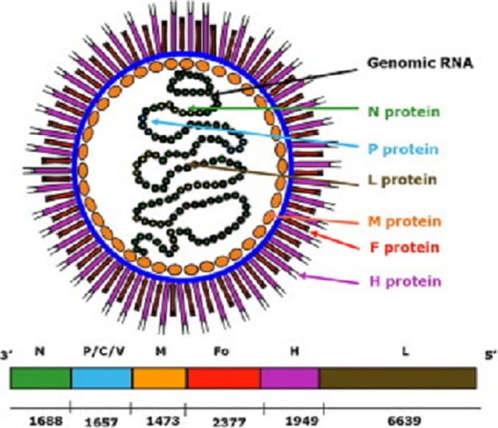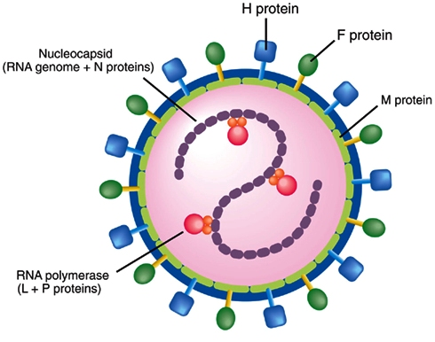

**Figure 1:** Schematic representation of the PPR morbillivirus

Review of literature

**2.4. Geographical Distribution**

The global spread of PPR is probably related to the progressive control and later, eradication, of rinderpest. The cessation of rinderpest vaccination campaigns and loss of antibody cross-protection between the two diseases means that small ruminants are now fully exposed to PPR. PPR was first reported in the Ivory Coast of West Africa and was later found in other parts of the world including sub-Saharan Africa, the Arabian Peninsula, the Middle East, and the parts of Asia **(Balamurugan *et al.,* 2012).** The first PPR observation outside West Africa was in Sudan, between 1970 and 1972 **(El Hag Ali and Taylor, 1984).** In 1983, it was confirmed in the Arabic Peninsula and subsequently in Asia **(Taylor *et al.,* 1990; Maillard *et al.,* 2008).** In recent years, field data and laboratory findings have confirmed the dramatic spread of PPR toward the south of Africa, affecting Gabon, Democratic Republic of Congo, Somalia, Kenya and Tanzania **(Swai *et al.,* 2009).** PPR has now been identified in Tunisia **(Ayari-Fakhfakh *et al.,* 2011)** and Algeria **(De Nardi *et al.,* 2012).** Outbreaks of PPR are now known to be common in India, Nepal, Bangladesh, Pakistan and Afghanistan **(Abdollahpour *et al.*, 2006).** In India, PPR was first recorded in the Tamil Nadu state during 1987 and was later an epidemic in northern India. At present, PPR is enzootic in India and outbreaks occur regularly among small ruminants throughout the country, incurring significant economic losses in terms of morbidity, mortality, and loss of productivity due to trade restriction **(Balamurugan *et al.,* 2012).** PPR has been recognised in Pakistan since 1991 when rinderpest like disease in goats was reported in the province of Punjab **(Athar *et al*., 1991).** In Bangladesh, the presence of PPR in goats was detected by FAO expert team in 1993. Disease investigation among organized goat farm in Bangladesh showed that outbreaks were always associated with introduction of new goats to the farm. Occurrence of PPR in an epidemic form has a drastic effect on the goat population in Bangladesh **( Khan *et al.,* 2005).** Although, there is only one serotype of the virus **(Barrett *et al.,* 1993),** PPRV isolates on the basis of partial sequence analysis of the fusion (F) protein gene, can be grouped into four distinct lineages **(Kwiatek *et al*., 2007)**, three of which (I, II, III) were first described in Africa, including Guinea, Ivory Coast, Senagal, Mali, Burkina Faso, Ghana, Nigeria, Uganda and Tanzania, and the fourth (IV) in Asia.

Review of literature

However, the Asian lineage was recently introduced in some African countries, including Cameroon and Central African Republic, Sudan and Morocco, Egypt, Algeria and Uganda **(Maganga *et al.,* 2013).** The PPR virus identified in Bangladesh is under the lineage 4 of PPR phylogenetic tree based on the N gene analysis **(Barrett *et al.,* 1998).** Molecular typing has revealed that Asian lineage IV has become established in an area of Sudan where PPR has re-emerged, edging out the indigenous African lineage. Similarly, the introduction of PPR into Morocco in 2008, which was hitherto free from the disease, also involved lineage IV strains **(Banyard *et al.*, 2010).**

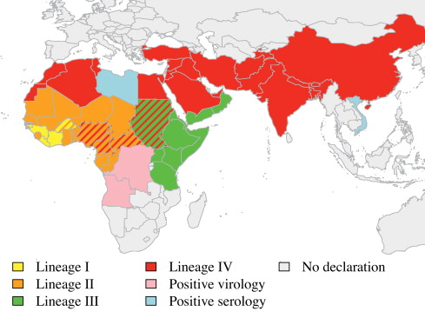

**Figure 2:** Worldwide cumulative distribution of the four PPR virus lineages. Different colors show different lineages and hached bars represent the last identified lineage in the corresponding country **(Albina *et al.,* 2012).**

**2.5. Incidence of PPRV**

Environmental factors influence disease occurrence. **(Hegde *et al.*, 2009)** showed that incidences were highest during the rainy season and in the dry agro-climatic zones. The dusty and dry winds that characterize winter season of the year has been shown to enhance the spread of PPR **(Obi, 1983). (Aruni *et al.,* 1998)** observed more than ten outbreaks of PPR in goats from Tamil Nadu. They observed that kids were susceptible than adult. An outbreak of

Review of literature

PPRV in approximately 100 goats was diagnosed in Rawalpindi city, Pakistan in June 1997 by **(Hussain *et al.,*1998)** with mortality rate of 80 %. PPRV was detected in blood and various tissue samples using a competitive ELISA and immunocapture ELISA. It was found that the isolates from Bangladesh were closely related with other strains from India, and clustered within the Asian group of PPR viruses **(Barrett *et al.,*1997).** The outbreaks of 74.13% morbidity and 54.83% mortality in Black Bengal goats in Bangladesh **(Islam *et al.,* 2001 and Das *et al.,* 2007).**

**2.6. Host Range of PPRV**

Epidemics in sheep and goats, the mainstay of subsistence farming in the developing world can cause mortality rates of 50-80 % in native populations. Cattle, buffaloes, camels and pigs can also be infected but there is little or no evidence of disease associated with their infection. PPRV antigen has been detected in an outbreak of respiratory disease in camel and sick domestic buffaloes **(Taylor *et al.*, 1990; Scott, 2000; Abraham *et al.*, 2005)** Antelope and other small wild ruminant species can also be severely affected **(Abu Elzein *et al.*, 2004).** A case of clinical disease has been reported in wildlife resulting in deaths of gazelles (Gazella dorcus), ibex (Capra ibex nubiana), gemsbok (Oryx gazelle) and Laristan sheep (Ovis orientalis laristanica). American white tailed deer (Odocoileus virginianus) can be infected experimentally (Hamdy and Dardiri, 1976). Changes in the allopatric speciation of lineages suggest that, when competing with indigenous strains, some strains have great power to spread because they are better adapted to the natural host and/or by switching to a new host.

**2.7.** **Transmission of PPRV**

Although the virus is highly contagious, it can only be transmitted when a healthy animal comes into direct contact with the secretions or excretions of a sick animal. Inhalation is thought to be an important route of spread. PPRV is shed in nasal and ocular secretions, saliva, urine and feces. It probably occurs in milk **(CFSPH, 2008).** Since the virus is enveloped, it is extremely sensitive to inactivation by environmental factors such as heat, sunlight and chemicals. It, therefore, require close contact with an infected animals for successful transmission. The disease is transmitted by aerosols between animals living in close contact. **(Lefevre and Diallo, 1990).**

Review of literature

**2.8. Pathogenesis**

The route of infection is respiratory and is spread by airborne droplets. PPR virus, Like all morbilliviruses, PPRV has an established lymphatic and epithelial tropism. The signaling lymphocyte activation molecule (SLAM) is well recognized as the universal receptor for morbillivirus infection of immune cells, and this receptor tropism results in the leukopenia observed during infection **( Bao *et al*., 2012).** Consequently, it induces the most severe lesions in organ systems rich in lymphoid and epithelial tissues. The respiratory route is the likely portal to entry. After the entry of the virus through the respiratory tract system, it localizes first replicating in the pharyngeal and mandibular lymph nodes as well as tonsil. Viremia may develop 2-3 days after infection and 1-2 days before the first clinical sign appears. Subsequently viremia results in dissemination of the virus to spleen, bone marrow and mucosa of the gastro-intestinal tract and the respiratory system **(Scott, 1981).**

**2.9. Clinical signs of PPR**

Animal affected by PPR shed the virus in exhaled air, in secretions and excretions (from the mouth, eye and nose, and in feces, semen, and urine) approximately 10 days after the onset of fever **(Maganga *et al*., 2013).** Clinical signs of PPR have been well documented **(Hamdy *et al*., 1976; Obi, 1984; Lefèvre, 1987; Taylor, 1984; Bundza *et al*., 1988; Roeder *et al*., 1994; Roeder and Obi, 1999).** Following infection there is a 3–4 day incubation period. The predominant form of the disease is the acute form. The salient clinical signs start with sudden rise in body temperature to 39.5 - 41°C. Affected animals breathe fast, sometimes so fast that they exhibit rocking movements with both the chest and abdominal walls moving as the animal breathes. They have obvious signs of pneumonia. A clear watery discharge starts from the eyes, nose and mouth, later becoming thick and yellow as a result of secondary bacterial infection. Appearance of a serous to muco-purulent nasal discharge which may crust over and occlude the nostril, sneezing, ocular discharge resulting in matting of the eyelids. The discharges wet the chin and the hair below the eye; they tend to dry, causing matting together of the eyelids, obstruction of the nose and difficulty in breathing. Unlike RP, there is a definite but inconstant, respiratory system component **(Brown *et al*., 1991; Bundza *et al*., 1988).** One to two days after fever has set in, the mucous membranes of the mouth and eyes become much

Review of literature

reddened. Then, epithelial necrosis causes small, pin-point, greyish areas on the gums, dental pad, palate, lips, inner aspects of the cheeks and upper surface of the tongue. The lining of the mouth is changed in appearance. It becomes pale and coated with dying cells and, in some cases; the normal membrane may be completely obscured by a thick cheesy material. Gentle rubbing across the gum and palate with a finger may yield a foul-smelling material containing shreds of epithelial tissue **(Braide, 1981).** Body temperature usually remains high for about 5-8 days, and then slowly returns to normal prior to recovery or drops below normal before death. Diarrhea commonly appears about two to three days after the onset of fever although, and death is usually preceeded by pneumonia **(Hamdy *et al*., 1976).** The faeces are initially soft and then watery, foul-smelling and may contain blood streaks and pieces of dead gut tissue. Such victims may eventually become dehydrated with sunken eyeballs, and death often follows within seven to ten days from onset of the clinical reaction. Other animals will recover after a protracted convalescence.

**2.10. Post mortem findings**

It was reported that the carcass of an affected animal is usually emaciated, the hindquarters soiled with soft/watery faeces and the eyeballs sunken. The eyes and nose contain dried-up discharges **(Chauhan *et al.*, 2009).** Lips may be swollen; erosions and possibly scabs or nodules in late cases. The nasal cavity is congested (reddened) lining with clear or creamy yellow exudates and erosions. Oral mucosa was congested in almost all cases with presence of minor erosions on lips and tongue in about 60% cases. There may be dry with erosions on the gums, soft and hard palates, tongue and cheeks and into the esophagus. The lung is dark red or purple with areas firm to the touch, mainly in the anterior and cardiac lobes (evidence of pneumonia). Mesenteric lymph nodes were swollen and oedematous in more than 80% cases **(Kumar *et al.,* 2004).** Abomasum congested with lining haemorrhages. The pathology caused by PPR is dominated by necrotizing and ulcerative lesions in the mouth and the gastro-intestinal tract **(Roeder *et al*., 1994).** The rumen, reticulum and omasum rarely exhibit lesions. Occasionally, there may be erosions on the pillars of the rumen. Lesions in the small intestine are generally moderate, being limited to small streaks of hemorrhages. The large intestine is usually more severely affected, with

Review of literature

congestion around the ileo-cecal valve, at the ceco-colic junction and in the rectum. In the posterior part of the colon and the rectum, discontinuous streaks of congestion “zebra stripes” form on the crests of the mucosal folds. The haemorrhages recorded on the luminal wall of gall bladder in the present outbreak in some cases has not been reported to the best of our knowledge but presence of thick granular bile had been reported **(Shaila *et al.,* 1996).** Though the types of lesions were more or less similar in all the animals but there was variation in the severity and involvement of the organs.

**2.11. Haematological changes in PPRV affected goats**

**(Kaneko *et al.,*1997)** stated that, haematological and blood biochemical measurements may vary depending on factors such as sex, age, weather, stress, season, pregnancy status and physical exercise.The severe dehydration in the affected animals was evidenced by increased viscosity and specific gravity which led to polycythaemia **(Bhikane *et al*., 1997).** Severe leucopoenia could have been due to the inhibition of peripheral blood lymphocytes proliferation by PPR virus **(Heaney *et al.,* 2002).** A marked lymphocytopenia, monocytopenia, neutrophilia and eosinopenia in present investigation could have been due to the combined effect of virus infection and stress as evidenced by elevated cortisol levels **(Kataria and Kataria, 2004).**

**2.12. Concomitant infection with PPR**

**(Obi *et al*.,1983)** showed that, the most significant bacteria associated with PPR infected goats were *Pasteurella haemolytica, Klebsiella* sp., *Pseudomonas aeruginosa* and *Staphylococus pyogenes* from the lungs, *Salmonella sp.* and *E. coli* from the faeces, *Moraxella bovis* from the eyes and *Staphylococcus pyogenes* from the oral cavity. Pneumonia is usually a very obviously presented sign in PPR. Pneumonic pasteurellosis is a purely respiratory disease of sheep and goats caused by the bacterium *Pasteurella haemolytica.*

**2.13. Differential Diagnosis**

Review of literature

The disease must be differentially diagnosed from Foot and Mouth disease, Bluetongue, Contagious ecthyma, Pasteurellosis, Contagious caprine pleuropneumonia, Nirobi sheep disease, Coccidiosis, Plant and Mineral poisoning etc **(Appel *et al*., 1981).**

**2.14. Treatment of PPR**

There is no specific treatment for PPR, however hyperimmune PPR serum produced in goats reverses the disease process if administered at the onset of fever **(Ihemelandu *et al.,* 1985).** The affected animals were given antibiotics to control secondary bacterial infections along with anti-inflammatory drugs. Specifically, oxytetracycline and chlortetracycline are recommended to prevent secondary pulmonary infections **(OIE, 2000). (Sil *et al.*, 2006)** reported that, the use of combined antibiotic hyper immune serum therapy (ACHST) for PPR helpful to overcome the condition. For diarrhoeal conditions, they suggested that 10 ml hyperimmune serum intravenous route per animal three doses every 3 days interval. Long acting Oxytetracycline tabs 1ml/10 kg body weight 2nd dose after 72 hours of 1st dose. A mixture of Oxytetracycline tabs and Metranidiozol (1:1) oral doses twice daily until diarrhea subsides.

**2.15. Prevention and control of PPR**

Control of PPR outbreaks depends on movement control combined with the use of vaccine. Although vaccination against PPR is being practiced in Bangladesh and other countries, PPR is still causing major constraints to the productivity of small ruminants. **(Singh *et al.*, 2009)** said that, the availability of an effective vaccine, accurate diagnostic tests for PPR and an experienced infrastructure prompt us to propose a national project for a Peste des petits ruminants eradication programme on the lines of National Project on Rinderpest Eradication. To control peste des petits ruminants (PPR) in Bangladesh a live attenuated conventional PPR vaccine was developed by Bangladesh Livestock Research Institute (BLRI) and currently being used in the country **(Rahman *et al.,* 2011).** This would greatly enhance the prospects of PPR eradication not only on a national level but also from the Asian continent, alleviate poverty and, in turn, contribute to the national economy.

**CHAPTER-III**

**3. MATERIALS AND METHODS**

**3.1. Location and duration of the study**

The study was conducted in different breeds of goats registered at the Upazila Veterinary Hospital, Cox’s bazar shadar, Cox’s bazar during July, August and December, 2012. Every goats registered here was clinically thoroughly examined.

**3.2. Study population**

About 182 goats were examined in the hospital during the said study period. Among them 87 goats of different breeds (Black bengal, Jamunapari and Crossbreds) were affected with PPR. The total samples were divided into different categories such as breed, sex, history of vaccination and months of the year.

**3.3. Case definition**

Diagnosis was made by means of anamnesis and clinical signs. A PPR case was initially suspected if an animal showed signs of fever in the initial stage followed by pneumoenteritis evidenced by nasal and ocular discharges, conjunctivitis, erosion in oral mucosa, dyspnoea, diarrhea, dehydration, generalized weakness. The degree of dehydration was estimated by conventional skin fold test. All the clinical signs were separately recorded for each clinical case. Sometimes the tentative diagnosis was supported with hematological findings and post mortem examinations.

**3.4. Haematological examination**

Blood was randomly collected from 10 goats clinically suffering from PPR. Blood samples were also collected from 10 healthy goats aseptically. A blood sample from a PPR- or a healthy goat was collected from the jugular vein in a vial containing Na EDTA at 2 mg/ ml of blood. The following haematological analysis were performed: total erythrocyte count (TEC), total leukocyte count (TLC), differential leukocyte count (DLC), hemoglobin content (Hb), packed cell volume (PCV) and erythrocyte sedimentation rate (ESR).

Materials and methods

**3.5. Clinical examinations of PPR cases**

**3.5.1. History**

Data were recorded by interviewing the owners regarding the breed/sex/age of the animals; probable date of clinical onset of the disease with the signs like fever, nasal and ocular discharges, diarrhea, depressed appetite from the last two or three days of clinical onset.

**3.5.2. Clinical inspection**

1. Close inspection was done carefully for each case to observe the signs :
2. Rough hair coat
3. Erosion in gum, tongue, and margin of the upper and lower lips
4. Conjunctivitis
5. Serous nasal discharge with froth becoming mucopurulent
6. Lacrimation on the eyes
7. Diarrhea
8. Per rectal temperature was recorded with a clinical thermometer.
9. Indirect auscultation was performed by means of a stethoscope to hear lung sound.
10. A conventional skin fold test was performed to estimate the degree of dehydration.

**3.5.3. Clinical signs and symptoms**

The following clinical signs were observed while treating the patients :

1. Markedly depressed and dull appearance
2. Rough hair coat
3. Thick serous or purulent discharge from the eyes and nose
4. Sudden high fever ( 104˚-105˚ F), remaining high for 5 to 8 days, returns to normal before recovery or drop below normal before death.
5. Anorexia, severe dehydration and emaciation followed by hypothermia.
6. The mucous membrane of the mouth and eyes become much reddened and small pinpoint grayish areas appeared on the gum, dental pad, palate, lips, and upper surface of the tongue and characteristics foul smell came out from mouth.

Materials and methods

1. Faces were semisolid and liquid brown, yellow and black colored, watery foul smelling and contain blood streaks and pieces of dead gut tissue.
2. In severe cases, difficulty in breathing marked by extension of head and neck, dilation of nostril, protrusion of the tongue and soft painfull coughs.

**3.5.4. Postmortem examinations**

Two dead animals were subjected for postmortem examinations. A PPR case was tentatively diagnosed if postmortem examinations reveal the presence of changes like consolidated and pneumonic lungs, erosive and hemorrhagic enteritis, enlarged lymphnodes, congested liver, characteristics Zebra striping in the mucosa of colon, necrosis and hemorrhagic plugs in the cecum etc.

**3.6. Medication**

For observing the treatment efficacy the goats were divided into three groups.

**Group I:** were treated with Diadin ( Sulphadimidine-Na), Antihista vet (Pheneramine meleate) and an oral saline - Renalyte(ORS) and

**Group II:** were treated with Renamycin-100 (Oxytetracycline), Antihista vet (Pheneramine meleate) and an oral saline, Renalyte (ORS) was given

**Group III**: were treated with a gut acting sulphonamide and an oral saline, Renalyte.

A response to a treatment was recovery from the clinical signs and death was considered as the failure of the treatment given.

**3.7. PPR-vaccination history of the goats registered to the hospital**

Each owner was asked about previous vaccination history of his or her goat suffering from PPR and the vaccination data were separately recorded for each goat.

Materials and methods

**3.8. Statistical analysis**

All the data including categorical variables - sex, breeds, vaccination status, season and continuous variables- age, temperature, heart rate, respiratory rate etc from the gaots clinically examined were entered into MS excel ( Microsoft office excel-2007, USA). Data management and data analysis were done by STATA version-12.1 (STATA Corporation, College Station, Texus). Prevalence was calculated according to different categories of the explanatory variables. To calculate the prevalence, total number of cases was divided with the total number of population for that specific category of the variable. Descriptive analysis was done by means of creating histogram and boxplot. To identify the association between a categorical explanatory variable with the outcome (occurrence of PPR), chi- square (χ2 test) test was performed and for continuous variables t-test was conducted to evaluate if the mean values between positive and negative group of animals differed significantly or not. An association was regarded as significant if the p value was <0.05.

**CHAPTER-IV**

**4. RESULTS**

**4.1. Prevalence of PPR**

During the study period as many as 182 goats belonging to different breed, sex, age groups with clinical ailments were registered to the Cox’s bazar Upazila Veterinary Hospital. By thorough clinical examinations 87 were diagnosed as PPR cases. The proportions of PPR cases according to different explanatory variables are shown in Figure 3.

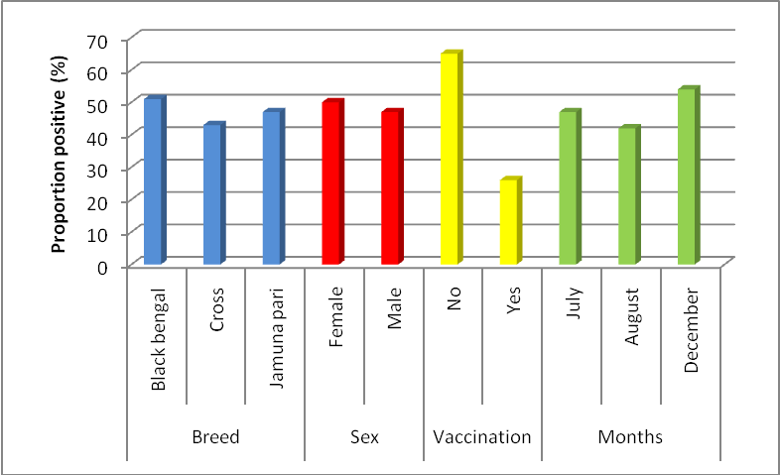

**Figure 3:** Proportion of PPR positive goats according to different explanatory variables

The overall prevalence of PPR during the study period was estimated to be 47% ( 95% CI 34.6-59.4%). Of the black bengal goats clinically examined during the study period 51% (**95% CI** 39.9-62.0%) were daignosed with PPR.On the other hand, 43% (95% CI 28.0-57.9%) and 47% (95% CI 34.6-59.4%) cross and jamunapari goats, respectively, was affected with PPR. Between male and female goats, the proportion of positive goats were nearly similar 47% (95% CI 38.2-55.8%) and 50% (95% CI 37.1-62.9%), respectively.

Results

Proportion of PPR positive goats were varied remarkably according to vaccination status. Twenty six percent (95% CI 16.4-35.6%) goats which were vaccinated and 65% (95% CI 55.7-74.3) among nonvaccinated goats were positive to PPR. Seasonal variation was not very notable in this present study.

**4.2. Descriptive statistics of continuous variables**



**Figure 4:** Boxplot showing the median, minimum, maximum, 25th and 75th percentile values of age among PPR positive and negative goats

In figure 4, boxplot is presented with the median, minimum, maximum, 25th and 75th percentile values of age between the 2 groups of goats (PPR negative and positive) investigated The median age of PP- positive goats was comparatively higher than PPR- negative goats.

Results



**Figure 5**: Boxplot showing the median, minimum, maximum, 25th and 75th percentile values of temperature among PPR positive and negative goats

Figure 5 is showed with the median, minimum, maximum, 25th and 75th percentile values of temperature between PPR negative and positive goats. The median temperature was higher in PPR positive goats than the PPR- negative ones.

Results

**Figure 6:** Boxplot showing the median, minimum, maximum, 25th and 75th percentile values of heart rate among PPR positive and negative goats

Figure 6 is portrayed with a boxplot showing the median, minimum, maximum, 25th and 75th percentile values of heart rate between PPR negative and positive goats, respectively. The median heart rate was observed in PPR-positive goats was higher compared with the negative goats.

**Figure 7:** Boxplot is presented with the median, minimum, maximum, 25th and 75th percentile values of respiratory rate among PPR positive and negative goats

Figure 7 is presentted with the median, minimum, maximum, 25th and 75th percentile values of respiratory rate between PPR negative and positive goats respectively. The median respiratory rate was higher in PPR positive goats compared with negative goats.

Results

**4.3. Association of categorical variables with the outcome**

Table 1 is presented with the statistics of 182 goats accoding to different categorical variables. Most goats registered to the hospital belonged to two breeds and a cross-bred. Of the 87 PPR-goats 40 beloned to the Black Bengal breed, 29 to Jamuna pari and 18 to the cross-bred. The prevalence of PPR was evenly distributed in both Black Bengal and Jamuna Pari goats (P=0.66). Its occurrence was proportionately but not significantly higher in female goats (P=0.68). The rate of PPR in the non-vaccinated gaots was 65% (**95% CI** 55.7-74.3) significantly higher comapred with the vaccinated goats, 26% (95% CI 16.4-35.6%)( P<0.001).

**Table 1: Association of different categorical variables with PPR occurrence in goats under the investigation**

|  |  |  |  |  |  |
| --- | --- | --- | --- | --- | --- |
| Variables | Level | Number of observation (N) | PPR positive  N (%) | Chi square value | P value |
| Breed | Black Bengal | 78 | 40 (51) | 0.81 | 0.66 |
| Cross | 42 | 18 (43) |
| Jamuna Pari | 62 | 29 (47) |
| Sex | Female | 58 | 29 (50) | 0.16 | 0.68 |
| Male | 124 | 58 (47) |
| Vaccination | No | 102 | 66 (65) | 26.57 | <0.001 |
| Yes | 80 | 21 (26) |
| Month of the year | July | 74 | 35 (47) | 1.38 | 0.50 |
| August | 52 | 22 (42) |
| December | 56 | 30 (54) |

According to season, the prevalence was recorded higher in the winter month ( December ) than in the rainy ones (July and August). During July, August and December the prevalence of PPR were 47%, 42% and 54%, respectively, and there were no significant difference ( P>0.50) in its occurrence in the said three months of investigation.

Results

**Table 2: Comparison of mean values of different continuous variables between PPR positive and negative goats tested with t test**

|  |  |  |  |  |  |
| --- | --- | --- | --- | --- | --- |
| Variables | Disease status of the goat | Mean | SE | 95% CI | p-value |
| Age (month) | PPR negative | 9.39 | 0.40 | 8.59-10.19 | 0.16 |
| PPR positive | 10.20 | 0.41 | 9.38-11.02 |
| Temperature | PPR negative | 102.88 | 0.09 | 102.69-103.08 | <0.001 |
| PPR positive | 103.80 | 0.08 | 103.63-103.96 |
| Heart rate | PPR negative | 71.33 | 0.52 | 70.29-72.37 | <0.001 |
| PPR positive | 80.73 | 0.73 | 79.27-82.19 |
| Respiratory rate | PPR negative | 31.71 | 0.45 | 30.81-32.61 | <0.001 |
| PPR positive | 36.33 | 0.56 | 35.20-37.46 |

Table 2 shows comparative mean values of different continuous variables such as age (in month), temperature, heart rate, respiratory rate etc. In the PPR positive goats the mean age was 10.20**±** 0.41, 9.39**±**0.40 months in the negative goats ( p= 0.16). In the PPR affected goats the mean temperature, heart rate and respiratory rate - all were significantly higher (p<0.001) compared with PPR-negative goats.

**4.4. Comparison of hematological pictures**

The 3 is presented with haematological pictures of 10 PPR affected goats compared with 10 normal goats. In the PPR-goats the Mean ± SE values of Hb ( 8.84±0.50 gm%), PCV

Results

(19.70±1.35 ), TEC ( 8.97±0.71 million/mm3), TLC (9.31±0.53 thousand/mm3), ESR (0±0 hour), Lymphocyte (41.20±2.26 %), Monocyte (3.50±0.50 %), Neutrophil (41.30±2.32%), Eosinophil (3.60±0.40%), Basophil (0.70±0.21%) all were lower compared with the healthy goats. The same hematological results were displayed in Figure 6.

**Table 3: Comparison of Haematological pictures (Mean± SEM) of healthy and PPRV affected goats**

|  |  |  |  |  |  |  |
| --- | --- | --- | --- | --- | --- | --- |
| **SL**  **NO** | **Parameters** | **Healthy goat** | | **PPR affected goat** | | **P-value** |
| **Mean± SE** | **Min-Max** | **Mean± SE** | **Min-Max** |
| 1 | Hb (gm %) | 8.93±0.47 | 6.70-12.00 | 8.84±0.50 | 6.80-12.00 | 0.8 |
| 2 | PCV (%) | 23.40±1.26 | 17-30 | 19.70±1.35 | 14.00-28.00 | 0.06 |
| 3 | TEC  (million/mm3) | 9.18±0.66 | 7.22-13.07 | 8.97±0.71 | 6.72-13.07 | 0.8 |
| 4 | TLC  (thousand/mm3) | 11.58±0.71 | 8.90-16.20 | 9.31±0.53 | 7.00-12.30 | 0.02 |
| 5 | ESR  (hour) | 0±0 | 0-0 | 0±0 | 0±0 | 0-0 |
| 6 | DLC (%) | - | - | - | - | - |
|  | Lymphocyte (%) | 51.90±2.72 | 39-69 | 41.20±2.26 | 31-53 | 0.01 |
|  | Monocyte (%) | 4.20±0.57 | 1-7 | 3.50±0.50 | 1-6 | 0.37 |
|  | Neutrophil (%) | 33.9±1.72 | 25-42 | 41.30±2.32 | 33-56 | 0.02 |
|  | Eosinophil (%) | 4.70±0.42 | 3-7 | 3.60±0.40 | 2-6 | 0.08 |
|  | Basophil (%) | 1.20±0.33 | 0-3 | 0.70±0.21 | 0-2 | 0.22 |

Results

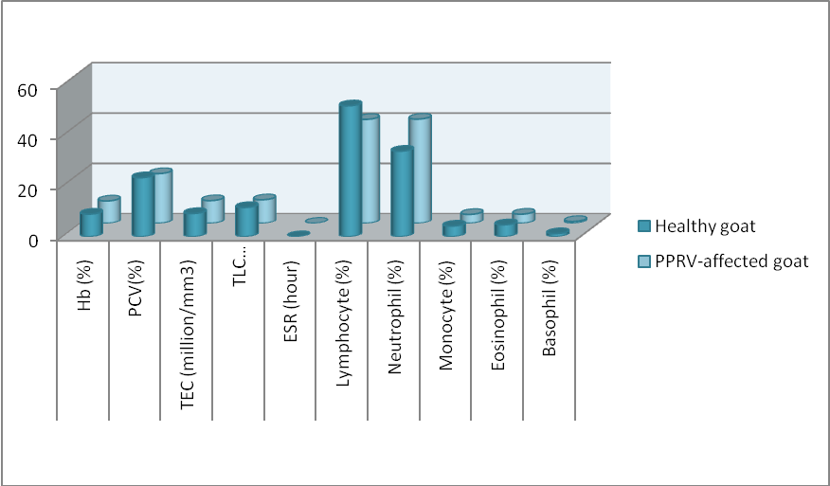

**Figure 8:** Haematological pictures of Healthy and PPRV-infected goats

Figure 8 showing the percentages (%) of different blood parameters among PPRV infected and healthy goats

**Table 4 : Response to treatments in the three different groups**

|  |  |  |  |  |  |
| --- | --- | --- | --- | --- | --- |
| **Groups of Drugs** | **Drug name** | **Response to treatment** | | **Total** | **% of response to treatment** |
| **Positive** | **Negative** |
| **I** | Diadin ( Sulphadimidine-Na) + Antihista vet (Pheneramine meleate) + Renalyte(ORS) | 8 | 12 | 20 | 40 |
| **II** | Renamycin-100 (Oxytetracycline) + Antihista vet (Pheneramine meleate) + Renalyte (ORS) | 11 | 9 | 20 | 55 |
| **II** | Oral or gut acting sulphonamide + Renalyte (ORS) | 3 | 9 | 12 | 25 |

Table 4 shows the efficacy of different drugs used in the treatment of PPR affected goats and Group-II shows higher response than other groups.

Results

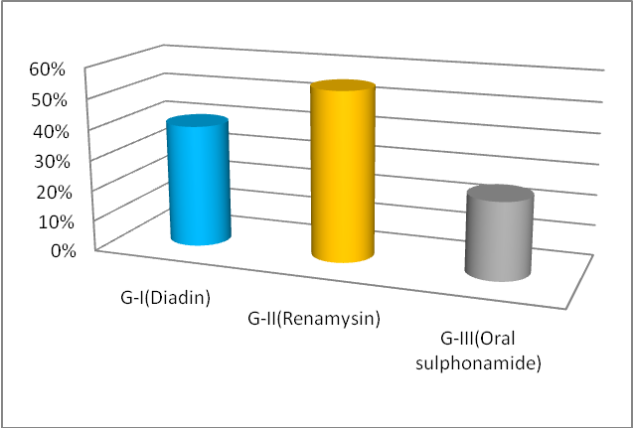

**Figure 9:** Group- wise response to the treatments

**4.5. Response of treatments**

The success rates of treatments in the three different groups are presented in table 4, and the same data graphically presented in Figure 7 for better understanding. The clinical recovery rate in the group 2 where oxytetracycline in the trade name of Renamycin was prescribed was 55% (95% CI), higher than that of the two other groups.

**4.6. Post-mortem findings**

Postmortem examinations of two PPR-affected goats reveal different changes in the body like congested and consolidated lungs, dark red/ purple and firm to touch, necrosed and congested liver, enlarged heart, spleenomegaly, soft and swollen intestinal lymphnodes, necrosed and haemorrhagic intestinal tract, zebra stripe lesion in ileo-caecal junction etc which are showing in Annexure-B.

**CHAPTER-V**

**5. DISCUSSION**

The prevalence of PPR was 51% in Black Bengal , 47% in Jamuna Pari and 43% in Cross-bred goats. Apparently the occurrence does not differ significantly ( P>0.05) between the breeds, but proprtionately, PPR was higher, an agreement with (**Sarker and Islam, 2011)** who found its prevalence 27.1% in Black Bengal goats, 11.8% in Jamunapari (11.81%) and 9.7% in exotic breeds (9.68%). **(Gupta *et al.,* 2007)** also reported that Black Bengal breed was more prone (60.3%) to PPR than Jamunapari (42.9%).

The prevalence of PPR was slightly higher in male gaots compared with females, but the differene was not statistically significant ( P>0.05), supported **(Abdalla *et al.*, 2012)** where its prevalence was54.2% in male and 64.2% in female goats; This finding was also corroborated with Osman (2005) that the sex of animals had no effect on the development of PPRV antibodies. Howeverr, because the small ruminants’ producers keep more females for breeding purposes their probability to expose to PPRV thus might higher compared with males **(Abdalla *et al*., 2012).**

In the vaccinated goats the prevalence of PPR was lower compared with non-vaccinated ones (p<0.05), is in the line with **(Islam *et al*., 2012)** where the prevalence of PPR is higher (66.40%) in the non-vaccinated compared with vaccinated (19.56%) animals. (**Gibbs *et al.,* 1979)** also found higher prevalence of PPR in the non-vaccinated goat population. The higher prevalence of PPR in non vaccinated animals in due to absence of antibodies to PPRV, therefore vaccination against the disease leads to decreasing its occurrence, but the entire population might not be rendered immune by using the current vaccine **(Banik *et al.,* 2008)**. The finding on the effects of PPR vaccination in this study supports the earlier observation of **(Das *et al*., 2007)** who reported efficacy of PPR vaccine against natural PPRV infection.

The disease occurrence in Cox’sbazar was higher during the months of December (54%), July (47%) and lowest in the month of August (42%). Based on season, apparently the disease does

Discussion

not differ significantly ( P>0.05) but during winter ( December) the percentage of occurance was comparatively higher than in Rainy season. This finding is supported by **(Gupta *et al.,* 2007)** where the highestwas recorded in winter (56.36%) than rainy (54.36%) and autum (38.27%). The dusty and dry winds that characterize winter season of the year has been shown to enhance the spread of PPRV **( Obi, 1983).**

Apparently the disease does not differ significantly ( P>0.05) between different age groups, but median age (11 month) was comparatively higher in PPR-positive goats than negative. It was previously reported that the the goats of age of between 4 to 12 months were more prone to PPR than older ( > 1 year) **(Gupta *et al.,* 2007).** **(Singh *et al.*, 2004)** also reported that the disease is more prevalent in the goats less than one year of age. A higher susceptibility of young goats to PPR might be due to malnutrition, poor immunity and poor management systems **(Sarker and Islam, 2011).**

The median temperature was significantly higher in PPR positive goats ( P<0.05) than negative goats. The median temperature recorded in this investigation was 104˚F. Similar higher temperature - of 106 ± 1˚F was described by **(Khan *et al.,* 2005)**. The present study also recorded a higher heart rate and respiratory rate in PPR-positive goats than negative ( P<0.05). A higher heart rate may be the results of severity of dehydration and nutritional status of the PPR- positive animals, supported by **(Rodestitis *et al.*, 2000).** On the other hand respiratory rate maight have increased in the PPR-goats because of pneumonic condition. A similar high respiratory rate in PPR-goats was reported by **(Rodestitis *et al.*, 2000)**.

The values of all hematological parameters were lower in the PPR-goats compared to healthy goats, except neutrophil counts. Total erythrocyte counts (million/mm3) and level of Hb (gm %) were similar in both the PPRV-infected and healthy goats and PCV (%) was lower (P>0.05). The Hb% and PCV (%) reflect the downturn of the TEC counts. ESR count was 0 mm in 1st hour in both groups. Total leukocyte counts were higher in healthy goat as

Discussion

compared to affected goats though this value does not cross the normal limit. The counts for neutrophils were significantly higher in the PPRV-infected goats (P<0.05). In contrast, lymphocyte counts in the PPRV-infected goats were lower than healthy goats (P<0.05). Monocyte, Eosinophil and Basophil counts were lower in the PPRV-infected goats than in healthy goats.

Postmortem examination of two dead animals reveal different changes in the body like consolidated and pneumonic lungs, erosive and hemorrhagic enteritis, enlarged lymphnodes, congested and enlaregd liver, characteristic Zebra striping in the mucosa of colon, necrosis and hemorrhagic plugs in the cecum etc. Similar findings were observed by **(Rahman *et al.,* 2011)** who reported stomatitis with erosions, ulcerations and necrotic lesions in the buccal cavity, erosions on the pillars of rumen, severe congestion throughout the intestinal tract, zebra stripes in caeco-colic junction, and pale and moderately enlarged liver with distended gall bladder. In this study congested and consolidated lungs, enlarged and oedematous lymph nodes, paintbrush haemorrhages in the heart and atrophied spleen were also found at necropsy.

The success rate of treatment with parenteral ( I/M) administration of oxytetracycline was higher (55%) than parenteral (I/M) use of sulphadimidine (40%) and oral/gut acting sulphonamide (25%), supported by the findings of **(Gupta *et al*., 2007)** who found that the percentage of response to treatment towards parenteral (I/M) oxytetracycline was high (33.9%) than parenteral (I/M) sulphonamide (31.6%) and oral/gut active sulphonamide (16.0%). To check secondary bacterial infections in PPR-goats oxytetracycline and chlortetracycline were especially recommended **(Taylor *et al.,* 1984).**

**CHAPTER-VI**

1. **CONCLUSION AND LIMITATION**
   1. **Conclusion**

Black Bengal goats are probably more susceptible to PPR than Jamunapari and Cross breed goats. Younger (<1year) goats are more susceptible than older ones. The occurance of PPR was higher in the non-vaccinated goats than the vaccinated. The prevalence of PPR was higher in the winter months than the rainy. Most haematological parameters except nutrophil counts might increase in PPR- than healthy goats. High rise of body temperature, increased heart rate and respiratory rate occur in PPR-goats, and at necropsy, consolidated and pneumonic lungs, erosive and hemorrhagic enteritis, enlarged lymphnodes, congested liver, characteristic Zebra striping in the mucosa of colon, necrosis and hemorrhagic plugs in the cecum etc. can be observed. If oxytetracycline is used parenterally the recovery rate from the disease might be higher compared with the administration of injectable sulphonamide or oral/gut acting sulphonamide. Routine vaccination program might reduce the intensity of PPR significantly.

* 1. **Limitation of the study**

During the course of examination, all aspects were observed carefully but there were also some limitations that influence the present study. The duration of the study was short that might have resulted in improper estimation and fluctuation in observing seasonal variations. The sample size was small – again relating to the short period of the study.

**CHAPTER-VII**

**7. REFERENCES**

Abdalla, S. A., Majok, A. A., El Malik, K.H. and Ali, A. S. 2012. Sero-prevalence of peste des petits ruminants virus (PPRV) in small ruminants in Blue Nile, Gadaref and North Kordofan States of Sudan. *J. Public Health Epidemiol.* 4(3): 59-64.

Abdollahpour, G., Roofi, A., Najafi, J., Sasani, F. and Sakhaie, E. 2006. Clinical and para-clinical findings of a recent outbreak of Peste des petits ruminants in Iran. *J. Vet. Med. B,* 53: 14-16.

Abraham, G., Sintayehu, A., Libeau, G., Albina, E., Roger, F., Laekemariam, Y., Abayneh, D. and Awoke, K. M. 2005. Antibody seroprevalence against PPR in camels, cattle, goats, and sheep in Ethiopia. *Prev. Vet. Med.* 70: 51–57.

Abu Elzein, E. M. E., Housawi, F. M. T., Bashareek, Y., Gameel, A. A., Al- Afaleq, A. I. and Anderson, E. C. 2004. Severe PPR infection in Gazelles kept under semi-free range conditions in Saudi Arabia*. J. Vet. Microbiol*. 51 (2): 68–71.

Abubakar, M., Ali, Q., Khan, H.A. 2008. Prevalence and mortality rate of peste des petits ruminant (PPR): possible association with abortion in goat. *Trop. Anim. Health Prod*. 40: 317–321.

Abubakar, M., Arshed, M.J., Zahur, A.B., Ali, Q., Banyard, A.C. 2012. Natural infection with peste des petits ruminants virus: a pre and post vaccinal assessment following an outbreak scenario. *Virus Res.* 167: 43–47.

Albina, E., Kwiatek , O., Minet, C.C., Lancelot, R., Almeida, R.S., Libeau, G. 2012. Peste des petits ruminants, the next eradicated animal disease, An expanding fatal disease of small ruminants: journal home page: www.elsevier.co m/lo cat e/vetmic*,* Pp: 2

Albina, E., Kwiatek , O., Minet, C.C., Lancelot, R., Almeida, R.S., Libeau, G. 2012. Peste des petits ruminants, the next eradicated animal disease, State of the art in diagnosis and control strategies : journal home page: www.elsevier.co m/lo cat e/vetmic*,* Pp: 3

Amin, M. R., Hussain, S. S. and Islam, A. B. M. M. 2001. Reproductive peculiarities and litter weight in different genetic groups of Black Bengal does. *Asian-Aust. J. Anim. Sci.* 14 (3): 197-301.

Anderson, E. C., Hassan, A., Barrett, T. and Anderson, J. 1990. Observation on the pathogenicity for sheep and goats and the transmissibility of the strain of virus isolated during the rinderpest outbreak in Sri Lanka in 1987. *Vet. Microbiol.* 21: 309-318.

Appel, M. J. G., Gibbs, E. P. J., Martin, S. J., Ter Meulen, V., Rima, B. K., Stephenson, J. R. and Taylor, W. P. 1981. Morbillivirus Diseases of Animals and Man. In Comparative

References

Diagnosis of Viral Diseases IV, E. Kurstak and C. Kurstak, eds. New York: Acad. Press, Pp: 235-297.

Aruni, A. W., Lalitha, P.S., Mohan, A.C.,Chitravelu, P. and Anbumani, S. P. 1998. Histopathological study of a natural outbreak of peste des petits ruminants in goats of Tamilnadu. *Small Rum. Res.* 28(3): 233-240.

Ayari-Fakhfakh, E., Ghram, A., Bouattour, A., Larbi, I., Gribaˆa-Dridi, L., Kwiatek, O., Bouloy, M., Libeau, G., Albina, E., Ceˆtre-Sossah, C. 2011. First serological investigation of peste-des-petits-ruminants and Rift Valley fever in Tunisia. *Vet. J.* 187: 402–404.

Bailey, D., Banyard A., Dash P., Ozkul, A. and Barrett, T. 2005. Full genome sequence of peste des petits ruminants virus, a member of the Morbillivirus genus. *Virus Research* **110:** 119-124.

Balamurugan, V., Saravanan, P., Sen, A., Rajak, K.K., Venkatesan, G., Krishnamoorthy, P., Bhanuprakash, V., Singh, R.K. 2012. Prevalence of *peste des petits ruminants* among sheep and goats in India. *J. Vet. Sci.* **13**(3): 279-285.

Banik, S. C., Podder, S. C., Samad, M. A. and Islam, M. T. 2008. Sero surveillance and immunization in sheep and goats against Peste des Petits Ruminants in Bangladesh. *Bangl. J. Vet. Med.*6 (2): 185–190.

Banik, S. C., Podder, S. C., Samad, M. A. and Islam, M. T. 2008. Sero surveillance and immunization in sheep and goats against Peste des Petits Ruminants in Bangladesh. *Bangl. J. Vet. Med.*6 (2): 188.

Banyard A.C., Parida S., Batten C., Oura C., Kwiatek O. & Libeau G. 2010. Global distribution of peste des petits ruminants virus and prospects for improved diagnosis and control. *J. G en.* *V irol.*, 91 (Pt 12), 2885-2897. E-pub: 2010 Sep. 15

Bao, J., Wang, Q., Parida, S., Liu, C., Zhang, L., Zhao, W. and Wang, Z. 2012. Complete Genome Sequence of a Peste des Petits Ruminants Virus Recovered from Wild Bharal in Tibet, China. *J. Virol.* 86(19): 10885.

Baron, M.D., Parida, S., Oura, C.A. 2011. Peste des petits ruminants: a suitable candidate for eradication? Veterinary Record 169: 16.

Barrett, T., Pronob, D., Sreenivasa, B.P. and Corteyn, M. 1997. Recent epidemiology of PPRV. *Vet. Microbiol.* 88: 125-130.

Barrett, T., Pronob, D., Sreenivasa, B.P. and Corteyn, M. 1998. Recent epidemiology of PPRV. *Vet. Microbiol.* 88: 125-130.

References

Barrett, T., Pronob, D., Sreenivasa, B.P., and Corteyn, M. 1997. Recent epidemiology of Peste des Petits Ruminants Virus. *Vet. Microbiol.*88: 125-130.

Barrett, T., Romero, C. H., Baron, M. D., Yamanouchi, K., Diallo, A., Bostock, C. J. and Black, B. 1993. The molecular biology of rinderpest and peste des petits ruminants. *Ann. Med. Vet.* 137 (2): 77-85.

Bhikane, A. U., Kulkarni, D. D., Narladkar, B. W. and Ali, M. S. 1997. Clinico-pathological and therapeutic investigations on peste des petits ruminants in goats. *Indian Vet J.* 74: 377-9.

Braide, V. B. 1981. Peste des petits ruminantss. *World anim. Review*. 39: 25-28.

Brown, C. C., Mariner, J. C., Olander, H. J. 1991. An immunohistochemical study of the pneumonia caused by PPR virus. *Vet. Path.* 28: 166-170.

Brown, C. C., Mariner, J. C., Olander, H. J. 1991. An immunohistochemical study of the pneumonia caused by PPR virus. *Vet. Path.* 28: 166-170.

Bundza, A., Afshar, A., Dukes, T. W., Myers, D. J., Dulac Susi, G., Becker, A. W. E. 1988. Experimental PPR (goat plague) in Goats and sheep. *Canadian J. Vet. Res.* 52: 46-52.

Bundza, A., Afshar, A., Dukes, T. W., Myers, D. J., Dulac Susi, G., Becker, A. W. E. 1988. Experimental PPR (goat plague) in Goats and sheep. *Canadian J. Vet. Res.* 52: 46-52.

Calain, P. and Roux, L. 1993. The rule of six, a basic feature for efficient replication of Sendai virus defective interfering RNA. *J. Virology.* 67: 4822–4830.

CFSPH. 2008. Peste des Petits Ruminants. http://www.cfsph.iastate.edu/Factsheets/pdfs/peste_des_petits_ruminants.pdf. Access on 14th May, 2011.

Chauhan, H. C., Chandel, B. S., Kher, H. N., Dadawala, A. I. and Agrawal, S. M. 2009. Pesti des petits ruminants virus infection in animals. *Veterinary World* 2 (4):150-155.

Couacy-Hymann, E. R. F., Bidjeh, K., Angba, A., Domenech, J. and Diallo, A. 1995. Protection of goats against rinderpest by vaccination with attenuated peste des petits ruminants virus. *Res. Vet. Sci.* 59: 106-109.

Das, K.K., Shil, N.K. and Islam, M.R. 2007. Sero-epidemiological investigation on Peste des Petits Ruminants in black Bengal goats. *Bangl. J. Vet. Med.* 24 : 143 – 145.

References

Das, K.K., Shil, N.K. and Islam, M.R. 2007. Sero-epidemiological investigation on Peste des Petits Ruminants in black Bengal goats. *Bang. J. of Microbiol.* 24: 143–145.

De Nardi, M., Lamin Saleh, S.M., Batten, C., Oura, C., Di Nardo, A., Rossi, D. 2012. First evidence of peste des petits ruminants (PPR) virus circulation in Algeria (Sahrawi territories): outbreak investigation and virus lineage identification. *Transbound. Emerg. Dis.* 59: 214–222.

Dhar, P., Sreenivasa, B. P., Barrett, T., Singh, R. P. and Bandyopadhyay, S. K. 2002. Recent epidemiology of peste des petits ruminants virus (PPRV). *Vet. Microbiol.* 8 (2): 153- 159.

Dhar, P., Sreenivasa, B.P., Barrett, T., Corteyn, M., Singh, R.P., Bandyopadhyay, S.K. 2002. Recent epidemiology of peste des petits ruminants virus (PPRV). *Vet. Microbiol.* **88:** 153–159.

Diallo, A. 2003. Peste des petits ruminants. In: Paris: Lavoisier, editor. Principales maladies infectieuses et parasitaires du bétail Europe et régions chaudes Tome 1: Généralités: Maladies virales. Lefèvre PC, Blancou J, Chermette R. Pp. 307–322.

Diallo, A. 2006. Control of peste des petits ruminants and poverty alleviation? *J. Vet. Med. B Infect. Dis. Vet. Public Health* 53: 11–13.

DLS (Department of Livestock Services). 2007. Livestock population in Bangladesh. <http://organization.kib.org.bd/2009/11/16/directorate-of-livestock-services-dls/>

Durojaiye, O. A., Taylor, W. P. and Smale, C. 1985. The ultrastructure of peste des petits ruminants virus. *Zbl. Vet. Med. B*. 32 (6): 460-465.

Durojaiye, O.A. 1980. Brief notes on history, epizootiology and the economic importance of PPR in Nigeria. In: Proceedings of the International Workshop on Peste des Petits Ruminants, IITA, Ibadan, Nigeria, 24-26 September, Pp: 24-27.

Durtnell, D.R. 1972. A disease of sokoto goats resembling "peste des petits ruminants". *Trop. Anim. Health Prod.* 4: 162-164.

El Hag Ali, B., Taylor, W.P. 1984. Isolation of peste des petits ruminants virus from Sudan. *Res. vet. Sci.* 36: 1–4.

EMPERS (Emergency Prevention System for Transboundary Animal and Plant Pests and diseases). Recognizing peste des petits ruminants. A field manual. Rome, Italy: FAO (Food and Agricultural Organization of United Nation, 1999)

References

FAO (Food and Agriculture Organization of the United Nations). 2009. Peste Des Petitis Ruminants (PPR): A Challenge for Small Ruminants’ Production Animal Production and Health Division.

FAO (Food and Agriculture Organization of the United Nations). 2003. Asian Livestock. Monthly Technical Magazine of the FAO. Anim. Prod. Health Comm. Asia Pac. (APHCA) 8: 85-87.

Gargadennec, L. and Lalanne, A. 1942. La peste des petits ruminants. Bull. Serv. Zoo AOF 5: 16–21.

Gibbs, E. P. J., Taylor, W. P., Lawman, M. P. J. and Bryant, J. 1979. Classification of the peste des- petits-ruminants virus as the fourth member of the genus *Morbillivirus*. *Intervirology* 11: 268-274.

Gupta, S.D., Biswas, P.K., Habib, S. and Debnath, N.C. 2007. Prevalence of PPR in the greater Chittagong district of Bangladesh. g-science, 3 (2):36-41

Hamdy, F. M. and Dardiri, A. H. 1976. Response of white tailed deer to infection with peste des petits ruminants virus. *J. Wildlife Dis.* 1: 516-522.

Hamdy, F. M., Dardiri, A. H., Nduaka, O., Breese, S. S. and Ihemelandu, E. C. 1976. Etiology of the stomatitis pneumoenteritis complex in Nigerian dwarf goats. Can. J. Comp.Med. 40: 276-284.

Heaney, J., Barrett, T. and Cosby, S. L. 2002. Inhibition of in vitro leukocyte proliferation by morbilliviruses. *J Virol.* 76: 3579-84.

[Hegde, R](http://www.ncbi.nlm.nih.gov/pubmed?term=%22Hegde%20R%22%5BAuthor%5D)., [Gomes, A. R](http://www.ncbi.nlm.nih.gov/pubmed?term=%22Gomes%20AR%22%5BAuthor%5D)., [Muniyellappa, H. K](http://www.ncbi.nlm.nih.gov/pubmed?term=%22Muniyellappa%20HK%22%5BAuthor%5D)., [Byregowda, S. M](http://www.ncbi.nlm.nih.gov/pubmed?term=%22Byregowda%20SM%22%5BAuthor%5D)., [Giridhar, P](http://www.ncbi.nlm.nih.gov/pubmed?term=%22Giridhar%20P%22%5BAuthor%5D). and [Renukaprasad, C](http://www.ncbi.nlm.nih.gov/pubmed?term=%22Renukaprasad%20C%22%5BAuthor%5D). 2009. A short note on peste des petits ruminants in Karnataka, India. [*Rev Sci Tech.*](javascript:AL_get(this,%20'jour',%20'Rev%20Sci%20Tech.');) 28(3): 1031-5.

Hussain, M., Afzal, M., Muneer, R., Ashfaq, M. and Haq, E. U. 1998. An outbreak of peste des petits ruminants in goats in Rawalpindi. *Pak. Vet. J.* 18: 224–226.

Ihemelandu, E. C., Nduaka, O. and Ojukwu, E. M. 1985. Hyperimmune serum in the control of peste des petits ruminants. *Trop Anim Health Prod.* 17:83-88.

Islam, M. A., Khan, M. S. I., Kader, H. A., Begum, M. R. and Asgar, M. A. 2012. Prevalence of PPR of Goat and Their Response to Antibiotic Treatment at Mirzaganj Upazila of Patuakhali District*. J. Environ. Sci. & Natural Resources,* 5(2): 181-184.

References

Islam, M.R., Shamsuddin, M., Das, P.M. and Dewan, M. L. 2001. An outbreak of Peste des Petits Ruminants (PPR) in Black Bengal goats in Mymensingh, Bangladesh. *The Bang. Vet.*18:14–19

Kaneko, J., Harvey, J. and Bruss, M. 1997. Clinical Biochem of Domestic Animals. 5th Ed. Academic Press, New York. Pp: 932.

Kataria, N. and Kataria, A. K. 2004. Use of blood analytes in assessment of stress due to drought in camel. *J Camel Pract Res.* 11: 129-33.

Khan, M.R., Haider, M.G., Alam, K.J., Hossain, M.G., Chowdhury, S.M.Z.H and Hossain, M.M. 2005. Pathological investigation of Peste des Petits Ruminants (PPR) in goats. *Bang. J.Vet. Med.* 3 (2): 134-138.

Khan, M.R., Haider, M.G., Alam, K.J., Hossain, M.G., Chowdhury, S.M.Z.H and Hossain, M.M. 2005. Pathological investigation of Peste des Petits Ruminants (PPR) in goats. *Bang. J.Vet. Med.*3 (2): 134.

Kulkarni, D. D., Bhikane, A.U., Shila, M.S., Varalakshmi, P., Aple, M. P. and Narlabker, B.W. 1996. Peste des petits ruminant in goat in India. *Vet. Rec.* 138: 187-188.

Kulkarni, D.D., Bhikane, M.S., Shaila, M.S., Varalakshmi, P., Apte, M.P., Narladkar, B.W. 1996. Peste des petits ruminants in goats India. *Vet. Rec.* 138: 187–188.

Kumar, P.,Tripathi, B.N., Sharma1,A.K., Kumar, R., Sreenivasa, B.P., Singh, P., Dhar, P., and Bandyopadhyay, S.K. 2004. Pathological and Immunohistochemical Study of Experimental Peste Des Petits Ruminants Virus Infection in Goats. *J. Vet. Med. B* 51: 153–159

Kwiatek, O., Minet, C., Grillet, C., Hurard, C., Carlsson, E. and Karimov, B. 2007. Peste des petits ruminants (PPR) outbreak in Tajikistan. J Comp Pathol. 136: 111–9

Lefèvre, P. C. 1987. Peste des petits ruminants et infection bovipestique des ovins et caprins (Synthèse bibliographique), Institute d’Elevage et de Médecine vétérinaire des pays tropicaux, 94704 Maison-Alfort, France, Pp: 99.

Lefevre, P. C. and Diallo, A. 1990. Peste des petits ruminants virus. *Rev. Sci. Tech. Off. Int.* *Epiz.* 9: 951-965.

Liermann, H., Harder, T. C., Lochelt, M., Von Messling, V., Baumgartner, W., Moennig, V. and Haas, L. 1998. Genetic analysis of the central untranslated genome region and the proximal coding part of the F gene of wild-type and vaccine canine distemper morbilliviruses. *Virus Genes* 17: 259-70.

References

Losos, G.J. 1989. Infectious tropical diseases of domestic animals. *Longman Sci. Techn., Can.* 12, 549–556.

Maganga, G. D., Verrier, D., Zerbinati, R. M., Drosten, C., Drexler, J. F. and Leroy, E. M. 2013. Molecular typing of PPRV strains detected during an outbreak in sheep and goats in south-eastern Gabon in 2011, <http://www.virologyj.com/content/10/1/82>, *Virol. J.* 10:82

Maganga, G.D., Verrier, D., Zerbinati, R.M., Drosten, C., Drexler, J.F.,and M Leroy, E.M. 2013. Molecular typing of PPRV strains detected during an outbreak in sheep and goats in south-eastern Gabon in 2011. *Virol. J.* 10:82. <http://www.virologyj.com/content/10/1/82>

Mulindwa, B., Ruhweza, S.P., Ayebazibwe, C., Mwiine, F. N., Muhanguzi, D. and Mukani, W.O. 2011. Peste des Petits Ruminants serological survey in Karamoja sub region of Uganda by competitive ELISA. *Veterinary World,* 4(4): 149-152.

Murphy, F. A., Gibbs, E. P. J., Horzinek, M. C. and Studdert, M. J. 1999. Classification and nomenclature of viruses. In: Veterinary Virology, 3rd Edn, Academic press, NewYork. Pp 4-13.

Obi, T. U. 1984. The detection of PPR virus antigen by agar gel precipitation test and counter-immunoelectrophoresis. *J.Hyg.* 93: 579-586.

Obi, T. U., Ojo, M. O., Durojaiye, O. A., Kasali, O. B., Akpavie, S. and Opasina, D. B. 1983. Peste des Petits Ruminants (PPR) in Goats in Nigeria: Clinical, Microbiological and Pathological Features. Zentralblatt für Veterin0000e4rmedizin Reihe B, 30: 751–761.

Obi, T.U. 1983. Studies on the epidemiology of PPR in Southern Nigeria. *Trop. Vet.* 1:209-217.

OIE (Office International des Epizooties). 2000. OIE manual of standards for diagnostic tests and vaccines. List A and B diseases of mammals, birds and bees. Paris: The Office; 2000.

OIE (Office International des Epizooties/World Organization for Animal Health). 2000. Peste des petits ruminants. In: Manual of standards for diagnostic tests and vaccines. Ed 4. Chap 2.1.5. Paris: OIE, 2000.

Osman, N. A. 2005. Peste des petits ruminants in Sudan: Detection, virus isolation and identification, pathogenicity and serosurveilance. Thesis for master degree, University of Khartoum, Sudan.

Ozkul, A., Akca, Y., Alkan, F., Barrett, T., Karaoglu, T., Dagalp, S. B., Anderson, J., Yesilbag, K., Cokcaliskan, C., Gensay, A. and Burgu, I. 2002. Prevalence, distribution, and host range of Peste des petits ruminants virus, Turkey. *Emerg Infect Dis.* 8: 708–712.

References

Singh, R.P., Saravanan, P., Sreenivasa, B.P., Singh, R.K. & Bandyopadhyay, S.K. 2004. Prevalence and distribution of peste des petits ruminants virus infection in small ruminants in India. *Rev. sci. tech.* 23 (3): 807-819.

Radecke, F., Spielhofer, P., Schneider, H., Kaelin, K., Huber, M., Dotsch, C., Christiansen, G. and Billeter, M. 1995. Rescue of measles viruses from cloned DNA. *EMBO J.* 14: 5773–5784.

Radostits, O.M., Gay, C.C., Blood, D.C. and Hinchcliff, K.W. 2000. Veterinary Medicine, 9th ed. W. B. Saunders Company Ltd. London. Pp: 563–565.

Radostits, O.M., Gay, C.C., Blood, D.C. and Hinchcliff, K.W. 2000. Diseases caused by viruses and Chlamydia. In: Veterinary Medicine, 9th ed.,W. B. Saunders Company Ltd. London. Pp: 177-179

Rahman, M. A., Shadmin, I., Noor, M., Parvin, R., Chowdhury, E. H. and Islam, M. R. 2011. Peste des petits ruminants virus infection of goats in Bangladesh: Pathological investigation, molecular detection and isolation of the virus. *The Bang. Vet.* 28(1) : 1 – 7

Rahman, M.M., Bhuiyan, A.R., Parvin, R., Giasuddin, M., Haque, M.E., Sayem, S.M., Islam, M.R. and Chowdhury, E.H. 2011. Immune response of goats to thermostable PPR vaccine in Bangladesh. *SAARC J. Agri. 9 (2) : 73-81.*

Roeder, P. L. and Obi, T. U. 1999. Recognizing peste des petites ruminants: A field manual, FAO Animal Health Manual (5), Pp: 28.

Roeder, P. L., Abraham, G., Kenfe, G. and Barrett, T. 1994. Peste des petits ruminants in Ethiopian goats. *Trop. Anim. Hlth. Prod*. 26 (2): 69-73.

Rossiter, P. B and Taylor, W. P. 1994. Peste des petits ruminants. In infectious diseases of livestock. Pp758. *Eds. Coezter, J.A.W. Vol. II.*

Rowland, A. C., Scott, G. R., Ramachadran, S. and Hill, D. H. 1971. Comparative study of peste des petits ruminants and kata in West African dwarf goats. *Trop. Anim. Health Prod.* 3: 241-245.

Saliki J.T., Wohlsein P. 2008. Peste des petits ruminants. In: US Animal Health Association, Committee on Foreign Animal Disease. Foreign animal diseases: the gray book. Ed 7. Part III, chap 36. Richmond, VA: US Animal Health Assoc, 2008:357-64

Samad, M.A. 2000. Poshu palan o chikitsa vidya LEP publication BAU Mymensingh, Pp: 693.

References

Samad, M.A. 2008. Animal Husbandry and Veterinary Science.Volume 2, 1st Pub., LEP No. 12, BAU Campus, Mymensingh, Bangladesh.

Sarker, S. and Islam, M.H. 2011. Prevalence and Risk Factor Assessment of Peste des petits ruminants in Goats in Rajshahi, Bangladesh. *Vet. World* 4(12): 546-549

Sarker, S. and Islam, M.H. 2011. Prevalence and Risk Factor Assessment of Peste des petits ruminants in Goats in Rajshahi, Bangladesh. *Vet. World*. 4(12): 547.

Scott, G. R. 1981. Rinderpest and peste des petits ruminants. In : Gibbs, E.P.J. (Ed.). Virus Diseases of Food Animals, Vol.II, Disease monographs. Academic Press, New York. Pp: 401-425.

Scott, G. R. 2000. Peste des petits ruminants and rinderpest. In: Martin W. B., and I. Aitken (ed), Diseases of Sheep, 3rd edn, pp. 398. Blackwell Publishing, Oxford, UK.

Shaila, M. S., Shamaki, D., Forsyth, M. A., Diallo, A., Goatley, L., Kitching, R. P. and Barrett, T. 1996. Geographic distribution and epidemiology of peste des petits ruminants virus. *Virus Res.* 43 (2):149-53.

Sil, B. K. 2000. Pesti des petits ruminants , A brief introduction ,its diagnosis ,treatment and control Pp: 1,6.

Sil, B. K., Rahman, M. F., and Taimur, M. J. F. A. 1995. Observation on outbreaks of peste des petits ruminants in organized goat farms and approach of its treatment and preversation.Second BSVER Annual Scientific Conference. Programme and Abstracts. Dhaka, 2-3 December, Pp: 10.

Sil, B. K., Taimur, M. J. F. A. and Giasuddin, M. 2006. Combined Antibiotic Hyper Immune Serum Therapy (ACHST) for PPR. A Compendium of Livestock Technologies developed by Bangladesh Livestock Research Institute. BLRI publication No. 130. pp. 65.

[Singh, R. K](http://www.ncbi.nlm.nih.gov/pubmed?term=%22Singh%20RK%22%5BAuthor%5D)., [Balamurugan, V](http://www.ncbi.nlm.nih.gov/pubmed?term=%22Balamurugan%20V%22%5BAuthor%5D)., [Bhanuprakash, V](http://www.ncbi.nlm.nih.gov/pubmed?term=%22Bhanuprakash%20V%22%5BAuthor%5D)., [Sen, A](http://www.ncbi.nlm.nih.gov/pubmed?term=%22Sen%20A%22%5BAuthor%5D)., [Saravanan, P](http://www.ncbi.nlm.nih.gov/pubmed?term=%22Saravanan%20P%22%5BAuthor%5D). and [Pal Yadav, M](http://www.ncbi.nlm.nih.gov/pubmed?term=%22Pal%20Yadav%20M%22%5BAuthor%5D). 2009. Possible control and eradication of peste des petits ruminants from India: technical aspects. [*Vet Ital.*](javascript:AL_get(this,%20'jour',%20'Vet%20Ital.');)Jul-Sep; 45(3):449-62.

Singh, R.P., Saravanan, P., Sreenivasa, B.P., Singh, R.K. & Bandyopadhyay, S.K. 2004.Prevalence and distribution of peste des petits ruminants virus infection in small ruminants in India. *Rev. sci. tech.* 23 (3): 807-819.

References

Swai, E.S., Kapaga, A., Kivaria, F., Tinuga, D., Joshua, G., Sanka, P. 2009. Prevalence and distribution of Peste des petits ruminants virus antibodies in various districts of Tanzania.*Vet. Res. Commun.* 33: 927– 936.

Taylor, W. P. 1984. The distribution and epidemiology of PPR. *Prev. Vet. Med*. 2: 157-166.

Taylor, W. P. 1984. The distribution and epidemiology of peste des petits ruminants. *Prev.Vet. Med.* 2: 157-166.

Taylor, W. P., Busaidy, S. A. and Barrett, T. 1990. The epidemiology of peste des petits ruminants in the Sultanate of Oman. *Vet. Microbiol.* 22 (4): 341-352.

Taylor, W.P., Barrett, T. 2007. Diseases of Sheep, 4th ed. Blackwell publishing, Oxford, UK, Pp. 460–469 (Chapter 61).

Taylor,W.P. 1979. Protection of goats against peste des petits ruminants with attenuated rinderpest virus. *Res. Vet. Sci*. 27: 321–4.

Wang, Z., Bao, J., Wu, X., Liu, Y., Li, L., Liu, C., Suo, L., Xie, Z., Zhao, W., Zhang, W., Yang, N., Li, J., Wang, S., Wang, J. 2009. Peste des petites ruminants virus in Tibet, China. *Emerg. Infect. Dis.* 15 (2): 299–301, [www.cdc.gov/eid](http://www.cdc.gov/eid).

**CHAPTER- VIII**

1. **ANNEXURE**

**Annexure -A : Questionnaire/Data collection form**

**Data collection form**

**Date: sample no:**

1. Name of the owner of goats------------------------------------------------------------------
2. Telephone No/Cell phone No. of the owner-----------------------------------------------
3. Age of goats------------------------------------------------------------------------------------
4. Sex of goats------------------------------------------------------------------------------M/F
5. Breed of goats (Black Bengal goat)-----------------------------------------------Yes/No
6. Date of clinical onset----------------------------------------------(From clinical history)
7. Date of come up to hospital for treatment-------------------------------------------------
8. Any drugs applied before-----------------------------------------------------------Yes/No

If yes, which drugs and what duration? ---------------------------------------------------

1. Date of death------------------------------------------------(to be known by telephoning of the owner)

Or,

Date of recovery -------------------------------------- (when all clinical signs are over)

1. Number of days between the clinical onset and death-----------------------------------

Or,

Number of days between the clinical onset and recover/sold/slaughtered------------

1. Clinical syndromes recorded:
   1. Temperature---------------------------------------------------------------------°F

Questionnaire

* 1. Diarrhoea-------------------------------------------------------------------Yes/No
  2. Dyspnoea-------------------------------------------------------------------Yes/No
  3. Lethargy--------------------------------------------------------------------Yes/No
  4. Others--------------------------------------------------------------------------------

1. Treatment history (Which antibiotic was given and for what duration?)--------------------------------------------------------------------------------------------------------------------------------------------------------------------------------------------------------------------
2. Other supportive treatments-----------------------------------------------------------------------------------------------------------------------------------------------------------------------------------------------------------------------------------------------------------------------
3. Date of contact with owners for follow up-------------------------------------------------

**Signature and date of Research Associate**

**----------------------------------------------------**

**Annexure -B : Some representative pictures**

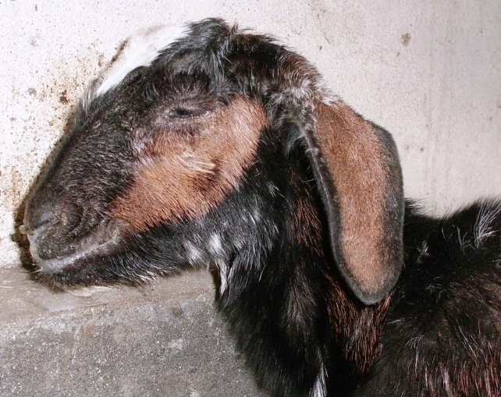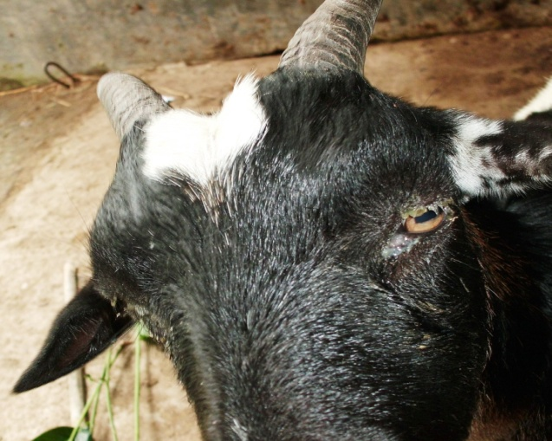

**b**

**a**

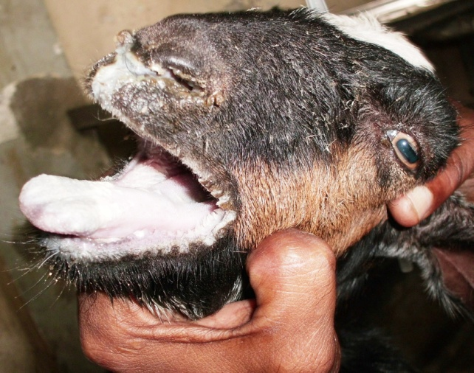

**c**

**d**

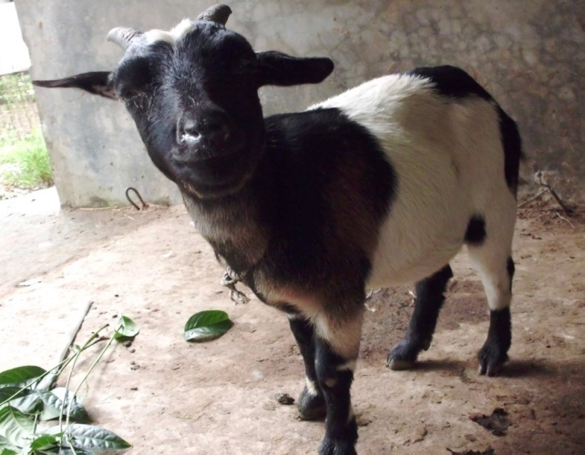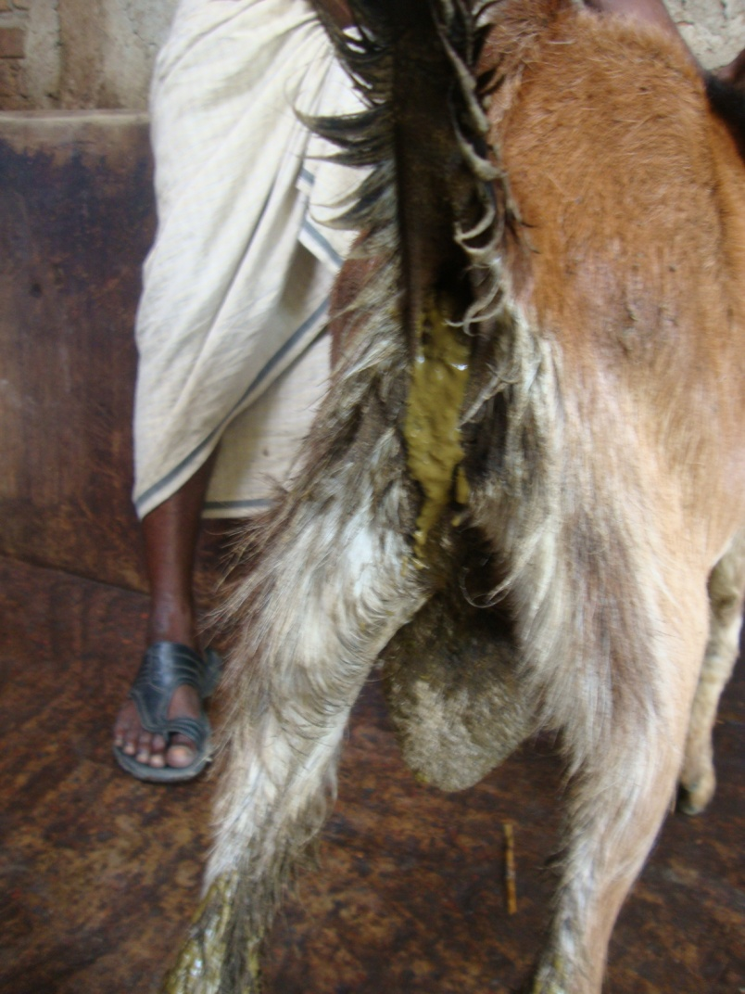

**f**

**e**

**Plate- 1: Clinical signs of PPR affected goats.** **( a )** Goat shoeing ocular discharge **( b )** Goat showing nasal discharge **( c + d )** Mouth lesions (erosions) in PPR affected goat **(e )** Diarrhoeal signs in PPR affected goats **( f )** PPR affected goat .

Some representative pictures

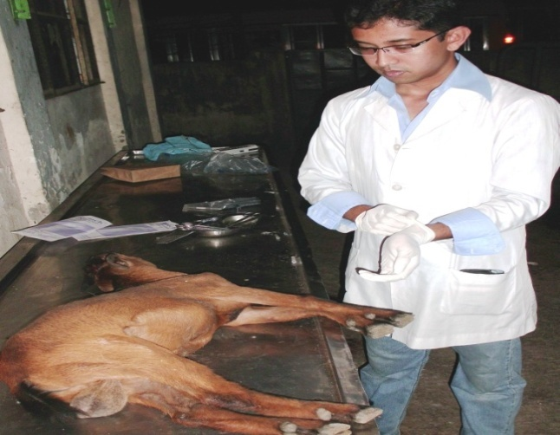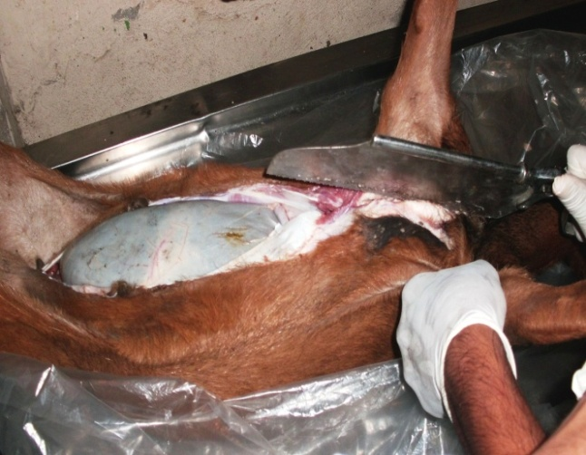

**h**

**g**

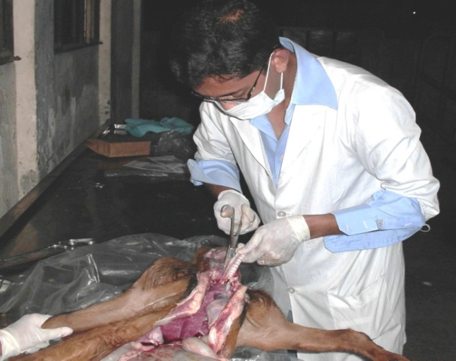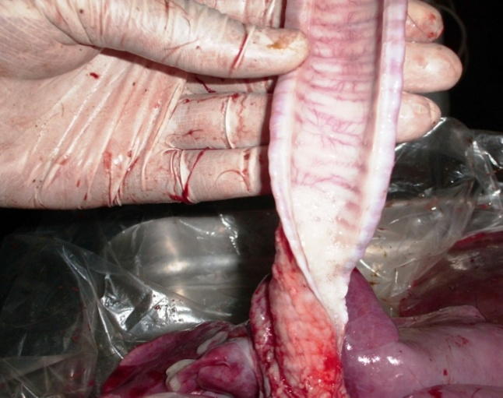

**j**

**i**

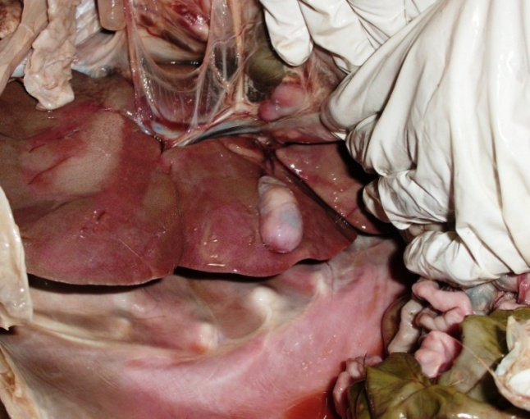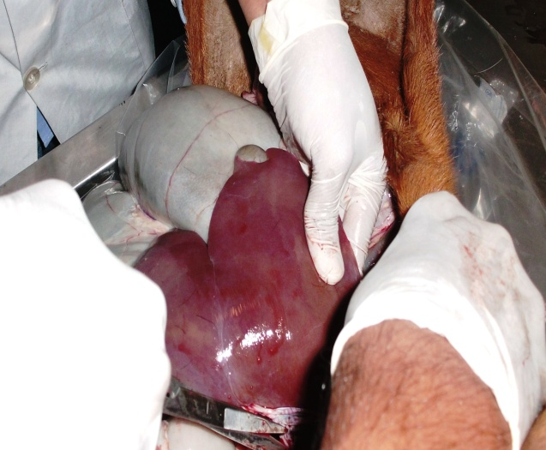

**k**

**l**

**l**

**k**

**Plate-2: Postmortem examination of PPR affected goats. (g + h )** Dissection of PPR affected goat **( i )** Examination of intestine for “Zebra stripe” **( j )** Examination of Trachea **( k + l )** Necrosed & congested liver of PPR affected goat .

Some representative pictures

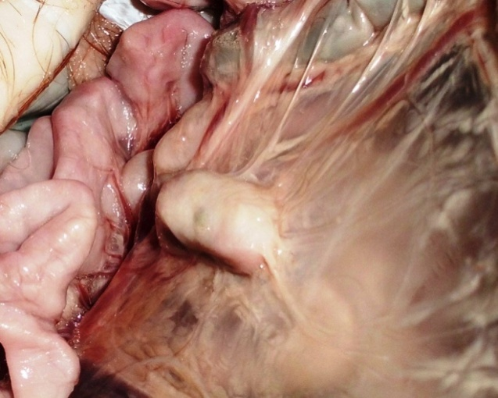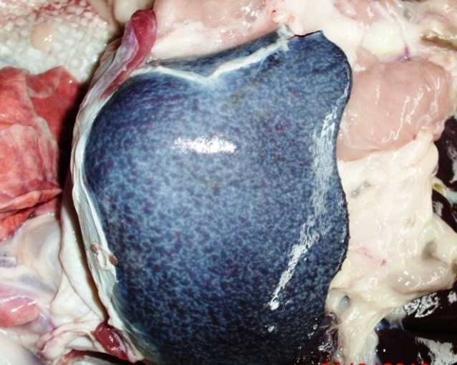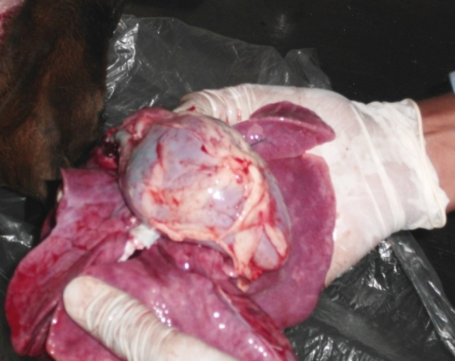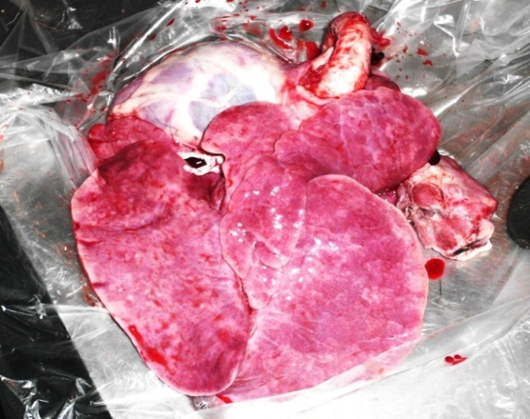

**n**

**m**

**p**

**o**

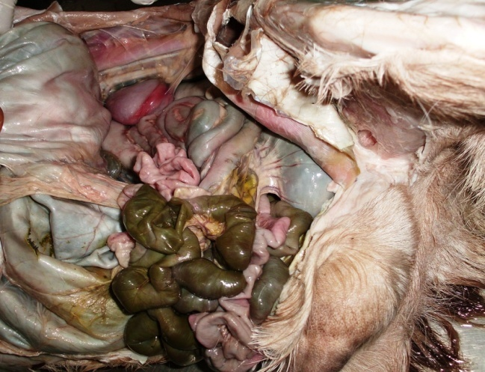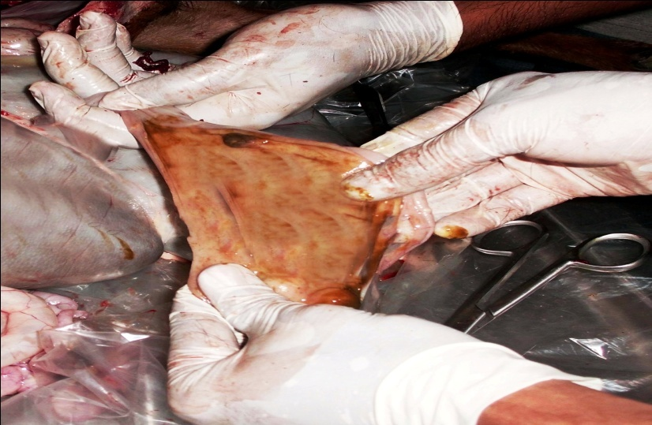

**r**

**q**

**Plate-3: Postmortem examination of PPR affected goats. (m)** Congested lung, dark red/purple areas & firm to touch **( n )** enlarged heart **( o )** Spleenomegaly **( p)** Soft and swollen intestinal lymphnode **( q )** Necrosed & haemorrhagic intestinal tract **( r )** Zebra stripe lesion in ileo-caecal junction in PPR affected goat.