CHAPTER-3

MATERIALS AND METHODS
3.1 Study period and area

The study was conducted at Upazila Veteinary Hospital, Kaliganj, Gazipur during the period of July to September 2012 and SAQ Teaching Veterinary Hospital, CVASU during the period of September to December, 2012.
3.2 Sample size
The sample size was 8 cattle and 8 goats, which were affected with acidosis. Total number of animals was recorded to determine the prevalence of ruminal acidosis. The cases in cattle were studied in the Upazila Veterinary Hospital (UVH) at kaliganj, Gazipur and the cases in goats were studied in SAQ Teaching Veterinary Hospital, CVASU.
3.3 Case selection
The cases were randomly selected on the basis of feeding history, clinical signs of complete anorexia, abdominal pain, rapid beating of the heart, abnormally fast breathing, diarrhea, lethargy, and eventually death as proposed by Krause and Oetzel ( 2006), and low ruminal pH (Cooper and Klopfenstein, 1996), low blood pH (Owens et al., 1998) and stop or reduced motility of microflora.

3.4 Diagnosis
Presumptive diagnosis of the cases was performed on the basis of the history of feeding of easily digestible carbohydrates (Cooked rice, jackfruit residue, potato etc), associated clinical signs (Nordlund, 2004) and examination of rumen fluid color, consistency and odor.
Confirmatory diagnosis was performed by exploring the low rumen fluid pH described by Kleen et al. (2003) and Khafipour et al. (2009) and or low serum pH stated by Owens et al. (1998).
3.4.1 Rumen fluid collection
Rumen fluid was collected by rumenocentesis as the method described by Radostits et al. (2006).
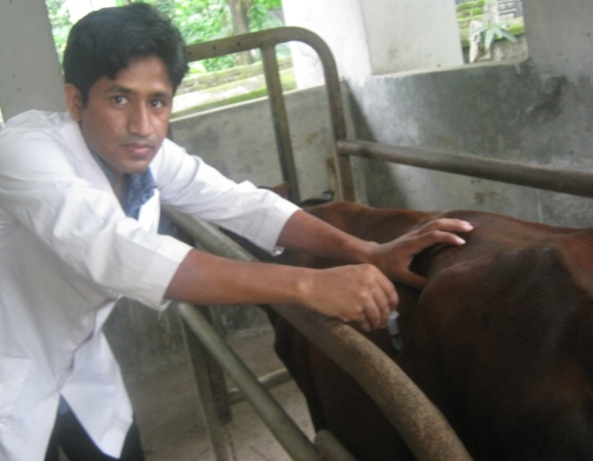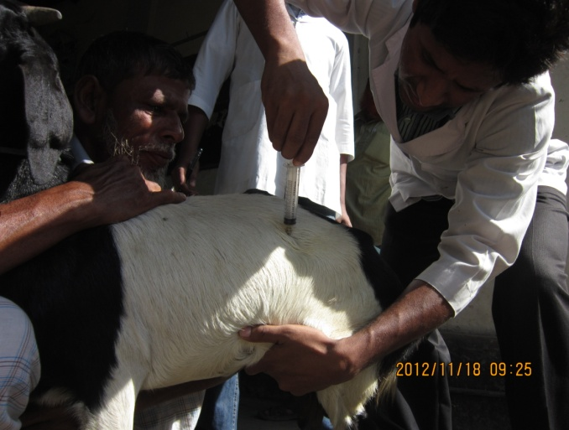
Fig. 6: Rumen fluid collection from cattle
Fig. 7: Rumen fluid collection from goat

Rumen fluid was collected by using a 14 gauge, 5 inch long needle attached to a 10ml disposable syringe. A 2x2cm area was marked on the left paralumbar fossa, approximately one hand length ventral to the lumbar transverse process and one hand width caudal to last rib, avoiding the major muscle masses. The selected area was shaved and sterilized with 70% alcohol or 10% povidone iodine solution and the sampling needle was inserted firmly through into the rumen. Three ml of rumen fluid was collected by applying back pressure to the piston of syringe. The collected fluid was taken into a sample vial.

3.4.2 Examination of rumen fluid

3.4.2.1 Examination of rumen fluid pH and microflora movement

One ml of collected rumen fluid was taken into a watch glass and a piece of pH indicator paper (Merck-universal indicator pH 1-10, Merck Limited, Worli, Mumbai-400 018) inserted into the fluid for a few seconds. Color change was observed in pH indicator paper. This color matched with the one of the different color of the color scale. The value of matched color was indicating the pH of the rumen fluid. To identify the motility of the rumen microflora a drop of fluid was taken into a clean glass slide and after putting a cover slip the content was observed under low power objective (10x).
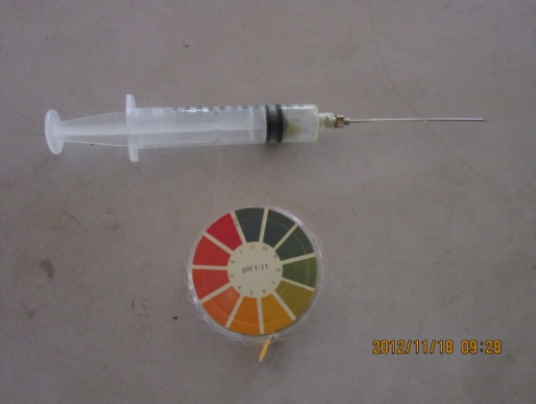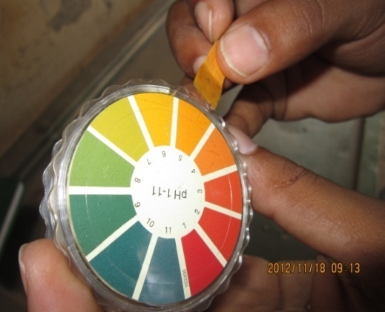
Fig. 9: Matching of pH indicator paper
with standard

Fig. 8: Syringe with 14 gauge needle and
pH Indicator paper for estimation
of ruminal and serum pH

3.4.2.2 Physical examination of rumen fluid

Physical characteristics (Color, consistency and odor) of rumen fluid were determined by using Organoleptic test.
3.4.3 Blood collection
Three ml of blood from the same animal was collected by using a 6 ml sterile disposable plastic syringe attached with 23 gauge needle from jugular vein after disinfection the side with 70% alcohol or povidone iodine.
3.4.4 Serum preparation
Serum was collected from the blood by two methods:
Method 1: The blood samples collected in UVH were retained in the syringe and the syringe was held inclined in refrigerator for overnight to separate the serum. The separated serum was carefully taken into an epindorf tube after removing the piston from the barrel and stored in refrigerator.
Method 2: The blood sample collected in SAQ Teaching Veterinary Hospital was taken into vacutainer that contain anticoagulants (Na-citrate) and stored in refrigerator. After that centrifugation of blood was done at 1000 rpm for 10 minutes at Biochemistry laboratory in CVASU for separation of serum. The serum was taken into epindorf tube with the help of Pasteur pipette.
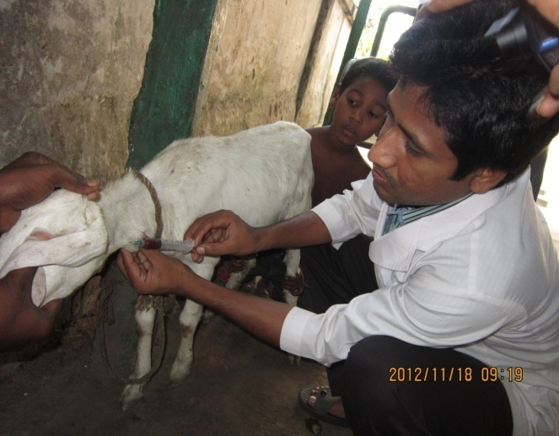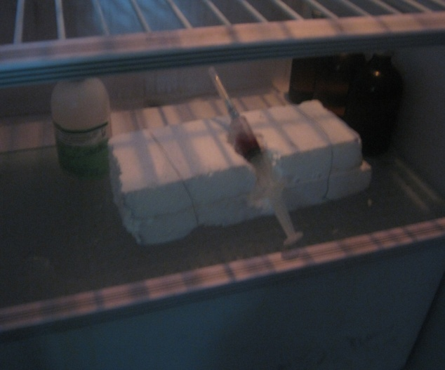
Fig. 11: Blood containing syringe slanted
in position for serum preparation
Fig. 10: Blood collection from
jugular vein
Or

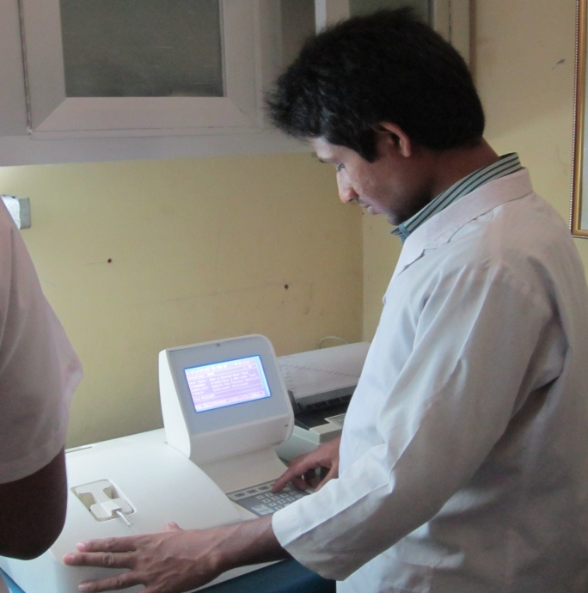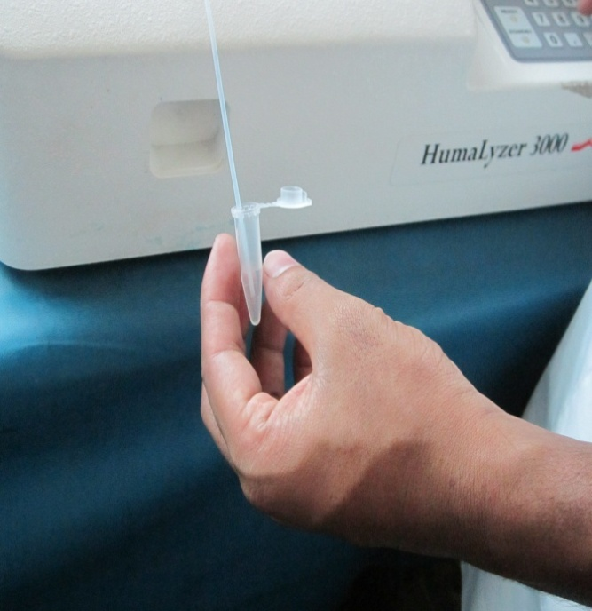
Fig. 13: Estimation of Ca of serum by
biochemical analyzer

Fig. 12: Preparation of biochemical analyzer
for Ca estimation

3.4.5 Examination of serum
3.4.5.1 Determination of serum pH
The collected serum was taken into a watch glass and a piece of pH indicator paper inserted into the serum for a few seconds. Color change was observed in pH indicator paper. This color matched with the one of the different color of the color scale. The value of matched color was indicating the pH of the serum.
3.4.5.2 Determination of serum Ca
Serum Ca level was determined by biochemical analyzer (Humalyzer-3000 Chemistry Analyzer, semi automated Benchtop chemistry photometer, CHEM- LABS company, East Africa- Kenya) at Biochemistry laboratory in CVASU.
3.5 Signalments and clinical parameters studied
The following signalments and clinical parameters were studied
- Species
- Breed
- Sex
- Age
- Body weight
- BCS (Body condition score)
- Temperature
- Rumen motility
- Rumen microflora movements
- Rumen fluid color
- Rumen fluid odor
- Rumen fluid consistency
- Rumen fluid pH
- Serum pH
- Serum Ca level

3.6 Treatment protocol
Clinically 16 ruminal acidosis affected cattle and goat were randomly selected and divided into four groups under four types of treatment:
Table1:Different treatments to different groups of animals
Groups | Animals | Treatment
A | 2 cattle and 2 goats | Ruminal alkalizer
B | 1 cattle and 1 goat | Ruminal alkalizer and purgatives
C | 1 cattle and 1 goat | Systemic alkalizer + fluid therapy
D | 4 cattle and 4 goats | Ruminal and systemic alkalizer + fluid therapy

Ruminal alkalizer: Powder sodium bicarbonate (Sodibicarb®, M. R. Chemicals, Bangladesh).
Ruminal alkalizer and purgatives: Powder sodium bicarbonate + Syrup magnesium hydroxide (Magvet®, Acme Pharmaceuticals, Bangladesh).
Systemic alkalizer + fluid therapy: Inj. 7.5% sodium bicarbonate (eg. Sodib®, Joyson Pharmaceuticals Bangladesh) + fluid therapy (Inj. 0.9% sodium chloride solution, Normal Saline®, Opso Saline Limited, Bangladesh).
Ruminal and systemic alkalizer + fluid therapy: Powder sodium bicarbonate + Inj. 7.5% sodium bicarbonate + fluid therapy (Inj. 0.9% sodium chloride solution).
3.7 Drug administration
Powder sodium bicarbonate: 1g/kg body weight mixed with double volume of water administered orally (Radostits et al., 2006), 3 times daily for 5 days.
Syrup magnesium hydroxide: 2ml/kg body weight, 2 times daily for 3 days.
Inj. Sodium bicarbonate: 5% sodium bicarbonate at the rate of 5 L for 450 kg body weight initially over a period of 30 minutes followed by isotonic sodium bicarbonate (1.3%) at 150 ml/kg body weight, I/V over next 6-12 hours (Radostits et al., 2006).
Inj. 0.9% sodium chloride solution: 50-100 ml/kg body weight (Depending upon severity of dehydration) (Tufani et al.,2013), I/V, once daily for 3 days.

3.8 Follow up of the animals
After giving the treatment, cases were kept under close observation by active participation, mobile phoning and recurring cases are observed in hospital.
3.9 Statistical analysis
The obtained data were imported and stored in Excell-2007 and analyzed by using STATA/IC-11. The mean and SEM with 95% CI were calculated to express the results. The comparisons of variables between cattle and goat, different breeds, male and female and different age groups were done by using online Epi info (http://www.openepi.com/OE2.3/Menu/OpenEpiMenu.htm).

