STUDY ON PREVALENCE, RISK FACTORS AND TREATMENT ASSESMENT OF RUMINAL ACIDOSIS IN CATTLE & GOAT
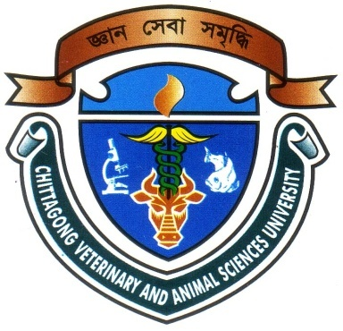

A Clinical Report Presented in Partial Fulfillment of the Requirement for the Degree of Doctor of Veterinary Medicine (DVM)

A Report submitted

By

Examination Roll No: 07/38

Registration No: 324

Intern ID: D-34

Session: 2006-2007

Faculty of Veterinary Medicine

Chittagong Veterinary and Animal Sciences University

Khulshi, Chittagong-4202
June, 2013
IV

STUDY ON PREVALENCE, RISK FACTORS AND TREATMENT ASSESMENT OF RUMINAL ACIDOSIS IN CATTLE & GOAT

A Clinical Report Submitted as per approved style and content

--------------------------  (Signature of Author)  Mahabub Alam  Roll No: 07/38  Reg. No: 324  Intern ID: D-34  Session: 2006-2007 | -------------------------------  (Signature of Supervisor)  Dr. Bhajan Chandra Das,  Associate professor,  Department of Medicine & Surgery  &  Director of SAQ Teaching Veterinary Hospital

Chittagong Veterinary and Animal Sciences University

Khulshi, Chittagong-4202
June, 2013
IV

