INTRODUCTION

Bangladesh owing to its favorable climatic influences has been blessed with immense natural resources including explored and unexplored herbal medicinal plants. About 5000 species of phanerogams and pteridophytes grow in the country’s forests, wetlands, farms and even roadsides as indigenous, naturally-occurring or cultivated plants. Of these, more than a thousand have been claimed to possess medicinal or curative properties. Recently, 546 species have been identified as having medicinal properties and therapeutic use (Ghani, 1998). We can use these resources for remedy of different diseases.
Medicinal plants are of great importance to the health of individual and communities. The medicinal value of these plants lies in some chemical active substances that produce a definite physiological action on the human body. The most important of these chemically active (bioactive) constituents of plants are alkaloid, tannin, flavonoid and phenolic compounds. Many of these indigenous medicinal plants are also used for medicinal purposes (Edeogra, 2005).
Since time immemorial, men have been using plant extracts to protect themselves against several diseases and to improve their health and life-style. No doubt, plants are serving several purposes whether health, nutrition, beauty or medicinal. New research suggests that prevention and natural treatment offer the healthiest, most lasting and least costly route to recovery. According to World Health Organization (WHO, 2002) medicinal plants would be the best source to obtain a variety of drugs. About 80% of individuals from developed countries use traditional medicine, which has compounds derived from medicinal plants. Therefore, such plants should be investigated to better understand their properties, safety and efficiency (Gupta, 1994).

An antimicrobial is a substance that kills or inhibits the growth of microbes such as bacteria, fungi, or viruses. Antimicrobial drugs either kill microbes (microbicidal) or prevent the growth of microbes (microbistatic). However, the future effectiveness of antimicrobial therapy is somewhat in doubt. Microorganisms, especially bacteria, are becoming resistant to more and more antimicrobial agents. Even though pharmacological industries have produced a number of new antibiotics in the last three decades, resistance to these drugs by microorganisms has increased (Cohen, 1992). Such a fact is cause for concern, because of the number of patients in hospitals who have suppressed immunity, and due to new bacterial strains, which are multi-resistant. Consequently, new infections can occur in hospitals resulting in high mortality.
Plants are an important source of natural chemical and are important in controlling agricultural pests. The antifungal activity of plant extracts using different solvent systems has been extensively reported(Gray and Harborne, 1994). Howevert, few studies have used water as a solvent system (Oasem and Abu-Balan, 1995) to determine the efficacy of plant extracts against fungal growth.
The use of plant extracts and phytochemicals, both with known antimicrobial properties, can be of great significance in therapeutic treatments. In the last few years, a number of studies have been conducted in different countries to prove such efficiency (Almagboul et al., 1985; Artizzu et al., 1995; Ikram et al., 1984; Izzo et al., 1995, Kubo et al., 1993; Shapoval et al., 1994; Sousa et al., 1994). Plants are rich in a wide variety of secondary metabolites, such as tannins, terpenoids, alkaloids, and flavonoids, which have been found in vitro to have antimicrobial properties. Many plants have been used because of their antimicrobial traits, which are due to compounds synthesized in the secondary metabolism of the plant. These products are known by their active substances, for example, the phenolic compounds, which are part of the essential oils (Jansen, 1987), as well as in tannin (Saxena, 1994). Traditional healers have long used plants to prevent or cure infectious conditions; Western medicine is trying to duplicate their successes. In the last few years, a number of studies have been conducted in different countries to prove such efficiency.
Although with the advent of synthetic drugs the use and procurement of plant-derived drugs have declined to a large extent a large number of drugs of modern medicine are still obtained from plant sources. As more data become available from phytochemical analysis and pharmacogical screening of medicinal plants, the number of plant derived drugs of modern medicine is increasing everyday.

Objectives of the this work:
- To evaluate the phytochemical properties of ethanol extracted leaves of Vitex negundo ( Verbanaceae )
- To evaluate the anti-inflammatory effects of ethanol extracted leaves of Vitex negundo ( Verbanaceae )
- To evaluate the anti-fungal effects of ethanol extracted leaves of Vitex negundo ( Verbanaceae )

REVIEW OF LITERATURE

2. Plant based remedies or Herbalism
2.1. Definition of herbalism
Herbalism is a traditional medicinal or folk medicine practice based on the use of plants and plant extracts. Herbalism is also known as botanical medicine, medical herbalism, herbal medicine, herbology, and phytotherapy. Sometimes the scope of herbal medicine is extended to include fungi and bee products, as well as minerals, shells and certain animal parts. Many plants synthesize substances that are useful to the maintenance of health in humans and other animals. These include aromatic substances, most of which are phenols or their oxygen-substituted derivatives such as tannins. Many are secondary metabolites, of which at least 12,000 have been isolated- a number estimated to be less than 10% of the total. In many cases, these substances (particularly the alkaloids) serve as plant defense mechanisms against predation by microorganisms, insects, and herbivores. Many of the herbs and spices used by humans to season food yield useful medicinal compounds (Lai, 2004; Tapsell, 2006).
2.2. Branches of herbal medicine
As many as 4 billion people, or 80 percent of the earth’s population, are estimated to use a form of herbal medicine in their health care, according to the World Health Organization (WHO). Herbal medicine is a large part of naturopathic, homeopathic, Native American Indian, Ayurvedic, and traditional oriental medicine. Branches of Herbal Medicine include Ayurvedic Herbalism and Traditional Chinese Herbalism. Ayurvedic Herbalism stems from Ayurveda and Western Herbalism and originated in Greece and Rome (Tapsell, 2006). Its practice spread throughout Europe and eventually to North and South America. Traditional Chinese Herbalism comes from Traditional Oriental Medicine.Western Herbalism is now considered folk medicine. Ayurvedic and Chinese Herbalism differ because they have developed over centuries into very advanced forms of treatment and systems of diagnosis (Tapsell, 2006).
2.3. Medicianl plants of Bangladesh
Bangladesh is a country considered to be rich in medicinal plants genetic resources. By virtue of its favourable agroclimatic condition, it has a large genetic resources base of agri-horticultural crops as well as medicinal plants. About 5000 species of phanerogams and pteridophytes grow in the country’s forests, wetlands, farms and even roadsides as indigenous, naturally-occurring or cultivated plants. Of these, more than a thousand have been claimed to possess medicinal or curative properties. Recently, 546 species have been identified as having medicinal properties and therapeutic use (Ghani, 1998).
2.4. Biological back ground of herbal medicine
All plants produce chemical compounds as part of their normal metabolic activities. These include primary metabolites, such as sugars and fats, found in all plants, and secondary metabolites found in a smaller range of plants, some useful ones found only in a particular genus or species. Pigments harvest light, protect the organism from radiation and display colors to attract pollinators. Many common weeds have medicinal properties (Stepp and Moerman, 2001; Stepp, 2004). The functions of secondary metabolites are varied. For example, some secondary metabolites are toxins used to deter predation, and others are pheromones used to attract insects for pollination. Phytoalexins protect against bacterial and fungal attacks. Allelochemicals inhibit rival plants that are competing for soil and light. The chemical profile of a single plant may vary over time as it reacts to changing conditions. It is the secondary metabolites and pigments that can have therapeutic actions in humans and which can be refined to produce drugs. Plants synthesize a variety of phytochemicals but most are derivatives of a few biochemical motifs. Alkaloids contain a ring with nitrogen. Many alkaloids have dramatic effects on the central nervous system. Caffeine is an alkaloid that provides a mild lift but the alkaloids in datura cause severe intoxication and even death. Phenolics contain phenol rings. The anthocyanins that give grapes their purple color, the isoflavones, the phytoestrogens from soy and the tannins that give tea its astringency are phenolics. Turpenoids are built up from terpene building blocks. Each terpene consists of two paired isoprenes. The names monoterpenes, sesquiterpenes, diterpenes and triterpenes are based on the number of isoprene units. The fragrance of rose and lavender is due to monoterpenes. The carotenoids produce the reds, yellows and oranges of pumpkin, corn and tomatoes. Glycosides consist of a glucose moiety attached to an aglycone. The aglycone is a molecule that is bioactive in its free form but inert until the glycoside bond is broken by water or enzymes. This mechanism allows the plant to defer the availability of the molecule to an appropriate time, similar to a safety lock on a gun.
2.5. Significance of herbal medicine in modern therapeutics
Over the years, natural products have contributed enormously to the development of important therapeutic drugs (Cragg et al., 1997; De Smet, 1997; Shu, 1998). The potential of higher plants as sources for new drugs is still largely unexplored. Among the estimated 250000 plant species existing world-wide, only a small percentage have been investigated phytochemically, and the fraction submitted to biological or pharmacological screening is even smaller (Hamburger and Hostettmann, 1991). The search for new pharmacologically active agents obtained from plants has led to the discovery of many clinically useful drugs that play a major role in the treatment of human disease. About 25% of all available modern drugs are derived directly or indirectly from higher plants (De Smet, 1997). Even the pharmacopoeia of scientific medicine in the 20th century was developed primarily from native herbal lore. Conditions such as high blood pressure, asthma, pain, and heart disease are often treated today with commercial medicines containing plant-based substances. Up to 25 percent of all prescription drugs in the United States have at least one active ingredient that comes from plant extracts or synthesized plant compounds. For example, ephedrine is derived from an herb called ephedra and is used in commercial medicines to relieve respiratory and asthma symptoms. The actual herb ephedra has been used for over two thousand years in Traditional Chinese Medicine to treat the same symptoms. The foxglove plant is an herb that has been used since 1775.

2.6.Vitex nigundo (Verbenaceae) - an important traditional medicinal plant
2.6. I. Vernacular names
Arabic: habul fiqa, nigand, sarsa . Bengali: samalu . Chinese: Huang Ping . English: chaste tree, cut-leaf chaste tree, five-leaved chaste tree, horseshoe vitex, Indian privet . Hindi: indrani, nilpushpi, nirgundi . Iloko: dangla . Kannada: nochi . Khmer: trasiet . Kurdish: paparau . Malayalam: lagundi, lemuning, lenggundi, vennocchi . Moldavian: legundi laut laki-laki. Nepali: simali . Portuguese: negundo. Sanskrit: nirgandhi, sephali. Spanish: agno-casto.Tagalog: legundi. Tamil: nocchi. Telugu: vavili. Thai: khonthi khemao, kunning. Urdu: atlaq, banna, danna, panjkasht, sanbhalo. Vietnamese: ngux traro
2.6. II.Taxonomy of Vitex nigundo
The genus Vitex belongs to the order Lamiales, Verbenaceae family Hundreds of Vitex nigundo are distributed throughout the world.
Kingdom : Plantae  Subkingdom : Viridaeplantae  Phylum : Tracheophyta Sub Phylum : Euphyllophytina InfraPhylum : Radiatopses Class : Magnoliopsida  SubClass : Lamiidae  SuperOrder : Lamianae Order : Lamiales Family :Verbenaceae Genus : Vitex  Species : Vitex nigundo | 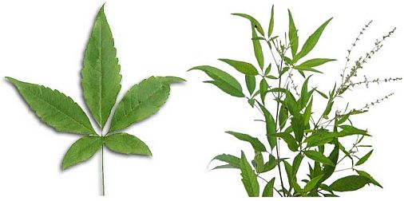  Fig 2.1Vitex nigundo (Verbenaceae)

2.6. III.Origin and distribution
Five-leaved Chaste Tree or Vitex Negundo is a medicinal shrub commonly found in tropical, subtropical and also warm temperate regions throughout the world, especially in the Philippines. The use of five-leaved chaste tree for medicinal purposes has been known for a long time in China, Korea, Japan, Indonesia, Philippines and other Asian countries. Today, pharmaceutical companies in Japan are importing wild vitex negundo from Philippines. Vitex negundo belonging to family Verbenaceae is a large aromatic shrub distributed throughout the greater part of India up to an altitude of 1500 m in the outer Himalayas. It is a gregarious shrub that is found abundant along the banks or rivers, in moist situations, open waste lands and near the deciduous forests. It is widely planted as a hedge plant along the roads and between the roads. The leaves are tri-or pentafoliate, lateral leaflets are smaller and nearly glabrous. The shrub is one of the important plants used in Indian medicine. Almost all parts of the herb are useful as a drug but the leaves and roots are most important and sold as drugs.
2.6.IV.Ethnopharmacology of Vitex Negundo leaves In all the regions of Vitex Negundo distribution, one of main organs used is the leaves; its medicinal uses throughout the world. Based on ethnopharmacological knowledge, a standardized aqueous extract of Vitex Negundo leaves with antioxidant, anti-inflammatory and immunomodulatory properties has recently been developed in Cuba. This extract is proposed as both a nutritional supplement (antioxidant) and an anti-inflammatory, analgesic and immunomodulatory treatment to prevent disease progress or increase the patient’s quality of life in gastric and dermatological disorders, cancer and asthma (NuNez-Selles, 2005).
2.6. V. Phytochemistry
The preliminary phytochemical study was screened for presence of alkaloid, flavonoid, tannin, carbohydrates, glycosides, proteins, amino acid, steroids, vitamin C, fat & fixed oil ( Trease and Evans , 1989 )

MATERIALS AND METHODS

3.1. Sample Collection
The leaves of Vitex nigundo (Verbenaceae) were collected from Chittagong district of Bangladesh. The plant was taxonomically identified by Dr. Md. Yousuf, Taxonomist, Industrial Botany Research Division, BCSIR laboratories, Chittagong.
3.2. Preparation of Plant Extract
The fresh leaves of Vitex nigundo (Verbenaceae) were washed with water immediately after collection. The collected leaves were chopped into small pieces, air dried at room temperature for about 10 days and ground into powder form and stored in an airtight container. 750 gm, 600gm and 650gm powder was macerated in 5L pure methanol for 7 days at room temperature with occasional stirring. After 7 days methanol extract was filtered off through cotton plug and finally with a Whatman No. 1 filter paper. The extract was concentrated under reduced pressure below 50 ºC through rotatory vaccum evaporator. The concentrated extracts were collected in a Petri dish and allow to air dry for complete evaporation of methanol. The whole process was repeated three times and finally, 50gm, 45 gm and 55gm greenish colored, concentrated leaves extract was obtained (yield 5.3 % w/w) which was kept in refrigerator at 4 ºC.
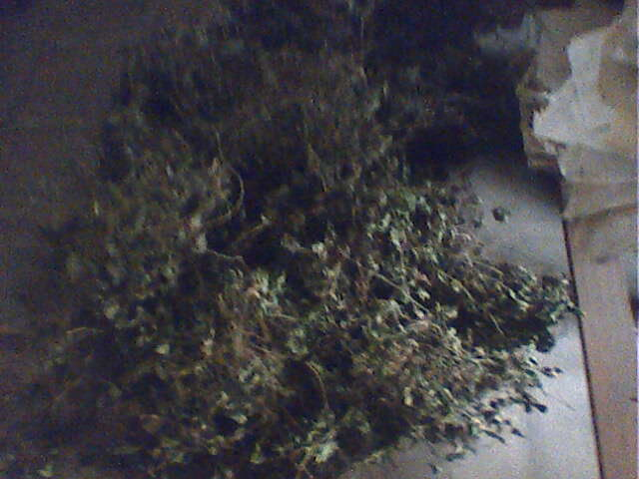 | 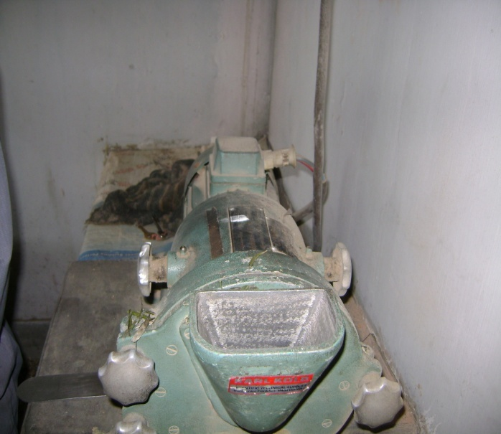
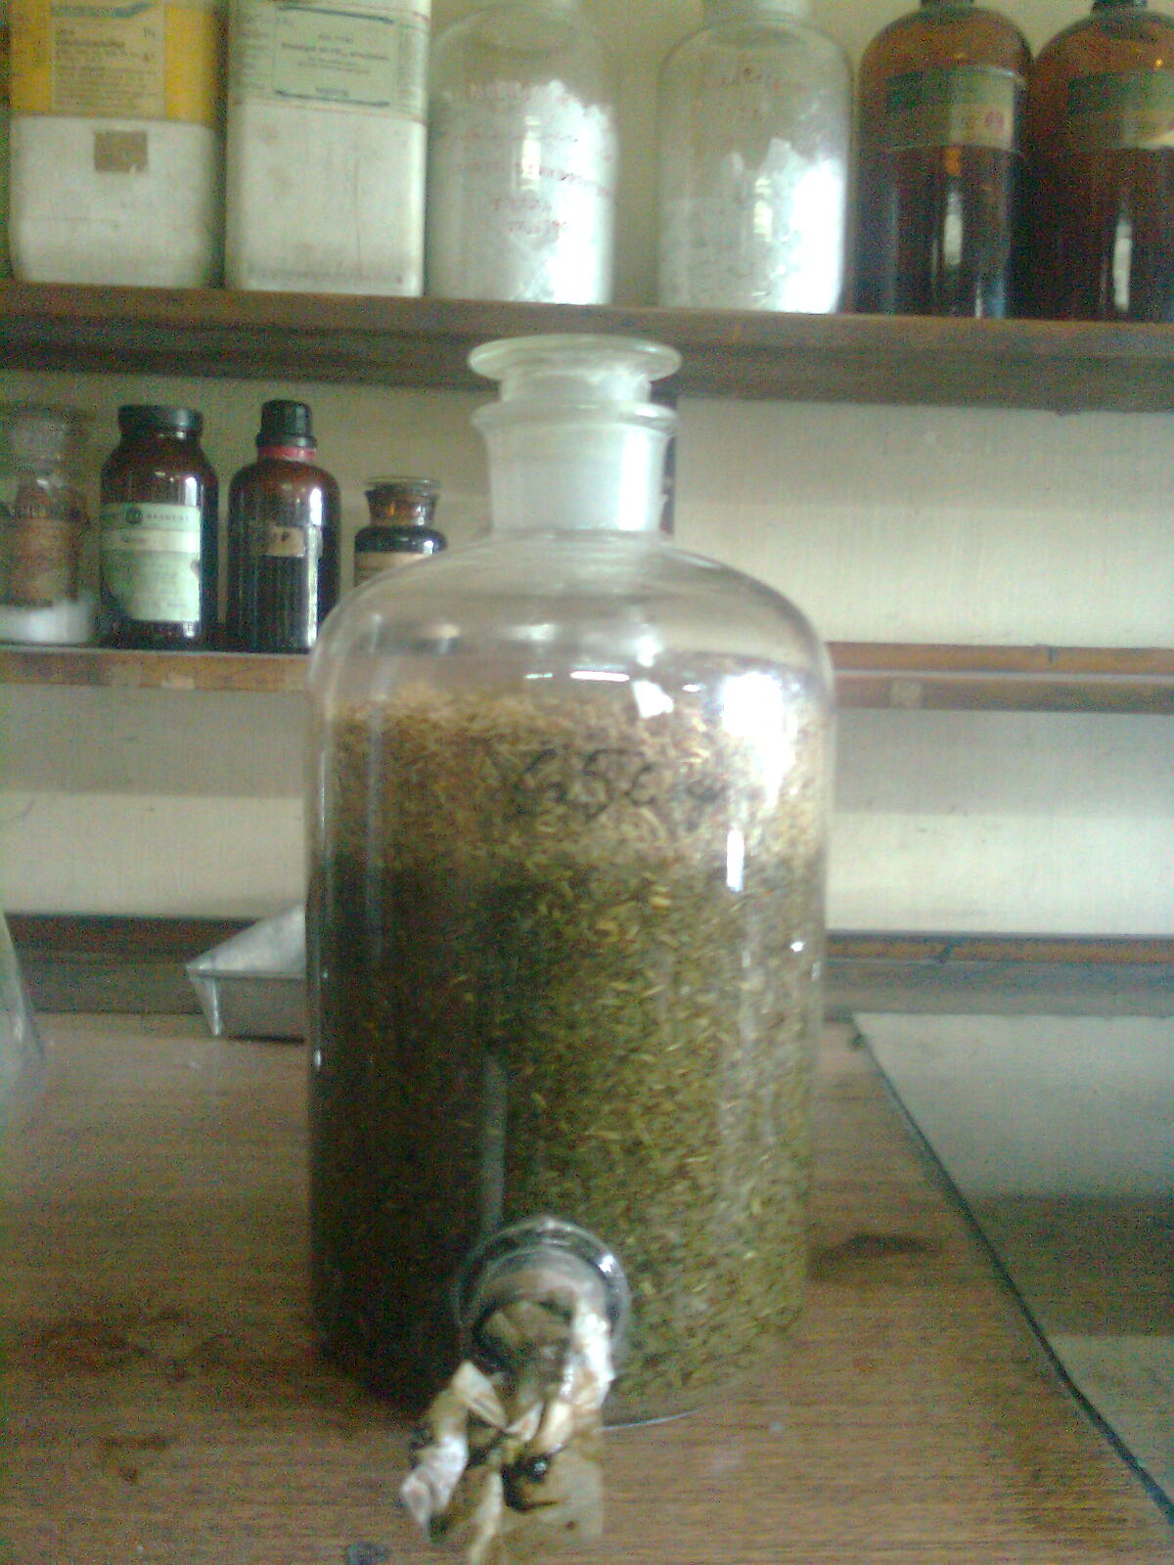 | 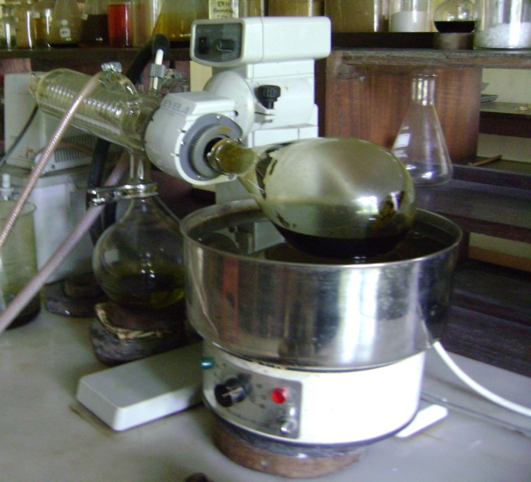
Fig 3.1: Photograph of dried leaves, chopping process, ethanol extraction and alcohol evaporation by vacuum rotatory machine
3.6. Antimicrobial screening
3.6. I .Preparation of test Solution:
A measured amount of test samples (e.g. Ethanol extract) were dissolved in definite volumes of ethanol to give solution of known concentration (e.g. 500µg/10µl). Ethanol was chosen as solvent because; in addition to that it can be used in dissolving the crude extracts completely. Volatile essential oils used directly without dissolving in any solvent.

3.6. II.Test Organisms:
In the present study, to screen the anti-microbial activity of plant extracts 10 bacteria and 4 fungi were used as test organisms. Among 10 bacteria, 6 were gram positive and 4 were gram negative. Bacterial and Fungus culture were collected from Institute of Nutrition and food Science, University of Dhaka. Test experiments were conducted in Industrial Microbiology Research Division, BCSIR Laboratories Chittagong, Bangladesh.

Table-3.2: List of test Organism (Bacteria)
Types of Bacteria | Test Organism | Source
Gram (+) | Bacillus subtilis | BTCC
Gram (+) | Staphylococcus aureus | BTCC
Gram (+) | Bacillus cereus | BTCC
Gram (+) | B. polymyxa. | BTCC
Gram (+) | B . megaterium | BTCC
Gram (+) | Klebsiella sp. | ICDDR’B
Gram (-) | Salmonella typhi | ICDDR’B
Gram (-) | Shigella flexneri | ICDDR’B
Gram (-) | Shigella sonnei | ICDDR’B
Gram (-) | Proteus sp. | ICDDR’B

3.7. Sensitivity spectrum analysis
3.7. I. Disc diffusion methods
The disc diffusion technique (Bauer et al, 1966) is a widely accepted in vitro investigation for primary screening of agents which may possess any antibacterial activity. It is essentially a qualitative or quantitative test indicating the sensitivity or resistance of the microorganism to the test materials. However, no distinction between bacteriostatic or bactericidal activity can be made by this method (Ronald, 1982)
The Kirby-Bauer and Stokes' methods are usually used for anti-microbial susceptibility testing, with the Kirby-Bauer method being recommended by the NCCLS. The accuracy and reproducibility of this test are dependent on maintaining a standard set of procedures as described here. NCCLS is an international, interdisciplinary, non-profit, non-governmental organization composed of medical professionals, government, industry, healthcare providers, educators etc. It promotes accurate anti-microbial susceptibility testing (AST) and appropriate reporting by developing standard reference methods, interpretative criteria for the results of standard AST methods, establishing quality control parameters for standard test methods, provides testing and reporting strategies that are clinically relevant and cost-effective Interpretative criteria of NCCLS are developed based on international collaborative studies and well correlated with MIC’s and the results have corroborated with clinical data. Based on study results NCCLS interpretative criteria are revised frequently. NCCLS is approved by FDA-USA and recommended by WHO.

3.7. II. Principle of disc diffusion method
Solution of known concentration (µg/ml) of the test samples were made by dissolving measured amount of the samples in definite volume of solvents. Sterilized and dried filter paper discs (4 mm in diameter) were then impregnated with known amounts of test substances by using micropipette. Discs containing the test materials are placed on nutrient agar medium uniformly seeded with the test organisms. Discs soaked in espective solvent are used as positive control. These plates are then kept at low temperature (4ºC) for two to four hours to allow maximum diffusion of compound. During this time dried discs absorb water from the surrounding media and then the test materials are dissolved and diffused out of the media. The diffusion occurs according to the physical law that controls the diffusion of molecules through agar gel (Barry, 1976). As a result, there is a gradual change of test materials concentration in the media surrounding the discs.The plates were then incubated at 37ºC for 24 hours to allow maximum growth of the microorganisms. If the test materials have any antibacterial activity, it will inhibit the growth of the microorganisms giving the clear distinct zone around the disc called “Zone of Inhibition”. The antibacterial activity of the test agent is determined by measuring the zone of inhibition expressed in millimeter, the antibacterial activities of the test materials were determined by measuring the diameter of the zones of inhibition in millimeter with transparent scale.
3.7. III. Reagents for the Disk Diffusion Test
3.7. III.i. Mueller-Hinton Agar Medium
Of the many media available, Mueller-Hinton agar is considered to be the best for routine susceptibility testing of non-fastidious bacteria for the following reasons:

  - It shows acceptable batch-to-batch reproducibility for susceptibility testing.
  - It is low in sulphonamide, trimethoprim, and tetracycline inhibitors.
  - It gives satisfactory growth of most non-fastidious pathogens.
  - A large body of data and experience has been collected concerning susceptibility tests performed with this medium.
Although Müeller-Hinton agar is reliable generally for susceptibility testing, results obtained with some batches may, on occasion, vary significantly. If a batch of medium does not support adequate growth of a test organism, zones obtained in a disk diffusion test will usually be larger than expected and may exceed the acceptable quality control limits. Only Mueller-Hinton medium formulations that have been tested according to, and that meet the acceptance limits described in, NCCLS document M62-A7- Protocols for Evaluating Dehydrated Mueller-Hinton Agar should be used.
3.7. III.ii. Preparation of Mueller-Hinton Agar
Mueller-Hinton agar preparation includes the following steps.
- Mueller-Hinton agar prepared from a commercially available dehydrated base (Hi-media, India) according to the manufacturer's instructions.
- Immediately after autoclaving, allowed it to cool in a 45 to 50°C water bath.
- Freshly prepared and cooled medium poured into glass, flat-bottomed petri dishes on a level, horizontal surface to give a uniform depth of approximately 4 mm. (This corresponds to 60 to 70 ml of medium for plates with diameters of 150 mm and 25 to 30 ml for plates with a diameter of 100 mm.)
- The agar medium allowed cooling to room temperature.

3.7. III.iii.Turbidity standard for inoculums preparation
To standardize the inoculums density for a susceptibility test, a BaSO₄ turbidity standard, equivalent to a 0.5 McFarland standard or its optical equivalent (e.g., latex particle suspension), should be used. A BaSO₄ 0.5 McFarland standards prepared as follows:
1. A 0.5-ml aliquot of 0.048 mol/L BaCl₂ (1.175% w/v BaCl₂. 2H₂O) is added to 99.5 ml of 0.18 mol/L H₂SO₄ (1% v/v) with constant stirring to maintain a suspension.
2. The correct density of the turbidity standard verified by using a spectrophotometer with a 1-cm light path and matched cuvette to determine the absorbance. The absorbance at 625 nm should be 0.008 to 0.10 for the 0.5 McFarland standards.
3. The Barium Sulfate suspension transferred in 4 to 6 ml aliquots into screw-cap tubes of the same size as those used in growing or diluting the bacterial inoculum.
4. These tubes were tightly sealed and stored in the dark at room temperature.
5. The barium sulfate turbidity standard vigorously agitated on a mechanical vortex mixer before each use and inspected for a uniformly turbid appearance.

3.7. IV.Procedure for Performing the Disc Diffusion Test
3.7. IV.i. Inoculums Preparation
3.7. IV.i.a. Growth Method
The growth method is performed as follows:
At least three to five well-isolated colonies of the same morphological type are selected from an agar plate culture. The top of each colony is touched with a loop and the growth is transferred into a tube containing 4 to 5 ml of a suitable broth medium, such as Mueller Hinton broth. The broth culture is incubated at 35°C until it achieves or exceeds the turbidity of the 0.5 McFarland standards (usually 2 to 6 hours). The turbidity of the actively growing broth culture is adjusted with sterile saline or broth to obtain turbidity optically comparable to that of the 0.5 McFarland standards. (This results in a suspension containing approximately 1 to 2 x 10⁸ CFU/ml for E.coli ATCC 25922). To perform this step properly, either a photometric device is used.
3.7. IV.ii. Preparation of discs
Whatman-1 filter papers were used for disc preparation. The discs of about 4 mm in diameter were prepared by using punching machine. The discs were taken in a petridish and sterilized by autoclave, dried in oven at 100°C. and then impregnated with required concentration of plant extract.
3.7. IV.iii. Inoculation of Test Plates
- Optimally, within 15 minutes after adjusting the turbidity of the inoculum suspension, a sterile cotton swab is dipped into the adjusted suspension. The swab rotated several times and pressed firmly on the inside wall of the tube above the fluid level. This will remove excess inoculum from the swab.
- The dried surface of a Mueller-Hinton agar plate is inoculated by streaking the swab over the entire sterile agar surface. This procedure is repeated by streaking two more times, rotating the plate approximately 60° each time to ensure an even distribution of inoculum. As a final step, the rim of the agar is swabbed.
- The lid was left ajar for 3 to 5 minutes (but no more than 15 minutes), to allow for any excess surface moisture to be absorbed before applying the drug impregnated disks.
3.7. IV.iv. Application of Discs to Inoculated Agar Plates
- The predetermined battery of anti-microbial discs is dispensed onto the surface of the inoculated agar plate. Each disc pressed down to ensure complete contact with the agar surface. Discs are distributed evenly so that they are no closer than 24 mm from center to center.
- The plates are inverted and placed in an incubator set to 35°C within 15 minutes after the discs are applied.
3.7. IV.v. Reading Plates and Interpreting Results
After 16 to 18 hours of incubation, each plate is examined. If the plate was satisfactorily streaked, and the inoculums were correct, the resulting zones of inhibition will be uniformly circular and there will be a confluent lawn of growth. The diameters of the zones of complete inhibition (as judged by the unaided eye) are measured, including the diameter of the disc. Zones are measured to the nearest whole millimeter, using sliding calipers or a ruler, which is held on the back of the inverted Petri plate. The Petri plate is held a few inches above a black, nonreflecting background and illuminated with reflected light.

3.8. Antifungal activity
Table-3.2: List of test organism (Fungi)
Name of Organism | Source | ID No.
Aspergillus ustus | DSM | 63535
A. niger | DSM | 737
A. ochraceus | DSM | 824
Candida albicans | BTCC  NCYC | 493

3.8. I. Preparation of fungal inoculums
For fungal inoculums PDA pour plates were prepared. At the center of these 5 days old test fungi were transferred and incubated at (25±2) ºC. After 5 days of incubation they were ready for use.
3.8. II. Procedure for anti-fungal activity
The poisoned food technique (Grover and Moore, 1962) was used to screen for anti-fungal activity. Potato dextrose agar was used as a culture medium. Each extract was dissolved in ethanol to obtain definite concentration. From this required concentration of extract was taken by sterilized pipette in a sterilized petriplate and then 15 ml medium was poured into the petriplate and mixed well and allowed to solidify. Inoculation was done at the center of each plate with 5 mm mycelium block for each fungus. The mycelium block was prepared with the help of cork borer from the growing area of a 5 days old culture of the test fungi on PDA. The blocks were placed at the center of each petriplate in an inverted position to get greater contact of the mycelium with the culture medium. The inoculated plates were incubated at (25±2)°C. The experiment was repeated for three times. Proper control (PDA without extract) was also maintained. After 5 days of incubation (3 days for Macrophomina phaseolina) the diameter of fungal colonies were measured. The average of three measurements was taken as colony diameter of the fungus in mm. The percentage inhibition of mycelial growth of the test fungus was calculated by the following formula:
I= (C-T)/C × 100
Here,
I=Percentage of Inhibition
C=Diameter of the fungal colony in control
T=Diameter of the fungal colony in treatment
Statistical analysis:
The results are presented as the Mean ± S.E.M (Standard Error) and statistical significance between the groups was determined by means of one-way analysis of variance (ANOVA) followed by unpaired Student’s t-test to determine statistical significance. SPSS for WINDOWS^{@TM} was applied for analysis of data. Probability (P) value of 0.05 or less (P≤0.05) was considered as significant.

RESULTS

4.1. Antimicrobial
4.3. I. Antibacterial activity
Antibacterial activity of Vitex nigundo (Verbenaceae) leaves extract was measured at 1mg/disc, 2 mg/disc , 3 mg/disc, 4 mg/disc, 5 mg/disc concentration and found moderate activity against Gram (+) bacteria and poor activity against gram (-) showed bacteria at 5 mg/disc. On the other hand, standard antibiotic tetracycline (30 μg/disc) showed significant antibacterial activity against all tested Gram (+) and Gram (-) bacteria.

Table 4.7: Anti-bacterial activity of ethanolic leaves extract of Vitex nigundo (Verbenaceae)
Typesof Bacteria | Test Organism | Tetracycline (30µg/disc) | V nigundo (1mg/disc) | V nigundo (2mg/disc) | V nigundo (3mg/disc) | V nigundo (4mg/disc) | V nigundo (5mg/disc)
Gram (+) | Bacillus subtilis | 20 | - | - | - | 4 | 6
Gram (+) | Staphylococcus aureus | 12.5 | - | - | 4 | 6 | 8
Gram (+) | Bacillus cereus | 19.5 | - | - | - | 5 | 6
Gram (+) | B. polymyxa. | 11.5 | - | - | 3 | 6 | 9
Gram (+) | B . megaterium | 6.5 | - | - | - | 4 | 6
Gram (+) | Klebsiella sp. | 22 | - | - | 5 | 6 | 8
Gram (-) | Salmonella typhi | 14.5 | - | - | - | 4 | 6
Gram (-) | Shigella flexneri | 23 | - | - | - | - | -
Gram (-) | Shigella sonei | 22.5 | - | - | 3 | 5 | 7
Gram (-) | Proteus sp | 11 | - | - | - | 4 | 8

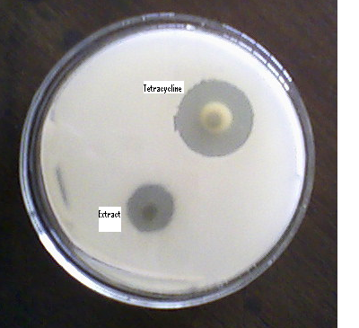 | 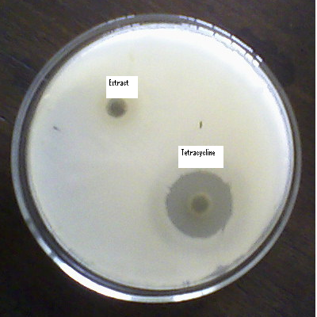
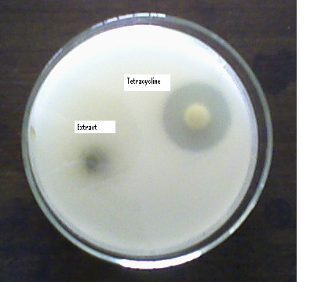 | 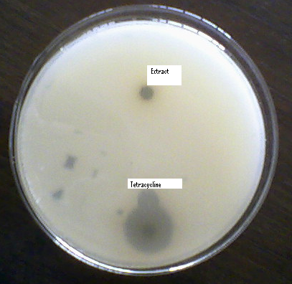
Fig- 4.14: Photograph showing zone of inhibition of leaves extract (5mg/disc) , and tetracycycline (30µg/disc) on Staphylococcus aureus , Bacillus cereus , Klebsiella sp and Shigella flexneri

4.3. II.Antifungal
Antifungal activity
Name of the organism | Percentage of inhibition
Name of the organism | Vitex nigundo (Verbenaceae) (4mg/20ml)
Aspergillus ustus | 20
A. niger | 13
A. ochraceus | 11
Vitex nigundo (Verbenaceae ) showed a prominent significant degree of Anti-fungal activity .Ethanolic leaves extract reveals much activity was showed by ethanolic extract (4mg/20ml) against Vitex nigundo which was 20%,13% and 11% .

DISCUSSION
Antibacterial activity
Ethanolic leaves extract of s Vitex nigundo howed antimicrobial activity against tested organism excepet Shigella flexneri. All the nine-organism gives zone of inhibition ranging from 3 mm to 9 mm. Overall, all the leaf extract showed a weak antibacterial activity compared with the tetracycline–positive control. Some of the bacteria which is used in this study are the common microbes caused various infective ailments. Klebsiella sp is a commonest pathogen for respiratory infectious, uninary tract infections and wound infection (Schneiders et al., 2003). In the present work ethanol extract of Vitex nigundo displayed antibacterial activity against Klebsiella sp.
In search for new antimicrobial substances amongst various plant sources in most cases only an antibacterial effect is established, as only few of them have been reported to have an antifungal effect (Mahasneh, 2002; Ristic et al.,2000).
Phytoconstituents have been found to inhibit bacteria, fungi, viruses and pests (Marjorie, 1999).
This results indicate that Vitex nigundo leaves extract possess certain phytochemicals which have moderate activity against Gram positive bacteria but low activity against Gram negative bacteria. Our results are consistent with other previous publications (Rahman et al, 2008).

5.3. II. Antifungal activity
Ethanolic leaves extract of Vitex nigundo showed good degree of antifungal activity. Vitex nigundo exhibit good activity against Aspergillus ustus.
There are alarming reports of opportunistic fungal infections (Singh, 2001). Trends in the epidemiology of opportunistic fungal infections, predisposing factors and the impact of anti-microbial use practices.
And the resistance of the organisms increased due to indiscriminate use of commercial anti-microbial drugs commonly used for the treatment of infectious disease. This situation forced the researchers to search for new anti-microbial substance from various sources including medicinal plant. (Bauer et al., 1996) Antibiotic susceptibility testing by standardized single disc method.

CONCLUSION

The present study was conducted to investigate the antibacterial and antifungal effects of ethanol extracted leaves of Vitex nigundo. The effects of ethanol extracted leaves of plant showed significant reduction of pain in comparison with available commercial analgesic drugs. They have also anti-inflammatory effect but the action was not significant i.e. the reduction inflammatory condition is lower than the commercially available drugs. In present study, ethanol extracted leaves showed moderate efficacy against some gram (+) organisms and few gram (-) organisms. It have also some effects against few fungi. In this study we can say that the plant have effect against some bacteria and also some fungus. Further investigation is required for isolation, identification and characterization of different active compounds and their mode of action and therapeutic range.

REFERENCE

Almagboul, A. Z., Bashi, A.K., Farouk, A.and Salih, A.K.M. (1985). Antimicrobial activity of certain Sudanese plants used in folkloric medicine. Screening for antibacterial activity. Fitoterapia 56, 331-337.

Anesini, E. and Perez, C.(1993).Screening of plants used in Argentine folk medicine for antimicrobial activity. Journal. Ethnopharmacol. 39, 119-128.

Bauer, A.W., Kirby, W.M., Sherris, J.C. and Turck, M. (1996). Antibiotic susceptibility testing by standardized single disc method. Am. J. Clin Pathol 44: 493-496.

Bremner, P.and Heinrich, M. (2002) Natural products as targeted modulators of the nuclear factor-_B pathway. J Pharm Pharmaco l;54:453–72.

Brray,T.M. (1976). Society for Experimental Biology and Medicine, pp. 195.
Calixto, J.B., Scheidt, C., Otuki, M. and Santos, A.R. (2001). Biological activity of plant extracts: novel analgesic drugs. Expert Opinion on Emerging Drugs, 6:2, pp. 261-279.

Chatterjee, G.K. and pal, S.P. (1984). Search for anti-inflammatory agents from Indian medicinal plants- Areview.Indian Drugs.21:413.

Chopra, R. N., Nayar, S.L. and Chopra, I.C.( 1992). G;ossary of India medicinal plants. 3rd ed. CSIR, New Delhi,PP:18.

Cotran; Kumar, and Collins, (1998). Robbins Pathologic Basis of Disease. Philadelphia: W.B Saunders Company. ISBN 0-7216-7335-X.

Cragg, G.M., Newman, D.J. and Snader, K.M.(1997). Natural products in drug discovery and development. J Nat Prod 60: 52-60.

David and Greenwood, (2008). Antimicrobial Drugs: Chronicle of a twentieth century medical triumph. ISBN13: 9780199534845.

De Smet, P.A.G.M. (1997). The role of plant-derived drugs and herbal medicines in healthcare. Drugs 54: 801-840.

Deng, W. L., Nie, R. J. and. Liu, J. Y .(1982). Comparison of pharmacological effects of four andrographolides. Chin. Pharm. Bull. 17, 195±198.

Desai, P.D., Ganguly,A.K., Govindachari, T.R., Joshi, B.S., Kamat,V.N., Manmade, A.H., Mohamed, P.A., Nagle, S.K., Nayak, R.H., Saksena, A.K., Sathe, S.S. and Vishwanathan ,N .(1966) .Chemical investigation of some Indian plants: Part II. Indian Journal of Chemistry 4, 457-549.

Dweck, A.C. (2001) .Article for cosmetics & toiletries magazine ethnobotanicalplants from Africa. Black Medicare Ltd, Iltshire.

Edeoga, H.O.,( 2005). Phytochemical constituents of some Nigerian Medicinal plants. Afr. J. Biotechnol., 4(7). 685-688.

Ellof, J.N.(1998) .Which extractant should be used for the screening and isolation of antimicrobial components from plants? J. Ethnopharmacol. 60, 1-6.
Emeruwa, A.C. (1991). The conservation of medicinal plants. J. Nat. Prodts. 45(2): 123-127.

Franklin, T.J.and Snow ,C.A.(1989). Biochemistry of antimicrobial action. 4th edn. Chapman and Hall. New York. pp. 134-155.
Ghani, A. (1998). Medicinal Plants of Bangladesh: Chemical Constituents and Uses. (Asiatic Society of Bangladesh, Dhaka).

Grayer, R. J. and Horborne, J.B. (1994) . A survey of antifungal compounds from higher phytochem ., 37:19-42.

Gupta, S.S. (1994). Prospects and perspectives of natural plants products in medicine Indian Journal of Pharmacology, 26: 1 -12.

Hamburge, M. and Hostettmann, K. (1991). Bioactivity in plants: the link between phytochemistry and medicine. Phytochemistry 30: 3864-3874.

Harrar and Sari, (2009)."Stop a Cold in Just 12 Hours". www.goodhousekeeping.com. http://www.goodhousekeeping.com/health/diseases/fight-common-cold-2.

Harrison, P. F. and Lederberg, J. (1998) .Antimicrobial Resistance: Issues and Options, Forum on Emerging Infections, Institute of Medicine.

Ikram, M. and Inamul, H. ( 1984). Screening of medicinal plants for antimicrobial activities. Fitoterapia 55, 62-64.
Izzo, A., Di Carlo, A., Biscardi, G., Fusco, D., Mascolo, R., Borreli, N., Capasso, F., Fasulo F. and Autore, M.P.G.(1995). Biological screening of Italian medicinal plants for antibacterial activity. Phytother. Res. 9, 281-286.

Kirtikar, K. R. and Basu, B. D. (1987) .Indian Medicinal plants . 2nd Edn, Delhi, PP:757-759.
Kirtikar, K.R., and Basu, B.D. (1993). Indian Medicinal Plants, Lalit Mohan Basu, Allahabad, India, 371 pp.

Lai, P.K. (2004). "Antimicrobial and chemopreventive properties of herbs and spices". Curr Med Chem: 1451–60.

Lemos, T.L.G., Monte, F.J.Q., Matos, F.J.A., Alencar, J.W., Craveiro, A.A., Barbosa, R.C.S.B. and Lima, E.D. (1992). Chemical composition and antimicrobial activity of essencial oils from Brazilian plants. Fitoterapia 63, 266-268.

Mahasneh, A. (2002).screening of some indigenous Qatari medicinal plants for antimicrobial activity. Phytother Res 16:751-753.

Marjorie, M.C. (1999) . Plant products as antimicrobial agents.Clinical Microbiology. Reviews, American Society for Microbiology.Department of Microbiology, Miami University,Oxford, OH, USA, 12, 564–582).

Maxwell, S.R.J. (1997) Antioxidant therapy: does it have a role in the treatment of human disease? Expert Opinion Investigational Drugs 6, 211-236.

Neon, B.(1984). Medicinal plants in Nigeria. Private edn. Nig. Coll. Arts. Sci. Tech. Ibadan. pp. 1-84.

Nunez-Selles, A.J. (2005). Antioxidant therapy: Myth or reality? Journal of the Brazilian Chemical Society 16, 699-710.

Oasem, J. R. and Abu- Blan, H. A. ( 1995). Antifungal activity of aqueous extracts from some common weed species. Ann. Appl. Biol., 127:215-219.

Owuor, B., Chege, J., Orwas, C., Simons, A.J., Salimm, A.S. and Mutua, A. (2002). World Agroforestree database. Nairobi Centre, Kenya.

Prescott, L., Harley, J. and Klein, D.A. (2002). Microbiology. 5th edn. McGraw- Hill. London. Pp 820-950.
P.B. Aswar, S.S. Khadabadi (2009) In-Vitro Evaluation of Anti-Bacterial and Anti-Fungal Activity of Vitex nigundo (Verbenaceae) Ethnobotanical Leaflets 13: 962- 67, 2009.

Ronald, R. (1982). Antimicrobial activity of essencial oils: a 1976-1986 literature review. Aspects of test methods. Planta Med. 40, 395-398.

Ross, I.A. (1999). Medicinal Plants of the world, Chemical constituents, Traditional and Modern Medicinal Uses, Humana Press, Totowa, pp 197-205.

Sahni, K.C. (1998). The Book of India Trees, Bombay Natural History Society, Oxford University Press, Mumbai, India, 140 pp.

Scartezzini, P. and Speroni, E. (2000). Review on some plants of Indian traditional medicine with antioxidant activity. Journal of Ethnopharmacology 71, 23-43.

Schneiders, T., Amyes, G.B., Levy, Role of AcrR and Rama (2003) in fluproguinolone resistance in clinical Klebsiella pneumoniae isolates from Singapore. Antimicrobial agents and chemotherapy.. 47(a):2831-2837.

Schowb, M. and Dubost, M.C. (1984). Entendre la Douleur. Pharmapost. RC Montargis, France,99.
Sharif, M.D.M., and Banik, G.R. (2006). Status and Utilization of Medicinal Plants in Rangamati of Bangladesh. Res. J. Agric. Biol. Sci. 2(6): 268-273.

Shu, Y-Z. (1998). Recent natural products based drug development: a pharmaceutical industry perspective. J Nat Prod 61: 1053-1071.
Singh, V., Dayal, R. & Bartley, J.P. 1999. Volatile constituents of Vitex negundo
leaves. Planta Medica 65: 580-582.

.
Tang, W. and Eisenbrand, G. (1992). Chinese Drugs of Plant Origin. pp. 97±103. Springer, Berlin.
Tapsell, L.C. (2006). "Health benefits of herbs and spices: the past, the present, the future". Med J Aust 1. PMID 17022438.

Underwood, J.C.E. (2000).General and systematic pathology. 3rd ed. (Churchill Livingstone, New York) pp 201.

World Health Organization, (2002) WHO launches the first global strategy on traditional medicine. Press release WHO/ 38.

