Chapter 1: Introduction
Paraplegia is the symptom of paralysis that mainly affects lower extremities of the body. In case of paraplegia one can’t deliberately control or move its muscle. This usually happens because of injuries to nervous system, especially in the spinal cord. Depending on how it happens, this paralysis may have different effects on systems or processes. It can be both complete & incomplete paraplegia; there are several causes of paraplegia such as: Accidental fall from high altitudes, trauma, penetrating wound ( stab or gunshot wounds), dog bites, diabetes, brain tumor, spinal tumor, hereditary spastic paraplegia etc (Dubey et al., 2018, Kim et al., 2013, Mittal and Rabinstein et al., 2012, Takahashi et al., 2004).
One of the most frequent causes for cats to be admitted to veterinary hospitals is bite wounds. The successful treatment of bite wound injuries appears to depend more on appropriate wound management than only antimicrobial medication (Kumru et al., 2007). Dog bite attack victims whose nerves were severely stretched but not severed may suffer from a more serious form of nerve damage known as axonotmesis. This kind of nerve damage can lead to paralysis. Dogs have strong jaws capable of biting deep into tissue and damaging the flesh, nerves, and muscles. Even a small bite can penetrate the skin, causing damage to the underlying nerves. Due to the cat’s soft skin and subcutaneous tissues, dogs’ teeth can move more easily, which accounts for the serious injury; bites can cause serious damage, including abdominal cavity invasion and death (Holt and Griffin, 2000).
Parturition in animals, after a normal gestation, is a unique physiological process that signifies the termination of pregnancy and beginning of extrauterine life of neonate. Dystocia, also known as difficult parturition, is a state in which the dam is unable to expel the fetus without manual assistance and/or medicinal or surgical interventions (Sahoo et al., 2018). Unlike large domestic mammals, the incidence of dystocia is fortunately quite low in cats, even lower than the dogs (Jackson, 2004). Only a few studies have been carried out in Bangladeshon the incidence & management of dystocia in cats.Dystocia in cat may be caused by fetal or maternal factors or in some casescombination of both (Stedile et al., 2011).However, dystocia due to spinal paraplegia is not so common in cats. Autonomic dysfunction & motor nerve damage caused by spinal Paralysis in cats causes dystocia by creating impaired organs & muscles that helps birth (Salci et al., 2020).According to studies conducted on people, spinal paraplegia can affect both the autonomic nervous system and the motor activity of the abdominal muscles, which interferes with the course of a normal birth (Rossier et al., 1969).
A dog bite can be a traumatic experience, leaving pets emotionally scarred and reliving moments of fear and pain for years. These stress levels can be toxic to the fetus. As a result, they can negatively impact the fetus and cause unintended injuries. Such injuries can include the loss or termination of the fetus. Moreover, dogs and other animals carry specific infections, which can be transferred after a bite. Dogs carry certain types of infections during bites, including secondary bacterial infections, rabies, etc. which enhanced the necrosis in the wound area. Bacteria isolated from these cases includeStaphylococcus aureus, Staphylococcus epidermidis, Staphylococcus albus, P. multocida, Actinomyces, and Nocardia (Nelson & Couto, 2003). Dog bite induced fatal meningitis in a kitten caused by P multocida was also reported in a study (Ghaffariet al., 2008).Local cellulitis is the most frequent side effect of P. multocida infection, while other severe systemic disorders (such as meningitis, emphysemas, pneumonia, peritonitis, osteoarticular infections, endocarditis, and septicemia) are also possible (Kimura et al., 2004). Additionally, subsequent infection can cause premature pregnancy or death by infectious wound and put stress on the dam. The objectives of this study were to diagnose the complications and manage the dog bite wounds associated with hind area paralysis and surgical correction of dystocia in a DSH female cat.

Chapter 2: Case presentation

2.1: Case details
A two year old local domestic short hair cat, weighing 4 kg body weight was presented to TTPHRC on 9th October 2022 with a history of dog bite four days ago. The cat was mated naturally & fulfilled her gestational period according to the information provided by the owner. The cat showed sign of onset of parturition such as restlessness, anorexia etc from yesterday. But she was unable to deliver the fetus. The cat was anorectic and depressed. No defecation & urination after dog bite according to the owner information. Moreover, the cat was unvaccinated and was her first parturition.

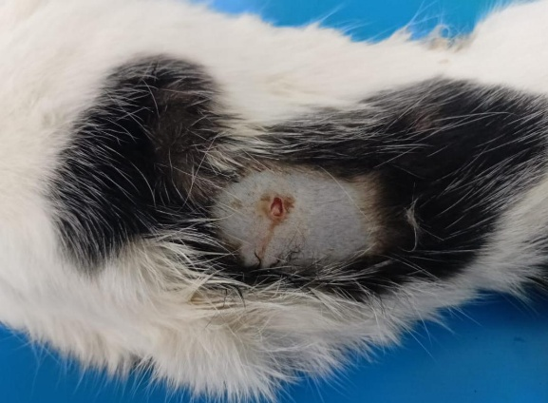
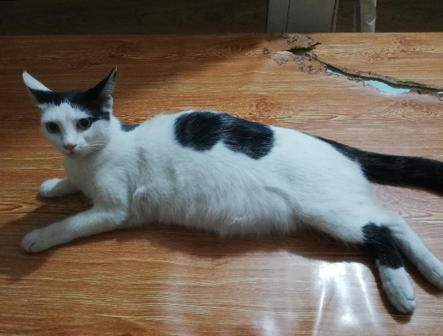

Fig1: A DSH cat with a history of dog bite admitted to TTPHRC
2.2: Case diagnosis
Clinical examination reveals an increased temperature, rapid respiration, and pulse rate. Bony-like structures were felt on both the left and right sides of the lower abdomen during the abdominal ballottement test. No fetal heart beat was detected by auscultation as well as abdominal ultrasonography (USG). After USG, it was confirmed that there were two fetuses in each uterine horn without any fetal movement. Then, during an X-ray examination, it was discovered that the spinal cord had been discontinued due to a dog bite in the middle of the vertebral columns, and a gas-filled tubular structure was discovered in the abdominal region. Therefore, the case was diagnosed as dystocia with an emphysematous condition in the uterus due to spinal paraplegia as the result of a dog bite injury. Finally, an ovariohysterectomy was decided to prevent further development of maternal toxemia or septicemia.

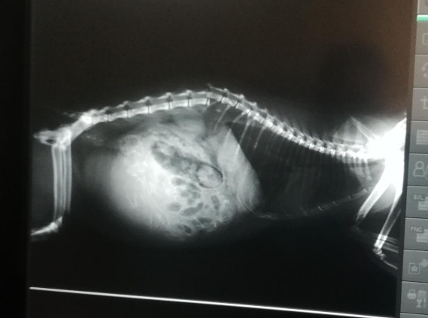
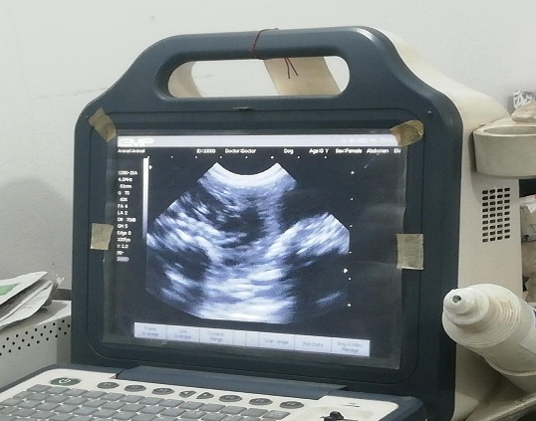

Fig2: Clinical examination through X-ray &Ultrasound
2.3: Restraining and anesthesia
In the beginning, the queen was received an intramuscular injection of the pre-anesthetic drug Xylazine Hydrochloride solution @1 mg/kg body weight (Inj. Xylazine®, Indian immunological Ltd. India). General anesthesia (GA) was induced after 10 minutes by intravenous injection of ketamine hydrochloride @10 mg/kg body weight (Inj. Ketalar®, Popular pharmaceuticals). In less than 20 minutes, anesthesia was achieved. The cat was then moved to the operating table, held in the dorsal recumbence posture, and had its bladder manually compressed empty since an enlarged bladder could make it difficult to locate and extract the uterus. Following that, ropes were used to secure the limbs. The mouth was shut and a tongue forcep was used to draw the tongue out to the side. Through vascular cannulation, 50 ml of 0.9% isotonic NaCl were administered.

\

2.4: Surgical techniques
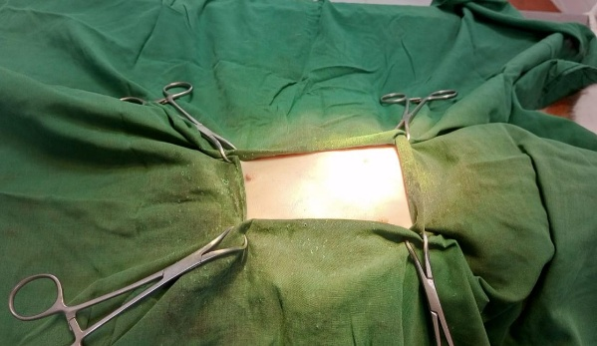
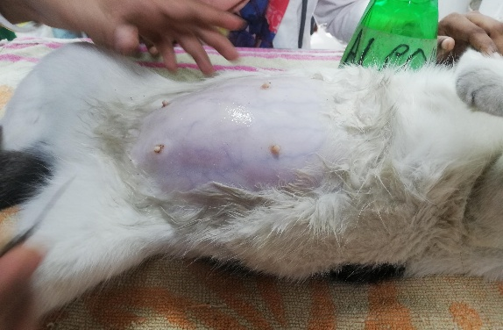
The animal was initially ready for aseptic surgery. To stop microorganisms from entering the operating room, asepsis is a need. The Operating area was cut, shaved, and disinfected for two to three times with 10% povidone iodine and 70% alcohol, respectively. The surgical site was covered with a sterile draper. 2-3 cm caudal to the umbelicus, a 4-5 cm laparotomic midline incision was made. Then the skin, subcutaneous tissue, linea alba, peritoneum were all successively excised. By adding gauge pressure, the bleeding was checked. A finger was used to locate the uterus, and then the uterus was removed from the cavity. There is one fetus in each uterine horn. A distal vessel was tied off after the left ovary was gripped with an artery forceps. The ligature’s connection to the ovary was then severed. The right ovary was operated in the same way. Around the cervix, catgut 1-0 was used to create a secure ligature. By using sterile scissors and sterile artery forceps to crush the structures around the uterus, such as the mesovarium and mesometrium, the uterus was freed from their attachment. The uterus was separated from the cervix by 1 cm cranially according to overiohysterectomy protocol. Crushing was done to stop bleeding. We carefully examined the abdominal wound for any signs of hemorrhage before closing it. The skin was closed by placing cross mattress with silk threads, and the peritoneum, muscle, and subcutaneous tissue were sutured using simple continuous suture with catgut 1-0. The suture site was next appropriately secured with povidone iodine cream(cream viodin®, Square Pharmaceutical Ltd.) & sterile surgical tape.

Fig3: Lying the cat at dorsal recumbent position &operation site covered with surgical drape.
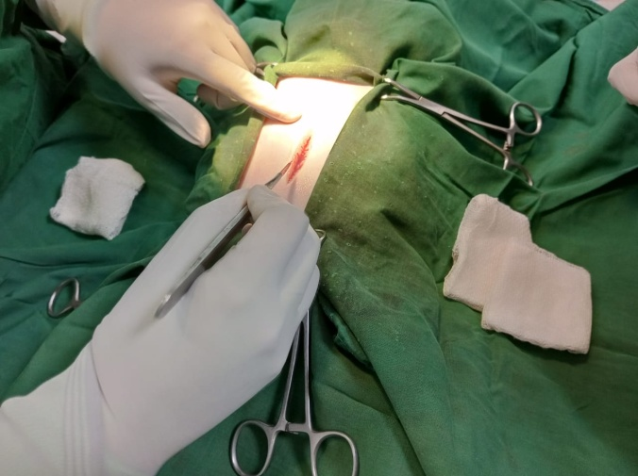
Fig 4: Incision caudal to the umbelicus
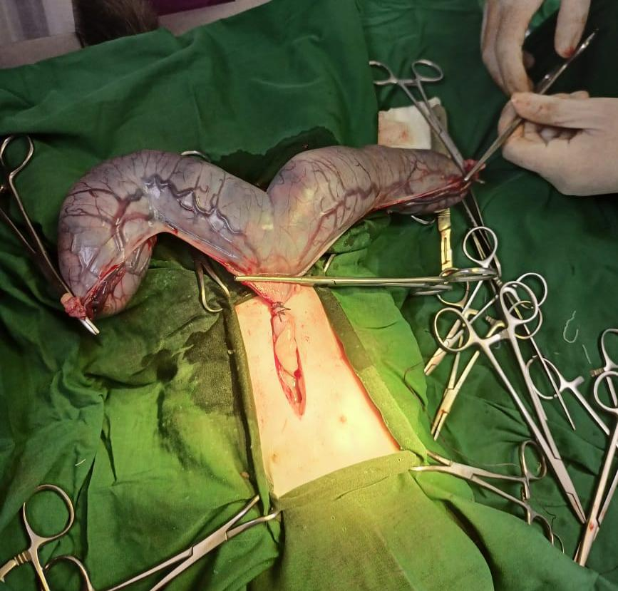
Fig 5: Ligating the uterus at the base of the uterine body.
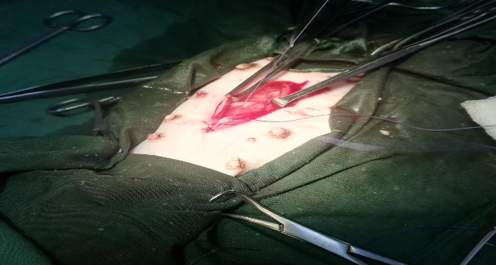

Fig 6: closing of wound by suture

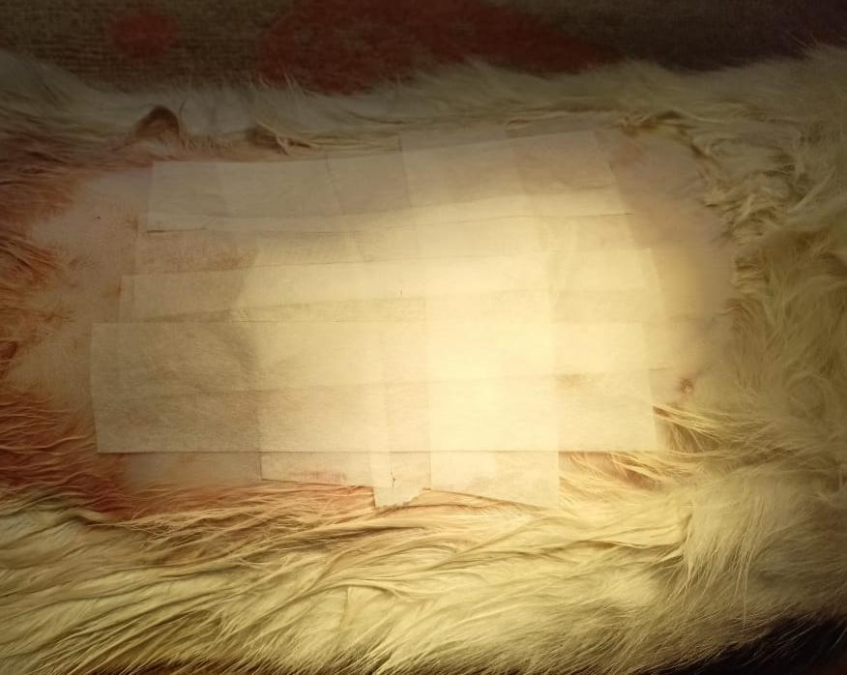
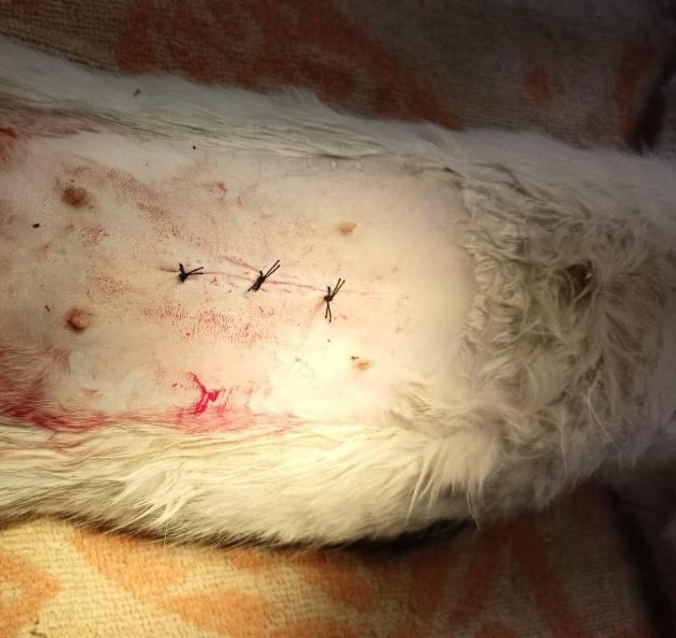

Fig 7: External suture on skin, Application of viodin & closed with sterile tape
2.5: Post operative care
Following surgery, the injectable antibiotic ceftriaxone was given daily for 7 days at a dose of 50 mg/kg body weight (Inj. Trijectvet 1gm®, SK+F Pharmaceuticals, Bangladesh). Antihistaminic pheniramine maleate was given intramuscularly every day for seven days at a dose of 1 mg/kg body weight (Inj. Astavet®, Acme Laboratories Ltd., Bangladesh). Meloxicam, an analgesic, was injected subcutaneously five days a week at a dosage of 0.2 mg/kg body weight (Inj. Melvet®, Acme Laboratories Ltd., Bangladesh) to manage pain. Additionally, 100 mg of vitamin C was given orally once a day for 15 days. To restore the stressed or anxious nervous system, Inj. Neuro B @200mg orally once daily for one month was administered. The bite wound site was properly cleaned & viodine ointment was applied. The owner was advised to keep the patient in a clean squeeze cage & to put a Elizabethan collar on mouth to prevent licking on the operated site. As paralyzed on the hind quarter side there might develop difficulty in normal defecation and micturation. In that case itwas suggested to the owner to assist her by applying gentle pressure on the abdomen. Other activities like feeding, drinking was normal. The surgical site was properly healed and the sutures were removed on the fourteenth days of post operation. The owner was suggested to provide physiotherapy like heat & massage to improve circulation &promote healing.

Chapter 3: Discussion
This report describes a heavily pregnant domestic short hair cat suffered severe dog bite wound on the spinal region causing paralysis of hind quarter. Due to paralysed hind quarter the patient was unable to deliver in normal process. When it brought to TTPHRC after examination it was found that there was no fetal movement & gas filled the uterus. Moreover, a foul smelling vaginal discharge, dullness, depression & anorexia was developed indicating maternal toxaemia. The cat was exhausted & was in severe pain. All these factors led us to perform an immediate overiohysterectomy to save the life of the dam.
After ovariohysterectomy, the uterus was incised by us to see the inner condition of the uterus. There were two dead fetuses. The fetuses were looked relatively larger in size. Gas was accumulated in the subcutaneous tissue of the fetuses, this condition known as emphysema. A foul odour was coming from the uterus. The color of uterine wall & fetuses was strongly indicating that gas forming bacteria infected the uterus. Emphysematous pyometra is a rare condition in canine & feline where the uterus becomes infected with gas-forming bacteria, resulting in a buildup of both gas and infectious exudate in the uterine lumen. Staphylococcus spp., Pseudomonas aeruginosa, Citrobacter diversus, Clostridium perfringens, and Enterococcus spp. were found in previous cases of emphysematouspyometra (Mattei et al., 2018).
Dog saliva harbors various types of microorganisms which can cause mild to severe infection to mammals. In this case, due to dog bite the cat was suffered from stress & pain & due to stressed condition gas forming bacteria accumulate in the uterus which ultimately causes death of fetuses.
The incidence of dystocia in cat fortunately is rare than other animals (Talukder et al., 2021). Most of the cause of dystocia in cat is related to maternal or fatal cause (Stedile et al., 2011).The only reports of extrauterine dead fetuses in cats after dog bite wounds come from Tirgari (1986) and Palmer (1989).Uterine rupture is reported to happen more frequently in cats than in dogs, either as an incidence or as a result, contrary to a previous report (Webb, 1972); external abdominal injuries (Godfrey 1997), or as a result of dystocia or a subsequent sickness (Hayes, 2004).There is no published report on the diagnosis and management of spinal paraplegia-induced dystocia in cats in Bangladesh.Spinal injury cause severe damage to the nervous system. Nerve & muscle receptor don’t work efficiently. Motor nerve harm in result of spinal paralysis cause dystocia by interfering uterine contractions; in this case, overiohysterectomy is suggested to be the best tactics by veterinary practitioner to the cat owner (Salci et al., 2020).
In our reported case, as the uterus was heavily infected & the cat was unable to do normal delivery due to paralysis it was decided to do ovariohysterectomy instead of C-section immediately to prevent development of maternal toxaemia or septicemia.
Finally, we carried out a successful ovariohysterectomy in a local domestic short hair cat for the first time suffering from dog bite complications such as spinal paralysis, stress &severe infection in uterus causing death of fetuses & dystocia. This ovariohysterectomy enabled delivery of two dead emphysematous fetuses & thereby saved the life of the mother.
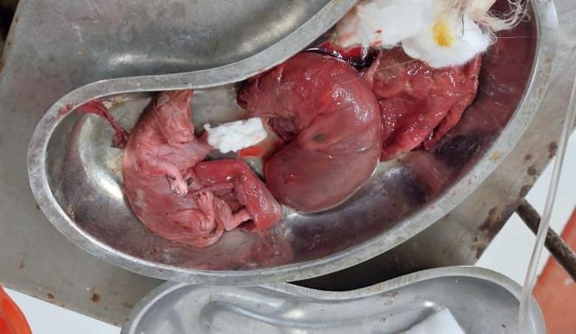

Fig 8: Two dead emphysematous fetuses was removed

Conclusion
Although dog bites may seem insignificant, if they are not treated properly, they can grow infected and cause harmful systemic problems, as was the case in our case. Patients with high-risk bite wounds and those who are susceptible to severe wound infection complications should start receiving antibiotic prophylaxis. In this instance, poor initial care and a delay in taking the animal to the vet clinic led to a severe uterine infection and an untimely loss of the fetus.

Reference

Dubey A, Tomar S, Gupta A, Khandelwal D. 2018. Delayed paraplegia in an adult patient with spinal cord injury without radiographic abnormality of dorsal spine: A lesson learned. Asian Journal of Neurosurgery. 13(3): 867.
Godfrey DR. 1997. A case of uterine rupture with complete division of the uterus and associated secondary ectopic fetus in a cat. Feline practice (Santa Barbara, Calif.: 1990) (USA).
Hayes G. 2004. Asymptomatic uterine rupture in a bitch. Veterinary Record. 154(14): 438-439.
Holt DE, Griffin G. 2000. Bite wounds in dogs and cats. Veterinary Clinics: Small Animal Practice. 30(3): 669-679.
Jackson, P.G., 1995. Postparturientmanagement. Handbook of veterinary obstetrics. 2nd Edn. WB Saunders. pp. 374
Kim J, Kim JH, Bang MS. 2013. A case report of spinal cord injury patient from a high velocity gunshot wound to the lumbar spine. Annals of rehabilitation medicine. 37(1): 118-122.
Kimura R, Hayashi Y, Takeuchi T, Shimizu M, Iwata M, Tanahashi J, Ito M. 2004. Pasteurella multocida septicemia caused by close contact with a domestic cat: case report and literature review. Journal of Infection and Chemotherapy. 10(4): 250-252.
Kumru IH, Seyrek-Intas K, Tuna B, Celimli N, Seyrek-Intas D. 2007. Severe abdominal dog bite wounds in a pregnant cat. Journal of feline medicine and surgery. 9(6): 499-502.
Ghaffari MS, Dezfoulian O, Moosakhani F.2008. Dog-bite induced fatal meningitis in a kitten: a case report.Iranian Journal of Veterinary Research. 9 (4): 381-383
Mattei C, Fabbi M, Hansson K. 2018. Radiographic and ultrasonographic findings in a dog with emphysematous pyometra. Acta Veterinaria Scandinavica. 60(1): 1-5.
Mittal MK Rabinstein AA. 2012. Spinal cord meningioma: a treatable cause of paraplegia. Journal of Clinical Medicine Research. 4(4): 286.
Nelson RW, Couto CG. 2003. Small animal internal medicine. 2nd Edn. Mosby, St. Louis. pp.1014
Palmer, N.E., 1989. Ectopic pregnancy in a cat. Veterinary Record (UK). 125(1): 24

Rossier AB. Ruffieux M, Ziegler WH. 1969. Pregnancy and labour in high traumatic spinal cord lesions. Spinal Cord. 7(3): 210-216.
Sahoo AK, Nath H, Nahak A, Behera SS, Parija D, NayakS. 2018. Surgical management of dystocia due to secondary uterine inertia in dog-case report. EC Veterinary Science. 3(1): 260-265.
Salci ESO, Guner B, Volkan IPEK. 2020. Dystocia Caused by Spinal Paraplegia in a Cat with Superfetation. Kafkas Universitesi Veteriner Fakultesi Dergisi.26 (6): 839-840
Stedile R, Oliveira ST, Muccillo MDS, Contesini EA, Beck CDC. 2011. Dystocia in a cat due to an ectopic artery. Veterinary Record, 169(21):10-1136.
Takahashi M, Ogawa J, Kinoshita Y, Takakura M, Mochizuki K, Satomi K. 2004. Experimental study of paraplegia caused by spinal tumors: an animal model of spinal tumors created by transplantation of VX2 carcinoma. The Spine Journal. 4(6): 675-680.
Talukder AK, Das ZC, Rahman MA, Rahman MT, Rahman AN. 2021. Caesarean section followed by ovariohysterectomy in a Bangladeshi domestic cat: A surgical intervention for management of dystocia due to partial primary uterine inertia. Veterinary Medicine and Science. 7(5): 1564-1568.
Webb AI. 1972. Ventral hernia and ruptured uterus in a cat. Australian veterinary journal. 48(4): 212-214.

Acknowledgement
First of all I would like to express my deepest sense of gratitude to Almighty ALLAH for providing me strength and sound health to finish my research and finally could write this clinical report.
I would like to thank my supervisor, Prof. Dr. Kh. Nurul Islam, Department of Anatomy & Histology, Faculty of Veterinary Medicine, CVASU for his excellent guidance, cordial support and constant encouragement throughout of my research period.
I am also grateful to Prof. Dr. Goutam Buddha Das (VC, CVASU) and Prof. Dr. Mohammad Alamgir Hossain (Dean, Faculty of Veterinary Medicine), Prof. Dr. A.K.M Saifuddin (Director, External Affairs) of CVASU.
I am grateful to the director, Teaching & Training Pet Hospital and Research Center, CVASU, Dhaka for providing me clinical support during my research period.
I would like to acknowledge the support and cooperation of DR. Mir Md. Afzal Hossain (VS, TTPRC), pet owner for their continuous encouragement and motivation during research period.
Last but not the least; I would like to thank my family members and friends for their constant inspiration and blessings throughout the entire period of academic life.

Biography
Jannatul Naima, the author of this manuscript, was born on October 4, 1998, in Chattogram, Bangladesh. She passed the Secondary School Certificate (SSC) in 2014 and the Higher Secondary Certificate (HSC) in 2016. Afterwards, she admitted a Doctor of Veterinary Medicine (DVM) course at Chattogram Veterinary and Animal Sciences University (CVASU), Chattogram, in 2017, and is currently enrolling as an intern student of the Faculty of Veterinary Medicine at Chattogram Veterinary and Animal Sciences University. She has received hands-on training in various clinical management in the field, as well as various intern educational placements throughout Bangladesh. As a future veterinarian, after completing her DVM degree, she would like to be a researcher, pursue higher studies in the field of public health and animal health, and try to make the world a better place for sustainability with her clinical as well as research knowledge and skills.

