Spaying of a rabbit in Raaz Pet Care, Chattogram: A Case Report
By:
Iqbal Hossain
Roll No.: 17/40; Reg No.:01869
Intern ID: 32
Session: 2016-2017
A clinical report submitted in partial satisfaction
of the requirements for the degree of

Doctor of Veterinary Medicine

Faculty of Veterinary Medicine

Chattogram Veterinary and Animal Sciences University
Khulshi, Chattogram-4225, Bangladesh

November, 2022

Spaying of a rabbit in Raaz Pet Care, Chattogram: A Case Report

Approved By:

Dr. Mohammad Mahbubur Rahman
Professor and Head
Department of Pathology and Parasitology
Faculty of Veterinary Medicine
CVASU

Faculty of Veterinary Medicine

Chattogram Veterinary and Animal Sciences University
Khulshi, Chattogram-4225, Bangladesh
November, 2022

Contents
List of contents Page No.
Abstract…………………………………………………………………………… iv
Chapter 1: Introduction………………………………………………………….. 1-2
Chapter 2: Materials and Method………………………………………………. 3-7
Chapter 3: Results and Discussion………………………………………………. 8
Chapter 4: Concclusion…………………………………………………………... 9
Refeerences………………………………………………………………………... 10
Acknowledgements……………………………………………………………….. 11
Biography…………………………………………………………………………. 12

List of figures

Figure No. Page No.
Figure 1…………………………………………………………………………….. 4
Figure 2…………………………………………………………………………….. 5
Figure 3…………………………………………………………………………….. 5
Figure 4…………………………………………………………………………….. 6
Figure 5…………………………………………………………………………….. 7
Figure 6…………………………………………………………………………….. 7

Abstract

The plan of this case study was to perform the standard surgical method of rabbit spaying. A local breed female rabbit, 8 months old and weighing 2 kg, was brought to Raaz Pet Care in Chattogram for spaying to reduce its aggressiveness and prevent reproduction. Under the anesthetic effects of xylazine and ketamine, the surgery was performed using a standard open surgical approach. The average surgical procedure took 45 minutes from incision to suture. After the successful operation, the rabbit was kept in a clean squeeze cage for seven days. In addition, povidone iodine ointment was used until the wound was completely healed. No post operative complications were observed during the patient's follow-up. This surgical procedure for rabbit spaying was simple, inexpensive, and highly effective.

Keyword: Spaying, Rabbit, Open surgical technique

Chapter 1: Introduction

Spaying or neutering is a common surgical procedure in domestic animals from ancient times. Both male and female rabbits are neutered or spayed to prevent breeding and unwanted behaviors. Spayed or neutered rabbits are also more friendly and affectionate toward their pet owner. Spaying and neutering our bunnies often eliminates their deeply ingrained desire to reproduce by altering their hormonal response, which is a huge step toward improving unwanted behaviors. During an ovariohysterectomy (OHE), also known as spaying, the female reproductive tract is completely removed. Spaying an animal not only prevents it from becoming pregnant, but it also prevents it from going into heat twice a year. Spaying is the most important surgery in proper pet care. With the exception of animals used solely for breeding or displaying, every pet should be spayed. Any pet who has access to the outdoors should be spayed or neutered to avoid an unexpected pregnancy.
The most common procedure on domestic pets like dogs and cats is ovariohysterectomy (OHE). However, there are numerous species of wild rabbits found all over the world. Ovariohysterectomy is one of the most routinely performed major abdominal surgeries in the veterinary practice (Pearson, 1973; Jason, 2009). Ovariohysterectomy (OVH) is an irreversible technique that is used for the sterilization of female animals (Kirsan et al., 2013) where surgery was done under proper general anesthesia and sterile operating technique (Virginia et al., 2012). This is usually done by a small incision on her left-hand side and can also be done underneath along her midline (Machado et al., 2012). Spaying is done for the prevention of reproduction and making docile the animal. It is also done to protect them from certain diseases (Janssens and Janssens, 1991). Spaying is the most common among elective surgeries (Pollari and Bonnett, 1996).
Technically, once a female reaches sexual maturity, which between the ages of three and six months, she can safely undergo her respective procedures. Depending on the rabbit's size, breed, and current health, a veterinarian may advise waiting until the rabbit is a little older. Spaying can be performed using either an open or laparoscopic approach. Due to the high cost of laparoscopic surgical equipment, the open approach to spaying is widely used. The size of the incision is determined by the surgeon and the animal's size. The procedure is carried out through a small incision in the midline of the abdomen, just below the umbilical area. Prior to surgery, the hair in this area will be shaved and surgically prepared. Ovaries and uterine horns are both removed. Several layers of sutures will be used to close the surgical incision (muscle and skin).
As a result, the purpose of this case report is to carry out and evaluate the traditional surgical technique of rabbit spaying in order to make it a powerful tool of birth control. It has some immediate or short–term surgical complications that include hemorrhage from uterine and ovarian vessels, anesthesia accidents, tissue reaction to suture material, wound infection (self-licking), evisceration or delayed healing (Pearson, 1973; Muir et al., 1991; Burrow and Batchelor, 2005).

Objective:
1. To perform and evaluate the traditional surgical technique of rabbit spaying.
2. To determine the pre and post anesthetic risks of a spayed doe.

Chapter 2: Materials and Method

2.1 Case history and description:
On 26th September 2022, A female local breed rabbit, 8 months old and weighing 2 kg, was brought to Razz Pet Care in Chattogram. It was difficult to handle, and the owner wishes to halt reproduction due to a lack of space in her home. The owner wished to spay the rabbit in order to reduce its aggression and prevent reproduction. A general examination revealed that it was in good health, with a respiratory rate of 40 beats per minute (normal) 160 beats per minute heart rate (normal), no dehydration, and pink mucous membrane. In this case, no blood tests or ultrasonography were performed.

2.2 Anesthesia and control:
Both physical restraint and pharmacological restraint were used on the rabbit. For 12 hours, the rabbit was kept in a fasting state. As a pre-anesthetic, 5mg/kg body weight xylazine hydrochloride (inj. xylazine®@Indian immunological ltd, India) was administered intramuscularly. The dose is 5mg/kg body weight, depending on the animal's condition. After proper shaving, the surgical site was aseptically prepped for the procedure. After premedication, ketamine hydrochloride (Inj.G-ketamine®, Gonoshasthayapharmaceuticals ltd, Bangladesh) was administered intravenously at a dose rate of 30mg/kg body weight. During the surgery, the maintenance an aesthetic dose was half of the original dose. During operation, 3ml/min of normal saline was administered intravenously.

2.3 Instruments and appliances used for aseptic surgery:
For aseptic surgery at first sterilized all basic instruments and appliances by autoclave at 121ºC temperature, 15lb pressure/inch for 15 minutes.

2.4 Operation procedure:
Before beginning the operation, we first developed a treatment plan. We wanted to make sure the bunny was secure. We utilize a common surgical pack that has been sterilized at 121 degrees Celsius. We provided proper anesthesia, ensured proper dose maintenance, and maintained a sterile atmosphere during the operation. The surgery site was correctly shaved. The area was delineated off from the pelvic area to the upper part of the umbilicus. A landmark was made using the umbilicus. After shaving, the incision site was carefully sterilized with povidone iodine and alcohol.

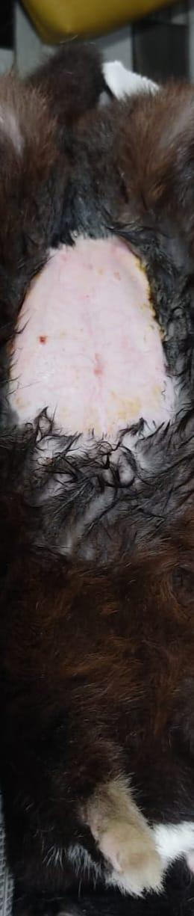

Figure 1: Clipping and shaving the area

After being appropriately positioned and towel clamped, the artificial drapes were cut. A 2-3 cm behind the umbilicus midline incision was made. By using artery forceps and gauge pressure, the bleeding was examined. To avoid cutting the undesirable muscles, a precise incision was created through the body's midline. Following a muscle incision, the two pieces were pushed in opposite directions using Allis forceps while the peritoneum was still in situ.
In that order, incisions were made in the skin, subcutaneous tissue, muscle, and peritoneum. After all layers were completed, the surgeon's index finger was introduced toward the left flank into the abdominal cavity, uterine horn, and broad ligament to remove it outside the incision.

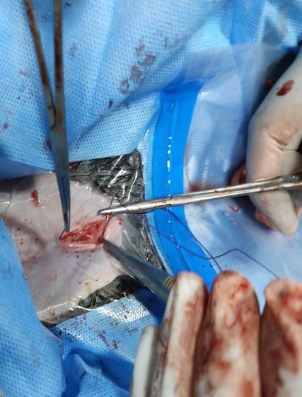

Figure 2: Cut the landmark area

The peritoneum was carefully cut. The ovaries were then located and removed using a finger that was inserted into the peritoneum. Ovaries were discovered following the uterine horns to their ends after the uterine horns were detected by fingers.

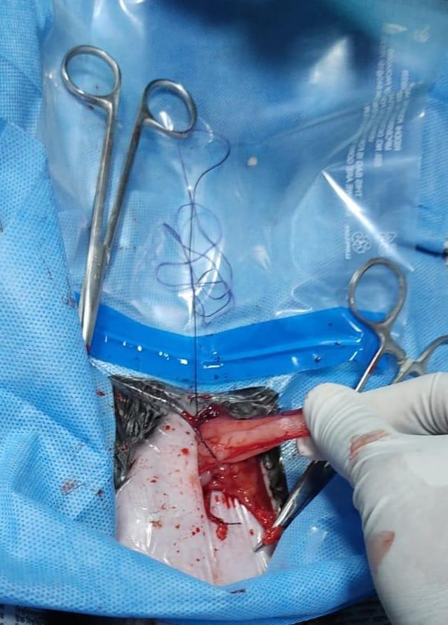

Figure 3: Ligating the uterus
The ovary was griped between the thumb and index finger and retrieved for ligation. Manual tension with the finger ruptured the suspensory ligament of the ovary. After passing the ovary, two ligations were employed in the vascular and avascular portions. A pair of artery forceps and a scalpel were used to remove the ovaries. After the uterine body had been sutured, it was then removed. By making a wide incision in the broad ligament with fingers, the ovaries connection and its blood vessels were exposed. A double chromic catgut ligation was used to ligate the ovarian pedicle. The attachments of the ligature and the ovary were separated.
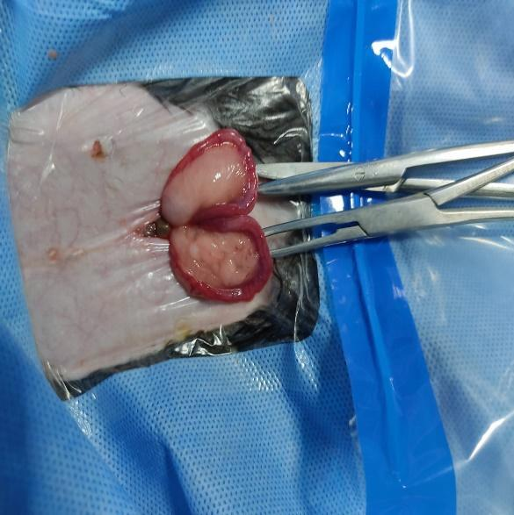

Figure 4: Grapsed and ligate the ovary.

After removing one ovary, another was discovered and removed in the same way. The body of the uterus was extracted from the abdomen. The uterine vessels were split and ligated on each side. Following that, the uterine stump was meticulously checked to rule out any bleeding. The abdomen was checked for bleeding. The remainder were pushed back into the peritoneum after the uterine body was severed. The peritoneum and muscular layers were sutured with catgut in a straightforward continuous pattern (1-0). Catgut was used to stitch the subcutaneous layer in a subcuticular pattern (1-0). Simple interrupted sutures made of nylon were used to stitch up the skin.

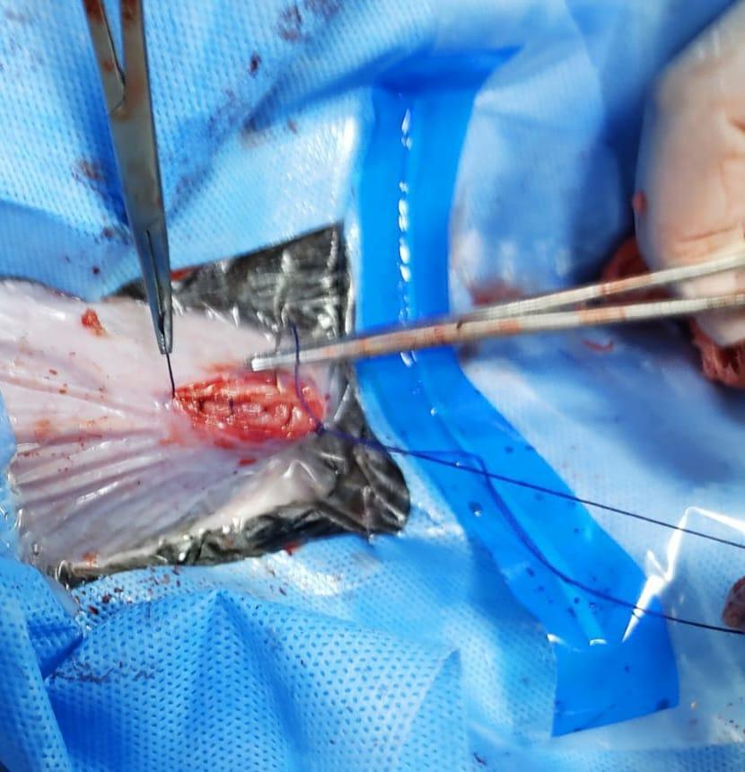

Figure 5: Suturing muscles layers by simple continuous pattern

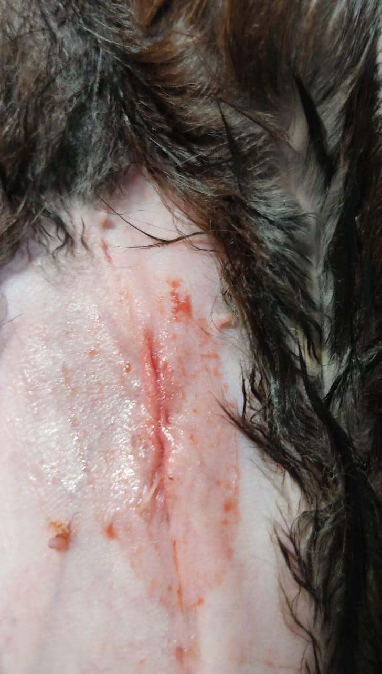
The peritoneum, muscles, and fascia were all sutured separately in a basic continuous suture pattern using 1-0 catgut. The skin was subsequently sutured with non-absorbable nylon suture material horizontal mattress sutures, followed by 2-0 catgut subcuticular suture.

Figure 6: After completing surgery, we were provided povidone iodine.

2.5 Post-operative treatment and care:
For 5 days following surgery, the antibiotic ceftriaxone @ 20mg/kg body weight (Inj. Ceftron IM 250mg) was injected intramuscularly. For 5 days, antihistaminic pheniramine maleate @ 0.5 mg/kg bwt (Inj. Alerin 10ml) was injected intramuscularly. Meloxicam at 0.2 mg/kg bwt (Inj. Mel vet 10ml) was used as an analgesic for three days. It was suggested that the animal be kept in a clean squeeze cage and observed for 7 days. The owner was advised to apply antiseptic povidone iodine ointment on the incision site until it healed completely.
Chapter 3: Results and Discussion

The operation was performed successfully because the rabbit recovered fast from anesthesia and there were no complications. There was minimum bleeding during the operation. The animal was returned home after recuperating from anesthesia and getting a prescription for systemic antibiotic medication for the next five days.

Spaying an animal can restrict reproduction and make it docile, according to a previous study (Janssens and Janssens, 1991). Spaying may also help prevent uterine infection, uterine cancer, and other reproductive system cancers. In this study, the owner of this rabbit sought to neuter it to reduce its aggressiveness and prevent reproduction.
The surgery is carried out while the patient is sedated. The abdomen's hair is cut and surgically cleansed. In the case of dogs and cats, a tiny incision is made along the midline, where there are fewer blood veins (Jason, 2009). The same procedure was used in this investigation when it came to spaying.
A generic surgical pack is used to find the uterus and uterine horns. The uterus and ovaries are removed completely, and the blood arteries are closed. After suturing the inside body wall using absorbable suture material, the exterior skin layer was closed. The similar strategy was followed in this inquiry.
Close observation and the provision of supplemental heat, fluids and stimulation can help to avoid postoperative complications. The most common complication is anesthetic overdose, which can be avoided by using the safest anesthetics and the smallest amount required.
There is still no published research on the use of spaying as a method of birth control. So, the goal of this study to educate the public on the spaying procedure so that they can easily control the rabbit population. It will also benefit animal welfare.

Chapter 4: Conclusion

Spaying a rabbit is a tried-and-true surgical treatment that has proven to be the most effective. There were no issues with the spayed rabbit’s follow-up in this inquiry. Spaying is a common surgical treatment intended to reduce the aggressiveness of a field condition and to prevent reproduction. More research is recommended to make the procedure easier. This paper will assist field veterinarian and pet owner in understanding how they control their pet population. Finally, we can conclude that spaying is a completely safe method of birth control.

References

Janssens, L.A.A., Janssens, G.H.R.R. 1991. Bilateral flank ovariectomy in the dog- surgical technique and sequelae in 72 animals. J. Small Anim. Pract. 32: 249-252.
Kirsan I., Enginler S. o., Toydemir T. S. F., Erzengin O. M., Sonmez K., & Sennazl G. 2013. Gynaecological complications following improper ovariohysterectomy in a dog. Int. J. Vet. Sci. 2(4):121-124.
Machado, S.M.A., Toniolloll, K.G.H., Freitas, C.C.D., &Veloso, B.C.Q.M. 2012. Pure-transvaginal natural orifice transluminal endoscopic surgery (NOTES) ovariohysterectomy in bitches: a preliminary feasibility study. Ciência Rural. 42(7): 1237-1242.
Pollari, F.L., Bonnett, B.N. 1996. Evaluation of postoperative complications following elective surgeries of dogs and cats at private practices using computer records. Canadian Vet. J. 37: 672-678.
Pearson H. 1973. The complications of ovariohysterectomy in the bitch. J. Small Anim. Pract. 14: 257-266.
Virginia, H.P, Adriano, B.C, Carlize, L., Martielo, I.G., Daniel, C.M.M., & Clarissa, D.G 2012. Epidural anesthesia and postoperatory analgesia with alpha-2 adrenergic agonists and lidocaine for ovariohysterectomy in bitches. Canadian J. Vet. Res. 76: 215–220.

Acknowledgements

Naturally, the almighty, omniscient, and all-powerful Almighty "Allah," to whom all praise is due, deserves thanks for enabling the author to successfully write this text. The author is indebted to his honorable teacher and internship supervisor, Professor Dr. Mohammad Mahbubur Rahman Department of Pathology and Parasitology, Chattogram Veterinary and Animal Sciences University for his academic guidance, sympathetic supervision, helpful advice, ongoing inspiration, radical investigation, and constructive criticism in all phases of study. The author is speechless in his expression of gratitude, respect, and immense indebtedness to Professor Dr. Mohammad Alamgir Hossain, Dean of the Faculty of Veterinary Medicine at Chattogram Veterinary and Animal Sciences University, the author would like to express his sincere gratitude and admiration. Special thanks to my honorable Professor Dr. AKM Saifuddin, Department of Physiology, Biochemistry and Pharmacology. The author also thanks his parents and friends for their support throughout the writing of this content and for their inspiration.

The Author
Iqbal Hossain
November, 2022

Biography

Iqbal Hossain, the author, is Mohammad Yasin and Aradhoni Begum's son. He resides in Kabirhat, Noakhali. He earned his S.S.C. from Chaprashir hat High School in Noakhali in 2014 and his H.S.C. from Noakhali Govt College in Noakhali in 2016. He was accepted to the Doctor of Veterinary Medicine program at Chattogram Veterinary and Animal Sciences University for the 2016–2017 academic year. He is a veterinary medicine faculty intern student at the moment. He is really keen to become a researcher and an accomplished veterinarian in the future.

