Quality Analysis of Chia Seed Bread and Its Effect on the Glycemic Index.

Akib Ziauddin Chowdhury
Roll No.: 0119/14
Registration No : 672
Session: 2019-2020

A thesis submitted in partial fulfillment of the requirements for the degree of Master of Science in the Department of Applied Food Science and Nutrition.

Department of Applied Food Science and Nutrition
Faculty of Food Science and Technology
Chattogram Veterinary and Animal Sciences University
Chittagong-4225, Bangladesh

June, 2022

Authorization
I thus declare that I am the thesis's single author. I also give Chittagong Veterinary and Animal Sciences University (CVASU) permission to lend this thesis to other organizations or individuals for academic research purposes. I also give the CVASU permission to photocopy or otherwise reproduce the thesis, in whole or in part, at the request of other institutions or people for scholarly research.
Within the limitations of the technology available, I, the undersigned and author of this work, declare that the electronic copy of this thesis delivered to the CVASU Library is an accurate copy of the print thesis submitted.

Akib Ziauddin Chowdhury
June, 2022

Quality Analysis of Chia Seed Bread and Its Effect on the Glycemic Index.

Akib Ziauddin Chowdhury
Roll No.: 0119/14
Registration No: 672
Session: 2019-2020

This is to certify that we have examined the above Master’s thesis and have found that is complete and satisfactory in all respects and that all revisions required by the thesis examination committee have been made

------------------------------------------- | ---------------------------------------------
Supervisor  Dr. Jannatara Khatun  Professor  Department of Animal Science and Nutrition  Faculty of Veterinary Medicine | Co-supervisor  Mohammad Mozibul Haque  Assistant Professor  Department of Applied Food Science and Nutrition  Faculty of Food Science and Technology

-----------------------------------------------
Chairman of the Examination Committee
Ms. Kazi Nazira Sharmin
Associate Professor
Department of Applied Food Science and Nutrition
Faculty of Food Science and Technology
Department of Applied Food Science and Nutrition
Chattogram Veterinary and Animal Sciences University
Chittagong-4225, Bangladesh
June, 2022
PLAGIARISM VERIFICATION

Title of the Thesis: Quality Analysis of Chia Seed Bread and Its Effect on the Glycemic Index..
Name of the student: Akib Ziauddin Chowdhury
Roll number: 0119/14
Reg. number: 672
Department: Applied Chemistry and Chemical Technology
Faculty: Food Science and Technology
Supervisor: Dr. Jannatara Khatun

For office use only
This is to report that as per the check 3.66% of the content thesis is stated to be plagiarized and covered/ not covered as per plagiarism policy and institutions issued from CASR, Chattogram Veterinary and Animal Sciences University.

The thesis may/may not be considered for the evaluation.

Dr. Jannatara Khatun
Professor
Department of Animal Science and Nutrition

Acknowledgment
All praise is to Almighty Allah for bestowing upon me the strength, aptitude, and patience necessary to pursue higher education and complete the thesis for the degree of Masters of Science (MS) in Applied Dietetics and Nutrition at Chittagong Veterinary and Animal Sciences University (CVASU) in Chittagong, Bangladesh. Professor Dr. Goutam Buddha Das, Vice-Chancellor, Chittagong Veterinary and Animal Sciences University (CVASU), deserves special thanks for offering such study opportunities and facilities. Dr. Jannatara Khatun (Professor, Department of Animal Science and Nutrition, Faculty of Veterinary Medicine, Chittagong Veterinary and Animal Sciences University, Chittagong, Bangladesh) is my key adviser and research supervisor, and I am grateful for her assistance and moral support. Her unwavering support, kindness, helpful recommendations, constructive criticism, consistent encouragement, and inspiration helped me overcome all obstacles during my research and thesis preparation. I am delighted to convey my gratitude and profound obligation to Professor Md. Ashraf Ali Biswas, Dean, Faculty of Food Science and Technology, and all of my renowned professors for their kind cooperation, helpful suggestions, and constructive criticism throughout the study time and thesis work. I'm also grateful to my Co-Supervisor, Mohammad Mozibul Haque, Assistant Professor (Department of Applied Food Science and Nutrition), for his enthusiastic support and encouragement throughout my research and analytical efforts. I'd like to express my gratitude and appreciation to the Ministry of Science and Technology of Bangladesh for providing me with a National Science and Technology (NST) Fellowship for the 2019-2020 academic year, as well as the Research and Extension of Chittagong Veterinary and Animal Sciences University, Bangladesh, for the financial assistance provided during my studies. I'd want to convey my heartfelt gratitude to my beloved friends and well-wishers for their support, encouragement, and inspiration throughout my research. I also want to express my gratitude to my loving parents and family members for their patience, spiritual support, kindness and blessings, forbearance, and unending love in helping me finish my study.

The Author
June, 2022

Table of Contents
Authorization...........................................................................................................i
Acknowledgement..................................................................................................iv
Table of Contents....................................................................................................v
List of Table............................................................................................................vii
List of Figure .........................................................................................................vii
List of Abbreviation ..............................................................................................viii
Abstract .................................................................................................................iX
Chapter 1: Introduction ......................................................................................01
1.1 Aim of the study...............................................................................................03
Chapter 2: Review of Literature .........................................................................04
2.1 Chia Seed .........................................................................................................04
2.2 Nutrition fact....................................................................................................05
2.2.1 Carbohydrate and Fibre ................................................................................05
2.2.2 Fat..................................................................................................................06
2.2.3 Protein ...........................................................................................................06
2.2.4 Vitamin and Minerals ...................................................................................06
2.2.5 Other Phytochemical ....................................................................................07
2.2.6 Chia seed Provide a lot of health benefit ......................................................07
2.3 Bread and its production method......................................................................09
2.3.1 Bulk fermention or direct dough method ......................................................09
2.3.2 Sponge batter or sponge dough or flour brew................................................09
2.3.3 Chorlywood bread process.............................................................................09
2.4 Research work carried out on chia bread and its effect on glycemic index......09
Chapter 3 : Materials and Method .....................................................................12
3.1 Sources of ingredients of bread.........................................................................12
3.2 Processing of chia seed into powder form........................................................12
3.3 Blend formation and backing ..........................................................................12
3.4 Proximate analysis ...........................................................................................13
3.4.1 Determination of Moisture content ..............................................................13
3.4.2 Determination of Ash content ......................................................................13
3.4.3 Determination of protein content..................................................................14
3.4.4 Determination of fat content.........................................................................15
3.4.5 Determination of crude fiber content ...........................................................15
3.5 Sensory evaluation ..........................................................................................16
3.6 Study of assessing glycemic index .................................................................17
3.6.1 Study subject................................................................................................17
3.6.2 Experimental procedure................................................................................17
3.6.3 Blood glucose and glycemic index determination .......................................18
3.7. Bio-Active Compound Tests...........................................................................18
3.7.1. Determination of Total Polyphenol Content (TPC).....................................19
3.7.2. Determination of Total Flavonoid Content (TFC).......................................19
3.7.3. Determination of Antioxidant Capacity........................................................19
3.8. Amino Acid Profile..........................................................................................20
3.9. Statistical Analysis...........................................................................................21
Chapter 4: Result
4.1 Nutritional composition of whole wheat bread and chia flour treated bread...22
4.2 Sensory evaluation............................................................................................23
4.3 Glycemic index.................................................................................................23
4.4 Amino Acid Contents.......................................................................................27
Chapter 5: Discussion...........................................................................................28
Chapter 6: Conclusion .........................................................................................30
Chapter 7: Recommendation and future perspective .......................................31
References..............................................................................................................32
Appendix 1: Quality standard for bread.............................................................38
Appendix 2: Acceptance Test (Sensory evaluation form)..................................39
Appendix 3: Sensory evaluation panelists work ................................................40
Appendix 4: Criteria for GI determination .......................................................41
Appendix 5: Photo Gallery ..................................................................................42

List of Tables

SL No. | Name | Page No.
01 | Composition of Chia Seed | 05
02 | Proximate Composition of Chia Seed in 100 g | 22
03 | Proximate composition of wheat flour and chia flour treated bread | 22
04 | Hedonic sensory score of the whole wheat and chia flour treated bread samples | 23
05 | Total Polyphenol Content present in different formulations of Chia Seed Bread. | 25
06 | Total Flavonoid Content present in different formulations of Chia Seed Bread. | 26
07 | Antioxidant capacity content (mg/100g) at different treatment effect in Chia Seed Bread. | 26
08 | Amino Acids Concentrations (µmol/mL) in Chia Seed Samples | 27

List of Figures

SL No. | Name | Page No.
01 | Blood glucose response curve for glucose and bread samples | 24
02 | Glycemic index of bread samples | 25

List of Abbreviation

Abbreviations | Elaboration
% | Percentage
°C | Degree Celsius
ALA | Alpa Linolenic Acid
mg | Milligram
g | Gram
EPA | Eicosapentaenoic acid
GI | Glycemic Index
GL | Glycemic Load
FAO | Food and Agricultural Organization
CVASU | Chattogram Veterinary and Animal Sciences University
AOAC | Association of official analytical chemist
SPSS | Statistical package for social science
SCFAs | Short Chain Fatty Acids
DHA | Docosahexaenoic acid

Abstract
Foods with a low glycemic index have been linked to a variety of health benefits. Similarly, due to its high nutritional content, chia-based food products are becoming more popular on the market. The purpose of the research was to develop a high-quality fiber-enriched cereal bread with good fat (omega-3), protein, and a low Glycemic Index (GI) in a healthy human body. In our experiment, chia flour was used to fortify bread. The bread sample's proximate analysis, bioactive compounds, sensory evaluation, and GI value were determined. The value of amino acid of chia seed is also determined. With the addition of chia flour, the bread's crude fiber, crude protein, fat, and ash content gradually increased, with 20 percent chia bread having the highest values of 5.63 percent, 15.80 percent, 4.5 percent, and 3.10 percent, respectively, and control bread having the lowest values of 0.31 percent, 14.39 percent, 1.8 percent, and 2.10 percent, respectively. The sensory examination of bread revealed significant differences in crust, shape, interior texture appearance, or general acceptance, however, the aroma and flavor of the bread samples differed considerably from the control bread. The taste of 20 percent chia substitute bread received a low score of 6.85 and was significantly different from control bread (p<0.05). The GI values of the chia sample bread were reduced by 15% (p<0.05) and 20% (p<0.05), respectively. The average GI values for Control, 10%, 15%, and 20% chia substitution bread were 60.11, 49.31., 44.72, and 38.89, respectively. With the addition of chia flour (10% to 20%) to the bread sample, the Glycemic Index dropped from 18 percent to 35 percent.
When compared to chia-untreated food, the bread made with chia flour was determined to be nutritionally superior.

Keywords: Bread; Glycemic Index Value; Proximate Analysis; Chia; Sensory Evaluation.

Chapter 1

Introduction

Bangladesh, as one of the world's most densely populated countries, has a predominantly cereal-based diet due to the land's topographical and climatic conditions. The most dominant food consumed by people is cereal rice which is followed by wheat. Rice and wheat account for 62% and 54% of the total intake of all foods (Humayun, 1995).
Cereals, cereal-based products, and cereal-based snacks are becoming increasingly popular in Bangladesh. Cereal processing and marketing industries are growing in popularity. Bread is one of the oldest and most traditional bakery items. It is a vital basic food, with stable and rapid growth in consumption. According to the worldwide table of GI and Glycemic Load value, normal bread has a high Glycemic Index (GI) value (GL) (Foster et al., 2002).
As a result, researchers are paying close attention to the enrichment of cereal-based food products with additional fibre and protein-based grains (J.A and O, 2003).

The small size chia seeds are packed with nutrients. Fiber, protein, omega-3 fatty acids, and different types of micronutrients rich in them. Chia seeds have a calorie count of 138 per ounce (28 grams). They are 6 percent water, 46% carbs (of which 83 percent is fiber), 34% fat, and 19 percent protein by weight. Chia seeds contain more than 80% of their carbohydrate content in the form of fiber (Munoz et al., 2013).
Chia seeds contain 11 grams of fiber per ounce (28 grams), which is a substantial component of the Recommended Daily Intake (RDI) for women and men, which is 25 and 38 grams per day, respectively (Slavin and J, 2008)) Soluble fiber and mucilage, the component that gives moistened chia seeds their gluey texture, are the main sources of fiber in chia seeds (Slavin and J, 2008).
Chia fiber can also be fermented in the gut, which promotes the synthesis of short-chain fatty acids (SCFAs) and improves colon health. Chia seeds have been demonstrated in human and animal studies to increase blood levels of ALA by up to 138 percent and EPA by up to 39 percent (Burdge et al., 2005).
Good blood sugar control is essential for good health. Chia seeds have been shown in animal tests to lower insulin resistance and improve blood sugar control, two key risk factors for metabolic syndrome, type 2 diabetes, and heart disease (Oliva et al., 2003; Vuksan et al., 2010).
Chia seeds increase the volume of foods in digestive tract due to their exceptional water-absorbing capacity, resulting in increased fullness and reduced food consumption. Chia seeds are typically considered safe to eat, and there have been few to no recorded ill effects from doing so (Yang et al., 2015).
Drink plenty of water when eating them, especially if they haven't been presoaked, to minimize any digestive side effects. Chia seeds, like all seeds, contain phytic acid. Phytic acid is a plant molecule that binds to minerals like iron and zinc and prevents them from being absorbed by the body (Schlemmer et al., 2009).
Large amounts of omega-3 fats, such as those found in fish oils, may thin the blood (Harris and S, 2007).
Consulting with doctor is necessary before adding substantial amounts of chia seeds into the diet if you're on blood-thinning medication. The activity of drug may be affected by omega-3 fatty acids (Farinelli et al., 1999).
Chia seeds are high in fiber, antioxidants, minerals, and omega-3 fatty acids, which are good for heart. They've been linked to a reduction in heart disease and diabetes risk factors, as well as digestive and gut health advantages. Chia seeds are a simple addition to any healthy diet. Incorporating chia seed into bread production is believed to improve the nutritional quality as well as its functional lower characteristics. If chia seed is a low-GI food, including it in bread can help lower the GI. In light of the foregoing, an experiment was conducted to evaluate the nutritional quality and glycemic index of chia seed flour used in bread making at varied proportions.

Aim of the Study:
The purpose of the research was to develop a high-quality fiber-enriched cereal bread with good fat (omega-3), protein, and a low Glycemic Index (GL) in a healthy human body.
Goals of this research:
1. To compare the nutritional benefits of bread with and without chia flour.
2. To compare the organoleptic and sensory properties of bread with and without chia flour.
3. To calculate the Glycemic Index of bread with and without chia flour.

Chapter 2
Review Literature
2.1 Chia Seeds:
Chia plant has small black seeds (Salvia hispanica). They were a staple diet for the ancient Aztecs and Mayans and were native to Mexico and Guatemala. In fact, the Mayan word "chia" means "strong" (Munoz et al., 2013).
Fiber and omega-3 fatty acids, as well as a good source of high-quality protein, vital minerals, and antioxidants are rich in chia seeds. They may help with digestion, omega-3 levels in the blood, and risk factors for heart disease and diabetes. Chia seeds are small, flat, oval-shaped seeds with a lustrous, silky texture. They are white, brown, or black (Munoz et al., 2012).
These seeds are extremely adaptable. They can be soaked and used in oatmeal, pudding, baked products, or simply sprinkled on salads or yogurt. They can also be used to thicken liquids because of their capacity to absorb moisture and form a gel. They can also be used to thicken sauces or as an egg substitute because of their propensity to absorb fluids and create a gel (Coorey et al., 2014; Borneo et al., 2010).
Some researchers believe that consuming more omega-3s than omega-6s decreases inflammation in the body (Harris and S, 2018).
Chia seeds produce a decreased omega-6 to omega-3 ratio because they're high in omega-3 fatty acids. A low ratio is linked to a lower chance of developing chronic diseases like heart disease, cancer, and inflammatory diseases, as well as a lower risk of dying young (Simopoulos and S, 2002). Chia seeds have a protein content of 19 percent, which is comparable to other seeds but higher than most cereals and grains (Munoz et al., 2013; Jubete et al., 2010).
High protein consumption is linked to feeling fuller after meals and eating less (Weigle et al., 2005).
These seeds are notable for providing all nine essential amino acids, making them a high-quality plant-based protein.
Chia seeds are a good source of several critical elements, although they are low in vitamins. Manganese, phosphorus, copper, selenium, iron, magnesium, and calcium are abundant (Blaszczyk et al., 2013).

2.2 Nutrition Facts:
Chia seeds have a calorie count of 138 per ounce (28 grams).
They are 6 percent water, 46% carbs (of which 83 percent is fiber), 34% fat, and 19 percent protein by weight.
3.5 ounces (100 grams) of chia seeds contain the following nutrients (Munoz et al., 2013; Coorey et al., 2014; Borneo et al., 2010).
Table 1: Composition of Chia Seed
Parameter | Value
Energy | 486 calories
Moisture | 6 %
Protein | 16.5 g
Carbohydrates | 42.1 g
Sugar | 0 g
Fiber | 34.4 g
Fat | 30.7 g
Saturated Fat | 3.33 g
Mono-unsaturated Fat | 2.31 g
Poly-unsaturated Fat | 23.67 g
Omega-3 | 17.83 g
Omega-6 | 5.84 g
Trans Fatty Acid | 0.14 g

Chia seeds, in particular, are gluten-free.
Source: USDA Food Data Central
(https://fdc.nal.usda.gov/fdc-app.html#/food-details/170554/nutrients)

2.2.1 Carbohydrates and fiber
Chia seeds contain more than 80% of their carbohydrate content in the form of fiber.
Chia seeds contain 11 grams of fiber per ounce (28 grams), which is a substantial component of the Recommended Daily Intake (RDI) for women and men, which is 25 and 38 grams per day, respectively. (Slavin and J, 2008) Soluble fiber and mucilage, the component that gives moistened chia seeds their gluey texture, are the main sources of fiber in chia seeds (Slavin and J, 2013). Chia fiber can also be fermented in the gut, which promotes the synthesis of short-chain fatty acids (SCFAs) and improves colon health (Slavin and J, 2008; Ayerza et al., 2009).
2.2.2 Fat
Chia seeds have a high quantity of heart-healthy omega-3 fatty acids, which is one of their distinguishing features. The omega-3 fatty acid alpha-linolenic acid (ALA) makes up around 75% of the fats in chia seeds, whereas omega-6 fatty acids make up about 20%. (Ixtania et al., 2011; Coates and W, 2011; Ciftci et al., 2012). Chia seeds are the most well-known plant-based source of omega-3 fatty acids, even surpassing flaxseed. Some researchers believe that consuming more omega-3s than omega-6s decreases inflammation in the body (Harris and S, 2008). Chia seeds produce a decreased omega-6 to omega-3 ratio because they're high in omega-3 fatty acids. A low ratio is linked to a lower chance of developing chronic diseases like heart disease, cancer, and inflammatory diseases, as well as a lower risk of dying young (Simopoulos and S ,2002). However, chia seeds' omega-3 fatty acids are not nearly as strong as those found in fish or fish oil, gram for gram (EPA and DHA). Before our body can use the ALA present in chia it must be transformed into active forms (EPA and DHA), which is a time-consuming process (Brenna et al., 2009).

2.2.3 Protein
Chia seeds have a protein content of 19 percent, which is comparable to other seeds but higher than most cereals and grains (Munoz et al., 2013; Jubete et al., 2010). High protein consumption is linked to feeling fuller after meals and eating less (Weigle et al., 2005). These seeds are notable for providing all nine essential amino acids, making them a high-quality plant-based protein. They are not, however, suggested as a child's sole source of protein. (Lugo et al., 2010)
2.2.4 Minerals and vitamins
Although chia seeds are high in many minerals, they are low in vitamins.
The following minerals are the most plentiful:
Manganese is abundant in whole grains and seeds, and it is necessary for metabolism, growth, and development. Phosphorus is a mineral that is found in protein-rich diets and helps to maintain bone and tissue health. Copper is a crucial mineral for heart health that is sometimes absent in modern diets. Selenium is a vital antioxidant that plays a role in a variety of bodily functions. Iron is involved in the transfer of oxygen throughout the body as a component of hemoglobin in red blood cells. Because of the phytic acid presence in chia seeds, it may be poorly absorbed. Magnesium: Magnesium is a mineral that is often deficient in the Western diet and plays a key role in a variety of biological functions. Calcium: Calcium is the most abundant mineral in our body and is necessary for the health of our bones, muscles, and nerves. Because of the phytic acid concentration of chia seeds, some minerals, such as iron and zinc, may be less absorbed (Aschner et al., 2006; Blaszczyk et al., 2013).
2.2.5 Other phytochemicals:
Chia seeds contain several plant chemicals that are helpful to humans, including:
Chlorogenic acid: This antioxidant has the potential to decrease blood pressure.
Caffeic acid: This chemical can be found in a variety of plant foods and may aid in the reduction of inflammation in the body.
Quercetin: This potent antioxidant may help to lower the risk of heart disease, osteoporosis, and several cancers.
Kaempferol: The use of this antioxidant has been linked to a lower risk of cancer and other chronic diseases (Curz et al., 2013).
Chia seeds have a long shelf life because their antioxidants shield their fats from oxidation (Munoz et al., 2013; Caudillo et al., 2008).
2.2.6 Chia seeds provide a lot of health benefits:
Because of their great nutritional value and potential health benefits, chia seeds have grown increasingly popular in recent years.
The following is a list of their most important health advantages.
Omega-3 levels in the blood have increased. Omega-3 fatty acids are essential for our body and brain, and chia seeds are a good source of omega-3 ALA. However, before our body can utilize ALA, it must be transformed into active forms like EPA. Chia seeds have been demonstrated in human and animal studies to increase blood levels of ALA by up to 138 percent and EPA by up to 39 percent (Burdge et al., 2005).
Improved blood sugar control:
Good blood sugar control is essential for good health. Chia seeds have been shown in animal tests to lower insulin resistance and improve blood sugar control, two key risk factors for metabolic syndrome, type 2 diabetes, and heart disease (Oliva et al., 2003).Human studies have shown that chia seed bread had a lower blood sugar response than more typical loaves (Vuksan et al., 2010;Vuksan et al., 2007).
Reduce blood pressure.
High blood pressure is a leading cause of chronic illnesses including heart disease.
Both chia seeds and chia flour have been shown to reduce blood pressure in persons who already have it (Vuksan et al., 2007).
Increased fiber consumption:
The majority of people do not eat enough fiber. Fiber consumption has been linked to better gut health and a lower risk of a variety of ailments (Yang et al., 2005).
Chia seeds give 9.75 grams of fiber per ounce (28 grams), which is 25 percent and 39 percent of the RDI for men and women, respectively.
Chia seeds increase the volume of foods in our digestive tract due to their exceptional water-absorbing capacity, resulting in increased fullness and reduced food consumption (Coorey et al., 2014; Borneo et al., 2020).
Individual concerns and negative impacts
Chia seeds are typically considered safe to eat, and there have been few to no recorded ill effects from doing so. Drink plenty of water when eating them, especially if they haven't been presoaked, to minimize any digestive side effects (Schlemmer et al., 2009).
Content of phytic acid
Chia seeds, like all seeds, contain phytic acid. Phytic acid is a plant molecule that binds to minerals like iron and zinc and prevents them from being absorbed by the body (Schlemmer et al., 2009).
Effect on blood thinning
Large amounts of omega-3 fats, such as those found in fish oils, may thin the blood (Harris and S, 2007)
Consulting with doctor is necessary before adding substantial amounts of chia seeds to the diet if you're on blood-thinning medication. The activity of drug may be affected by omega-3 fatty acids (Farinelli et al., 1999).

The bottom line:
Chia seeds are high in fiber, antioxidants, minerals, and omega-3 fatty acids, which are good for heart.
Chia based enriched products have been linked to reduction in heart disease and diabetes risk factors, as well as digestive and gut health advantages. Chia seeds are a simple addition to any healthy diet.
2.3 Bread and its production methods
Bread is a fermented product produced mainly from wheat flour, water, yeast, and salt by a series of processes involving mixing, kneading, proofing, shaping, and baking (Dewettinck et al., 2008).
There are many methods of making bread (Edwards, 2007) and some of them are stated here:

2.3.1 Bulk fermentation or direct dough method
In the UK the method is used by most traditional small bakers. It has been used in plant bakeries but this is not uncommon in UK. However, it is still a common method in the USA.

2.3.2 Sponge batter or sponge dough or flour brew
Several countries, including France and the USA are used this method. The characteristic difference with other methods is that a portion (one-third portion) of the flour is fermented with water, yeast, and any added sugars. Some bakers have used stronger flour i.e. one with a lower amylase level for the fermented part of the process.
2.3.3 Chorleywood bread process
This process takes its name from the Flour Milling and Baking Research Association that was situated at Chorleywood in Hertfordshire, UK. The main difference between this process and bulk fermentation or sponge batter processes is that the dough enrichment is gained by a combination of high mechanical energy and chemical action.
2.4 Research work carried out on chia bread and its effects on the glycemic index
Foods based on whole grain cereals play an important part in health and well-being in our daily nutrition. Individuals who ingest three or more portions of foods per day based on whole grain cereals have a 20-30% lower risk of cardiovascular disease than the ones who ingest low quantities of cereals. The combination of whole-grain cereals and fruits and vegetables in a daily diet can reduce the risk of disease development. Protection against the risk of several diseases such as colorectal cancer and other cancers of the digestive tract, cancers related to hormones, and pancreatic cancer has been associated with the regular consumption of whole grain cereals and derived products such bread, oats meal, etc. (Gil et al., 2011).
Regular heavy consumption of white bread was associated high risk of becoming overweight or obese but no association was observed between whole-grain bread, Glycemic index, or Glycemic load, and overweight or obesity (de le et al., 2014).
The sensory analysis determined that sour dough bread with the addition of dietary fiber has great acceptability than normal yeast-raised bread. The GI of fiber-enriched bread has 41% lower than the normal control bread (De Angelis, 2009).
Bread fortification was done in several deficiencies such as folic acid supplementation was done in the women of reproductive age in Chile and fortification of wheat flour substantially improved folate status significantly (Hertrampf et al., 2003).
Breads containing soluble fibers were the most attractive in terms of crumb color and uniformity but addition the fiber to bread flour resulted in a higher level of moisture retention than the control bread. It is concluded that overall, 5% hulls or insoluble fibers, or 3% soluble fibers can be successfully incorporated with wheat bread to provide good quality bread (Dalgetty, 2006).
It has been reported that the GI value of wheat bread was 68-70% where malted whereas was 61-62% and this suggested malted rice bread is better for diabetic and coronary heart patients et al., 2008).
Fortification of bread was done in several nutrients as well as locally available nutritious raw materials such as potato, chia seed flour, and incorporate, the action of essential fatty acid oil, iodine, iron etc. Bread fortification with potato was done to produce nutritious bread. The proximate analysis of potato bread shows protein content increase (2.3%) than market breads (1%) a bread product quality enhances than normal market bread as showed extraordinary softness and flavor relative to other market breads (Rupa bread, 2013).
In bakery products, cereals and pasta, chia protein ingredients are being used for a variety of economical, functional, and nutritional reasons. A series of laboratory studies show chia flour effects on bread at the levels of 2, 4, 6, 8, 10 and 12%. The test is showed that several changes occurred with the incorporation of chia flour such as an increase in water absorption and weakening of the dough, and a decrease in the dough developing time. Chia-containing bread flavor were slight lower than wheat bread and the texture became coarser with increasing substitution of chia flour. For the bread containing 6% chia flour, the protein efficiency ratio of bread improved from 1.2 for the wheat bread, to 2.1 (Yanez et al., 1982).
A 10% level of chia flour substitution chia wheat flour also produced bread with lower quality sensory scores (Conforti and Davis, 2006). Several type of chia flour was types to measure the quality of chia flour and chia products. Enzyme active full fat, heat treated full fat and enzyme chia flours, and commercial chia protein isolates are used to study the several quality attributes as mixing properties, extensibility of dough, gluten formation, gas production, and retention properties of dough and bread quality. Quality was decreased with increase of chia proportion comparing with normal standard products. Chia seed protein was chia seed as an important factor in determining dough and bread properties but in sense of nutritional value chia provides the best result, and better choice for diet (Ribotta et al., 2005).

Chapter 3

Materials and Methods
3.1 Sources of Ingredients of Bread
To make the experimental bread, chia seed and wheat flour were purchased from the Wireless Jawtola market in Chittagong, while "Saf-instant" instant dry yeast, sun flower oil, skim milk powder, refined sugar, and vacuum refined salt were purchased separately from the Khulshi Mart Super Market in Chittagong, Bangladesh.
3.2 Chia seeds are ground into a powder.
Using the International Institute of Tropical Agriculture's procedure, the chia seeds were ground into powder (flour) (Monuz et al., 2013).
Most anti-nutritional factors, such as protease inhibitors and lectins, were removed during the procedure.
Chia seeds were cleaned thoroughly to eliminate any visible dirt or debris, then ground and sieved to obtain powdered chia seed flour.
3.3 Creating the Blend and Baking:
A total of four bread samples were made, one of which served as a control and the others as chia flour-treated examples. The following was the ratio of whole wheat flour to chia flour in several samples: Control sample: 100:0, 90:10, 85:15, and 80:20 (treated samples).
The straight dough method was used to bake the four mix compositions (W.p, 2013). All of the bread samples were baked using the same recipe (W.p, 2013).
56 percent whole wheat flour (or a combination of whole wheat flour and chia flour), 36 percent water, 3.4 percent sugar, 1.6 percent vegetable oil, 1% skim milk powder, 1% salt, and 1% yeast After that, all of the components were stirred by hand for 20 minutes to obtain a suitable well-mixed dough. The dough was then fermented for 1 hour at 29°C in a bowl covered with sterilized, damp clean muslin cloth. During this time, the fermented dough had doubled in volume due to air trapping. The dough was then scaled to 350g dough pieces after being punched to remove air. This weighted dough was shaped into its final shape in a bread making deice and proofed for an hour at 30°C with an 85 percent relative humidity in a manually prepared proving cabinet. The final proofed dough was cooked for 30 minutes at 220°C.
The breads were prepared following these formulations below.
Sample A= Bread made entirely of wheat flour.
Sample B= Bread made from a blend of wheat and chia seed flours including 90% wheat and 10% chia seed.
Sample C= Bread made with a blend of 85 percent wheat and 15 percent chia seed flour.
Sample D= Bread made from a blend of 80 percent wheat and 20 percent chia seed flour.
3.4 Proximate Analysis:

3.4.1 Determination of moisture content procedure
The AOAC technique was used to determine the moisture content (1965).
Every seed chia sample was carefully blended. A total of 5g of the material was put into a dry crucible that had been pre-weighed. Weighing the crucible and its contents each sample was then dried to a consistent weight at 95-100ºC under a pressure of no more than 100mm Hg (for about 5 hours). The crucibles were placed in a desiccator to cool after completely drying each sample. The sample was weighed again, and the weight loss due to moisture was noted.
The moisture percentage was calculated as follows:

% moisture =$\frac{W2-W3 }{W2-W1}×100$
Where: percent moisture Equals W1 is the initial weight of the crucible when it is empty.
W2 = crucible weight + samples before drying
W3 = crucible final weight + samples after drying

3.4.2 Determination of ash content
Procedure
The ash content was calculated using the AOAC technique (1965). 2 to 5 g finely ground Sample moisture was evaporated in an oven at 100ºC into a crucible, and samples were correctly weighed. A Bunsen flame was used to scorch the sample. The sample was placed in a pre-heated muffle furnace set to 600ºC and left there until it turned white or light, then moistened with a tiny amount of water to dissolve salts, dried in an oven, and the process was repeated. The sample was weighed after cooling in a desiccator.
Formula: percent Ash (dry base) =
% Ash (dry basis) = $\frac{Weight of ash}{Weight of Original Samples}×100$
=$\frac{W3-W1}{W2-W1}×100$
W1 is the initial weight of the crucible when it is empty.
W2 = Crucible weight + Samples before ashing
W3 = crucible final weight + samples after ashing

3.4.3 Determination of protein content
Procedure
The Kjeldahl Method was used to determine the protein concentration.
Step 1. Digest the proteins:
In a Kjeldahl flask, 0.3g of each seed chia sample was weighed. Then 4g of catalyst (9:1 ratio of potassium sulphate to copper sulphate). Following that, 5mL concentrated Sulphuric acid was added to the mixture, along with 5 glass beads. The digestion tubes were then placed in the digestion unit () and heated for 30 minutes, shaking occasionally, until the solution turned green. Distilled water was used to remove the black particles from the tubes' neck and mouth. Then it was gently reheated until the green tint had vanished. After that, it was allowed to cool. 25mL of water was added to each once it had cooled. After adding water, 10 mL of mixed indicator was placed in the distillation unit's conical flask.
Step 2. Protein distillation and titration
The distillation was carried out using a distillation device (Model: UDK 129, Company: VELP Scientifica). Before using the distillation apparatus, it was steamed for around 15 minutes. A 100mL conical flask containing 10 mL of mixed indicator was put beneath the condenser, with the condenser tip submerged in the liquid. 5 mL of digest was pipette into the apparatus's body through a small funnel opening; the digest was rinsed down with distilled water, then 25 mL of 35 percent NaOH solution was added. To collect enough ammonium sulphate, the mixture was heated for around 3 minutes. The condensed water and the ammonium sulphate receiving flask were removed. The solution was titrated against 0.2N hydrochloric acid in the receiving flask, and the nitrogen concentration and hence the protein content of the sample were calculated (seed chias).
% of N =
% Protein = %N ×5.85 (Plant Origin)

3.4.4 Determination of fat content by Soxhlet extraction method
Procedure
The AOAC method of analysis was used to determine the fat content of the products (1965). For around 30 minutes, clean 250 mL flasks were dried in an oven at 105-110ºC. 2 grams of the material were weighed and placed in thimbles with labels. Weighing the cooled boiling flasks that had been labeled the boiling flasks were filled with around 300ml of petroleum ether (boiling point 40- 60ºC). Cotton wool was used to plug the top of the extraction thimble. The Soxhlet extractor was connected, and the mixture was left to reflux for around 6 hours. During this time, the petroleum ether gathered the fat contents of the sample into the flasks. The thimble was taken away. Heating separated the petroleum ether from the flask, which was collected in the setup's top container and emptied into a flask for reuse. The flask was removed and dried at 105-110ºC for 1 hour until it was almost free of petroleum ether. The flask was removed from the oven and placed in a desiccator to cool before being weighed.
Calculation:
% fat =$\frac{Weight of fat }{Weight of samples taken}×100$
The AOAC technique was used to perform proximate analysis on the control and treated bread samples (AOAC, 2007).
The moisture, ash, crude fiber, crude protein, crude fat, and carbohydrate content are all determined by the proximate analysis.

3.4.5 Determination of Crude Fiber:
Reagent:
- H₂SO₄
- NaOH

Apparatus required:
- Conical flask
- Reflux condenser
- Desiccator
- Hot air oven
- Volumetric flask
- Analytical balance
- Watt man filter paper

Procedure:
In a volumetric flask, a 0.5gm sample was weighed. The sample was then boiled for 30 minutes in a reflux condenser with 50 ml 0.255N H2SO4. The insoluble residue was filtered and collected after that. In a reflux condenser, the remaining chemicals were boiled for 30 minutes with 0.313M NaOH. After that, it was rinsed in order and filtered to remove the insoluble residue. The residue was then dried in an oven for two hours at 103.2°C. The weight of the dried residue was calculated using filter paper and blank paper. The blank paper and the filter paper with residue were ashed in a muffle furnace at 525.25°C for 4.5 hours. The mass loss of the sample was measured after ashing.
Calculation of crude fiber content:

% Crude Fiber = $\frac{Weight of Ash}{Weight of sample taken}*100$

3.5 Sensory Evaluation:
21 untrained panelists (15 male and 6 female; 19-24 years of age) of the Faculty of Food Science and Technology, Chittagong Veterinary and Animal Sciences University, Khulshi, Chittagong, performed sensory evaluations on freshly baked bread samples (control and treated).
Crust, aroma, form, internal texture, taste, appearance, and general appeal were the sensory evaluation attributes. The panelists rated each sensory quality of the bread samples on a 9-point Hedonic scale (1=dislike exceedingly, 2=dislike very much, 3=dislike moderately, 4=dislike slightly, 5=neither like nor dislike, 6=like slightly, 7=like moderately, 8=like very much, and 9=like excessively) ( Ranganna and S, 1991).
See Appendix 1, Appendix 2 and Appendix 3
3.6 Glycemic Index Assessment Research:
The research was carried out utilizing a widely accepted GI assessment approach (F et al., 2005).
3.6.1. Subjects of Research:
Ten healthy, non-smoking employees were chosen at random. Overweight, dieting, impaired glucose tolerance, illness, food allergy, or being on frequent medication were all factors for exclusion. Each participant gave their verbal and written agreement.
3.6.2 Procedure for the experiment:
The participants were given glucose (Galaxose D powder, Galaxo Smithkline Company, BD) as a control and four test bread samples (one control and three chia flour treated) at a rate of 25g of accessible carbohydrate plus additional ingredients per bread sample. Table 1 shows the mass and nutrient content of the reference and bread samples. The reference glucose was made by dissolving it in 250mL of ordinary water. The day before the experiment, bread samples (control and treatment) in the required number of species were made. To retain the finest quality, the made bread samples were stored overnight in a bread box with a top, allowing for regular air circulation. On the day of the experiment, the study participants were provided 250 cc of ordinary water with individual portions of bread that had been weighed.
Within 10 minutes, the participants had devoured their bread and drink at a leisurely rate. The study's experimental procedures (Bronus et al., 2005) are briefly described here. The six-session trial with samples (glucose and bread samples) took place between Day 0 and Day 12, giving the participants one day to wash off. Before beginning to fast, the study participants ate light foods such as their regular diet. For each experimental session, all participants fasted overnight (10-12 hours), then had finger-prick blood drawn at 8-9 a.m. and the samples consumed according to the schedule. The sensitivity to blood glucose response appears to be greatest in fingertip capillary blood (Bronus et al., 2005).
The first and last experimental sessions were the only ones where glucose was consumed. Six more finger-prick blood samples were collected from each participant at 15 minute intervals up to 60 minutes, then 30 minute intervals up to 120 minutes during each experimental session. The glucose level in the blood samples were tested right away (Details given below).
3.6.3 Determination of Blood Glucose and Glycemic Index
The Gluco Dr. (Korea, model number AGM 2100) blood glucose test Meter was used to measure the glucose concentration in the blood sample in mmol per ml. The incremental area under the glucose response curve (IAUC) was computed after constructing a two-hour blood glucose response curve (0-120 minutes at 15 minute intervals) versus blood glucose concentration. Individual participants' Glycemic Index values were computed by dividing the samples' IAUC value by their average two-hour blood glucose IAUC value for the reference glucose and multiplied by 100 to get a percentage score. The mean GI value for each sample in the group of ten people was used to calculate the final reported GI value for each sample.GI equals two hours after consuming 25 gm of accessible carbohydrates from sample bread for two hours, the area under the blood glucose response curve increased. After consuming 25 gm of reference glucose, the area under the blood glucose response curve grows. 100 Statistical Analysis in a Microsoft Excel 2007 file, data on proximate, sensory, and glucose incremental area were collected. After that, the data was imported into SPSS 17. (SPSS Inc., 233 South Wacker Drive, 11th Floor, Chicago, IL 60606-6412). Before statistical analysis, the data were sorted, coded, and recorded using the SPSS 17 software. The significant level of variance in proximate and sensory data was determined using a one-way ANOVA test with a 95 percent confidence interval (CI). The variation between the sample groups was determined using a post hoc (Tukey) test. To indicate significant variance within the four sample groups, a glycemic index was generated in Microsoft Excel, followed by a one-way ANOVA and post hoc test with a 95 percent confidence interval. For each bread sample, descriptive statistics (frequency, percentage, averages, standard deviation, and standard error mean) were calculated.
For more, please see Appendix 4 and Appendix 5.
3.7. Bio-Active Compound Tests
Extract preparation:
With a spoon, the samples were chopped into little pieces. The samples were then transferred to beakers containing 100% ethanol and shaken for 72 hours at room temperature on a shaker. The solvent was strained out and the residue was separated. The filtrates were separated and kept at room temperature, while the residues were extracted twice more with new solvent. To collect the crude extracts, all of the filtrates were combined and evaporated under lower pressure at 60°C using a rotary evaporator. Weighed and kept at 4°C were the crude extracts.
3.7.1. Determination of Total Polyphenol Content (TPC):
The Folin-Ciocalteu technique was used to determine the total polyphenol content (TPC) of the Red Kidney seed Cheese extracts. (Parthasarathy et al., 2009; Sarwar et al., 2019). Extract stock solutions of 1 mg/mL were made. 1.5 mL FC reagent (1:10) was pipetted into a cuvette, followed by 0.3 mL extracts transferred using a micropipette. The solutions were combined and stored at room temperature for 3 minutes. Then 1.5 mL of 7.5 percent sodium carbonate solution was pipetted in and incubated for another 60 minutes at room temperature. A UV-VIS Spectrophotometer was used to detect the absorbance at 765 nm (UV-2600, Shimadzu Corporation, USA). In another cuvette, ethanol was utilized as the blank. A Gallic acid standard curve was drawn with different values to measure the Total Polyphenol Content (TPC).
3.7.2. Determination of Total Flavonoid Content (TFC):
The colorimetric method was used to determine the total flavonoid content (TFC) of the seed cheese extracts (Chang et al., 2002; Sarwar et al., 2019).
In a cuvette, 0.5 mL of diluted extract was combined with 1.5 mL of 95 percent ethanol to make a 1 mg/mL stock solution of extracts. The cuvette was then pipetted with 0.1 mL of 10% aluminum chloride, 0.1 mL of 1 mol/L potassium acetate, and 2.8 mL of distilled water. For 30 minutes, the mixture was left at room temperature. In a UV-visible spectrophotometer, the absorbance was measured at wavelength 415nm (UV-2600, Shimadzu Corporation, USA). A cuvette containing other reagents was used as the blank, with the same amount of 10% aluminum chloride swapped with distilled water. To make standard solutions, quercetin is dissolved in 80% ethanol.
3.7.3. Determination of Antioxidant Capacity:
The antioxidant capacity of the extracts was determined using DPPH assay as described by Chan (2007) & Azlim (2010). Stock solution (1mg/mL) of extract was diluted to concentrations of 0.10, 0.20, 0.30, 0.40, 0.60, and 0.80 mg/mL in methanol. Methanolic DPPH solution was prepared by dissolving 6 mg of DPPH in 100 mL methanol. The methanolic DPPH solution (2 mL) was added to 1 mL of each extract solution of different concentrations and the mixture was left for 30 min and the absorbance will be read at wavelength 517 nm. Control was prepared by mixing 1 mL of methanol with 2 mL of DPPH solution. Methanol was used as a blank.
Antioxidant capacity based on the DPPH free radical scavenging ability of extracts was calculated using the following equation:

%inhibition=$(1-\frac{Absorbance of Sample}{Absorbance of Control})×100\% each experiment was replicated three time$.
3.8. Profile of Amino Acids
The Waters AccQ•Tag Amino Acid Analysis Method was used to determine the amino acid profile of the bean cheese compositions using High Performance Liquid Chromatography (Waters Corporation, USA, Model: e 2695).
Sample Preparation:
For each sample, the procedure for testing amino acids was repeated three times. Two grams of each bean cheese formulation sample was placed in a 50 mL volumetric flask with three replications. Each conical flask was then filled with 20 mL of 6N HCl. After that, the volumetric flasks' caps were correctly closed to make them airtight. The hydrolysis was carried out by placing each flask in the oven for 24 hours at 105°C. The conical flasks were cooled once the hydrolysis was completed, and the solution was combined with 20 mL of water. The solution was thoroughly mixed before being filtered via Whatman filter paper. The filtrate was collected, and the pH was adjusted to 7-10 by adding 0.1 N NaOH to the filtrate. After that, each solution was filtered with a 0.2m filter syringe and placed in a 2mL sample vial as a stock solution. About 50L of each stock solution was pipetted into a separate vial (reagent + sample vial) and labeled according to the replications. 350L of AccQ-Fluor Borate Buffer was pipetted and vortexed for 10 seconds in this vial. After that, each vial was pipetted with 50L of reagent dilutent and 50L of reagent powder and vortexed for 10 seconds. Finally, the solutions were heated for ten minutes at 55°C. About 150L of the solution was pipetted into the HPLC vials containing the inner tube from each vial (reagent and sample). Amino acid analysis was carried out on a High Performance Liquid Chromatography system (Waters e2695, Waters Corporation, USA) equipped with a Fluorescence Detector (FLR 2475) and a C8 column (3.9 x 150mm). The following were the instrumental parameters: Temperature of the column: 37°C, injection volume: 10L, detection wavelength: 250-395 nm, and flow rate: 1 mL/min the following mobile phases were utilized in the method: aqueous buffer, acetonitrile, and deionized water.
3.8. Statistical Analysis
All the statistical data analysis was done using the statistical software named SPSS (Version 26). One way ANOVA test were done to determine the mean and standard deviation and the values were compared using Duncan multiple comparison post hoc test, p<0.05. All the test were taken in three replications strategy.

Chapter 4

Results

4.1. Proximate composition
Nutritional Composition of Whole Wheat and chia Flour Treated Bread: Table 3 shows the proximate analysis results for whole wheat flour bread and chia flour treated bread samples. The proximate analysis revealed that bread made with chia flour had considerably higher levels of protein, carbohydrate, fat, ash, and fiber than bread made with whole wheat flour (p<0.05). The bread with 15% Chia (Sample C) had the highest protein among others. When the amount of chia flour added to the bread, the fiber and protein level increased and the carbohydrate level reduced, according to the hypotheses. The proximate analysis of chia seed was also done which is shown in Table 02.
Table 2: Proximate Composition of chia seed in 100g
Parameter | Value
Dry Matter | 91.33
Moisture | 8.67
Crude Protein | 21.40
Ash | 4.34
Fat | 31.17
Fiber | 34.30

Table 3: Proximate composition of wheat flour and chia flour treated bread
Sample
 | A(N=3) | B(N=3) | C( N= 3) | D(N=3)
Crude Fiber | 0.31± 0.02^{d} | 2.30 ± 0.02^{c} | 3.74 ± 0.02^{b} | 5.63 ± 0.23ª
Crude protein | 14.39±0.22^{c} | 15.21± 0.32^{b} | 15.63± 0.11ª | 15.80 ± 0.12ª
Crude fat% | 1.8± 0.46^{d} | 2.8± 1.14^{c} | 3.7 ± 0.04^{b} | 4.5 ± 0.70ª
Ash% | 2.10 ± 0.35^{d} | 2.62 ± 0.83^{bc} | 2.81± 0.06^{bc} | 3.10 ± 0.22ª
Moisture% | 31.17± 0.76^{c} | 31.46 ± 0.56^{b} | 31.72± 0.01ª | 31.88±0.74ª
Total CHO % | 50.23 ±0.05ª | 45.61 ± 0.01^{b} | 42.4± 0.05^{c} | 39.09± 0.05^{d}
Results are expressed in wet weight basis as means ± standard deviations of three replicates. Different superscript letters in the same column within each fraction indicate significant difference between mean values (One-way ANOVA followed by Duncan multiple comparison post hoc test, p<0.05).
Where,
A- Bread made entirely of wheat flour.
B- Bread made from a blend of wheat and chia seed flours including 90% wheat and 10% chia seed.
C- Bread made with a blend of 85 percent wheat and 15 percent chia seed flour.
D- Bread made from a blend of 80 percent wheat and 20 percent chia seed flour.
.4.2 Sensory Assessment:
The mean taste score differed considerably between bread classes, and the post-hoc test revealed that the mean score in all bread classes was significantly lower than in bread class A (P<0.05) (Table 2). In comparison to control bread, the mean score for crust, shape, internal texture, appearance, and general acceptability was statistically different in all bread classes. The mean scent score differed considerably between bread classes, and the post-test revealed that sample D's mean score was significantly lower than that of bread class A.

Table 4: Hedonic sensory score of whole wheat (Control) and Chia flour treated bread samples
Attributes | Control bread | Chia treated bread (10%) | Chia treated bread (15%) | Chia treated bread (20%)
Crust | 7.562±0.013ª | 7.418±0.010^{ab} | 7.180± 0.018^{b} | 7.048± 0.013^{b}
Aroma | 7.360±0.012ª | 7.116± 0.011ª | 6.874±0.018^{b} | 6.812±0.008^{b}
Shape | 7.470±0.010^{c} | 7.856±0.024ª | 7.732±0.013^{ab} | 7.656± 0.017^{b}
Texture | 7.136±0.013^{d} | 7.356±0.015ª | 7.284±0.008^{b} | 7.222±0.019^{c}
Taste | 7.222±0.019ª | 6.970± 0.016^{b} | 6.908± 0.019^{c} | 6.854± 0.011^{d}
Appearance | 7.630±0.012ª | 6.660± 0.010^{b} | 6.092± 0.008^{c} | 5.834±0.011^{d}
Overall acceptance | 7.846±0.011ª | 7.312±0.008^{b} | 7.238±0.008^{c} | 7.170±0.012^{d}
* Data are expressed as mean ± standard deviation. Different superscripted (a to d) letters in same rows defines significant differences. The highly acceptable attributes contains the letter ‘a’ and the lowest one contain ‘d’ in the superscript.
4.3 Glycemic Index:
Figure 1 shows the mean blood glucose response curves for the glucose and bread samples. The reaction curves in the 10% and 15% chia flour treated bread samples rose continuously until 45 minutes, then gradually dipped below the response curve in the control bread sample. During the first 30 minutes, the response curve in the 20 percent chia flour treated bread sample rose consistently and fell below the curves produced by the other samples. The mean GI values differed considerably (p<0.05) between sample types (Figure 2). Samples B to D (Chia flour treated bread) had lower mean GI values than sample A (no chia flour=control) (p<0.05). In a pair-wise comparison, the mean GI value in samples C and D was substantially lower than in sample B (p<0.05). Sample D had a lower mean GI value than sample C (p<0.05).

Time in Minute
Blood Glucose Level

Figure 1: Blood Glucose response curve of glucose and bread samples
Glycemic Index Value

Data expressed as mean ± standard Deviation
Fig. 2: Glycemic index of bread samples.

Table 5: Total Polyphenol Content present in different formulations of Chia Seed Bread.
Formulaton/ Treatment | Total Phenolic Content  mg GAE/g
Raw Chia Seed | 3.425 ± 0.026
S1 (Control bread) | 0.559 ± 0.016
S2 Chia treated bread (10%) | 1.092± 0.031
S3 Chia treated bread (15%) | 1.583 ± 0.039
S4 Chia treated bread (20%) | 2.288± 0.096
Mean values along with the standard deviation are presented as obtained data.

Table 6: Total Flavonoid Content present in different formulations of Chia Seed Bread
Formulaton/ Treatment | Total Phenolic Content  mg QE/g
Raw Chia Seed | 75.690± 0.089
S1 (Control bread) | 36.330 ± 0.045
S2 Chia treated bread (10%) | 51.791 ± 0.031
S3 Chia treated bread (15%) | 59.709 ± 0.039
S4 Chia treated bread (20%) | 65.721 ± 0.096
Mean values along with the standard deviation are presented as obtained data.

Table 7: Antioxidant capacity (mg/100g) at different treatment effect in Chia Seed Bread
Formulaton/ Treatment | Antioxidant Capacity  mg/100 g
Raw Chia Seed | 4.192 ± 0.078
S1 (Control bread) | 2.999 ± 0.052
S2 Chia treated bread (10%) | 3.154 ± 0.019
S3 Chia treated bread (15%) | 3.181 ± 0.075
S4 Chia treated bread (20%) | 3.200 ± 0.069
Mean values along with the standard deviation are presented as obtained data

Table 8: Amino Acids Concentrations (µmol/mL) in Chia Seed Samples

Amino Acids | Concentration (µmol/mL)
Aspartic | 0.0125±0.001
Threonine | 0.008±0.000
Serine | 0.0265±0.0015
Glutamic | 0.0495±0.001
Proline | 0
Glycine | 0.888±0.001
Alanine | 0
Cystine | 0.128±0.011
Valine | 0.001
Methionine | 0.014±0.001
Isoleucine | 0.003±0.001
Leucine | 0
Tyrosine | 0.315±0.002
Phenylalanine | 0.125±0.003
Histidine | 0.076±0.013
Lysine | 0.233±0.004
Argnine | 0.251±0.003
Mean values along with the standard deviation are presented as obtained data.

Due to the time limitation amino acid analysis of Control Bread and different treatments could not be done. It can be done to determine the amino acid contents of different chia treated bread in future.

Chapter-5
Discussion
Proximate Composition:
In the current study, proximate analysis revealed that the content of crude protein, crude fiber, crude fat, ash, and moisture increased greatly, whereas the level of carbohydrate reduced (Borneo et al., 2010; Coorey et al., 2014; Caotes and W, 2011). The addition of chia, which has more fiber and good fat than wheat flour in the same weight, results in a higher level of fiber and good fat in the treated bread (Salvin et al., 2013). The current study's immediate results are consistent with the findings of several previous investigations (Brenna et al., 2009; Burdge et al., 2005; Cruz et al., 2014; De le et al., 2014; De Angelis, 2009).
As a result of the current and previous research' findings, chia flour treated bread has been classified as a better diet in all aspects of nutrition when compared to chia flour untreated bread. Because chia -treated bread provides extra fiber to consumers (Slavin et al., 2013; Gil et al., 2011).
Bio active Compounds:
Overall, the values of total flavonoid content, polyphenol content and antioxidant activity in chia treated breads increase gradually, and when compared to chia untreated bread, the increasing rate was considerably higher in 20% chia treated bread, followed by 15% chia treated bread, and 10% chia treated bread. It means that replacing wheat flour with chia flour increase the food quality (Simopoulos and S, 2002).
According to Cornejo et al. (2015), in the pre germinated and germinated brown rice bread the total phenolic content was higher than the control bread. The highest value of TPC (almost 195 mg GAE/100g) was observed in the 48 hour germinated brown rice bread. This result is higher than our observed value. Still our chia seed bread is higher than the control bread. So, the chia seed bread can be a sustainable alternative and better for the diabetic patient.
Sensory Evaluation:
Sensory evaluation of sample loaves revealed that the scent and taste of the breads were significantly different with the 20% chia treated bread sample (P<0.05), implying that chia flour may have a negative impact on bread aroma and flavor. People in Bangladesh are used to eating wheat bread. That could explain why the panelists disliked the smell and flavor of the chia -treated bread. There was no statistical difference between the two groups. In this investigation, the crust, form, internal texture, appearance, and general approval of chia -treated and untreated loaves were statistically identical. Several studies came to the same conclusion (Dalgettty, 2006; Feili et al., 2013; Goesaert et al., 2005; Rupa, 2013).
Glycemic Index value:
Overall, the GI values in chia treated breads fell gradually, and when compared to chia untreated bread, the reduction rate was considerably higher in 20% chia treated bread (60 to 39%), followed by 15% chia treated bread (60-44%), and 10% chia treated bread (60-49%). (60-50 percent). It means that replacing wheat flour with chia flour lowers the food's glycemic index value. chia carbohydrates are slowly digested and absorbed, resulting in modest and tiny increases in blood sugar and a reduced glycemic index ( Conforti and Devi, 2006; Toscano et al., 2014; Vuksan et al., 2007).. Because a high amount of chia added reduces customer acceptance, the amount added must be at a level that ensures maximum consumer acceptance while also providing health benefits to the human body. In our tests, 15% chia integration resulted in high acceptability and a significantly decreased GI value (P<0.05). One method was used in the current investigation to measure glucose levels. However, the validity of glucose estimation may have been improved if more than one method of measuring glucose concentration in blood was used. In addition, the sample size for measuring GI value in this study was modest (Brouns et al., 2005; Juarez-Garcia et al., 2006).
Amino Acid Content:
Among the amino acids the Aspartic, Threonine, Serine, Glutamic acid, Proline, Glycine, Alanine, Cysteine, Valine, Methionine, Isoleucine, Leucine, Tyrosine, Phenylalanine, Histidine, Lysin, Arginine were determined. The highest amino acid were observed in the Glycine (0.888±0.001). The Alamine, Proline, Leucine content was found nil in our observed study. According to USDA and Kulczyński et al. (2019), the highest amino acid was glutamic acid in chia seeds and it was 0.526 µmol/mL. According to our study, the lowest value was observed in the valine and threonine. According to USDA, the lowest amino acid was observed in Cystine and the value was observed in 0.061 µmol/mL. In our study Cystine was found 0.128±0.011 µmol/mL. Among the essential amino acid we found that leucine was not detected and valine was found in very little amount. On the other hand based on USDA result all the essential amino acids were present in chia seeds.
Chapter 06
Conclusion

The nutritional value of chia flour-treated breads (particularly 20 percent chia flour added bread) was higher than that of chia flour-untreated bread (bread produced entirely of 'flour'). Fiber, protein, fat and ash content were all increased in the 20 percent chia-treated bread. The bread made with 15% chia flour had better nutritional and organoleptic properties. The bread treated with 10% chia flour obtained the greatest overall acceptance mean scores. In average, the chia flour-treated loaves had lower GI values after eating, implying that the product was of higher nutritional quality. Chia flour, which is less expensive than wheat flour, has economic ramifications in the baking industry, reducing the need for wheat flour imports. For the underprivileged in Bangladesh, chia flour-based bread could cover their fiber needs, as well as protein, fat and calorie requirements, preventing protein deficiency. The low GI of chia -treated bread appears to be an added benefit for human health, implying that chia foods should be included in diet regimens aimed at improving blood glucose control.

Acknowledgement:
The authors would like to thank the Ministry of Science and Technology of Bangladesh, as well as the Center for Advanced Studies and Research at CVASU, for funding this research.

Chapter 07

Recommendation and Future perspectives

According to the findings of this study, chia food has the ability to drastically cut the GI value. As a result, substituting a high-glycemic item for a chia ingredient may improve glucose control.

Due to the use of hand mixing in the current study, bread quality was not as good as it could have been, and humidity was not kept adequately during proofing time. As a result, improving dough mixing and maintaining the required humidity level may improve bread quality.

In this experiment, a microwave oven was employed. However, for superior bread quality, it would have been preferable to utilize a new rotary gas oven.

The way bakery foods are made, the materials used, and how they are baked, all have an impact on their overall acceptance. For consumer approval, contemporary instruments, uniform method, and quality control assessment should be ensured.

The nutritional value of a food may be altered by the addition of chia food. By adding chia components to cereal-based products, they can be fortified to become high omega-3, fiber-rich foods with functional benefits.

Chia flour is easily digested and has GI-reducing properties, lowering the risk of a variety of disorders.

References
Alvarez-Jubete, L., Arendt, E. K., & Gallagher, E. (2010). Nutritive value of pseudocereals and their increasing use as functional gluten-free ingredients. Trends in Food Science & Technology, 21(2), 106-113.
AOAC International. Official methods of analysis, 20th edn, 2016; AOAC International, Washington DC.
Aschner, M., & Dorman, D. C. (2006). Manganese: pharmacokinetics and molecular mechanisms of brain uptake. Toxicological reviews, 25(3), 147-154.
Ayo J. A., Olawale O. Effect of defatted groundnut concentrate on the physicochemical and sensory quality of “fura”. Nutrition & Food Science. 2003; 33(4):175-183
Ayerza, R. H., & Coates, W. (2009). Some quality components of four chia (Salvia hispanica L.) genotypes grown under tropical coastal desert ecosystem conditions. Asian Journal of Plant Sciences, 8(4), 301.
Ayerza Jr, R., & Coates, W. (2007). Effect of dietary α-linolenic fatty acid derived from chia when fed as ground seed, whole seed and oil on lipid content and fatty acid composition of rat plasma. Annals of Nutrition and Metabolism, 51(1), 27-34.
Allman-Farinelli, M. A., Hall, D., Kingham, K., Pang, D., Petocz, P., & Favaloro, E. J. (1999). Comparison of the effects of two low fat diets with different α-linolenic: linoleic acid ratios on coagulation and fibrinolysis. Atherosclerosis, 142(1), 159-168.
Borneo, R., Aguirre, A., & León, A. E. (2010). Chia (Salvia hispanica L) gel can be used as egg or oil replacer in cake formulations. Journal of the American Dietetic Association, 110(6), 946-949.
Brouns F., Bjorck I., Frayn K. N., Gibbs A. L., Lang V., Slama G., Wolever T. M. S. Glycaemic index methodology. Nutr Res Rev. 2005; 18(1): 145-171.
Brenna, J. T., Salem Jr, N., Sinclair, A. J., & Cunnane, S. C. (2009). α-Linolenic acid supplementation and conversion to n-3 long-chain polyunsaturated fatty acids in humans. Prostaglandins, leukotrienes and essential fatty acids, 80(2-3), 85-91.
Burdge, G. C., & Calder, P. C. (2005). Conversion of $\alpha $-linolenic acid to longer-chain polyunsaturated fatty acids in human adults. Reproduction Nutrition Development, 45(5), 581-597.
Blaszczyk, U., & Duda-Chodak, A. (2013). Magnesium: its role in nutrition and carcinogenesis. Roczniki Państwowego Zakładu Higieny, 64(3).
Cornejo, F., Caceres, P. J., Martínez-Villaluenga, C., Rosell, C. M., & Frias, J. (2015). Effects of germination on the nutritive value and bioactive compounds of brown rice breads. Food Chemistry, 173, 298-304.
Coorey, R., Tjoe, A., & Jayasena, V. (2014). Gelling properties of chia seed and flour. Journal of food science, 79(5), E859-E866.
Coates, W. (2011). Protein content, oil content and fatty acid profiles as potential criteria to determine the origin of commercially grown chia (Salvia hispanica L.). Industrial Crops and Products, 34(2), 1366-1371.
Conforti FD, Davis SF. 2006. The effect of chiaa flour and flaxseed as a partial replacement for bread flour in yeast bread. International journal of food science & technology. 41(s2): 95-101.
Ciftci, O. N., Przybylski, R., & Rudzińska, M. (2012). Lipid components of flax, perilla, and chia seeds. European Journal of Lipid Science and Technology, 114(7), 794-800.
Da Silva Marineli, R., Moura, C. S., Moraes, E. A., Lenquiste, S. A., Lollo, P. C. B., Morato, P. N., ... & Maróstica Jr, M. R. (2015). Chia (Salvia hispanica L.) enhances HSP, PGC-1α expressions and improves glucose tolerance in diet-induced obese rats. Nutrition, 31(5), 740-748.
Dalgetty DD, Baik BK. 2006. Fortification of bread with hulls and cotyledon fibers isolated from peas, lentils, and chickpeas. Cereal Chemistry. 83(3): 269-274.
De Angelis M, Damiano N, Rizzello CG, Cassone A, Di Cagno R, Gobbetti M. 2009. Sourdough fermentation as a tool for the manufacture of low-glycemic index white wheat bread enriched in dietary fibre. European Food Research and Technology. 229(4): 593-601.
De la Fuente-Arrillaga C, Martinez-Gonzalez MA, Zazpe I, Vazquez-Ruiz Z, Benito Corchon S, Bes-Rastrollo M. 2014. Glycemic load, glycemic index, bread and incidence of overweight/obesity in a Mediterranean cohort: the SUN project. BMC public health. 14(1): p.1091.
Edwards W. P. The Science of Bakery Products,1st edn, 2007; The Royal Society of Chemistry, London.
EFSA Panel on Nutrition, Novel Foods and Food Allergens (EFSA NDA Panel), Turck, D., Castenmiller, J., de Henauw, S., Hirsch‐Ernst, K. I., Kearney, J., ... & Knutsen, H. K. (2019). Safety of chia seeds (Salvia hispanica L.) as a novel food for extended uses pursuant to Regulation (EU) 2015/2283. EFSA Journal, 17(4), e05657.
Ho, H., Lee, A. S., Jovanovski, E., Jenkins, A. L., Desouza, R., & Vuksan, V. (2013). Effect of whole and ground Salba seeds (Salvia Hispanica L.) on postprandial glycemia in healthy volunteers: a randomized controlled, dose-response trial. European journal of clinical nutrition, 67(7), 786-788.
Feili R., Abdullah W. N. W., Yang T. A. Physical and sensory analysis of high fiber bread incorporated with jackfruit rind flour. Food Science Technology. 2013; 1(2): 30-36.
Foster-Powell, K., Holt, S. H., & Brand-Miller, J. C. (2002). International table of glycemic index and glycemic load values: 2002. The American journal of clinical nutrition, 76(1), 5-56.
Goesaert H., Brijs K., Veraverbeke W. S., Courtin C. M., Gebruers K., Delcour, J. A. Wheat flour constituents: how they impact bread quality, and how to impact their functionality. Trends Food Science Technology. 2005; 16(1): 12-30.
Gil A, Ortega RM, Maldonado J. 2011. whole grain cereals and bread a duet of the Mediterranean diet for the prevention of chronic diseases. Public health nutrition. 14(12A): pp.2316-2322.
Highly respected food and nutrition database from the United States Department of Agriculture, Governmental authority.
Harris, W. S. (2018). The Omega-6: Omega-3 ratio: A critical appraisal and possible successor. Prostaglandins, Leukotrienes and Essential Fatty Acids, 132, 34-40.
Harris, W. S. (2007). Expert opinion: omega-3 fatty acids and bleeding—cause for concern?. The American journal of cardiology, 99(6), S44-S46.
Humaywn M. K. A study on consumption pattern of some selected commodities in sadarthana of Mymensingh district. Mymensingh, Bangladesh: Bangladesh Agricultural University; 1995.
Ixtaina, V. Y., Martínez, M. L., Spotorno, V., Mateo, C. M., Maestri, D. M., Diehl, B. W., ... & Tomás, M. C. (2011). Characterization of chia seed oils obtained by pressing and solvent extraction. Journal of Food Composition and Analysis, 24(2), 166-174.
Juarez-Garcia E, Agama-Acevedo E, Sayago-Ayerdi SG, Rodriguez-Ambriz SL, Bello-Perez LA. 2006. Composition, digestibility and application in bread making of banana flour. Plant foods for human nutrition. 61(3): p.131.
Kim, Y., & Je, Y. (2014). Dietary fiber intake and total mortality: a meta-analysis of prospective cohort studies. American journal of epidemiology, 180(6), 565-573.
Muñoz, L. A., Cobos, A., Diaz, O., & Aguilera, J. M. (2013). Chia seed (Salvia hispanica): an ancient grain and a new functional food. Food reviews international, 29(4), 394-408.
Muñoz, L. A., Cobos, A., Diaz, O., & Aguilera, J. M. (2012). Chia seeds: microstructure, mucilage extraction and hydration. Journal of food Engineering, 108(1), 216-224.
Martínez-Cruz, O., & Paredes-López, O. (2014). Phytochemical profile and nutraceutical potential of chia seeds (Salvia hispanica L.) by ultra high performance liquid chromatography. Journal of Chromatography A, 1346, 43-48.
Nieman, D. C., Gillitt, N., Jin, F., Henson, D. A., Kennerly, K., Shanely, R. A., ... & Schwartz, S. (2012). Chia seed supplementation and disease risk factors in overweight women: a metabolomics investigation. The Journal of alternative and complementary Medicine, 18(7), 700-708.
Olivos-Lugo, B. L., Valdivia-López, M. Á., & Tecante, A. (2010). Thermal and physicochemical properties and nutritional value of the protein fraction of Mexican chia seed (Salvia hispanica L.). Food Science and Technology International, 16(1), 89-96.
Reyes-Caudillo, E., Tecante, A., & Valdivia-López, M. A. (2008). Dietary fibre content and antioxidant activity of phenolic compounds present in Mexican chia (Salvia hispanica L.) seeds. Food Chemistry, 107(2), 656-663.
Ranganna, S. Handbook of Analysis and Quality Control for Fruit and Vegetable Products. 2nd edn, 1991; Tata McGraw-Hill Publishing Company Limited, New Delhi.
Ribotta PD, Arnulphi SA, Leon AE, Anon MC. 2005. Effect of chiaseed addition on the rheological properties and breadmaking quality of wheat flour. Journal ofthe Science of Food and Agriculture. 85(11): pp.1889-1896.
Rupa AZ, Hussain I, Goni O. 2013. Production of potato breads. Bangladesh Journal of Scientific and Industrial Research. 48(3): pp.201-204.
Slavin, J. L. (2008). Position of the American Dietetic Association: health implications of dietary fiber. Journal of the American Dietetic Association, 108(10), 1716-1731.
Schlemmer, U., Frølich, W., Prieto, R. M., & Grases, F. (2009). Phytate in foods and significance for humans: food sources, intake, processing, bioavailability, protective role and analysis. Molecular nutrition & food research, 53(S2), S330-S375.
Shakib MC Gabrial SG. 2010. Post-prandial responses to different bread products based on wheat, barley and fenugreek or ginger or both in healthy volunteers and their effect on the glycemic index of such products. Journal of American Science. 6(10): 89 96.
Simopoulos, A. P. (2002). The importance of the ratio of omega-6/omega-3 essential fatty acids. Biomedicine & pharmacotherapy, 56(8), 365-379.
Simopoulos, A. P. (2006). Evolutionary aspects of diet, the omega-6/omega-3 ratio and genetic variation: nutritional implications for chronic diseases. Biomedicine & pharmacotherapy, 60(9), 502-507.
Slavin, J. (2013). Fiber and prebiotics: mechanisms and health benefits. Nutrients, 5(4), 1417-1435.
Toscano, L. T., da Silva, C. S. O., Toscano, L. T., de Almeida, A. E. M., da Cruz Santos, A., & Silva, A. S. (2014). Chia flour supplementation reduces blood pressure in hypertensive subjects. Plant Foods for Human Nutrition, 69(4), 392-398.
Vuksan, V., Jenkins, A. L., Dias, A. G., Lee, A. S., Jovanovski, E., Rogovik, A. L., & Hanna, A. (2010). Reduction in postprandial glucose excursion and prolongation of satiety: possible explanation of the long-term effects of whole grain Salba (Salvia Hispanica L.). European journal of clinical nutrition, 64(4), 436-438.
Vuksan, V., Whitham, D., Sievenpiper, J. L., Jenkins, A. L., Rogovik, A. L., Bazinet, R. P., ... & Hanna, A. (2007). Supplementation of conventional therapy with the novel grain Salba (Salvia hispanica L.) improves major and emerging cardiovascular risk factors in type 2 diabetes: results of a randomized controlled trial. Diabetes care, 30(11), 2804-2810.
Weigle, D. S., Breen, P. A., Matthys, C. C., Callahan, H. S., Meeuws, K. E., Burden, V. R., & Purnell, J. Q. (2005). A high-protein diet induces sustained reductions in appetite, ad libitum caloric intake, and body weight despite compensatory changes in diurnal plasma leptin and ghrelin concentrations. The American journal of clinical nutrition, 82(1), 41-48.
Yang, Y., Zhao, L. G., Wu, Q. J., Ma, X., & Xiang, Y. B. (2015). Association between dietary fiber and lower risk of all-cause mortality: a meta-analysis of cohort studies. American journal of epidemiology, 181(2), 83-91.
Zhao, Y., Wang, J., Ballevre, O., Luo, H., & Zhang, W. (2012). Antihypertensive effects and mechanisms of chlorogenic acids. Hypertension Research, 35(4), 370-374.

APPENDIX
Appendix 1: Quality Standard for Bread

Appendix 2: Acceptance Test

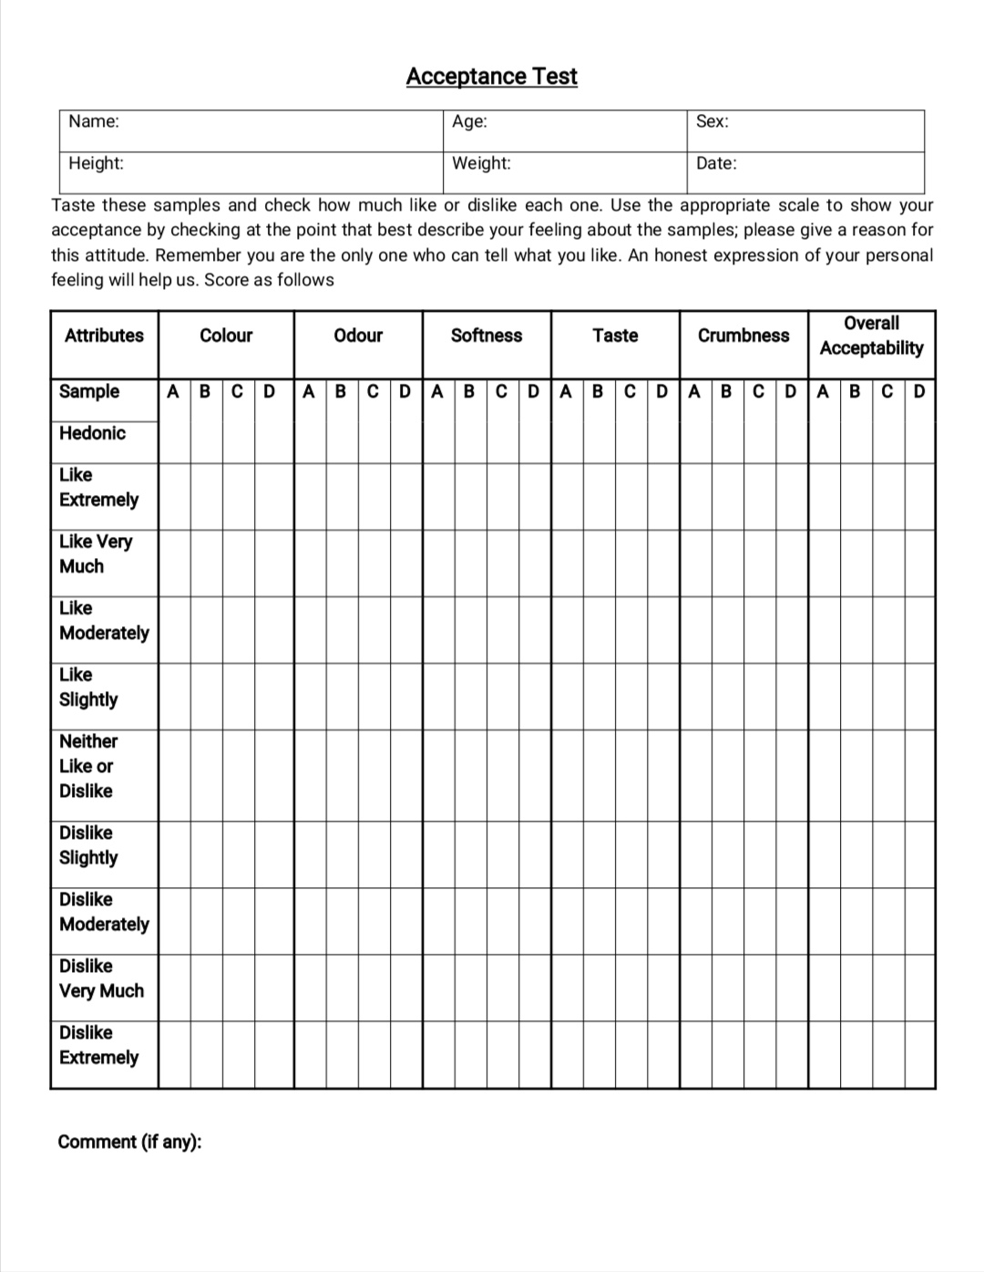

Appendix 3: Sensory evaluation panelist work
Sensory panelist don't do it
1. Eat, Drinks or Smoke within 90 minutes prior to test.
2. Use gum, mints etc flavored item within 30 minutes
3. Wear perfumes, cologne and fragrance item during test
4. Talk and comment during evaluation
5. Taste if you have a lot of prior knowledge about the manufacturing which you may dislike
6. Taste if you have a cold.
7. Share the product with other.

Sensory panelists should
1. Be attractively dressed and well groomed.
2. Be tactful and concerned about the exhibitors and
3. Have a pleasant manner; smile; be prompt.
4. Avoid consulting with spectators.
5. Hide personal likes and dislikes.
6. Be familiar with the products being judged.
7. Take the time to get a general picture of the entries.
8. Recognize quality standards.
9. Don't give top placing if entries are not worthy
10. Don't rule out unfamiliar ways of doing things if the results obtained are satisfactory. Judge the results that you see, rather than what "might" have been done.
11. Make quick and firm decisions.
12. Offer reasons for decisions, encourage the exhibitor to continue, to learn and to improve.
13. Offer compliments and constructive criticism.
14. Be fragrance neutral
15. Participate regularly
16. Take sensory evaluation seriously
17. Take time and focus during test
18. Follow the method and instruction precisely
19. Be confident in initial judgment 20. Rest and cleanse your palate for next sample

Remember
No food entry is so poorly done that it is not worthy of an encouraging comment. No food entry is so well done that some improvement may not be made their feelings.

Appendix 4: Criteria for GI determination
For glycemic index determination
Subject characteristics do not appear to have a significant effect on mean GI levels, although the variance of values may differ in different groups, with type 1 diabetes patients having the most variation. As a result, healthy human volunteers are encouraged for routine testing (non smoking). In practice, we believe that there is no need to restrict exercise, smoking, or food the day before the test. However, unusually strenuous activities should be avoided. The subjects should eat their normal diet the day before. We recommended that the subject have a meal of their choice the night before each test and repeat that meal for each fasting night before each test. On the day of the test, smoking should be prohibited. We want to be clear that our proposal only relates to glycaemic response measurements.Other metabolic studies, particularly those looking at fat metabolism, may be more vulnerable to the effects of preceding activity and diet.

Exclusion criteria
Overweight, Dieting, IGT, Illness, Allergy and regular use of prescribed medicine.

Appendix 5: PHOTO GALLERY

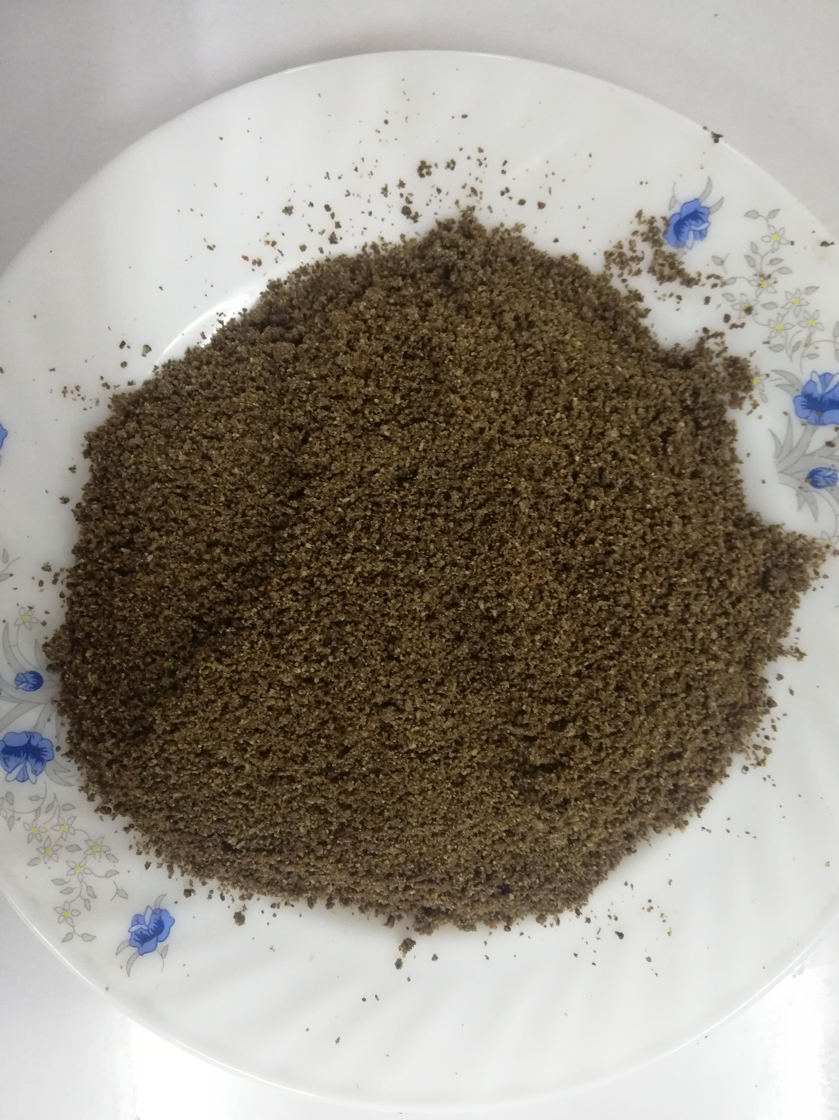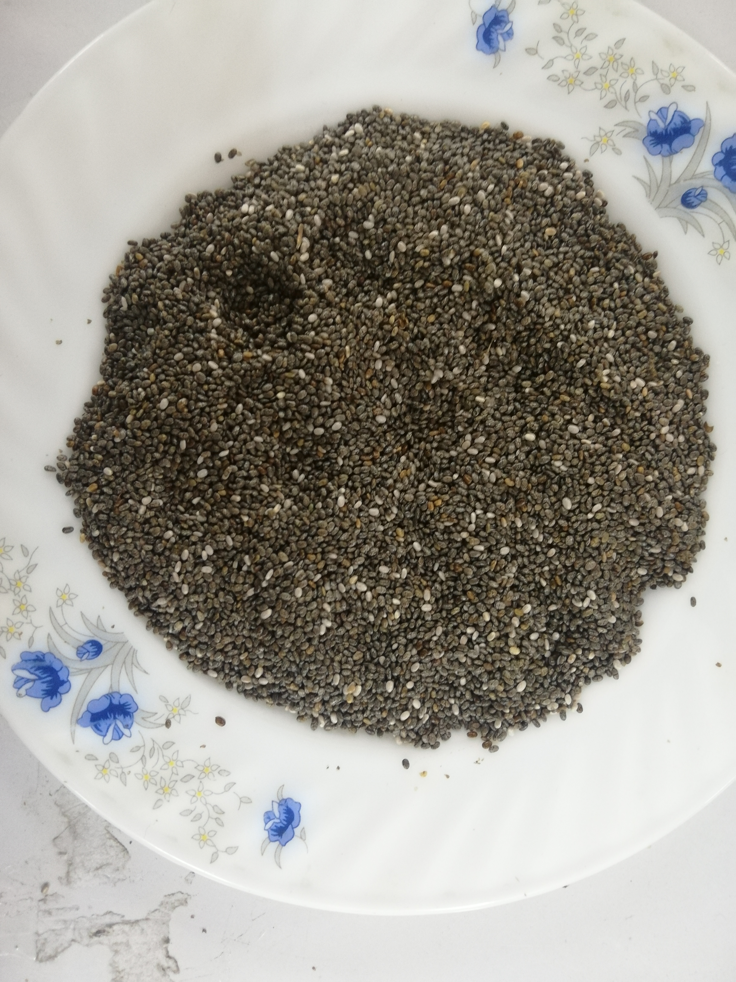
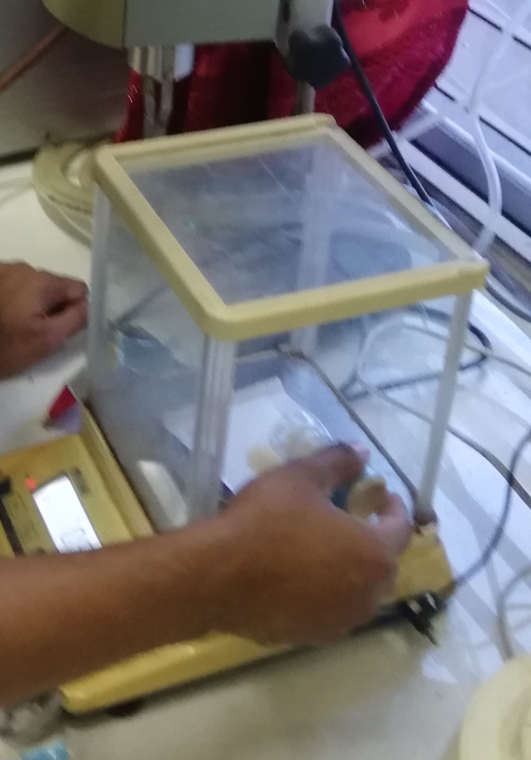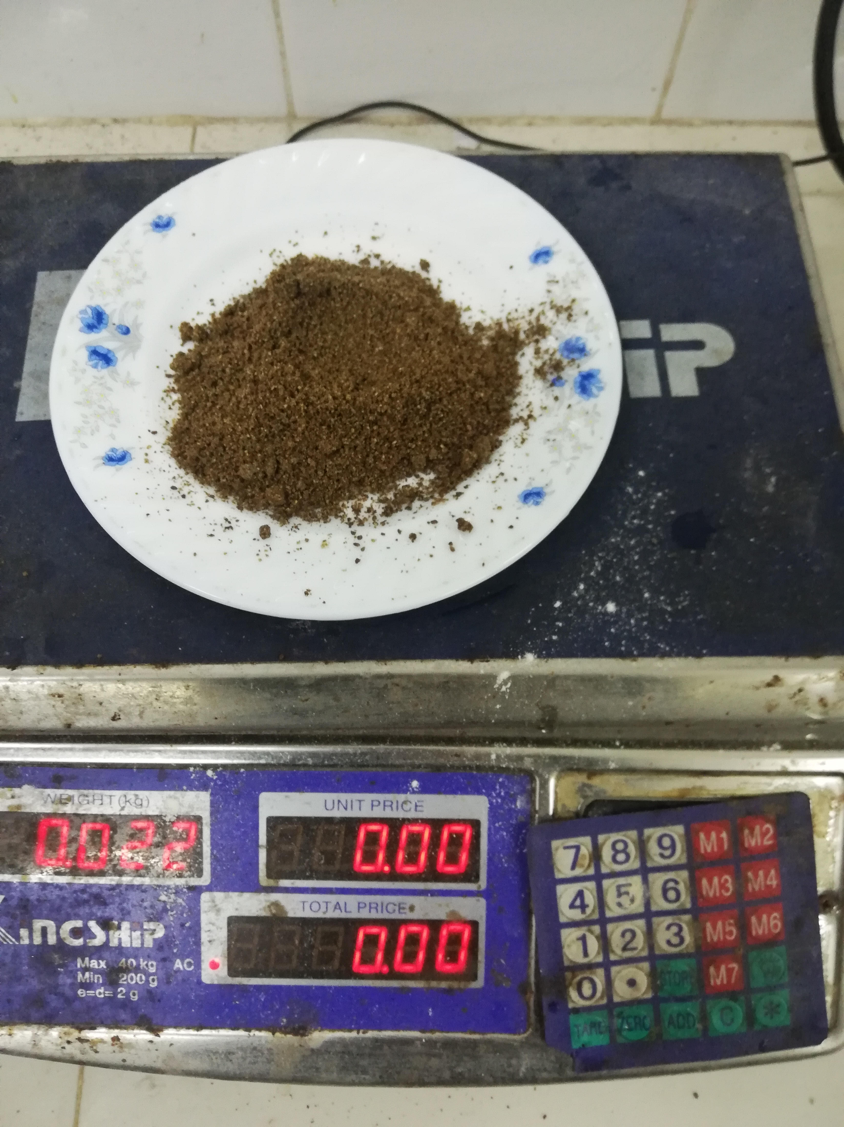
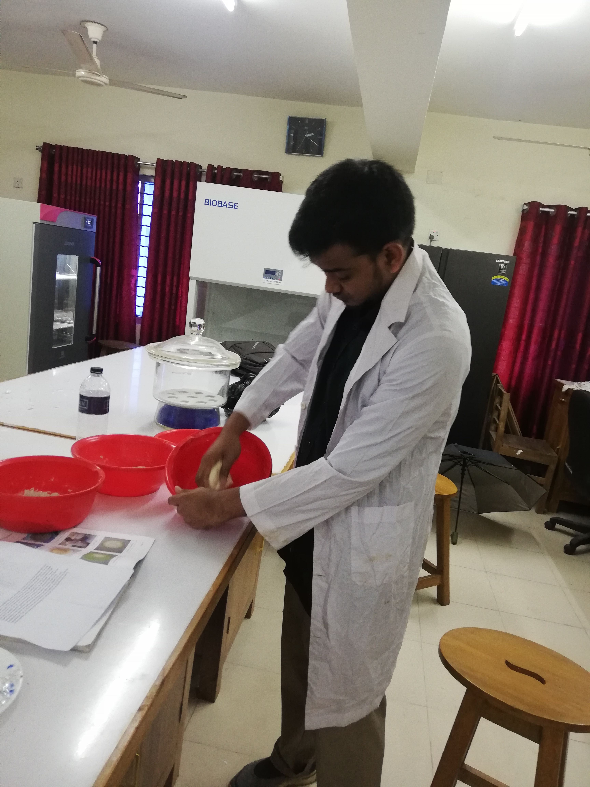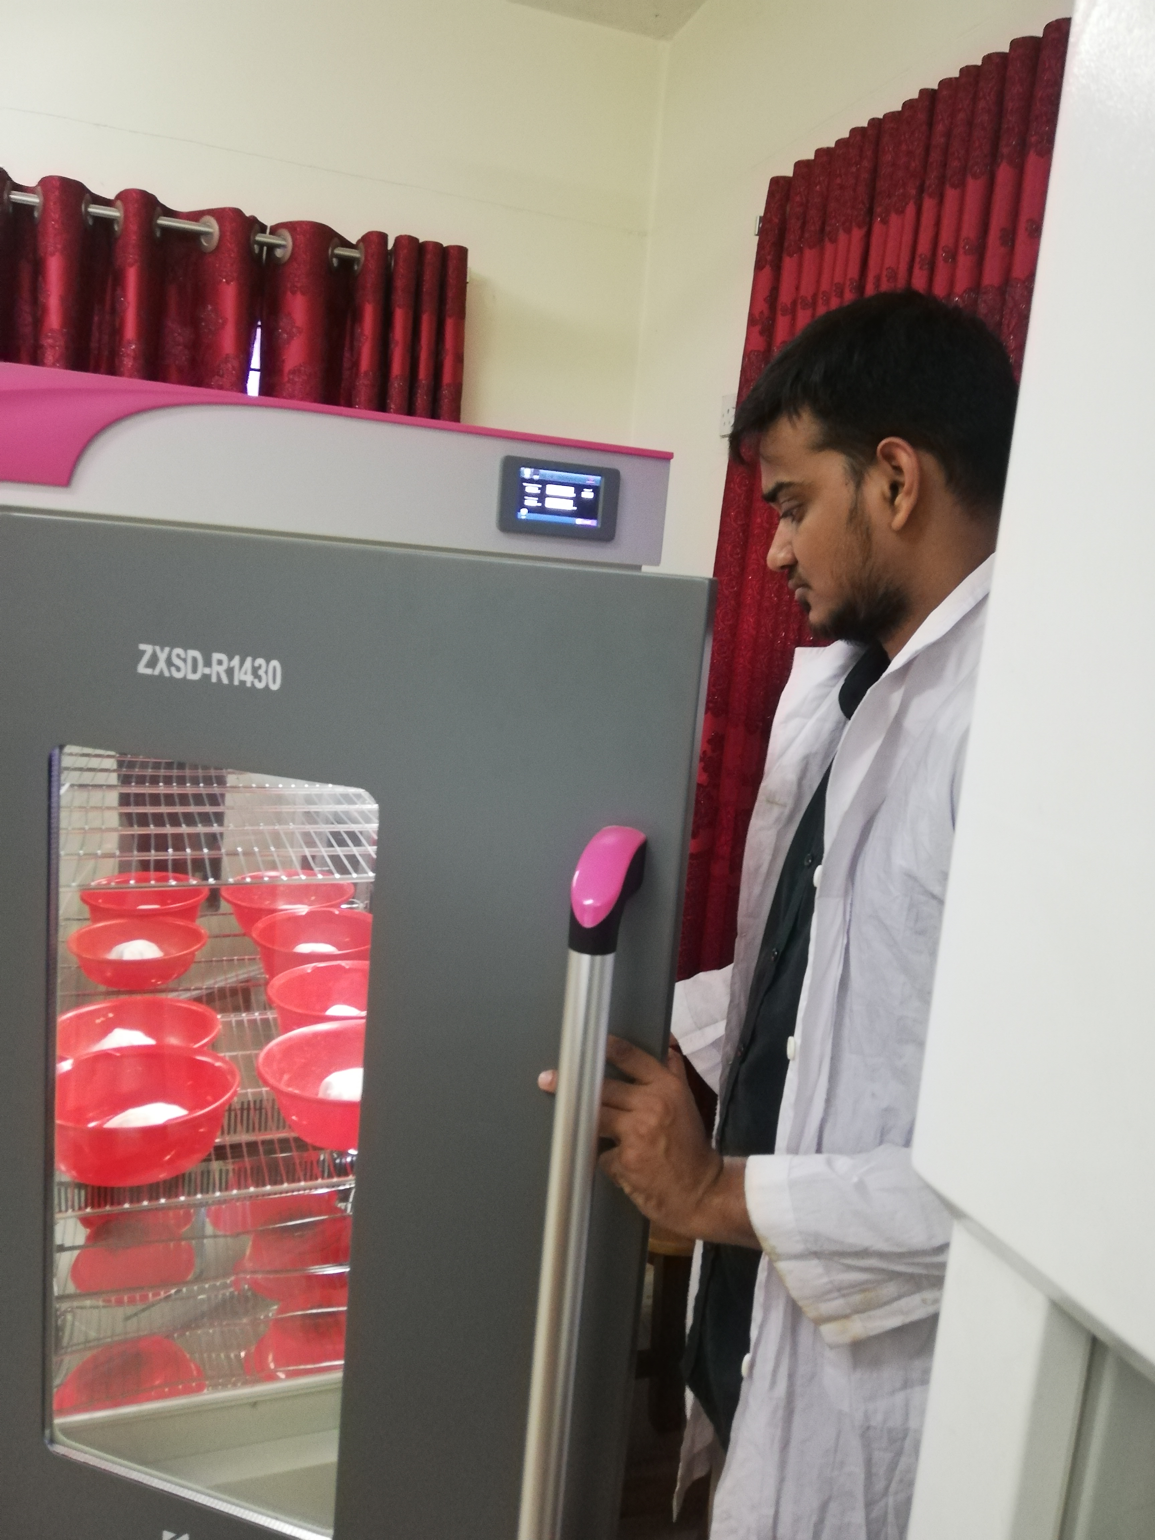

Lab Works during development of Chia Breads

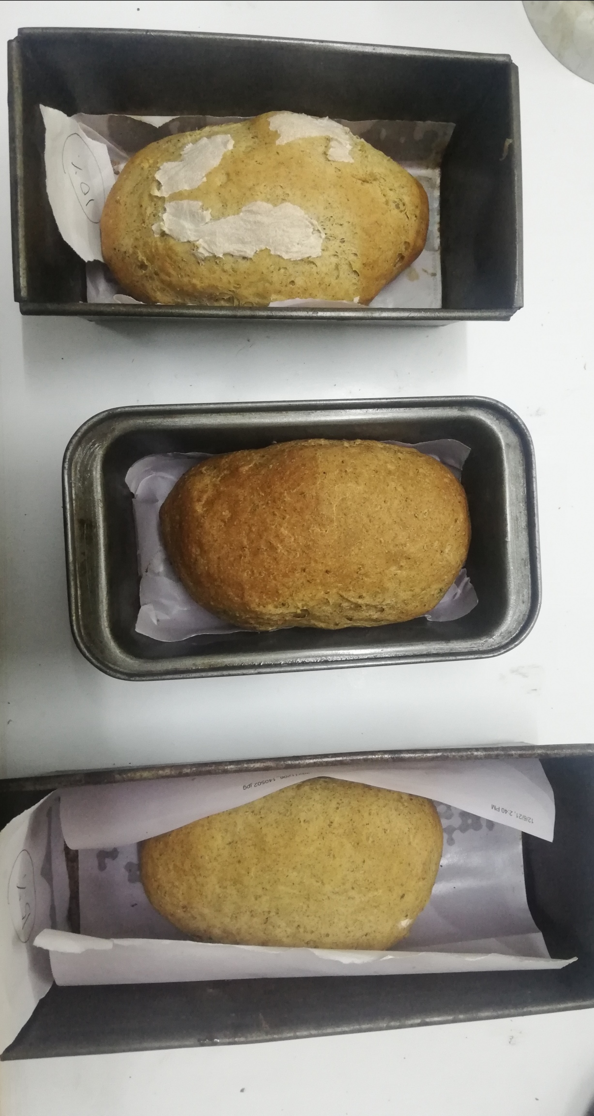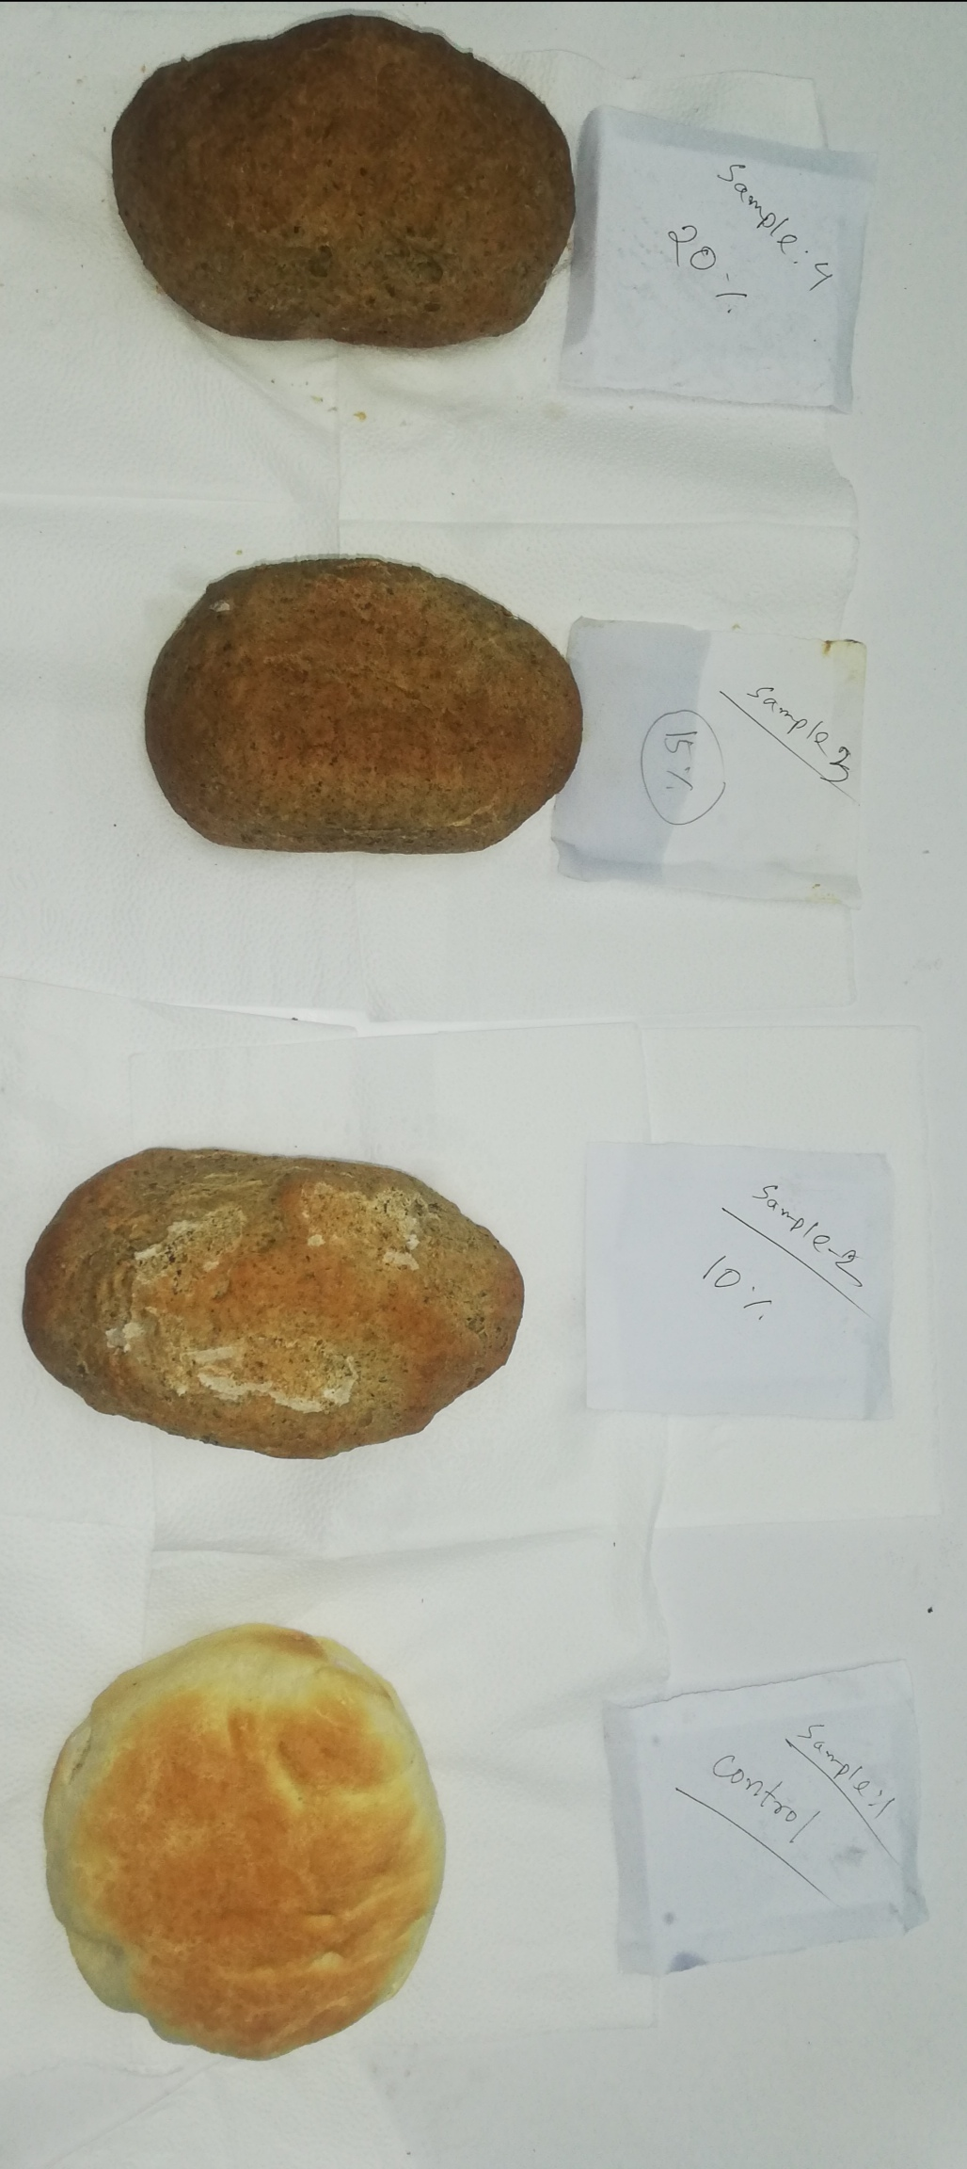
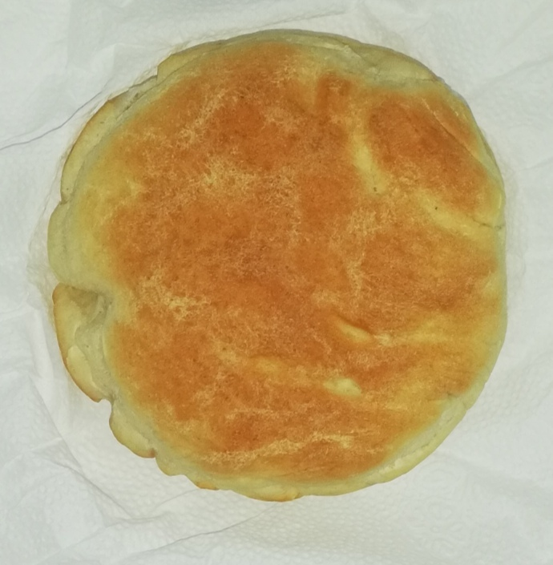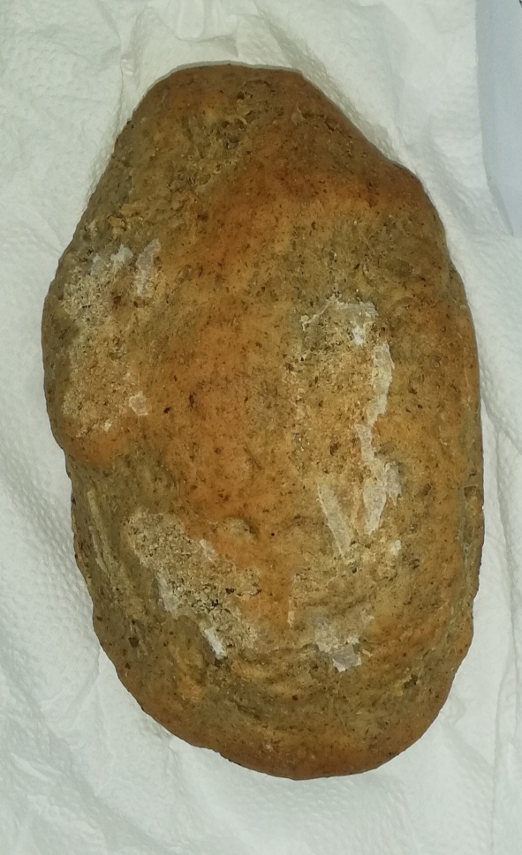
B=10% Chia Flour
A=0% Chia Flour
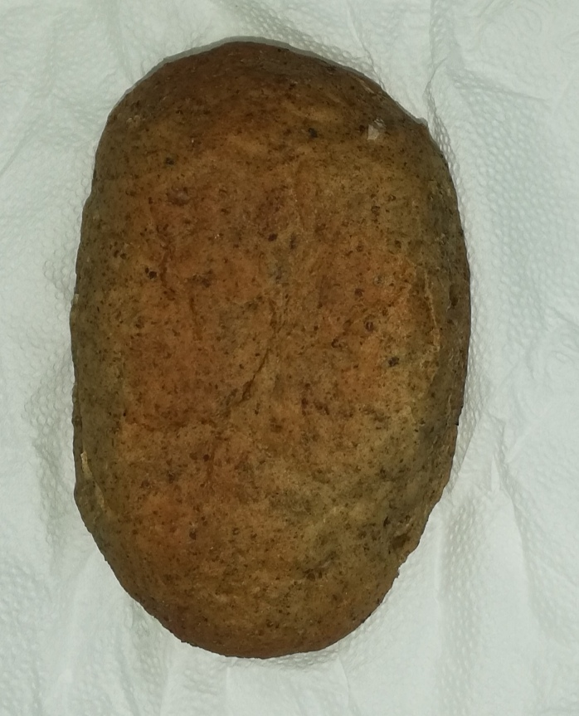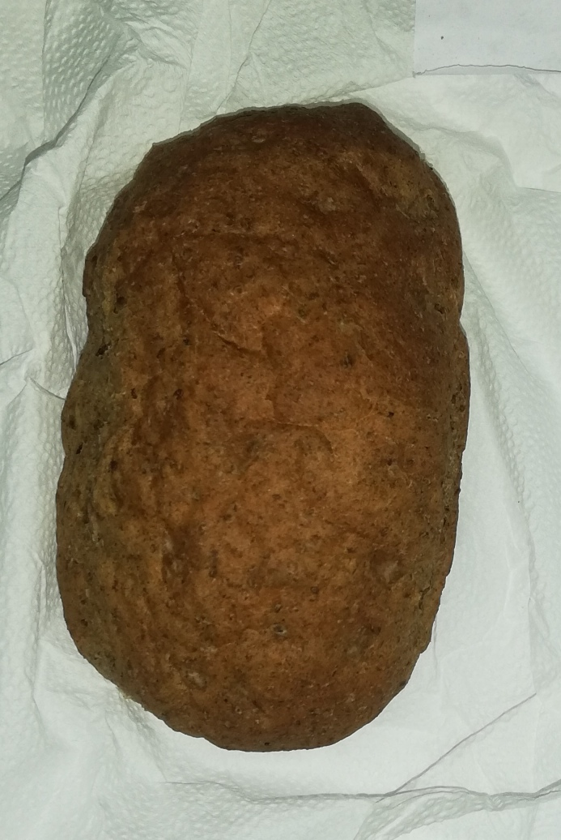
C=15% Chia Flour
D=20% Chia Flour
Different breads used for the study
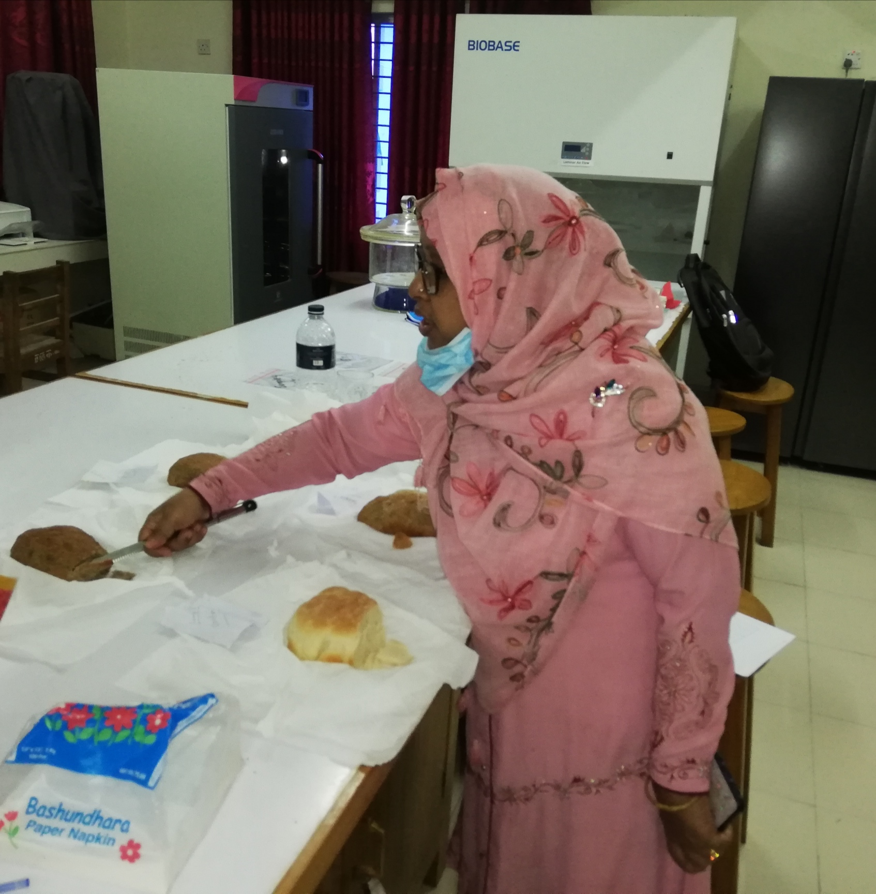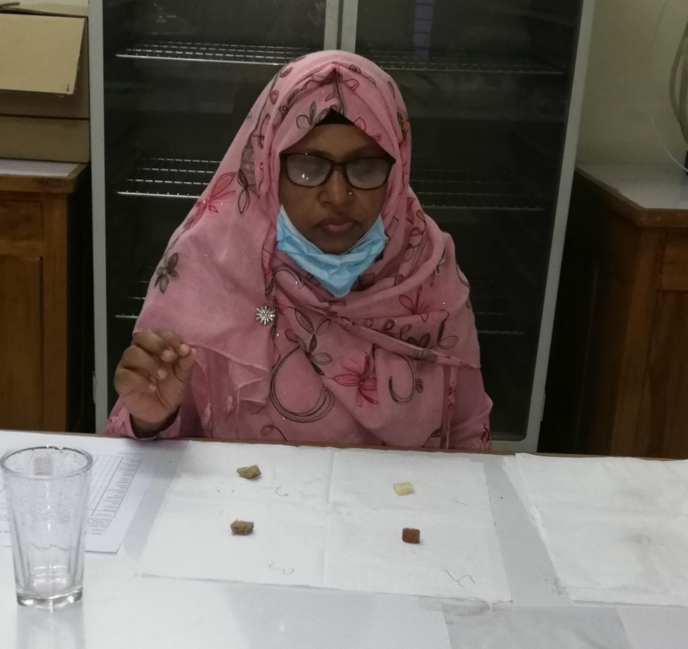
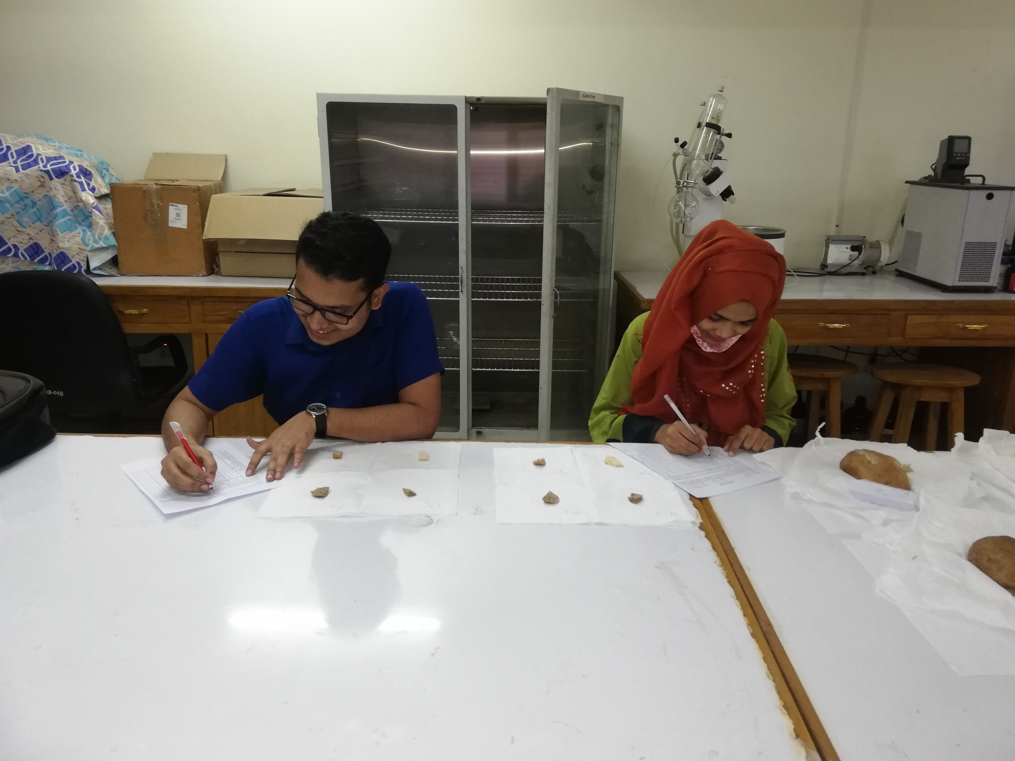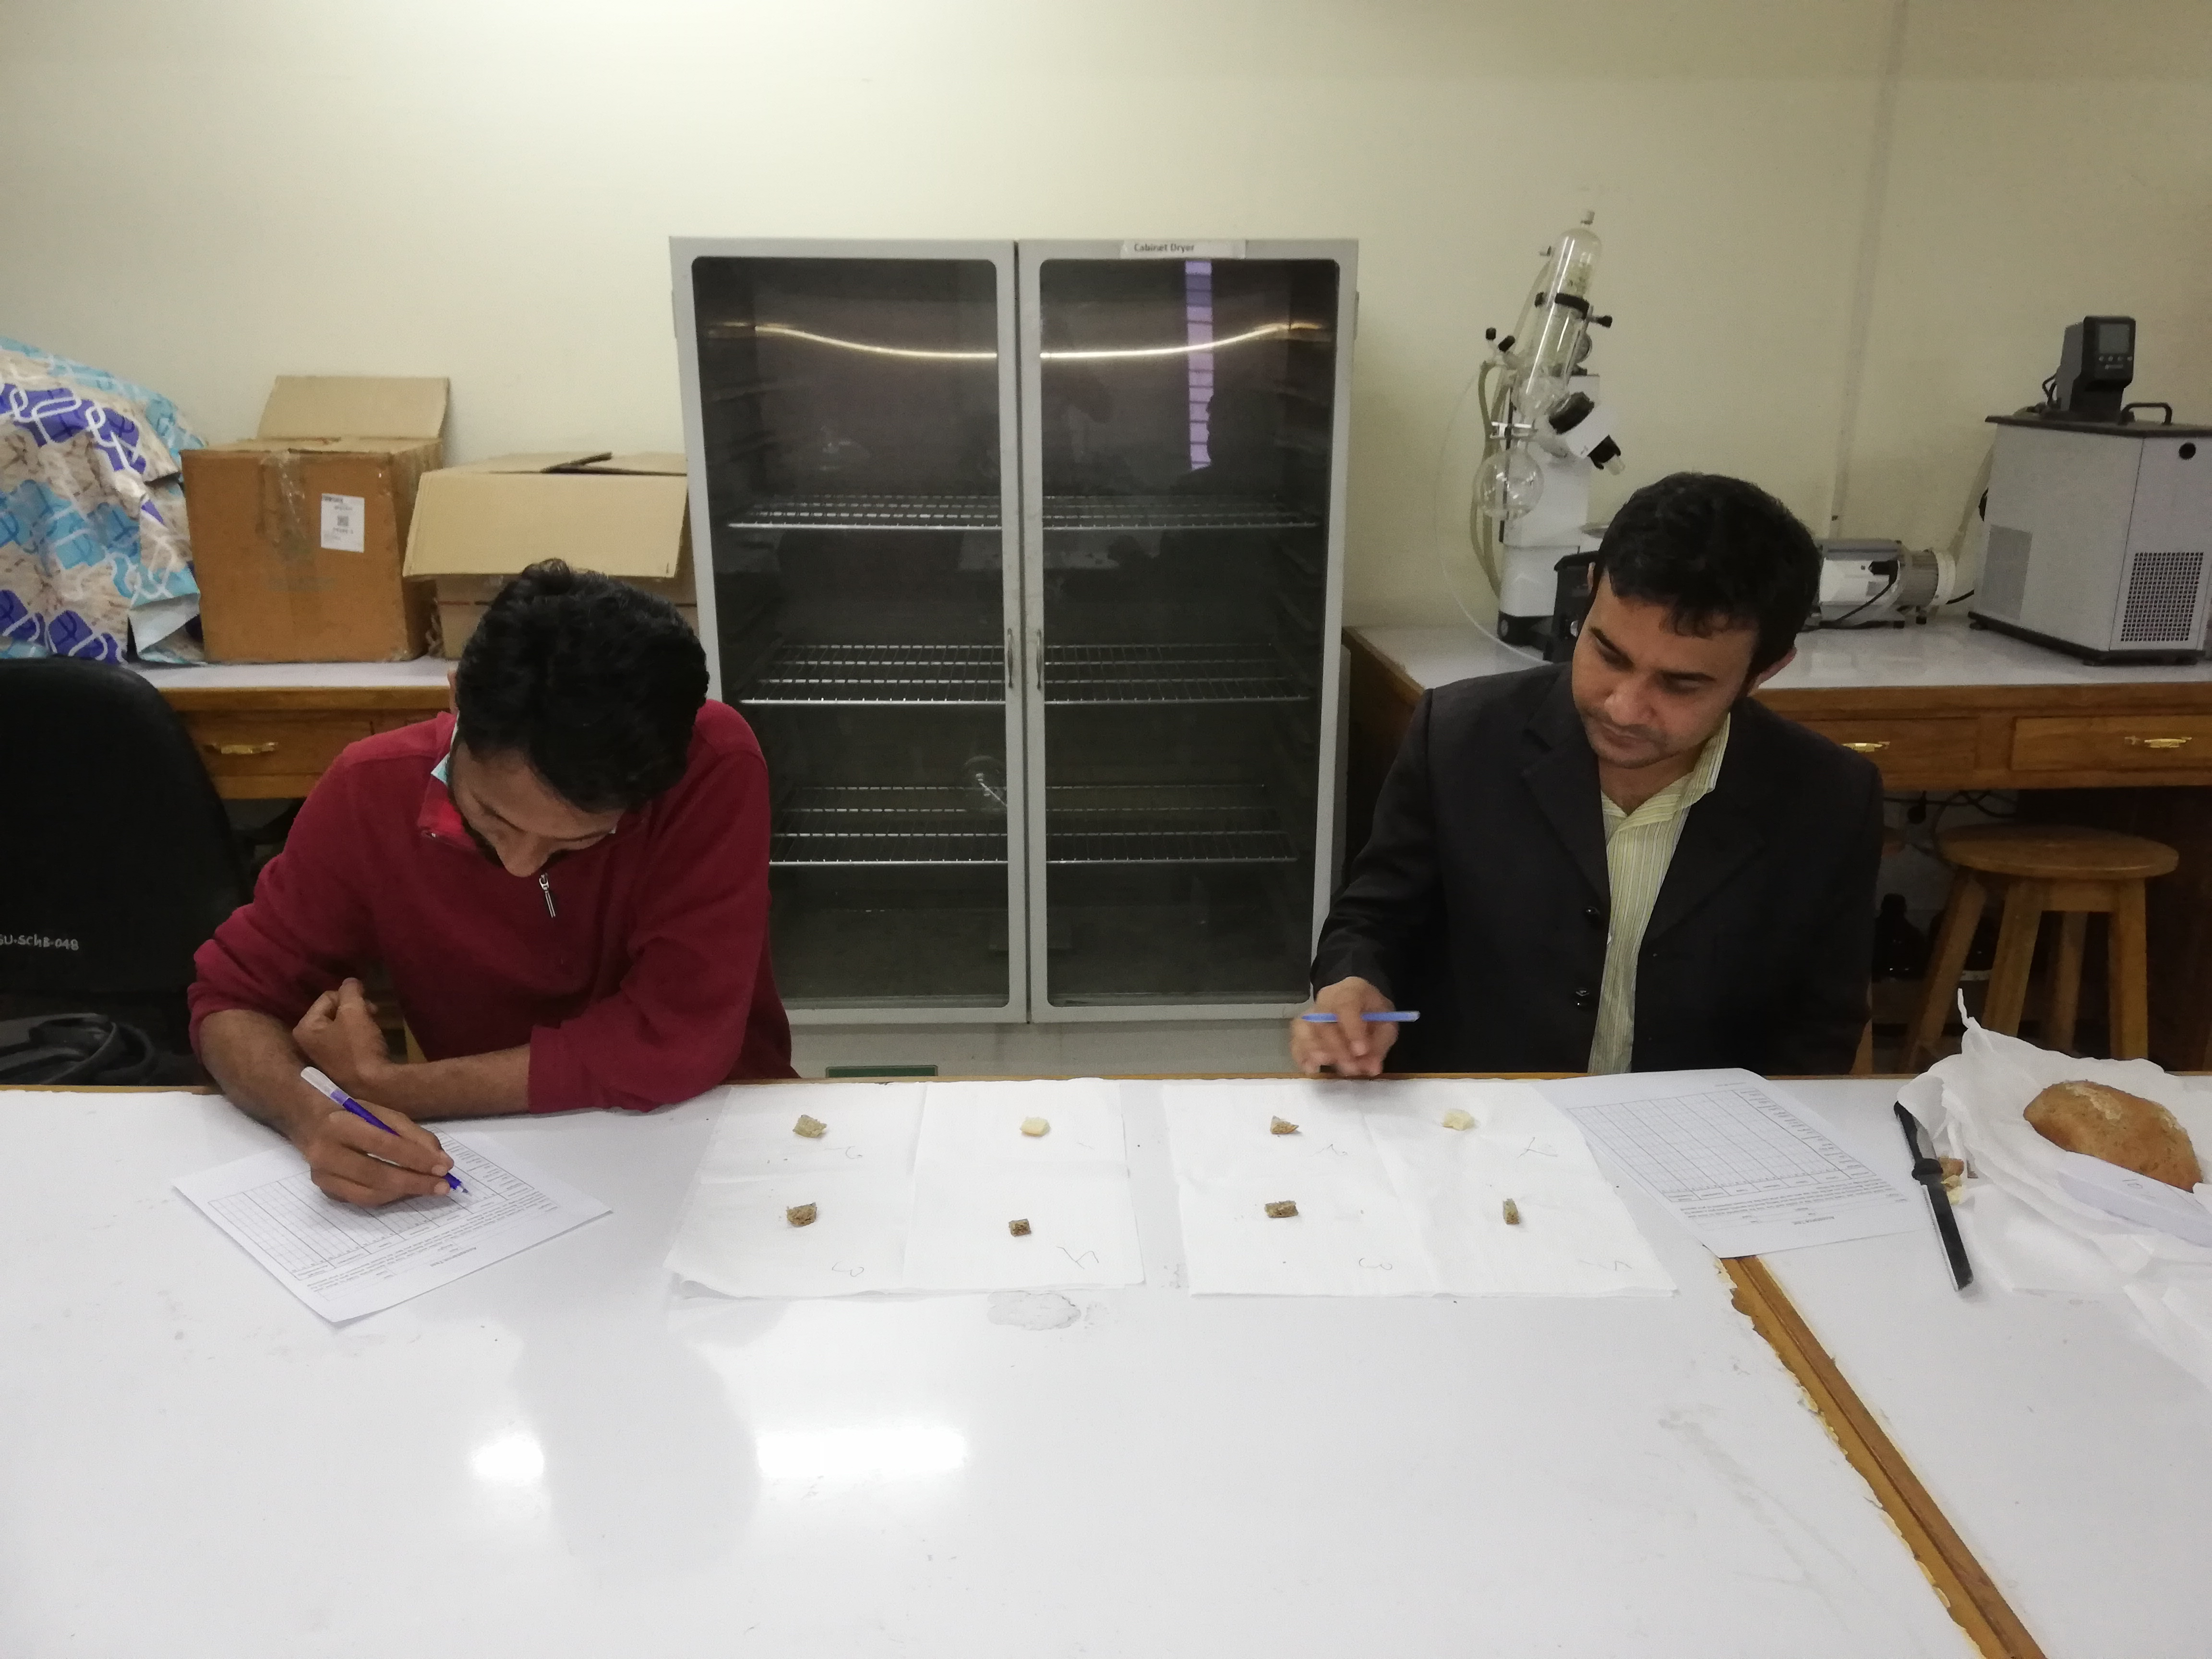
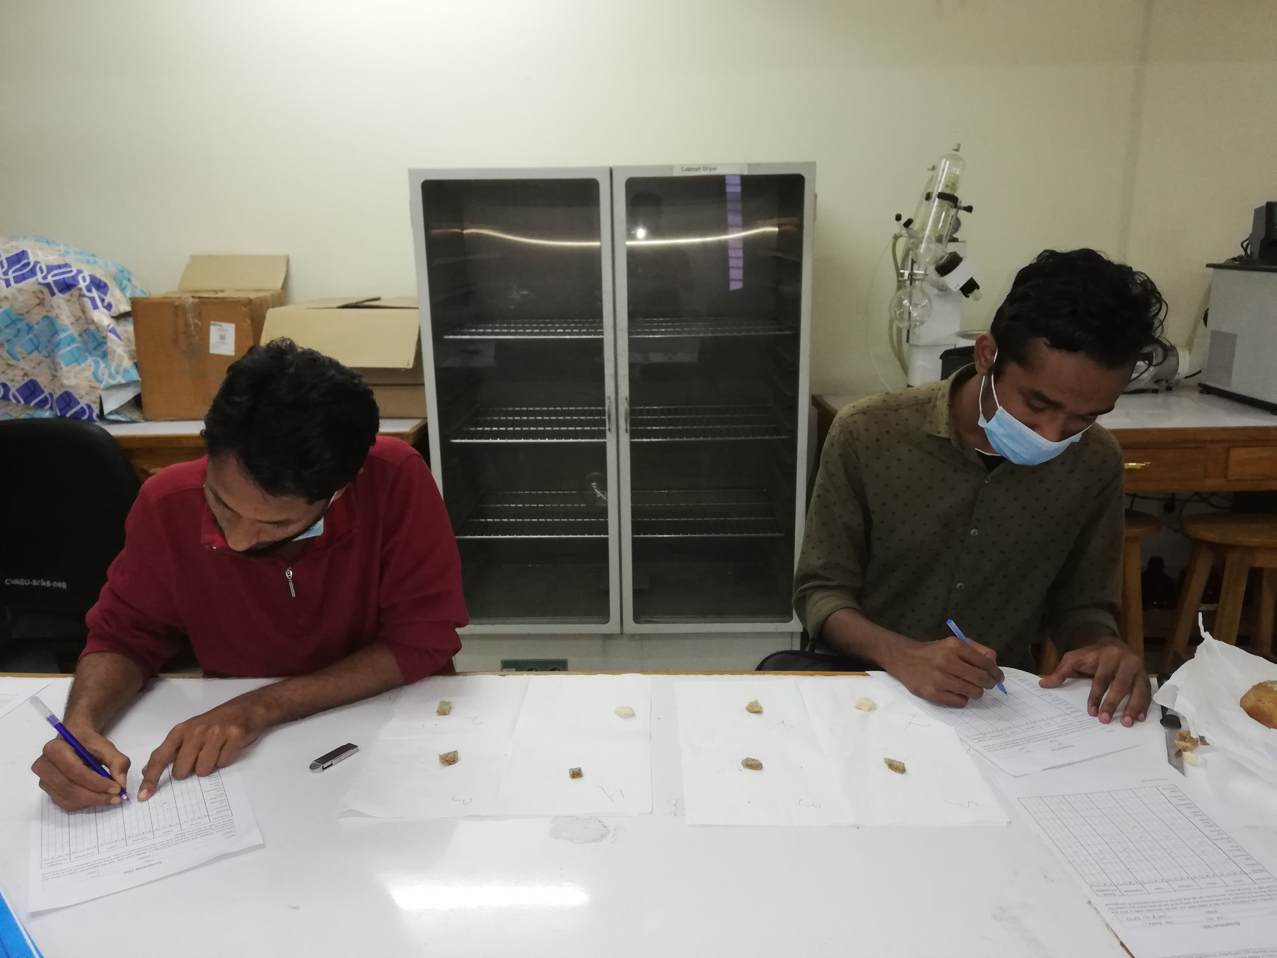
Sensory Evaluation of developed Chia Breads

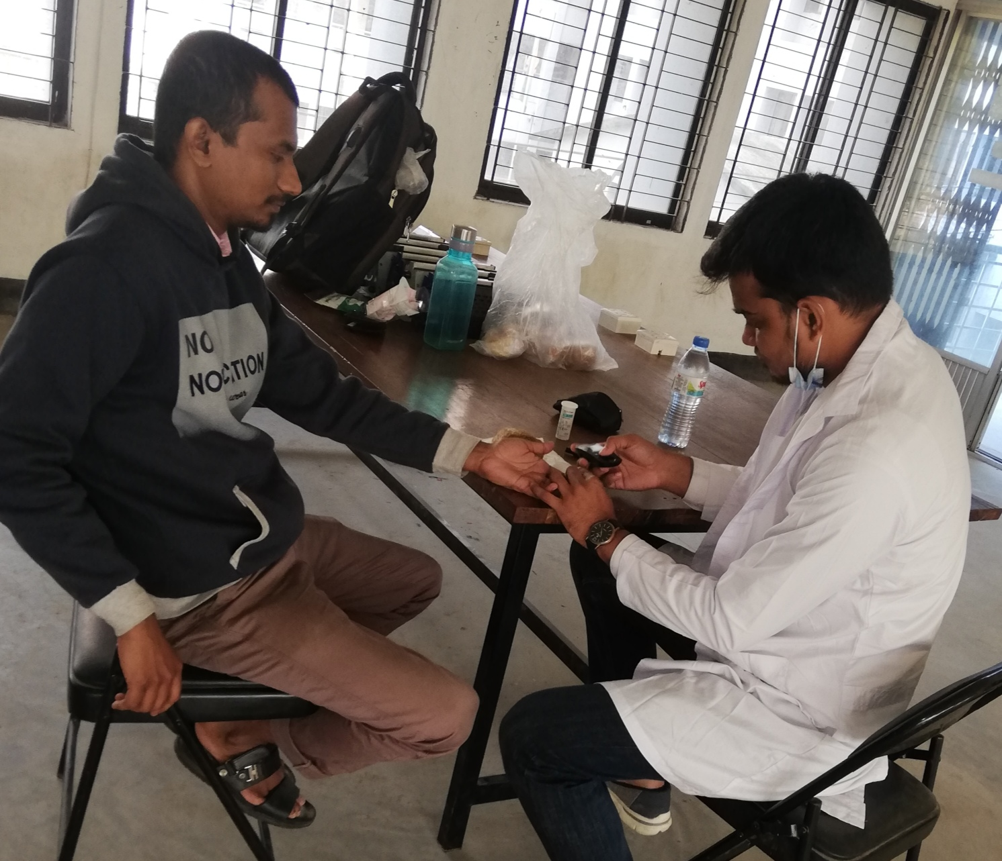
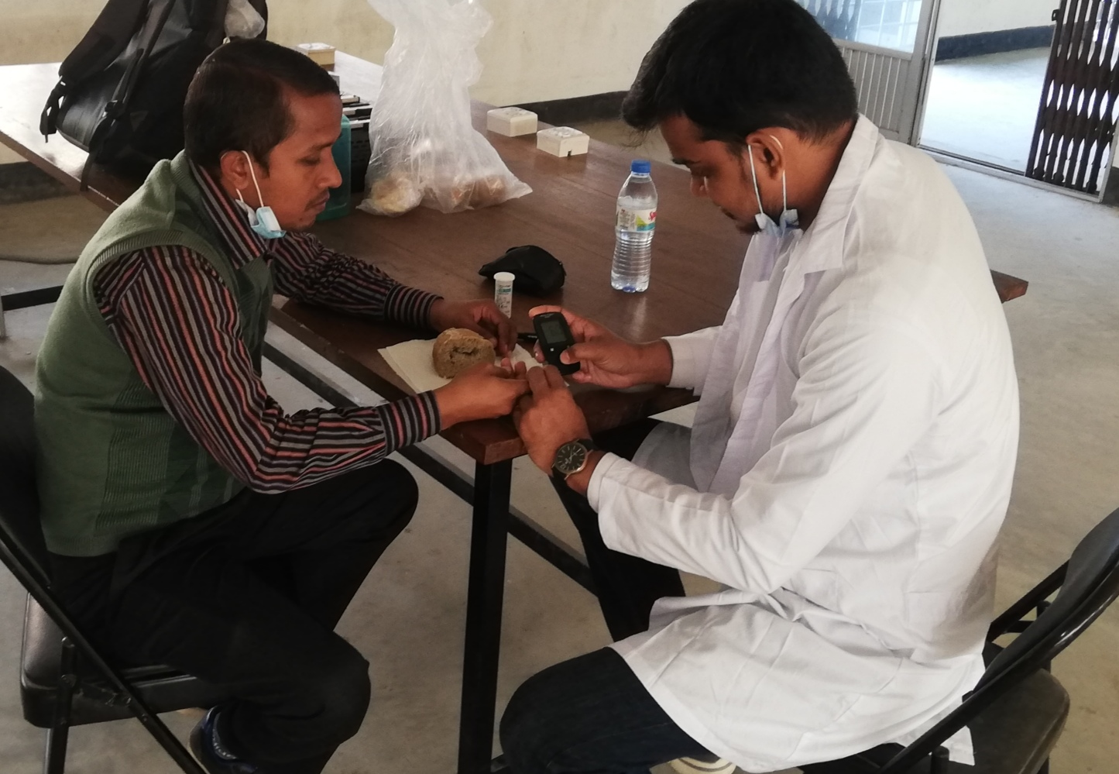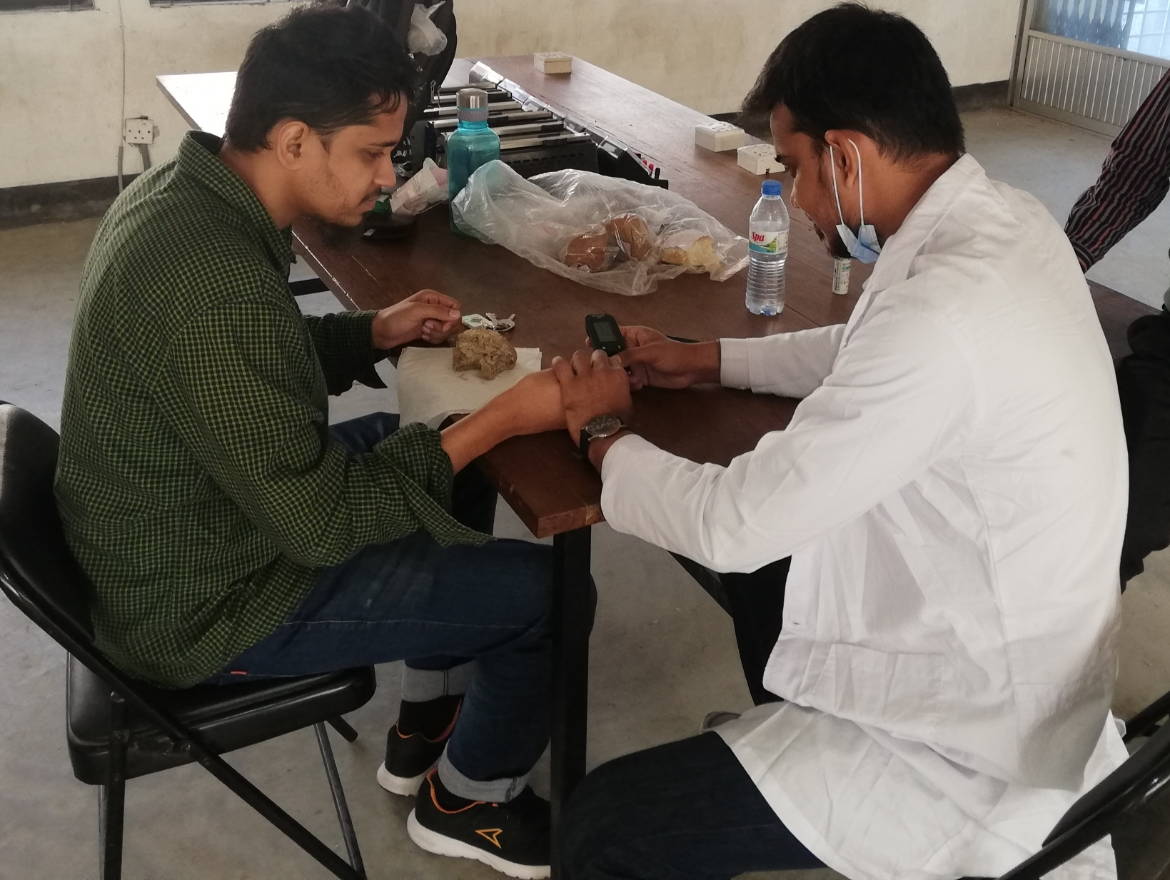
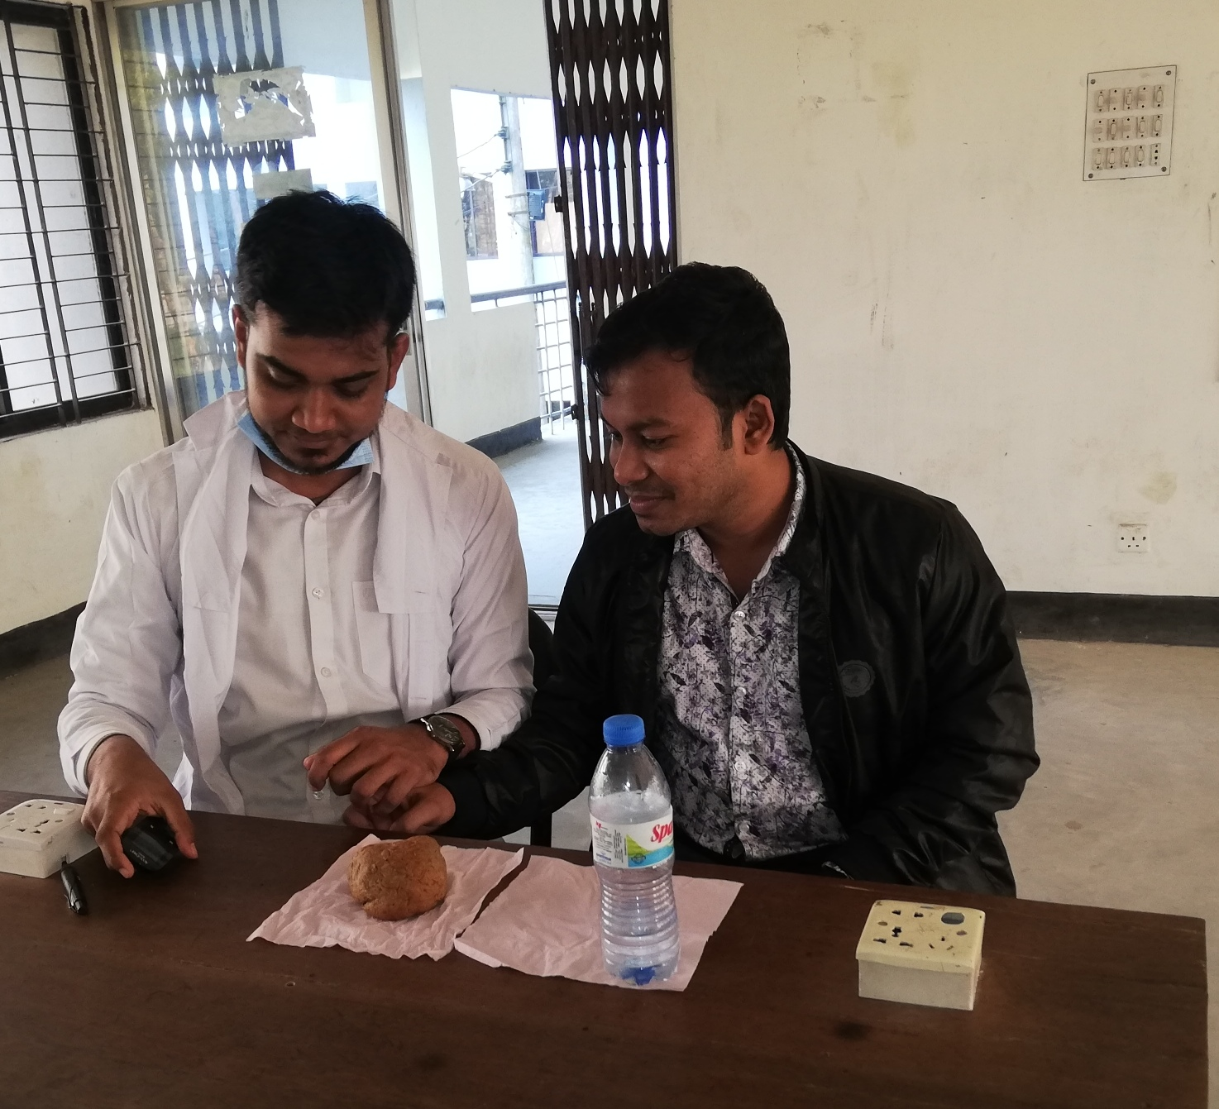
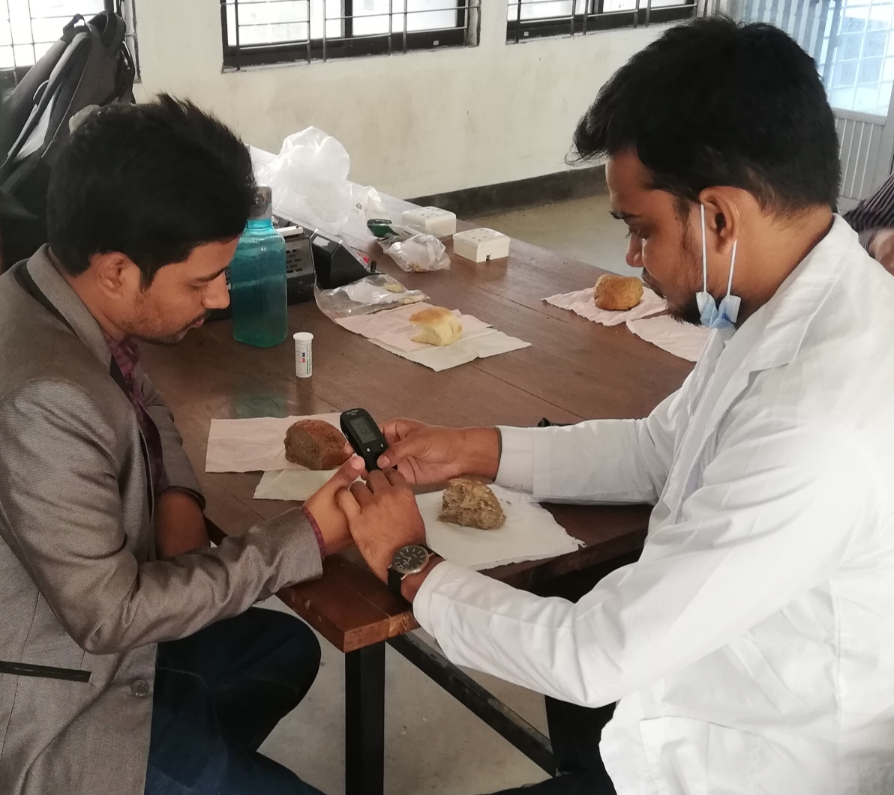

Determination of Glycemic Index and Blood Glucose Level

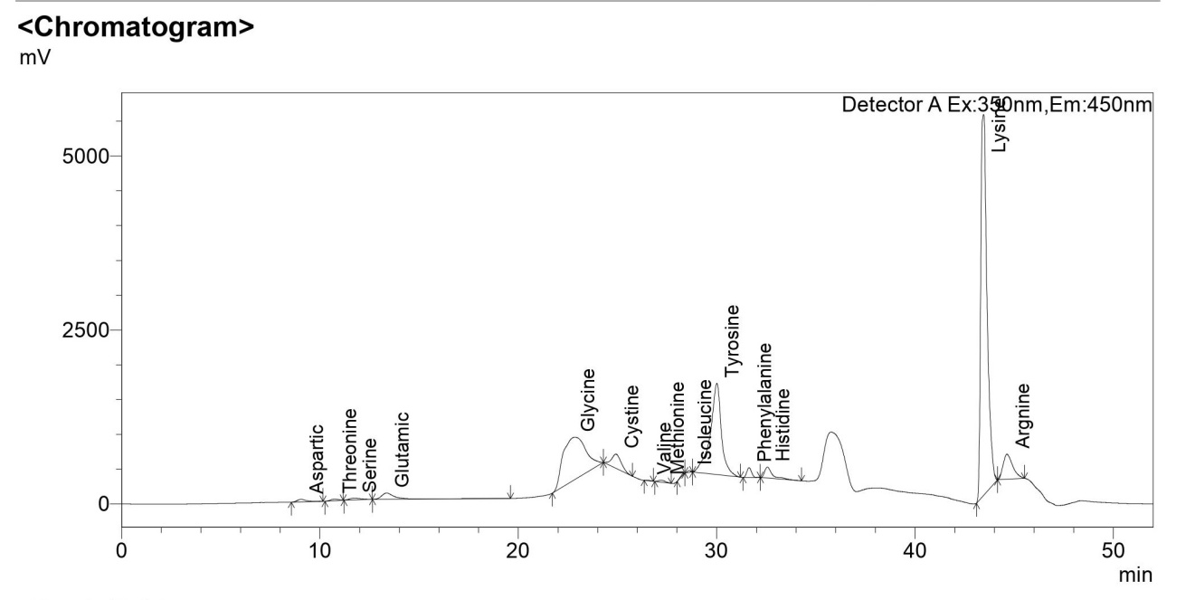HPLC graph for the Amino Acids in Chia Seed

