Effect of Urea Molasses Treated Rice Straw for the Fattening of Emaciated Bull Calves at Mohadevpur Upazilla Under Naogaon District
ABSTRACT
Rice straw as one of agricultural by-products has low quality due to low content of essential nutrients like protein, energy, minerals and vitamin as well as poor palatability and digestibility. Therefore, the quality of rice straw needs to be improved in order to increase its utilization by gastrointestinal tract of ruminants. The purpose of this study is to compare untreated and urea treated rice straw as basal diets for cattle. Six local calves approximately 1.5 to 2.5 years of age with an average live weight of 64 kg were divided into 3 dietary groups according to some scope and privileges. They were given 3 different straw based rations namely, Urea supplemented diet (Diet-A), Urea-molasses treated rice straw diet (Diet-B) and Untreated rice straw diet (Diet-C). Each animals received 2 kg straw with ad libitum green grass with kitchen by product or kitchen waste (average 1 kg) daily for 60 days. Total body weight gain and dry matter intake were determined. The total dry matter intake in the dietary animals group-A and B was higher than the dietary animals group-C but not significant (p>0.05)(difference is 13 kg). But significantly higher body weight gain was observed in the animals group-B which given the urea-molasses treated rice straw diet as compared to the supplemented diet and urea untreated control group.
Key words: Urea supplementation, urea-treated straw, urea, molasses. Fattening,dietary group, feed intake, protein, ration, calves, backyard system, weight gain, FCR.

INTRODUCTION
Rice straw is commonly used as a ruminants feed in tropical countries. This residue is available on most rice base farms and is an important source of fodder especially in the dry season. Rice straw is characterized by low protein content, mineral, and energy levels. The lower energy content of rice straw has been reported by Ristianto et al. (1998). It observed the average total digestible nutrient of rice straw were 39.13%, consequently rice straw have a poor nutritive value for ruminants (Doyle et al., 1986). This low nutritive value can be improved by pre-treatment or supplementation with high quality feed. The application of urea treatment by farmers in the village level may be limited due to the fact that it is labor intensive and time consuming and causes management problems (Cheva and Jaerachi, 1987).
Like other agro-based developing countries Bangladesh also has to depend mainly on agriculture. About 80% people dependent on agriculture. Livestock play a great role in this agriculture dependent country. About 50% people dependent on livestock in village (Agriculture census livestock survey and Report of FAO-1998). The livestock sector contributes 3 percent to the Gross Domestic Product (GDP) (BBS, 1989). To improve this contribution the government should has to take extensive development and extension program on livestock production. Feeds and strategy of feeding are the important factors for livestock development. The feeding practice of livestock of Bangladesh is very much traditional and conventional. The ruminant available is crop residue and rice straw contributes about 87% of the dry roughage available for cattle (Tareque, 1991).
Green grass from arable and non-arable land and some concentrates are also available at a sub-normal amount. To fulfill the requirement of cereal grain for human consumption, farmers use all their land for crop cultivation. Due to inadequate production of green grasses, rice straw has become the major feed resource for the livestock production of Bangladesh. In some areas of the country rice straw constituting over 90% of dry matter intake due to lack of alternative feed resources (Chowdhury and Haque, 1996). Again there exist a huge shortage of feed and the situation is getting worse day by day (Mamun et al. 1986). To overcome this shortage of feed and to provide adequate nutrition to the existing animals the conventional rice straw can be fed to the animal by somewhat modern feeding system. Modifying or treating this rice straw by other feed supplements like is an effective program for local cattle development. One of these processes is urea treatment of the straw. It is very much effective in cattle growth and also fattening. Cattle fattening for beef production has become an important business of the small farmers in Bangladesh. The Directorate of Livestock Services (DLS) of the Government of Bangladesh has taken beef fattening as an action program to generate income for the rural poor farmers. There is little information available on cattle fattening by the rural farmers. Hossain (1986) however worked on management system of cattle regarding feeding, housing, disease prevention and marketing in the Comilla district. Hossain et al., (1996) conducted a study on beef fattening in the Manikganj district. They all trialed on beef fattening by urea feeding.
The cattle population of our country very much suffering from malnutrition. They need minimum of 16% CP (crude protein) in their ration for their optimum growth, production, and reproduction. But through the conventional feeds and feeding systems they get a very lower amount of CP. The true protein (TP) feeds are very much expensive and so farmers can't offer their livestock the high protein source feeds. On the other hand urea is a NPN (non-protein nitrogen) substance which provide 16% CP to the ruminant animals. So incorporation of urea into the ruminant diet along with a higher carbohydrate (CHO) source can provide adequate protein as well as energy requirement of the ruminants which subsequently positively affect the growth, production, and reproduction of the ruminants. Urea can be provided by different methods and systems, with consideration given to the a) protein needs of the animal as dictated by the type of production; b) availability and cost of the urea c) availability of the energy sources and amount of plant protein being used D) cost of processing and mixing. Moreover the farmers in many areas of the country already practice chopping and soaking straw in plant water prior to feeding resulted in increased dry matter consumption (Mathur and Sharma, 1985).

Most of the urea fed to growing and lactating dairy cattle is incorporated into the concentrate protein of the ration. Generally speaking, urea is not employed in amounts higher than 3% of the total concentrates feed or 1% of the total dry matter in the ration which comes to be 1/3 of the total nitrogen in the ration. Liquid supplement of urea is a homogenous mixture of urea in the liquid molasses along with minerals and vitamins at the rate of 2.5 parts urea + 2.5 parts water +1 part salt + 2 parts mineral mixture + 92 parts molasses = 100 parts. Urea mixed with silage is another way of feeding urea to cattle - especially dairy cattle is through the addition of urea to crops which are being ensiled. If chopped, whole maize plant is being ensiled at 35% to 40% dry matter, urea is then added a level of 0.5% of wet material. Urea added to dry roughages is a newer method of adding urea has not only enhanced the palatability and the nutritive value of straw but also partially solved the crisis of quality dry roughages in the country. The formula has been suggested by the National Dairy Research Institute at Karnal in India for enrichment of straw quality by adding urea is straw 100kg of 90% dry matter, urea 4kg and clean water 50 liters. Urea in salt blocks is another simple way of supplying protein precursors to livestock on pasture is through the use of urea in salt licks or blocks. Numerous combination of all salt and urea are in use. One such preparation developed by the National Dairy Development Board. Anad in India is one of the latest innovations. The block is known is "Urea molasses block" contains molasses, urea, minerals like calcium, phosphorus, iron, cobalt, manganese, copper salt with small amounts of oil cakes. It has been claimed that animal's body derives 40-50% more nutrients from straw and other crop residue and also increase the consumption of such crop residues. (G. C. Banerjee, 1998)
Due to rice straw based ration the cows get very lower amount of nutrients which are required for their growth, milk production and reproduction. As a result, their offspring also born by malnutrition and smaller size. The growth of the calves also retarded as they also have to grow on poor quality rice straw. Again they get insufficient amount of milk from their dam. The farmers of out country most of them are illiterate and have a little knowledge on cattle rearing. So they can't manage their livestock in proper way. As a result different types of diseases attack their livestock. About 80% cattle are suffering from malnutrition and parasitic infestation and they all are very much emaciated, weak and sometimes cachectic (Field Survey,2008-2009).
As indicated earlier the information related to cattle fattening in Bangladesh is very sporadic. Detailed study is needed covering different districts of Bangladesh to recommend cattle fattening programs for the rural poor farmers as an income generating activity. Therefore, the present study was undertaken to investigate the effect of urea-molasses treated straw with kitchen by product(kitchen waste) diet, urea-supplemented diet on the growth of local emaciated calves and also the cost and return of the feeding practices.

REVIEW OF LITERATURE

Urea treatment is one of the various chemical treatment which has been found beneficial as it increased the nutritive value of rice straw by increasing the protein content and nutrient digestibility and palatability of rice straw (Wongsrikeao and Wanapat, 1985). supplementation with NPN (non protein nitrogen) can stimulate animal performance but care must be taken to avoid excessive intake of urea, as urea can be toxic when small amounts are consumed rapidly. At present, non protein supplements are not widely used by farmers in Asia because of the uncertainty surrounding the provision of urea (Doyle et al., 1986). Since urea need to be fed slowly, several ways was explored to ensure an even intake of urea. one technical solution is the addition of urea in urea molasses mineral block (Sharma et al., 1995). Supplementation of urea molasses block in the rice straw basal diet increased feed intake (PurnomoadI and Rianto, 2002). Astutik et al. (2002) reported that urea molasses mineral block together with rice bran and cassava supplemented to rice straw basal diet resulted in increased body weight gain of crossbred cattle. Feeding only rice straw generally does not provide sufficient nutrient to maintain body weight of ruminant animals. Supplementation to rice straw basal diet can be done with either concentrates, roughage or both. Forage legumes supplementation have been found to be effective in improving the utilization of crop residues (Richard et al., 1994).

Rice straw, the most available feed stuff for cattle and buffalo in Bangladesh, has low nitrogen and minerals but high lignin and silica contents. These reasons account for the low digestibility of rice straw and consequently the low productivity of livestock fed on it (Sundstol et al.,1978). Feedstuffs which contain nitrogen in a form other than proteins or peptides are termed non-protein nitrogen (NPN). Organic NPN compounds would include ammonia, amides, amines, amino acids. Inorganic NPN compounds would include variety of ammonium salts and ammoniated by-products. Of these urea dominates for feeding of animals with a functioning rumen as a substitute of protein feeds (G. C. Banerjee, 1998).
The major constraint of livestock production in the country is an acute shortage of feeds and fodder both in quantity and quality. Due to high pressure on land for crop production for human consumption, farmers cannot spare land for fodder production for feeding cattle (Akbar et al., 2000). Cattle and buffalo mainly subsist on straw based diet with limited supplementation of green fodder and little or no concentrate.

Feeding urea to ruminants replacing a part of costly protein feed becomes a conventional method for economic livestock production ( Loosely et al., 1968). Studies have shown that feeding of urea/ammonia and urine treated straw along with a forage of choice e.g. water hyacinth can increase voluntary intake, digestibility, body weight gain, feed efficiency and milk yield of cattle (Dolberg et al.. 1980; Daves et al., 1983). Several studies have shown that urea can replace satisfactorily up to about 30 percent of the protein in practical ration for natured ruminants (Z. H. Khandaker and A. Reza, 1993).

A. Mukammeluddin et al., 1989 worked on twelve local bull calves approximately 2 years of age with an average weight of 75 kg which were randomly divided into 4 equal groups. The animals were than dewormed with a broad spectrum anthelmintic (Systamex) before and on the 23rd day of experiment. Each group was given any of the following four rations: (A) urea supplemented, (B) urea treated, (C) urine treated and (D) untreated rice straw along with approximately 7 kg fresh water hyacinth. In case of urea supplemented diet, he has given 40 gm urea per kg rice straw along with 7.15 kg water hyacinth and 1.94 kg rice straw; in case of urea treated diet, 50 gm urea per kg rice straw along with 6.99 kg water hyacinth and 2.24 kg rice straw; in case of urine treated diet, 1 liter urine per kg straw along with 7.10 kg water hyacinth and 1.85 kg rice straw and in case of untreated rice straw diet, 2.2 kg water hyacinth and 1.76 kg rice straw which treated with urea or urine. The animals were raised on these rations for 56 days and found highest body weight gain in urea treated straw diet group which is 7.5 kg, then in urine treated straw diet group which is 7.00 kg, then in urea supplemented diet grout which is 4.67 kg and in control group that is in urea or urine untreated straw diet group it is only 2.67 kg.
Z. H. Khandaker and A. Reza, 1993 worked on twelve emaciated indigenous male cattle of almost 9 years of age (average body weight of 133 kg) which were purchased from the market and randomly divided into three groups having 4 animals in each and fed individually in the stalls. The animals were dewormed prior to initiating the experiment. Animals in group- A, B and C were supplied with the following diets: a) rice straw + green grass + concentrate mixture (A), b) rice straw + kitchen by product + concentrated mixture containing urea (B) and c) rice straw soaked in urea-water + green grass + concentrate mixture (C) respectively. In case of diet -A, urea is not incorporated with the diet and the animals fed of 3 kg rice straw. 400 gm til oil cake, 700gm wheat bran, 250gm molasses and 50 gm bone meal; in case of diet-B, 60 gm urea supplemented with concentrate mixture containing 3 kg rice straw , 550 gm wheat bran , 500 gm molasses and 50 gm bone meal; and in case diet-C, 3 kg of rice straw was treated with 60 gm of urea which was fed along with 550 gm of wheat bran, 500 gm of molasses and 50 gm of bone meal. The green grass was fed adlibitum to the animals. Animals were fed twice a day. The experiment was continued for a period of 75 days and found highest body weight gain in case of diet-C animals which is 15.7 kg, then next body weight gain found in case of diet-A animals which is 13.4 kg and the lowest body weight gain found in case of diet-B which is 7.3 kg.

Rahman et al., 2010 worked an experiment which was conducted to investigate the effects of supplementation of Urea-Molasses-Straw (UMS) based diet with different levels of concentrate for fattening emaciated bulls. The un-supplemented control diet T0 was composed of UMS (80%) and green grass (20%). In the treatment diets T1, T2 and T3 concentrate mix was added at 10, 20 and 30% of DM requirement, respectively to replace the same amounts of UMS and green grass. There was significant (p < 0.01) difference in average DM intake, which were 3.42, 4.65, 4.79 and 5.14 kg for T0, T1, T2 and T3, respectively. The animals fed supplemented diets T3, T2 and T1 gained significantly (p < 0.01) higher live weight (56.0, 46.0 and 40.0 kg, respectively) and had better feed conversion ratio (6.58, 7.34 and 8.22, respectively; non-significantly) than the animals fed on T0 (Live weight gain 11.0 kg and feed conversion ratio 21.95). There was a tendency to increase nutrient digestibility with increased levels of concentrate supplementation. The highest cost for each kg meat production was recorded for diet T0 (Tk. 143.45) followed by diets T3 (Tk. 75.67), T2 (Tk. 72.91) and the lowest was recorded for diet T1 (Tk. 68.73) .

MATERIALS AND METHOD
3.1: Animals and housing:
3.1.1: Animals : Six emaciated, pot belly in appearance but not diseased indigenous young calves of almost 1.5 to 2.5 years of age (average body weight of 64 kg) were selected from the backyard system inhibiting under Bakapur village at Mohadevpur Upzilla, under Naogaon district of Bangladesh. The animals were divided into three groups (each having 2 calves) (group-A , group-B and group-C) according to some scopes and privileges. The A1 cattle is about 1.9 year of age and body weight is 61.2 kg (bull calf). The coat colour is red with white marking present in the face. The A2 calf is also a bull calf of about 1.8 year age and body weight is 54 kg. It is also a local breed.
The B1 calf is a bull calf of about 1.5 year of age and body weight is 58 kg . The coat colour is brown with white markings present at the face, tail and necks. The B2 calf is a bull calf of about 2.2 year of age and body weight is 69 kg. The body coat colour is a mixture of white and red. The C1 calf is also a bull calf of about 2.6 year of age and 74 kg body weight. The body coat colour is dark brown. The C2 calf is a bull calf of about 2 year of age and 64 kg body weight. The body coat colour is a combination of red and white.
3.1.2: Housing :
3.1.2.1: Width, height and length: The animals under group A were housed into two different houses of two different owners. The group-B and C animals were housed into two separate sheds of two different owners (each having two animals). The animals shed for A1 calf is 8 feet in width, 16 feet in length and 6 feet in height. The shed for A2 calf is 6 feet in width, 10 feet in length and 6 feet in height. The animals shed for B1 and B2 calves is 8 feet in width, 18 feet in length and 7 feet in height. The shed for C1 and C2 calves is 10 feet in width, 20 feet in length and 7 feet in height.

3.1.2.2: Shape: The animal sheds for A1 and A2 calves are rectangular in shape with angled roof. The shed for B1 and B2 calves is also almost rectangular in shape with angled roof but there is a run in front of the shed. The animal shed for C1 and C2 cattle is almost square with angled roof.
3.1.2.3: Building materials and facilities: The A1 calf was housed into a shed having bamboo and straw made roof, earthen wall and earthen floor. The shed is east-west is length and doored. There are available sunlight, air and drainage facilities. The A2 animal was housed into a shed having bamboo and straw made roof, bamboo made wall and bricked floor. The shed is also east-west in length but ease doored. There are also available sunlight, air and straw made roof, bamboo made wall and earthen floor. The shed is also made east-west is length and west doored. There are also optimum facilities of sunlight, air and drainage. The dietary group C animals were housed into another shed having bamboo and straw shade roof, earthen wall and bricked floor. The shed is east-west in length but north doored. There are also sufficient sunlight, air and drainage facilities.
3.1.2.4: Cleaning and washing: The animals sheds were cleaned everyday for two times (one at morning and another at afternoon). During washing of the sheds they used clean water from the ponds. Through washing of the sheds removed the residual drug, Urine and other waste materials. They didn't use any types of disinfectants during cleaning of the sheds.
The animals in group-A were supplied the experimental diet-A containing urea mixed in concentrate with green grass, the group-B animals were supplied the experimental diet-B containing urea-molasses treated straw with kitchen by product and green grass and the group-C animals were supplied the diet -C diet containing untreated straw which was taken as control group.
3.2: Experimental design and dietary treatment: In the present study following three types of diets are offered to three different groups.
3.2.1: Urea supplementation with concentrates: Animals of group-A were supplied rice straw, green grass, concentrate mixture. Animals of group-B were supplied with urea molasses straw with kitchen by product, green grass, 250 gm rice polish. The ingredients composition and nutritive value of the experimental diet-B are shown in the table-1.
The efficiency of urea utilization is dependent on the composition of the ration and practical feed management. Since microorganisms in the rumen of ruminant animals degrade dietary protein to synthesize microbial protein, similarly they degrade urea into ammonia which microbes utilize as the nitrogenous portion of the amino acids. For complete synthesis of amino acids which will b utilized as polymer of protein microbes need carbon skeleton of amino acids. This will come from readily available carbohydrates. Thus for utilization of urea of any other NPN compounds simultaneous ingestion of soluble carbohydrate is a must. (G. C. Banerjee, 1998)
3.2.2: Urea treated straw: The group-B animals were supplied with urea-molasses treated rice straw, kitchen by product green grass and concentrate mixture. The urea and molasses were supplied to the animals by mixing with the rice straw. The ingredients composition and nutritive value of the experimental diet-B are shown in the table-1.
3.2.3: Urea untreated straw (control): The group-C animals were supplied the urea free diet containing rice straw, green grass and concentrate mixture. Here urea was not supplied but molasses was supplied with the concentrate mixture. The ingredients composition and nutritive value of the experimental diet-C and shown in the table-1.
3.3: Ration formulation: The following ration have supplied to the experimental animals throughout the experimental period:

Table 1: Ingredient composition and nutritive values of the experimental diets:
Particulars | Dietary group A (per day) | Dietary group A (per day) | Dietary group C (per day)
Ingredients composition

Rice straw | 2kg | 2kg | 2kg
Green grass, kitchen waste | Adlibitum(1kg average) | Adlibitum(1kg average) | Adlibitum(1kg average)
Rice polish | 250gm | 250gm | 250gm
Urea | 20gm | 20gm | 20gm
Molasses | 300gm | 300gm | 300gm
Salt | 3gm | 3gm | 3gm
Total | 3573gm | 3573gm | 3573gm
Nutritive value (calculated)

DM% | 71.7% | 71.7% | 67%
CP% | 7% | 7% | 5.6%
DCP% | 2.3% | 2.3% | 2.3%
TDN% | 45.5% | 45.5% | 45.5%

3.4: Methods of feeding: In case of group-A animals, the concentrate mixture was prepared daily using 250 gm rice polish, 20 gm urea, 300 gm molasses and 3 gm salt (each measured with manual balance).
The mixture then divided into two equal part offered to an animal twice daily (at morning and afternoon). Green grass offered ad libitum and 2 kg straw offered whole day. The residual rice straw of previous day was offered the next day by mixing with another 2 kg rice straw. At first week urea added at the rate of 5 gm and then the next week 10 gm and consequently 15 gm and 20 gm. The following weeks were maintained 25 gm.

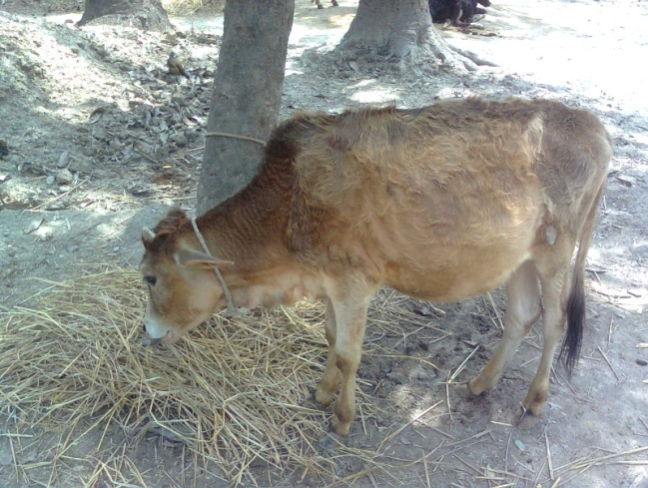
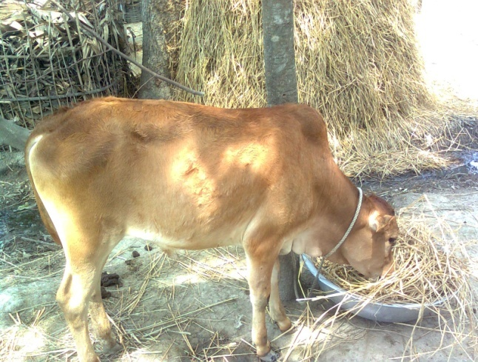

Fig: Feeding of urea- molasses treated rice Straw
Firstly, all the ingredients were measured using manual balance and then the urea was mixed with 4 liter of water and finally the molasses mixed homogenously. Then the urea-molasses solution was sprinkled over the rice straw. During sprinkling the rice straw was stirred for several times. The prepared treated straw stored with polythene and fed to the animals to a special bamboo made feeder. The prepared treated straw was fed to the animals at first week @ 1 kg treated straw + 1 kg untreated straw and then the following weeks @ 2 kg treated straw to each animal. The rice polish and salt measured everyday and fed to each animals by mixing with water twice a day (at morning and afternoon). The residue of treated rice straw of previous day was mixed with the treated rice straw of the next day. Green grass offered ad libitum. In case of diet-C , the rice straw was offered untreated and concentrated mixture was offered excluding urea. Everyday 2 kg rice straw was measured and offered to each animal. The residue of the rice straw of the previous day was offered by mixing with the next day diet. Green grass offered ad libitum. The daily concentrate mixture having 250 gm rice polish,300 gm molasses and 3 gm salt which offered twice daily at morning and at afternoon. The chemical composition of the supplied ingredients is given in the following table.

Table-2: Chemical composition of the ingredients supplied:
Ingredients | DM % | CP % | DCP% | TDN%
Rice straw | 88 | 2.4 | 0 | 41.62
Green grass | 30 | 9.36 | 5.13 | 58.43
Rice polish | 91.8 | 12.2 | 6.76 | 64.4
Urea
Molasses | 73.6 | 3
Source :( G.C. Banerjee,1998)
3.5: Body weight measurement: At the beginning of the experiment the animals were weighted at morning before any types of feeding by using Shaeffer’s formula and the measurement was continued throughout the experiment at morning once weekly. The formula is given below:
Shaeffer’s formula,
Body weight =(L× G²)/300 = Weight (lb)
Here,
L= Length of the body starting from point of the shoulder to the point of buttock in inch.
G=Heart girth in inch
By dividing with 2.2 to get the reading in kg. (G.C. Banerjee, 1998)
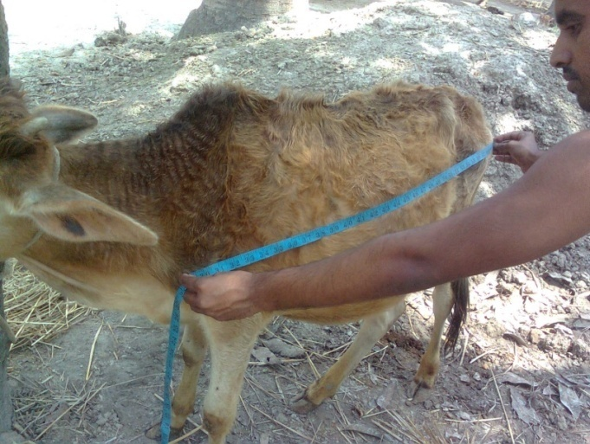
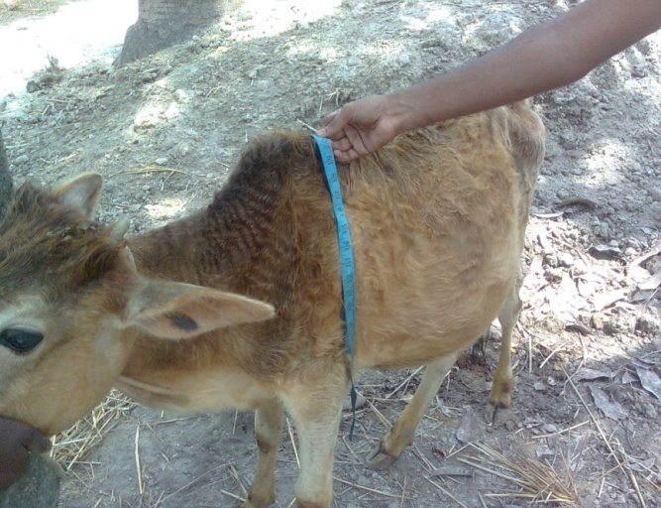

Fig: Measurement of L (Length in inch) & G ( Heart girth in inch)

RESULTS AND DISCUSSION
4.1: Dry matter intake: Dry matter intakes of the experimental animals are shown in tables-3. It can be seen from the tables that total dry matter intake in dietary group-A and dietary group-B animals were similar and slightly higher than that of the dietary group-C animals. However the difference, is not significant (p>0.05). Green grass intake was also similar in the animals of each group. Since the animals were given fixed quantity of rice straw the response on straw intake was not noticed. Rice straw was deficient in nitrogen, energy, and minerals and cannot support maintenance or production unless supplemented with deficient nutrients required for microbial growth in the rumen as well as by the animal (Preston and Leng. 1984). The DM intake of the experimental animals group A and B are similar and it may due to affinity of the animals towards the ure-molasses treated straw and urea-molasses supplemented concentrations. As the experimental diet-C has no such type of urea-molasses treated straw or urea-molasses supplemented concentrate the DM intake also significantly lower than the experimental diets A and B.
Campling et al., (1962) have reported that when urea infused continuously in the rumen of cattle (150gm/day), straw consumption. It appears that such supplementation speed up the rate of fermentation of straw due to increased microbial activity in the rumen through microbial proliferation but this did not alter the extent of fermentation on terms of unit amount of ingested straw.
Fig-1: Total DM intake of experimental animals.
Table-3: Statistical analysis of body weight:
No. of weeks | Dietary Treatment |  |  | Level of significance
 | A | B | C
0 | 57.6 ± 7.6 | 63.5 ± 7.6 | 69 ± 7.6 | NS
1st | 57.5 ± 7.6 | 63 ± 7.6 | 68.5 ± 7.6 | NS
2nd | 57.65 ± 7.6 | 63.25 ± 7.6 | 68.5 ± 7.6 | NS
3rd | 57.8 ± 7.6 | 63.45 ± 7.6 | 67.5 ± 7.6 | NS
4th | 58.05 ± 7.6 | 63.65 ± 7.6 | 67.65 ± 7.6 | NS
5th | 58ᵇ ± 7.6 | 63.6ᵇ ± 7.6 | 67.55ᵃ ± 7.6 | *
6th | 58.05 ± 7.6 | 63.7 ± 7.6 | 67.55 ± 7.6 | NS
7th | 58.35ᵇ ± 7.6 | 63.85ᵇ ± 7.6 | 67.5ᵃ ± 7.6 | *
8th | 58.55ᵇ ± 7.6 | 64.6ᵇ ± 7.6 | 67.65ᵃ ± 7.6 | *
Table-4: Effect on live weight gain and feed efficiency of different experimental diets:
Particulars | Animal Group |  |  | Level of significance
 | Dietary animals group A | Dietary animals group B | Dietary animals group C
Initial body wt.(kg) | 57.6 ± 7.68 | 63.5 ± 7.68 | 69 ± 7.68 | NS
Final body wt(kg) | 58.55 ± 7.8 | 64.6 ± 7.8 | 67.65 ± 7.8 | NS
DM intake(kg) | 191 ± 9.00 | 191 ± 9.00 | 178 ± 9.00 | NS
Gain inbody wt(kg) | 2.6ᵃ ± 0.13 | 4.15ᵇ ± 0.13 | 3.05ᵇ ± 0.13 | *
Feed convertion efficiency(kg feed/live wt gain) | 102.9ᶜ ± 1.44 | 64.15ᵃ ± 1.44 | 87.65ᵇ ± 1.44 | *
Total cost(taka) | 500 ± 23.84 | 510 ± 23.84 | 502 ± 23.84 | NS
Profit(taka) | 200ᵃ ± 32.62 | 587ᵇ ± 32.62 | 330ᵃ ± 32.62 | *

4.2: Feed intake: The average fortnightly feed intake of each group animals are given in the following table:
Table-5: Comparative average fortnightly feed intake of each group animals:
Weeks | Gr.-A (kg) | Gr.-B (kg) | Gr.-C (kg)
2nd | 21.25 | 19.95 | 25.25
4th | 26 | 26.5 | 24.5
6th | 31.2 | 27.65 | 28.24
8th | 27 | 30.7 | 29.75

From the table -4, it is evident that the amount of feed intake is lower at early weeks of the experiment in the group-A and group-B animals and rapidly increased later. But the rate of feed intake in the group-C animals is almost similar throughout the experimental period. This condition also happened in the experiment done by Khandaker and Reza,1993 (He also found that the intake of urea-molasses treated rice strew was significantly higher than untreated rice straw). It may due to same experimental and season.
4.3: Weight gain: I have measured the body weight of animals by Shaeffer’s formula once per week. The weekly measured body weight of different animals group is shown in the following table .
Table 6: Weekly measured body weight gain of the experimental animals:
Weeks | Animal’s body weight gain (kg)
 | A | B | C
1st | -2.80 | -2.09 | 0.00
2nd | 0.10 | 0.15 | -0.20
3rd | 0.20 | 0.24 | -0.20
4th | 0.33 | 0.40 | 0.30
5th | 0.48 | 0.55 | 0.43
6th | 0.55 | 0.75 | 0.15
7th | 0.67 | 0.89 | 0.52
8th | 0.53 | 1.20 | 0.97
From the table-5 it is seen that the body weight gain of the experimental group-A and B at first week were decreasing at frontal weeks and then and increased gradually at the end of the experimental period. But then there were slow increase in body weight at 7th to 8th weeks and again rapidly increased was observed. On the other hand the body weight gain of the experimental group-C was constant and even decreased at second week of age through the weights gain was somewhat continuous throughout the experimental period. The body weight gain of the experimental group-B is the highest among the experimental groups. This indicates that treatment of straw with urea has positive effect on the live weight gain of the animals. Statistical analysis showed that gains in animals receiving diet-A and C were significantly lower than those receiving diet-B. The reason for lower live weight gain in group-A and C animals is might be due to the type of the experimental diets (without urea in diet-C and without processing of rice straw by urea in diet-A) which has been reported by Sadullah and Haque (1981) and might due to higher digestible energy intake by group-B animals, Jayasuriya, 1981.

Fig.-2: Comparison of body weight gain (kg) of the different experimental animals.
The body weight gain of the experimental group-A is slightly lower than the weight gain of the experimental group-C and it may due to the in acceptance, non-suitability and also the adverse seasonal condition on the experimental group-A. Significantly highest body weight found in experimental group-B which is shown in the above graph.
4.4: FCR analysis: The FCR of the experimental animals group was determined by dividing the kg body weight gained to the kg feed intaken and it was found that the FCR is significantly lower in experimental animals group-B than the group-A and C . So it can say that urea-molasses treated straw is more suitable, preferable and economic than the urea-molasses supplementation or the untreated rice straw diets which is also reported by Z. H.Khandaker and A. Reza.
4.5: Profit analysis: The total profit of the each experimental animals group was determined by subtracting the total cost of the feed ingredients required for total study from the estimated income by extra body weight gain.

Total profit In taka

Dietary animals groups

Fig.3: Comparison of total profit of the different experimental diets.
It is found that the profit is significantly higher in the experimental animals group-B than the experimental animals group-A or C and it is due to higher body weight gain of the experimental animals group-B.

CONCLUTION
Feeding of urea treated rice straw to the cattle shows better utilization of roughages as well as rapid live weight gain rather than urea supplemented or urea untreated rice straw diet. As ours is a poor country and we cannot offer good quality roughage to our cattle most of them are malnourished and emaciated. Again the rice straw is harder than other dry roughages and requires more energy to digest it. So in comparison to other forages rice straw shows minimum growth of animals. The experiment proved that treatment of rice straw with urea-molasses increase the protein, energy as well as palatability and tenderness of rice straw which subsequently increase the intake as well as growth of the animals. The other method having urea supplementation with concentrate mixture not shows a marked positive effect on the feed intake as well as the growth of the animals. So in the poor countries like Bangladesh the farmers both at backyard and farm level can fed the urea treated rice straw to the cattle. As it requires least cost, labor and time but gives better result it is applicable throughout the country. The farmers of our country yet unaware of it and who know about it they also afraid of applying this feeding method (due to sometimes change of urea toxicity).If the feeding method can be followed scientifically it will improve the health of the animals as well as the farmers condition. The farmers of our country should fed their animals urea treated straw instead of untreated rice straw.

ReferenceS

Akbar, M.A., M.A. Islam, M.S.U. Bhuiya, M.S. Islam and M.A. Hossain (2000). Integration of fodder legumes into rice-based cropping systems in Bangladesh: Production of Lathyrus sativus and its use as a supplement to straw-based rations of dairy cows. Asian-Aust. J. Anim. Sci., 13: 526-528.

Astutik, M Arifin and W Dilaga ( 2002). Formula of urea molasses block. Prosiding Seminar Nasional Teknologi Peternakan dan Veteriner, Ciawi-Bogor, 30 September- 1 Oktober 2002. Pusat Penelitian dan Pengembangan Peternakan,pp: 82-86.

Banerjee,G.C (1998).Non-Protein nitrogen (NPN) feed stuffs, Factors affecting urea utilization, Methods of feeding urea, In: A Text Book of Animal Husbandry, 8th edition. Oxford & IBH publishing Co. PVT. LTD, New Delhi, Kolkata, pp: 405-409.

Campling,R. C.; M. Freer & C.C. Balch.(1962).Factors affecting the voluntary intake of feed by cows,3. The effect of urea on the volantery intake of oat straw. Brit. J. Nutr, 16: 115.

Cheva Isarakul Boonserm and Jaerachai Kanjanaphruthipong (1987). A comparison of urea treated rice straw with urea molasses sprayed rice straw as basal diet for growing cattle. In: Ruminant Feeding System Utilising Fibrous Agricultural Residues-1986. R.M. Dixon (Ed.). pp. 191-198. IDP, Canberra. JITV Vol. 8. No.1. Th. 2003

Chowdhary, S.A. & K. S. Huque,( 1996). Study on the development of a technique for preserving straw under wet condition in Bangladesh. Asian- Australian journal of Animal Science, 9 : 91-99.
Davis , C. H.; Saadullah, M, ; Dolberg, F and Haque, M.(1983). Ammonia treatment of straw for cattle production in intensive agrarian agriculture. Paper presented at the 4th seminar on maximam Livestock production from minimum Land, held at Bangladesh Agriculture University,Mymensing,during May 2nd to 4th,1983.

Dolberg F.; Saadhullah, M; Haque M.; Ahmed, R. and Haque, R. (1980). Different ways of keeping straw during treatment with urea and urine sources of ammonia using indigenous material for storage including some observations on temperature and treatment time. Paper presented at the 1st Asian Australian Science congress, held at Seralang, Selongor, Malaysia during September 2nd to 6th, 1980.

Doyle PT., Devendra and GR Pearce( 1986). Rice Straw As Feed For Ruminants. IDP. Canberra. Goering, H and P van soest ( 1970). Forage Fiber Analysis. U.S. Dept. Agric. Hand book No. 379, Washington, D.C.,

Gupta,B. N. and M. L. Mathur ( 1972).Utilization of non –protein nitrogen by ruminants. Review India J. Dairy Sci. 25: 121.

Helmer, L. G. and E. C. Bartley (1971). Progress in the utilization of urea as a protein replacer for ruminants. A Review. J. Dairy Sci. 54: 25.

Homar B. Sewell (2005). Urea supplements for beet cattle. Dept. of Animal Science, pp: http:// extention.missouri.edu/agguides/ansci/g02071 htm

Jayasuria, M. C. N (1981). Effect of urea ensiling of rice straw on digestibility, voiuntary intake and VFA production in growing buffalo calves. In proceeding of co-ordination meeting of the Regional co-operative agreement of the use of nuclear techniques to improve domestic buffalo production in Asia, March, 26.45-46, Bangkok, Thailand.
Khandakar, Z.H. and Reza, A., (1993). Effect of urea feeding on the fattening of local emaciated cattle of Bangladesh, Bangladesh Journal of Animal science, Vol-22, Number 1 and 2,: 101-106.

Loosely, L. K. and I.W. Mc. Donald (1968).Noon- protein nitrogen in the nutrition of ruminants,F.A.O., Rome.

M. Atiqur Rahman, A.M.N Nural Alam & M Shahjalal (2009).Suplimentation of urea molasses straw based diet with different levels of concentrates for fattening of emaciated bulk. Pakistan journal of biological science; 12: 970-975.

Mamun, A. and M.M. Rahman (1986). Fooder Production in the Existing Cropping System in Bangladesh, Journal of Animal Science, 15 (1-2): 69-79.

Mathur, M. C. and V. V. Sharma (1985).Feed intake, digestibility and nitrogen retention in crossbred heifer fed water soaked straw rations, Indian J. Arim.sci. 55(3) : 218.

Muklammeluddin A., A.M.M. Tareque, M.R.H. Bhuiya and S. Gheyasuddin (1989).Effects of urea supplemented, urea treated and urine treated rice straw on the growth and serum transaminase activities of calves, The Bangladesh Veterinarian 6(2):18-22.

Preston,T. R. and R. A. Leng (1984). Supplementation of diet based on fibrous residues and by-products, In: Straw and other fibrous by- products as feed (F. sundstol and E.C. Owen, Eds).Elsevier press Amsterdam. pp : 373.

Purnomoadi and Edy Rianto (2002). Feeding behavior of Buffalo Heifers fed rice straw supplemented with urea-mollases. Prosiding Seminar Nasional Teknologi Peternakan dan Veteriner. Ciawi-Bogor, 30 September- 1 Oktober 2002. Pusat Penelitian dan Pengembangan Peternakan, pp:79-81.
Richard, W Brown, G Ruegsegger and D Bates (1994). Replacement value of tree legumes for concentrates in forage based diets 1: Replacement value gliricidia sepium for growing goats. Anim. Feed Sci. Technol,46 : 37 – 51.

Ristianto utomo; S Reksodiprodo; B Widyobroto; Z Bachrudin and B Suhartanto (1998). Determination of nutrients digestibility, rumen fermentation parameters, and microbial protein concentration on Ongole Crossbred cattle fed rice straw. Bull. of Anim. Sci. Supplement edition. Faculty of Animal Science, Gadjah Mada University. pp. 82 – 88.

Saadullah, M.; Haque,M. and Dolberg F. (1980). Treating rice straw with animal urine. Tropical Animal Production 5: 273-277.

Saadullah, M.; Haque,M. and Dolberg F. (1981). Effectiveness of ammonifation through urea in improving feeding value of rice straw in ruminants. Tropical Animal Production 6: 30-32.

Sharma D,T.K. Walli and R.C. Saha (1995). Feeding of non-protein nitrogen and crop residues. In: “Handbook for Straw Feeding System” Principles and application with emphasis on Indian Livestock production. Kiran singh and J.B. Schiere (Eds.),Indo-Dutch Project on Bioconversion of Crop Residues, pp. 215-224.

Sundstol, F,; Corworth, E. and Mowat, D. N. (1978).Improving the nutritive value of straw and other low quality roughages by treatment with ammonia. World Animal Review 26: 13-21.

Traque, A. M. M., (1991).Feeds and fodder resources in Bangladesh and pattern of Utilization, ADB, Second Livestock Project, TA No.. 668-BAN.

Wongsrikeao, M and M. Wanapat ( 1985). The effects of urea treatment of rice straw on feed intake and live weight gain of buffaloes. In: The Utilization of Fibrous Agricultural Residues as Animal Feeds. Doyle. P.T. (Ed.), IDP Canberra, pp:81-84.

