**PRODUCTION OF YEAST AS A POULTRY FEED SUPPLEMENT**

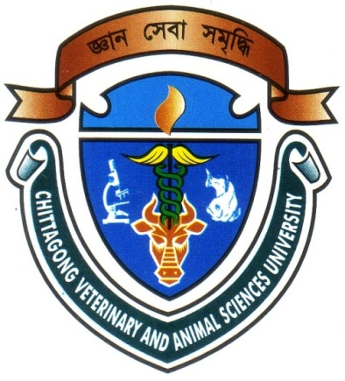

**A Production Report Submitted**

**By**

**Roll No: 2006/17**

**Registration No: 255**

**Intern ID: B-15**

**Session: 2005-2006**

**Report Presented In Partial Fulfillment of the Requirement for the Degree DVM (Doctor of Veterinary Medicine)**

**CHITTAGONG VETERINARY AND ANIMAL SCIENCES UNIVERSITY, KHULSHI, CHITTAGONG-4202**

**MAY 2012**

**PRODUCTION OF YEAST AS A POULTRY FEED SUPPLEMENT**

##### Veterinary Logo

##### A production report submitted as per approved style and content.

###### **Signature of Supervisor**



**Name:** **Ashraf Ali Biswas**

**Designation:** Director (external affairs) and Professor

**Department: General Animal Science and**

**Nutrition**

Chittagong Veterinary and Animal Sciences University

Date:

**PRODUCTION OF YEAST AS A POULTRY FEED SUPPLEMENT**



##### A production report submitted as per approved style and content.

**Signature of Author**

**Name: Md. Rofy Foysal Talukder**

**Roll No. :**  **2006/17**

**Registration No. :** **255**

**Intern ID. : B-15**

**Session : 2005-2006**

**CONTENTS**

|  |  |  |
| --- | --- | --- |
| **SL. NO.** | **TOPICS** | **PAGE NO.** |
|  | ACKNOWLEDGEMENT | I |
|  | ABSTRACT | II |
| Chapter-I | INTRODUCTION | 1-3 |
| Chapter-II | REVIEW OF LITERATURE | 4-10 |
| Chapter-III | METHODS AND MATERIALS | 11-15 |
| Chapter-IV | RESULTS AND DISCUSSION | 16-19 |
| Chapter-V | CONCLUSION | 20 |
| Chapter-VI | REFERENCES | 21-25 |

**List of Tables**

|  |  |  |
| --- | --- | --- |
| **Serial No.** | **Topics** | **Page No.** |
| **01.** | Composition of media(10% molasses) for yeast production | **11** |
| **02.** | Composition of media(15% molasses) for yeast production | **11** |
| **03.** | Composition of media(20% molasses) for yeast production | **12** |
| **04.** | Composition of media(25% molasses) for yeast production | **12** |
| **05.** | Composition of media(30% molasses) for yeast production | **12** |
| **06.** | Yield of yeast in different concentrations of molasses. | **16** |
| **07.** | Crude protein (%) of yeast in different concentrations of molasses. | **16** |

**List of Figures**

|  |  |  |
| --- | --- | --- |
| **Serial No.** | **Topics** | **Page No.** |
| **01.** | Yeast in naked eye. | **14** |
| **02.** | Yeast cells under light microscope. | **14** |
| **03.** | Yeast cells under electron microscope. | **14** |
| **04.** | Activities in CVASU Animal Nutrition Lab. and PRTC Lab. | **15** |
| **05.** | Yield of yeast in different media. | **17** |
| **06.** | CP% in yeast cells of different media. | **18** |
| **07.** | Comparison of yield(%) and CP% of yeast in different media. | **18** |