STUDY ON FEED CONVERTION EFFICIENCY OF BROILER UNDER DIFFERENT FARMS

EXAMINATION ROLL NO: 06/30
INTERN ID: D-27
REGISTRATION NO: 268
SESSION: 2005-2006

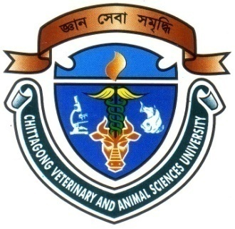

AS THE PARTIAL FULFILLMENT FOR THE DEGREE
OF

DOCTOR OF VETERINARY MEDICINE (DVM)

CHITTAGONG VETERINARY AND ANIMAL SCIENCES UNIVERSITY

KHULSHI, CHITTAGONG-4202

May 2012
STUDY ON FEED CONVERTION EFFICIENCY OF BROILER UNDER DIFFERENT FARMS

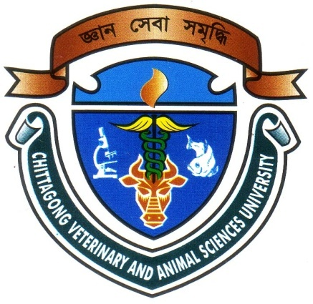

Approved as to style and content by

Signature of the Supervisor

Name: Professor Md. Kabirul Islam Khan
Designation: Professor and Head,
Department of Genetics & Animal Breeding
Chittagong Veterinary And Animal Sciences University.
Date:15/05/2012

Signature of the Author
Name: Shahnaj Pervin
Roll No: 2006/30
Reg. No.: 268
Intern ID: D- 27

Date of submission: 15/05/2012

Date of submission: 15/05/2012

CHITTAGONG VETERINARY AND ANIMAL SCIENCES UNIVERSITY

KHULSHI, CHITTAGONG-4202
MAY 2012
LIST OF CONTENTS
CHAPTER | TITLE | PAGE NO
I  II  III  IV  V  VI | INTRODUCTION  REVIEW OF LITERATURE  MATERIALS AND METHODS  RESULTS AND DISCUSSION  CONCLUSION  REFERENCES | 1-2

LIST OF TABLE
TABLE NO | TITLE | PAGE NO
Table1  Table 2  Table 3  Table-4 | Ration for broilers from day old to finisher  Vaccination Schedule  Effect of liveweight, and weight gain on different farms  Effect of feed intake and FCR on different farms

LIST OF graphs
GRAPH NO. | TITLE | PAGE NO
Graph 1  Graph 2  Graph 3  Graph 4 | Relationship between time with live weight (gm) in Farm-1  Relationship between time with live weight (gm) in Farm-2  Relationship between time with feed intake (gm) in Farm-1  Relationship between time with feed intake (gm) in Farm-2 | 11  11  13  13

Acknowledgements
The author bends her heads to the Almighty who is omnipotent, omniscient and omnipresent for His endless blessing to conduct this research work for the fulfillment of the requirement for the degree of Doctors of Veterinary Medecine(DVM).

The author desires to express her earnest gratefulness and profound appreciation to the following persons for the accomplishment of this dissertation.

The author convening her gratitude and great appreciation to the venerable internship supervisorr Professor Md. Kabirul Islam Khan, Professor and Head,Department of Genetics & Animal Breeding,,CVASU for his valuable guidance, suggestion, supervision and encouragements during the entire period of this study to complete this report.

The author also feels great pleasure to express her best regards to Mr. Iqbal ,farm owner Mr. Shahin ,manager and all employees of Sotota broiler farm, Gazipur sodor ,Gazipur, for their active co-operation during the experimental period.

Last but not least, the author is profoundly grateful to all of her well wishers, room mates and close friends for their encouragements and inspiration during her study period and preparation of this report at this level.

The Author

