A STUDY ON SUCCESS OF ESTRUS SYNCHRONIZATION AND ARTIFICIAL INSEMINATION IN CATTLE
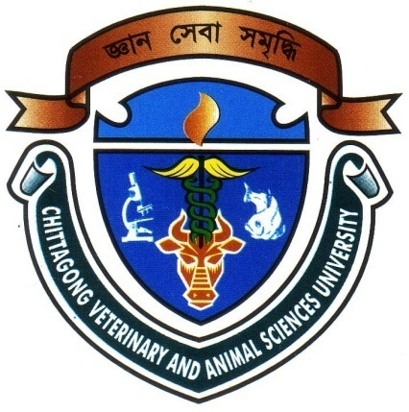

A CLINICAL REPORT SUBMITTED BY
Roll No.2006/05
Reg.No.243
Intern ID: A-04
Session: 2005-2006

A clinical report presented in partial fulfillment of the requirement for the degree of Doctor of Veterinary Medicine (DVM)

CHITTAGONG VETERINARY AND ANIMAL SCIENCES UNIVERSITY KHULSHI, CHITTAGONG-4202

A STUDY ON SUCCESS OF ESTRUS SYNCHRONIZATION AND ARTIFICIAL INSEMINATION IN CATTLE

A clinical report submitted as per approved style and content

----------------------------------- -----------------------------------
Signature of Author Signature of supervisor
Tareq mahmud Dr. A.K.M SAIFUDDIN
Roll No: 2006/05 Professor
Reg. No: 243 Department of
Intern ID: A-04 Physiology, Pharmacology,
&Biochemistry
Chittagong Veterinary and Animal
Sciences University, Chittagong-4202

CHITTAGONG VETERINARY AND ANIMAL SCIENCES UNIVERSITY KHULSHI, CHITTAGONG-4202.
CONTENTS

01 | ACKNOWLEDGEMENT
02 | ABSTRACT

CHAPTER | NAME OF CONTENTS | PAGE NO.
I. | INTRODUCTION | 01-02
II | REVIEW OF LITERATURE | 03-07
III | MATERIALS AND METHODS | 08-09
IV | RESULTS AND DISCUSSION | 10-12
V | CONCLUSION | 13
 | REFERENCE | 14-17
 | APPENDIX | 18-22

ACKNOWLEDGEMENTS

First praise to acknowledge the immeasurable grow and profound kindness of my creator the Almighty Allah, the supreme ruler of universe.
It is my great privilege to express deep sense of gratitude and heartfelt indebtedness, sincere appreciation and profound regards to my honorable supervisor Dr. A.K.M SAIFUDDIN Professor, Department of Physiology, Pharmacology & Biochemistry Chittagong Veterinary and Animal Sciences University, Chittagong, who involved during every steps of this study from its inception to completion.
I would also like to express my special gratitude to Project Manager Artificial Insemination in Dairy and Beef Cattle, Mahideb Jubo Somaj Kallayan Somity (MJSKS) Ulipur, Kurigram. I acknowledge to all respondents of the study areas and different institution without whose willingness to provide information this study would not be possible to perform.

The Author

ABSTRACT

An experiment was performed to synchronize estrus in cattle by the Mahideb Jubo Somaj Kallayan Somity under a project of Artificial Insemination in Dairy and Beef cattle at Ulipur upazila in Kurigram district for the year 2011. The aim of this project was to synchronize estrus of cattle as they give birth between September to November. My internship placement was ZIBIKA,CLP,Kurigram from 02/04/2012to 21/04/2012. I collected all recorded data about estrous synchronization for my clinical report from the Mahideb Jubo Somaj Kallayan Somity under a project of Artificial Insemination in Dairy and Beef cattle at Ulipur upazila in Kurigram district . Under the project 184 cattle were selected for synchronization of estrus. All selected cattle were dewormed, vaccinated against harmful diseases before synchronization treatment. Moreover they got a dose of prebiotic-probiotic combination and multivitamin before synchronization treatment. Among the selected cattle 165 were heifer and 19 were cow. The age of heifers were around 2.5-3years and cows parity were 1.The body condition score was above 3.5. The Ovsynch (First day GnRH-8th day PGF2α-10th day GnRH and estrous with 48hrs) method of estrus synchronization was followed. Injection GnRH (Fertilon®, Synthetic Gonadorelin-100microgram per ml , Dose-5ml/cattle, Marketed by Techno Drugs) at first day and Injection PGF2α( Dinoprost®, Trometamol-5mg per ml ,Dose-5ml/cattle, Marketed by Techno Drugs) at day 8th then again injection GnRH at day 10 was used. 122 heifers and 13 cows were respond to synchronized method . Overall conception rate was 51.51 and service per conception rate was 1.97.
Key words: Estrus synchronization, Ovsynch, Conception rate, Prostaglandin, Gonadotropin releasing hormone.

