STUDY ON CASTRATION AND ITS EFFECTS ON BODY WEIGHT IN GOAT
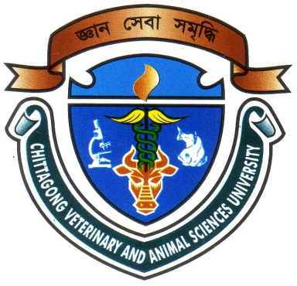

A Clinical Report Presented in Partial Fulfillment of the Requirement for the Degree of Doctor of Veterinary Medicine

A Report submitted by

Roll.No:06/20

Reg.No:258

Intern ID: C-17

Session: 2005-2006

Faculty of Veterinary Medicine

Chittagong Veterinary and Animal Sciences University

Khulshi, Chittagong-4202
STUDY ON CASTRATION AND ITS EFFECTS ON BODY WEIGHT IN GOAT

A Clinical Report Submitted as per approved style and content

--------------------------  (Signature of Author)  Nuzhat Nadia  Roll No: 06/20  Reg.No:258  Intern ID: C-17  Session: 2005-2006 | -------------------------------  (Signature of Supervisor)  Dr. Bhajan Chandra Das  Associate Professor  Dept. Medicine and Surgery  Faculty of Veterinary Medicine

Chittagong Veterinary and Animal Sciences University

Khulshi, Chittagong-4202

