CHAPTER I
INTRODUCTION

Bangladesh is a Muslim country where the larger part of the population is non vegetarian and largely dependent on meat based food. Cattle and buffalo are the largest source of meat in this country. Although there is 23.90 million cattle and 1.0 million buffalo (DLS, 2002, Bangladesh Agricultural Census, 1977, FAO.) hundreds of thousands of live cattle and buffalo are being imported in this country each year to meet up the increasing demand (Alam et al., 2010). Slaughterhouse or abattoir is the facility where these animals are killed for consumption as food products (http://en.wikipedia.org/wiki/Slaughterhouse).

An ideal slaughterhouse fulfils the features such as antemortem and postmortem carcass inspection, hygienic management and condemnation of diseased animal to ensure the best quality consumable animal products (Torres, 2007). Therefore, slaughter house inspection is a very important responsibility of the local veterinary authority and municipality to determine whether or not the animal was suffering from any disease or disease condition that makes the carcass inconsumable.

Food animal carcasses are a possible source of several infectious zoonotic diseases such as tuberculosis, leptospirosis, salmonellosis, campylobactoriosis, anthrax, hydatidosis etc (Scott et al., 1987). The emergence of high pathogenic avian influenza (HPAI) and anthrax have made the society more concerned about the health issues and quality of slaughtered animal carcass (Tulayakul et al., 2008). FAO impose veterinary public health systems and services to strengthen veterinary supervision as well as the inspection of animal slaughter, slaughterhouse hygiene and meat (www.fao.org/foodchain).

While slaughterhouse inspection is mandatory and assessment of carcass quality is strictly followed in developed countries the scenario of underdeveloped and third world country is quite opposite (Joshi et al., 2003). In Bangladesh there were no slaughterhouses yet established with appropriate facilities; instead, traditional slaughtering places and slaughter slabs are present in municipalities and city corporations throughout the country (APHCA).

The liver is the largest gland and one of the vital organs of the body comprising about 1-1.5% of total body weight. It is also the most susceptible organ for various infectious diseases and pathological affections (McGavin et al., 2001). In carcass inspection, liver gets condemned for consumption for a variety of reasons. Several parasitic diseases like fascioliasis, amphistomiasis, hydatidosis; bacterial diseases such as tuberculosis, bacterial hepatitis, hepatic abscess and leptospirosis are very common among the different pathological affections of liver (McGavin et al, 2001). Besides, several other systemic anomalies such as hepatitis, abscess, leptospirosis, icterus, hepatic encephalopathy, cholicystitis, fibrosis, cirrhosis etc are very common in liver (Jones et al, 1997).

A number of studies have been conducted on pathological affections of livers in slaughtered animal carcass from different part of the world and in Bangladesh (Ahmedullah et al, 2007, Kabir et al., 2010, Basak et al., 2011). The prevalence of disease and disease conditions in this animal defers largely from that of the local animal population (Kabir et al., 2010) and therefore investigation is required to identify and to ensure the quality consumption.

Several factors such as species, breeds, sex, age, origin of the animal, seasonal variations etc may play role in the incidence of pathological affections of lung in slaughtered animal (Jared et al., 2010). The condemnation policy and practice may vary from country to country depending on the infection load and socio-economic condition. Therefore these factors are very impotent guideline for the meat inspectors to determine the carcass quality and to make certification standards (Hansson et al.,2000).

Gross pathological examination is the most common practice to conduct slaughterhouse survey throughout the world. Hence histopathological study of the gross affections also consolidates the diagnostic precision and thereby implies positive impact on effective survey and so secure public health (Belkhiri et al., 2009).

Chittagong is the second largest metropolitan city and the economic capital Bangladesh. Chittagong City Corporation encompasses 168 square kilometer area and 5.5 million human populations. There are established slaughterhouses in Chittagong city where Firingibazar is the largest one. Yet there is no reported study on the incidence pathological affections in slaughtered carcasses from the slaughterhouses of Chittagong metropolitan.

So, considering the above facts in mind, the present study was undertaken with the following objectives:
- To identify the incidence of pathological affections of liver in slaughtered animals carcasses in a selected slaughterhouse of Chittagong metropolitan.
- To determine the frequency of different pathological lesions among the affected liver.
- To identify the gross and microscopic features of these lesions.

CHAPTER II
REVIEW OF LITERATURE

Pathological affections in liver have been studied in slaughterhouses of all over the world by several researchers. The literature cited in different journals and publications are reviewed as follows:
2.1 Records from Bangladesh:
Ahmedullah et al. (2007) studied different pathological affections in liver of buffalo carcasses in slaughterhouses of Barisal district. They recorded Gigantocotyle explanatum infection (amphistomiasis) in 31.25%, Fasciola gigantica 22.5%, hydatidosis in 2.5%, abscesses in 3.75% and hemorrhages in 2.5% carcasses. Besides, cirrhosis 7.5%, granulomatous hepatitis 5% and parasitic cholecystitis 15% were the observed microscopic lesions.

Kabir et al. (2010) worked in buffalo In Bangladesh, reported overall prevalence of hydatidosis was highest (26.01%) followed by fascioliasis (20.74%), amphistomiasis (19.62%). The prevalence of above mentioned diseases was higher in older animals. The prevalence of hydatidosis, fascioliasis and amphistomiasis was higher in male in case of cattle and goats. The study revealed that out of 3510 examined animals, the parasitic infections due to one or more disease conditions were found in 1216 (83.28%) of 1460 cattle and 187 (30.16%) of 620 buffaloes, 738 (76.08%) of 970 goats and 189 (41.08%) of 460 sheep

Miazi et al. (2010) conducted a study to investigate about the prevalence of parasitic diseases in different abattoirs in selective area of Bangladesh. The overall prevalence of hydatidosis was highest (26.01%) followed by fascioliasis (20.74%), amphistomiasis (19.62%). He mentioned the diseases were higher in older animals and females. He also reported that proportional prevalence of different disease conditions in cattle was much higher in Hariana breed than those of local and crossbred cattle. According to his study buffaloes are more prevalent with different parasitic disease.
Rahman et al. (2011) identified the prevalence of brucellosis at Bagerhat, Bogra, Gaibangha, Mymensingh and Sirajgonj of Bangladesh by serological study and determined 2.87% in buffaloes, 2.66% in cattle, 3.15% in goats, and 2.31% in sheep prevalence.

Talukder et al. (2010) worked on pathological effect of liver fluke in Black Bengal goats in Sylhet district of Bangladesh. They described that migratory tract with lymphocytic infiltration, atrophy, necrosis and fatty changes in the liver was the common histopathological changes associated with fascioliasis.

2.2 Records from Abroad:
Abayneh and Urga (2007) studied 21.6% prevalence of Fascioliasis in Tigray region, Sudan.

Bala et al. (2011) studied that in Nigeria the Species-specific prevalence of tuberculosis was 1.6%, 0.4%, 0.3%, 0.3% for cattle, sheep, goats and camels respectively with a 0.7% crude prevalence.

Ballweber (1958) studied that distinct migratory tract caused by Migration of immature flukes that causes traumatic hepatitis and hemorrhage, Migratory tracts eventually heal by fibrosis. By cross section of the affected liver reveled mature flukes may be found within the bile ducts. Flukes are leaf-shaped, greenish-brown, with conical anterior end and shoulders. Immature flukes (up to 7 mm in length) may be difficult. To find within the liver parenchyma; requires sequential slicing of the liver and expressing flukes from cut surfaces. Presence of adults causes extensive proliferation of the bile duct epithelium, cholangitis, and necrosis of the ductal wall. Fibrosis of the lamina propria of the bile duct occurs that may eventually calcify.

Basak et al. (2011) has observed the prevalence of fascioliasis was showed highest (65.78%), followed by hydatidosis (25.67%), Cirrhosis (9.86%), amphistomiasis (5.26%) and abscess (3.95%) in cattle liver from different slaughterhouses in Dinajpur district of Bangladesh.

Battelli et al. (2002) and Sadjjadi, (2006) showed high prevalence of hydatidosis in from all countries in the Middle East and Arabic North Africa.

Benito et al. (2006) dentified cystic ecchinococcosis (CE) as one of the most important zoonotic diseases and it is of great social importance.

Berhe et al. (2009) studied 4,481 slaughtered cattle at Mekelle municipal abattoir and observed a prevalence of 32.1% for hydatidosis.

Berhe et al. (2010) in kenya, found mixed infection with hydatidosis and fascioliasis in most of the liver affections While the individual prevalence of hydatidosis and fasciolosis was 32.11% and 24.32%, respectively.

Cullen et al. (1995) reported that Hepatic cirrhosis is defined by these pathological affections, loss of normal architectural structure due to nodular regression of parenchyma, fibrosis and often biliary duct hyperplasia, profound vascular abnormalities and irreversible result. Hepatic abscess is defined by, phlebitis that results in mural thrombosis, passive congestion of the liver, portal hypertension .hydatid cyst measures usually less then 10 cm in diameter, chronic inflammation in biliary duct.

Dakhly et al. (2007) identified fascioliasis, hydatid cysts, cysticercoids as the common parasitic affections in liver while Enterobacter, Micrococcus, Citrobacter, Aerococcus, Pseudomonas, Chrysomonas and Streptococcus were the identidified bacterial diseases from slaughterhouses of Egypt.

Elmahdi et al. (2004) repported hydatidosis has been reported to have a prevalence of 45% in camels, 3% in cattle and 7% in sheep.

Ernest et al. (2004) showed that 48% of cattle, 34.7% of goat, 63.8% of sheep and 10% of dogs were infected with E. granulosus in Tanzania.

Garippa et al. (2004) and Ibrahim et al. (2008) identified that raising small ruminants (extensive or semi extensive grazing), illegal slaughtering of the animals, and the presence of high number of dogs is the predisposing cause of high rate of hydatidosis.

Getaw et al.( 2009) identified hydatidosis in 46.8% cattle, 29.3% sheep, and 6.7% goats Sudan.

Goto et al. (2010) identified Echinococcus Multilocularis frequently from the liver of race horse in yamagata, japan.

Hansson et al. (2000) reported that Pathological and additional findings are registered by meat inspectors from the Swedish National Food Administration at the post-mortem inspection. There was a significant difference at the post-mortem inspection of growing-fattening pigs; 28% of conventionally and 17% of the organically reared pigs had one or more registered lesion. The carcass evaluation of swine shows a higher meat percentage in conventional swine production. The total rate of registered abnormalities in cattle was systems around 28% from organic and 27% from conventionally reared herds.

Ibrahim et al. (2004) studied that Cystic Ecchinococcosis (CE) is an important problem for public health and the economy in many parts of the world.

Jacinta, (1983) reported that the infection rates of fascioliasis was higher in the highlands are influenced by environmental conditions including rainfall, temperature and biotopes that influence the parasite, intermediate and final host.
Kambarage et al. (1995) reported that, liver condemnation due to fasciola in cattle (8.6 %),sheep (3.1 %) and goat (3.1 %).Suggest the parasite economic importance in domestic ruminants.indded ,fesciolosis was the leading cause of liver condemnations.

Kebede et al. (2009) found a prevalence of 34.5% (143/420) and 16% (64/400) hydatid cysts in cattle slaughtered at Bahir Dar and in Wolaita Sodo abattoir, respectively.

Kithuka et al. (2002) Mungube et al., 2006 identifies the prevalence of fasciolosis was 8% and 26% were found from abattoir survey in Kenya.

Mellau et al. (2007) reported that out of 115186 cattle,61551 sheep and 37851 goats salughterd 18829(16%),10515(17%) and 7011(18.5%) livers of cattle, sheep and goats respectively condemned due to 11 diseases namely fasciolosis, stilesiosis, hydatidosis, calcified cyst, abscess, cysticercus tenuicollis infection, telangiectasis, hepatitis, fatty degeneration, melanosis and liver cirrhosis.

Moro et al. (2008) mentioned that six species have of Ecchinococcosis been recognized about which Echinococcus granulosus (which causes cystic echinococcosis), Echinococcus multilocularis (which causes alveolar echinococcosis), and Echinococcus vogeli and Echinococcus oligarthrus (which cause polycystic echinococcosis). He have shown that these diseases are an increasing public health concern and that they can be regarded as emerging or re-emerging diseases.

Njoroge et al. (2002) in In Kenya found 19.4% of cattle, 3.6% of sheep, 4.5% of goats and 61.4% of camels were found infected with hydatidosis.

Pfukenyi et al., (2004 ) identified 31.7% prevalence of fasciolosis in Zimbabwe.

Salih et al. (2011) in Ethiopia, determined that hydatidosis was the most common liver affection with high prevalence (28.63%) and the distributions of the cysts were 67.3% in lung alone, 25% both liver and lungs, 6.73% in liver only and 0.96% in heart.

Sohair et al. (2009) studied 56 bovine liver samples were collected from and found acute suppurative hepatitis while 39 (69.6%) out of 56 cases appeared to be infected with chronic hepatitis.

Swai et al. (2011) reported that currently in Tanzania, there is limited documentation of zoonoses in slaughtered stock. Lack of awareness of meat-borne zoonoses can put the lives of livestock producers, abattoir workers and the general public at risk from infection.

Takele et al. (1995) recorded 15.9% F. hepatica, 57.2% F. gigantica and 26.9% mixed infection.

Tilahun et al., 2006 in Wondogenet and Kemissie areas revealed the prevalence of 39.7% and 41%, respectively.

CHAPTER III
MATERIALS AND METHODS

3.1. Study area and duration
This study was carried out by 28 visits to Firingibazar slaughterhouse from January to May 2012. In the month of March no visits was conducted for certain causes. All the animals slaughtered in these working days were counted and demographic data like species, age, sex, origin, body condition etc was carefully recorded.

3.2. Sampling strategy
A total of 882 animals were carefully examined at the lairage (docking area) to record the demographic data. At slaughter slabs when the carcasses are bled and completely opened, the visceral organs were thoroughly examined by close inspection and palpation. Livers suspected with pathological affections were isolated from the carcass and washed with water for detailed gross examination. Gross pathological lesions were detected and recorded with the aid of an experienced pathologist following FAO meat inspection manual (Herenda et al. 1994). From each and every suspected liver with pathological affections, samples were collected with the help of the butcher leader and city corporation meat inspector. The tissue samples were carried to CVASU pathology laboratory in cool boxes as early as possible and fixed at 10% neutral buffer formalin for histopathological study.

3.3. Histopathological study
For histopathological study formalin fixed tissue samples were washed and dehydrated in graded ethanol and embedded in paraffin wax. Fixed tissues were sectioned at 5 μm thickness and stained with hematoxylin and eosin as per standard method (Luna, 1968).

3.3.1 Equipment and appliances for histopathology
- Sample from animals(Liver)
- 10% neutral buffered formalin
- Chloroform
- Paraffin
- Alcohol
- Tape Water
- Xylene
- Hematoxylin and Eosin Stain
- Distilled water
- Clean Slides
- Cover slips
- Mounting media (DPX)
- Microscope

3.3. 2. Collection of tissue and tissue processing
During tissue collection the following point were taken into consideration; the tissues were collected in conditions as fresh as possible. Normal and diseased tissues were collected side by side. The thickness of the tissues were as less as possible (5mm approximately). Formalin fixed tissues were processed by following protocol.

Fixation: 10% neutral buffered formalin was added in the plastic container. (10 folds of the tissue size and weight) and fixed for 3-5 days.

Washing: The tissues were trimmed into a thin section and washed over night in running tape water to remove formalin.

Dehydration: The tissues were dehydrated by ascending ethanol series to prevent shrinkage of cells as per following schedule. The tissues were dehydrated in 50%, 70%, 80%, 95%, 100%, 100%, 100% ethanol one hour in each.

Cleaning: The tissues were cleaned in chloroform for 3 hours to remove ethanol (two changes; one and half hour in each).

Impregnation: Impregnation was done in melted paraffin (56- 60°c) for 3 hours.

Sectioning: Then the tissues were sectioned with a microtome at 5-µm thickness. A small amount of gelatin was added to the water bath for better adhesion of the section to the slide. The sections were allowed to spread on warm water bath at 40-42°C. Then the sections were taken on grease free clear slides.
Drying: The slides containing section were air dried and kept in cool place until staining.

3.3.3. Routine hematoxylin and eosin staining procedure
The sectioned tissues were stained as described below:
- The sectioned tissues were deparaffinized in three changes of xylene (three minutes in each)
- Then the sectioned tissues were rehydrated through descending grades of alcohol (three changes in absolute alcohol, three minutes in each; 95% alcohol for two minutes; 80% alcohol for two minutes; 70% alcohol for two minutes) followed by distilled water for five minutes.
- The tissues were stained with Harris hematoxylin for fifteen minutes.
- Washed in running tap water for 10-15 minutes.
- Then the tissues were differentiated in acid alcohol by 2 to 4 dips (1 part HCL and 99 parts 70% alcohol).
- Washed in tap water for five minutes followed by 2-4 dips in ammonia water until sections were bright blue.
- Stained with eosin for one minute.
- Differentiated and dehydrated in alcohol (95% alcohol: three changes, 2-4 dips each; absolute alcohol: three changes 2-3 minutes for each).
- Cleaned in xylene: three changes (five minutes each).
- Tissues were mounted with cover slip by using DPX.
- The slides were dried at room temperature and examined under a low (10X) and high (40X, 100X) power objectives.

3.4. Statistical analysis
The obtained data form gross and microscopic examination was imported, stored and coded accordingly using Microsoft Excel-2000. Chi Square test was done for determination of association between the variables by using statistical software STATA/IC-11. Significance was determined in 95% confidence interval when P<0.05.

CHAPTER VI
Results
4.1. Incidence of pathological affections in Liver in slaughtered carcasses:
Form 28 visits over 4 month period a total of 882 (660 cattle and 222 buffalo) carcasses were examined where different types of pathological affections were found in 105(11.90%) liver. The incidence of liver affections was found in higher rate April-May (20.40%) month compared to that of 12.86% in January and 8.63% in February (Table. 1). About 11.06% cattle and 14.41% buffalo liver (Table. 2) essentially showed different pathological affections (Table. 2).
Table: 1. Incidence of pathological affections of liver over the study period:
Month of Visit | No. of Visits | No. Animal Slaughtered | Observed Liver lesions |  |  | Overall Percentage
 |  |  | Cattle | Buffalo | Overall
January | 8 | 272 | 17 | 18 | 35 | 12.86%
February | 15 | 463 | 31 | 9 | 40 | 8.63%
April-May | 5 | 147 | 25 | 5 | 30 | 20.40%
Total | 28 | 882 | 73 | 32 | 105 | 11.90%

Table: 2. Frequency of liver lesions in different species (Cattle and Buffalo):
Observed Animal Species | No. Animal Slaughtered | No. of affected Liver | Percentage
Cattle | 660 | 73 | 11.06%
Buffalo | 222 | 32 | 14.41%
Total | 882 | 105 | 11.90%

4.2. Frequency of different lesions among the affected liver:
Based on gross and microscopic examination, the frequencies (%) of different pathological lesions in liver are demonstrated in Figure.1. Hydatid cysts was the most frequent liver affection found in 50.47% case which is followed by fascioliasis (33.33%), amphistomiasis (21.25%), hepatic abscess (16.19%), hepatic cirrhosis (13.33%), hepatic necrosis (8.57%) and nodular lesions (5.71%). It is to be mentioned that mixed type lesions, i.e. multiple hepatic affections observed in many cases.
N= Total Number of affected liver (105)
Figure 1: Observed proportion of liver lesions in the study period
In the present study the most common pathological affections found in cattle liver was hydatid cyst (56.16%) which is significantly higher than buffalo (37.50%). On the other hand, in buffalo liver incidence of amphistomiasis (31.25%) and cirrhosis (28.12%) was significantly higher than that of cattle where 16.43% and 6.84% cattle liver affected respectively. Although fascioliasis was the commonest pathological affection in buffalo liver, no significant variation was observed with the incidence of fascioliasis in cattle. Other than that no hepatic nodule was observed in buffalo liver (Table. 3).

Table. 3: Comparative frequency of liver affections in cattle and buffalo
Pathological Affections | Cattle (N= 73) |  |  | Buffalo (N=32 ) |  |  | P value
 | No. | (%) | 95 % CI | No | (%) | 95 % CI
Hydatid Cyst | 41 | 56.16 | 44.56- 67.76 | 12 | 37.50 | 20.25-54.74 | 0.031*
Amphistomiasis | 12 | 16.43 | 10.73-32.22 | 10 | 31.25 | 18.41 -38.86 | 0.031*
Fascioliasis | 22 | 30.13 | 19.41 -40.86 | 13 | 40.62 | 23.13-58.11 | 0.147
Hepatic Nodule | 6 | 8.21 | 1.80- 4.63 | - | - | - | -
Abscess | 9 | 12.32 | 4.64- 20.01 | 8 | 25.00 | 9.57-40.42 | 0.052
Cirrhosis | 5 | 6.84 | .94-12.75 | 9 | 28.12 | 12.11-44.13 | 0.001*
Calcified Cyst | 1 | 1.36 | -1.3-4.08 | 2 | 6.25 | -2.37- 14.87 | 0.083
Hepatic Necrosis | 5 | 6.84 | 0.94-12.75 | 4 | 12.5 | 0. 72-24.27 | 0.170

4.3. Gross lesions:
The gross features of the pathological affections of liver have been demonstrated in Fig.2. Hepatic abscess was characterized by large solid space occupying lesion in the quadrate lobe of liver (Fig. 2.B). The liver capsule was separated from the base by large accumulation of pus. Lumps of solid mass diffusely present throughout the liver with marked nodular consolidation indicated cirrhosis (Fig. 2.A). Hydatid cysts of varying size were found on the surface of liver. The average diameter of the hydatid cysts were 3-5 cm in diameter, but in some cases large cysts exceeding 20 cm diameter containing large quantity of fluid was also observed. Polycystic liver with multiple number of yellowish fluid filled viable cysts were most common liver affections (Fig. 2.C). Often abscess was formed on the edge of the liver surface following cystic lesion (Fig. 2.D). Suppurative lesion was observed in many degenerated cysts. Distinct grey-white migratory tract was observed at the visceral surface of the liver lobes as evidence of fascioliasis (Fig. 2.E). Besides, large liver flukes were seen expelled out in high pressure around the gall bladder and large bile ducts. Moreover the capsular surface of Fasciola affected liver showed grayish discoloration. In the cut surface of the liver and bile ducts movement of live worms are visible. Marked necrosis and fibrosis was evident around the affected bile ducts (Fig. 2.F) where gritty cut sound was found indication calcification.
4.4. Microscopic lesions
The liver samples with selected gross pathology were carefully examined under microscope after preparation of the histopathological slides. The microscopic features liver affection has been demonstrated in Fig. 3. Microscopically the hydatid cyst induced abscess have shown thick inflammatory zone with centrally caseous mass showing remnant of cyst wall (Fig.3. F). The hepatic necrosis was characterized by necrotic zone around the periportal areas (Fig. 3.A) around the hydatid cyst there was marked cellular reaction characterized by proliferation of fibroblasts, infiltration of mononuclear cells. Cross section of large liver fluke in the stretched bile duct with massive biliary fibrosis and cirrhosis of the affected liver section was associated with Fascioliasis (Fig.3. C, D, E). Along with the hepatic fibrosis the hyperplasia of bile ducts and pipe stem liver were also common with chronic Fascioliasis (Fig. 3.B) The nodular lesions in liver showed variable forms of hepatic fibrosis and infiltration of inflammatory cells.

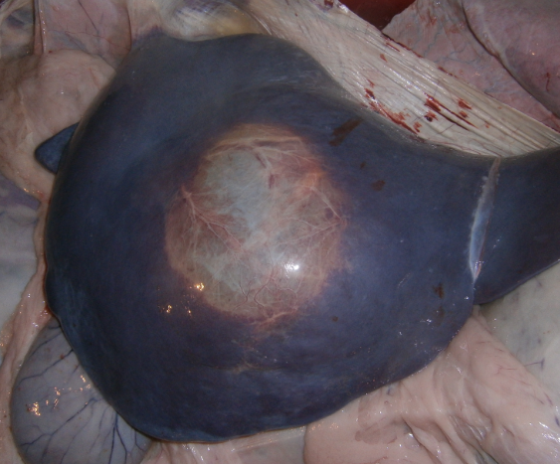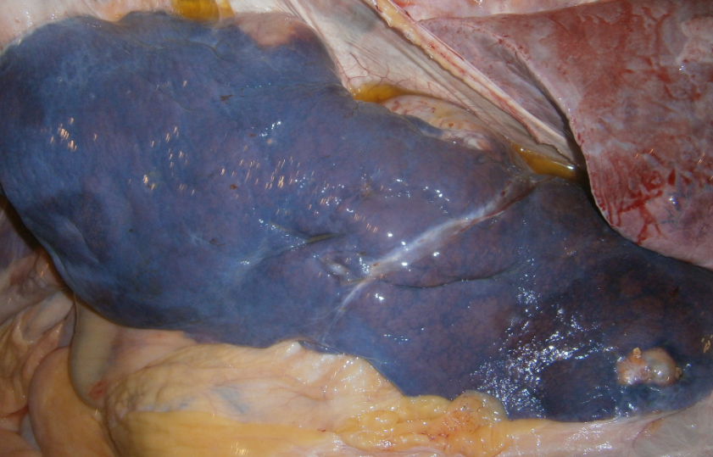

B
A

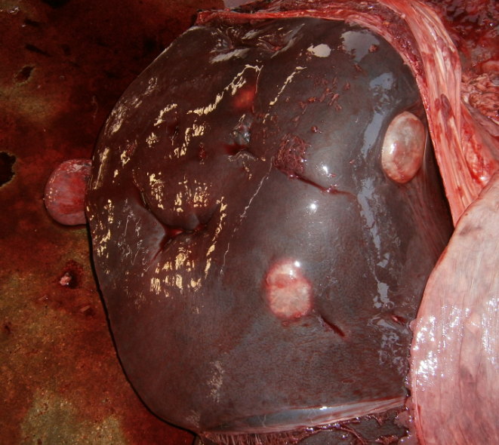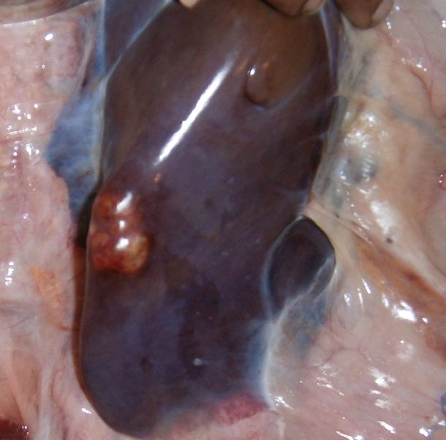

D
C

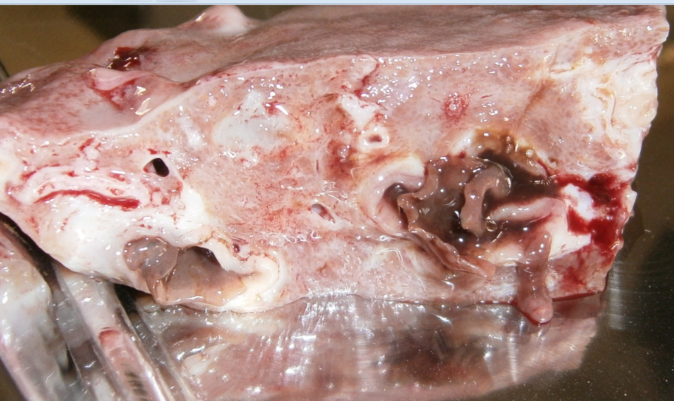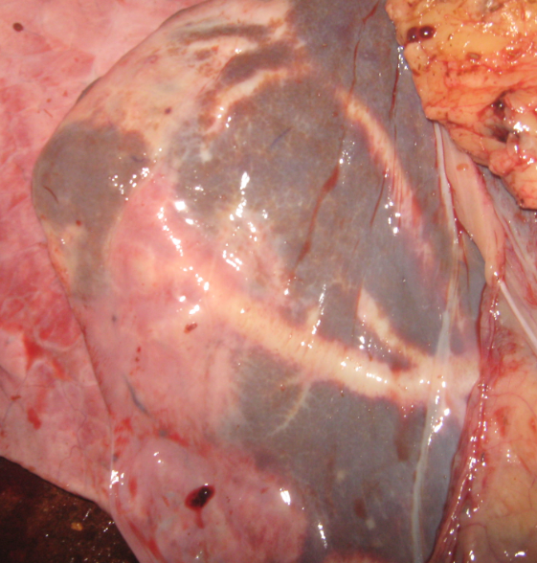

F
E

Fig. 2: The gross pathological lesions observed in liver of slaughtered animal: A. Hepatic cirrhosis characterized by marked nodular consolidation in liver; B. Large hepatic abscess occupying most of the quadrate loab; C. Multiple large hydatid cyst over the capsular surface of the liver; D. Abscess on the edge of the liver surface following cystic lesion; E. Distinct migratory tract under the hepatic capsule caused by the movement of liver fluke; F. Cross section of the affected liver, adult fluke (Fasciola spp) protruding out from the bile ducts, marked necrosis and fibrosis present.

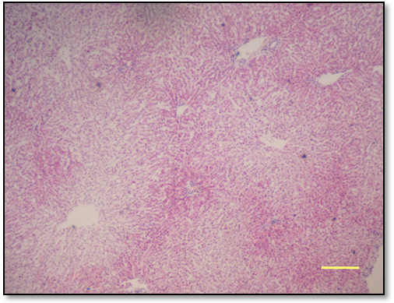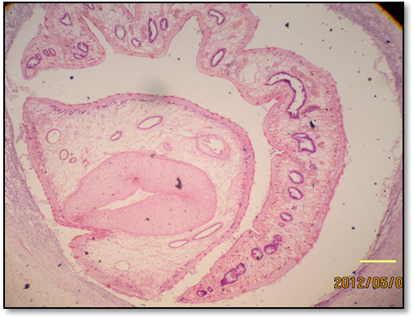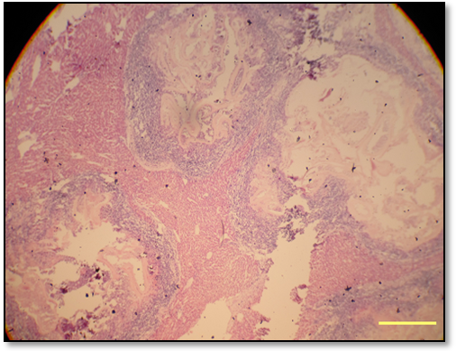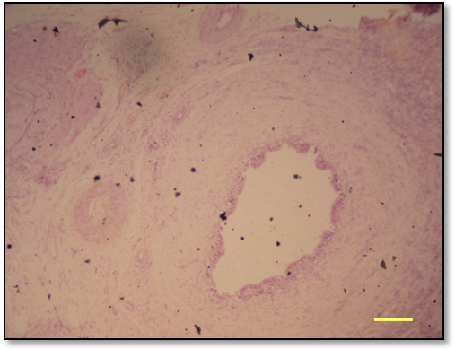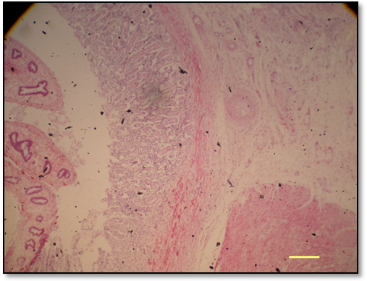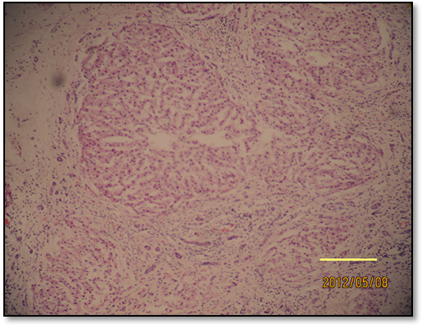
Fig. 3: Microscopic features of the liver affections: A. Periportal necrosis of hepatic lobules (H &E 120 X); B. Marked fibrosis and hepatitis of the hepatic lobules with bile duct hyperplasia (H &E, 200 X); C. Section of adult liver fluke in large bile duct (H &E, 80 X); D. Massive thickening of the bile ducts and fibrosis around the fluke infested liver section (H &E, 80 X); E. Biliary cirrhosis characterized by dense fibrous accumulation around the duct lumen (Pipe stem liver) (H &E, 120 X); F. Multiple hepatic abscess, thick inflammatory zone with centrally caseous mass showing remnant of cyst wall (H &E, 80 X). BAR=200 µ
A
B
C
D
E
F

200 µ

200 µ
200 µ
200 µ
200 µ
200 µ

CHAPTER V
DISCUSSION

In the present study about 11.90% carcasses showed different types of pathological affections in liver and incidence of liver affections was relatively higher in buffalo carcasses compared to that of cattle. This might be due to that fact that buffaloes are reared in scavenging system in marshy land and get more exposure to the various infectious agents and helminthes (Rodostits et al., 1995).
Higher prevalence of hepatic lesions observed in April-May month compared to the earlier months of observation. This difference might be influenced by the seasonality and climatic factors. In Bangladesh January is considered as winter, February as late winter and April-May is considered as summer season and high ambient temperature facilitate the infection with different pathogen which might affect the liver. There have been many reports on the seasonal influence of the liver affections. Usually high rainfall and hot summer season is highly preferable for infection with many helminth parasites such as fascioliasis, hydatidosis amphistomiasis etc. for which liver is the predilection site (Soulsby, 1982 and Phiri et al., 2005).
Among the different pathological affections maximum (56.16%) liver was positive for presence of hydatid cysts which is highest compared to the previous reports in Bangladesh. Kabir et al., (2010) also reported high prevalence (29.65%) of hydatidosis over Fascioliasis and Amphistomiasis from a study of different slaughterhouses of Bangladesh. Basak et al. (2010) also reported 25.67% prevalence of hydatid cysts in cattle liver whereas Sarder et al. (2005) recorded 17.17% hydatidosis in cattle liver. The higher prevalence of different parasitic infections might be due to that fact that most of the slaughtered cattle are imported from India. Kabir et al. (2010) demonstrated that Indian cattle particularly of Hariana breed suffer more than those of local and crossbred deshi cattle. The prevalence of hydatidosis was significantly found in higher rate in cattle then that of buffalo, this might be due to species preference of the helminth parasite.

Overall 33.33% liver was infected with fascioliasis which is comparatively lower to the reports by Basak et al. (2011) who showed 65.78% prevalence. Alternatively our study result is higher than the findings of Sarder et al. (2006) and Kabir et al. (2010) who found 25% and 20.74% prevalence respectively. This variation might be resulted from the study population where the previous studies only considered the cattle populations from Bangladesh whereas in this study both cattle and buffalo carcasses are taken under consideration and these animals are mostly imported from India. Kabir et al. (2010) reported that imported cattle form India is much more prone to helminth infection than local or cross breed cattle.

Although Fascioliasis observed in higher rate in buffalo, there is no significant variation observed between the prevalence of Fascioliasis in cattle. Ahmedullah et al. (2007) reported 22.5 % Fascioliasis in buffalo liver which is much lower than our study result. The overall prevalence of amphistomiasis was recorded 21.25 % in the present study and the infection rate in buffalo liver (31.25%) was significantly higher than cattle (16.43%). This result is exactly similar to the report by Ahmedullah et al, 2007. Kabir et al., 2010 recorded similar prevalence rate (26.36%) while Basak et al. (2011) lower (5.25%) rate from Rajshahi district.
Overall 16.19 % abscess was recorded in the present study which is much higher than previous reports. Basak et al. (2011) and Ahmedullah et al. (2007) reported 3.95% and 3.75% cases of hepatic abscess in their respective studies. This high percentage of hepatic abscess might be resulted from higher rate of infection with hydatidosis. Older hydatid cyst when ruptured get infected by the suppurative organisms and resulted in abscesses.
In the present study overall 13.33% cases of hepatic cirrhosis was observed which is much lower than the findings of Ahmedullah et al. (2007) but closer to the results of Basak et al. (2011). Significant different was observed between the proportion of cirrhosis in cattle and buffalo where buffalo shows much higher rate. The hepatic cirrhosis is resulted from varieties of pathogenic organisms and helminth infection. The higher rate of liver cirrhosis in buffalo might be due to the fact that the rate of infection with fascioliasis is higher in buffalo which resulted such lesion. Similar to the lesions observed with fascioliasis in our study Dawes (1963), Ross (1966) and Dow et al. (1967) described that Fasciola affected liver was discolored color with capsule was thick, rough with whitish or reddish discoloration and fibrosis of the bile ducts which indicated sub-acute form of infection.
The pathological lesions observed in this study come in agreement with many previous reports. Ahmedullah et al. (2007) large multiple hydatid cysts were found on the liver just beneath the capsule which is analogous to the lesions observed in this study. The size of the cyst varied largely but their average diameter (5-10 cm) which was similar to the findings of Basak et al. (2011). Almost 2.85% calcified cyst was observed in this study. There was evidence of migratory tract and hyperplastic bile ducts found in relation to fascioliasis which is relevant to the reports of (Roberts 1968, Acosta-Fereira et al. 1980, Ross et al. 1967 and Dow et al. 1967).
Hepatic abscess were characterized grossly by whitish foci on the surface of liver. Polymorphonuclear leukocytes at the center surrounded by a thin fibrous capsule were seen microscopically. Similar histopathological changes have been reported in earlier studies (Runnels et al., 1965; Uzoukwn and Ikeme, 1978). Hepatic cirrhosis was found associated with massive accumulation of fibrous connective tissue and atrophy of the hepatic lobules and found mostly associated with Fascioliasis and hydatidosis. Similar findings were described by previous researchers (Balasingam, 1962; Dawes, 1963; Gupta, 1983; Khalilov and Namosov, 1983).

CHAPTER VI
CONCLUSION

This study reports, a considerable number of slaughtered animal in Chittagong metropolitan area suffer from various types of liver diseases where hydatid cyst was the most common among them. The incidence of liver affection seems to be high in hot summer season and in buffaloes. More elaborative study is essential to identify the several risk factors associated with such condition. Bacteriological and molecular investigation is recommended to determine the incidence of potential zoonotic pathogen from the slaughtered animal carcass.

Chapter VII
Reference

Abayneh, T. and Urga, B. 2007. Study on management practices and work-associated health of draught oxen around Debreberhan, Central Ethiopia. Livestock Research for Rural Development 19 :1

Ahmedullah, F., M. Akbor, M.G. Haider, M.M. Hossain and M.A.H.N.A. Khan et al., 2007. Pathological investigation of liver of the slaughtered buffaloes in barisal district. Bangladesh J. Vet. Med 5: 81-85.

Alam, M. R., Jabbar, M. A., Uddin, M. S., Kibria, A. S. M. G., Gregory, N. G. and Silva-Fletcher, A. 2010. Skin injuries identified in cattle and water buffaloes at livestock markets in Bangladesh. Veterinary Record 167: 415-419.

Bala, A. N., Garba, A. E., Yazah, A. J. 2011. Bacterial and parasitic zoonoses encountered at slaughter in Maiduguri abattoir, Northeastern Nigeria, Vet. World 4(10):437-443.

Ballweber, L.R.,1958. Parasites of other organ,in Veterinary parasitology. Butterworth–Heinemann,U.S.A.pp. 270 -271.

Basak, P., Rashid, S.M.H., Isalm, M.N., Hossain M.,2011. Pathological investigation of liver of slaughtered cattle in dinajpur district of Bangladesh. Bangladesh research publication journal 5 (2):86-91.
Bekele, M. and Belay, I., 2011. Evaluation of Routine Meat Inspection Procedure to Detect Bovine Tuberculosis Suggestive Lesions in Jimma Municipal Abattoir, South West Ethiopia. Global Veterinaria 6 (2): 172-179.

Belkhiri, M., Tlidjane, M., Benhathat, Y. and Meziane, T., 2009. Histopathological study and pulmonary classification of bovine lesions . African Journal of Agricultural Research 4(7): 584-591.

Berhe, G., Tadesse G., Kiros, H. and Abebe, N., 2010. Concurrent Infection of Hydatidosis and Fasciolosis in Cattle Slaughtered at Mekelle Municipal Abattoir, Tigray Region. Ethiop. Vet. J 14 (2): 39-49.

Bob, T., 2007. Making a Killing ,U.S. Beef and Catttle industry, pp. 45.

Çetinkaya, B., Ertas H. B., Öngör H. and Muz, A., 2000. Detection of Leptospira Species by Polymerase Chain Reaction (PCR) in Urine of Cattle , Turk. J. Vet. Anim. Sci. 24:123–130.

Cullen et al,1995, 2001, Liver,biliary system,exocrine pancreas, Thomson’s special veterinary pathology,3rd Edn. pp.81-118.

Dakhly, K. M. E., Hassan, W. H. and Lotfy, H. S., 2007. Some parasitic and bacterial causes of liver affections in ruminants. BS. VET. MED. J. 21: 62-68.

Elmahdi, I.E., Ali, Q.M., Magzoub, M.M., Ali Abrahim, A.M., Saad, M.B. and Romig, T. 2004. Cystic echinoccosis of livestock and humans in central Sudan. Ann. 35: 43-45.

Ernest, E., Kassuku, A. and Kazwala, R., 2004. Studies on the epidemiology of echinococcosis/ hydatidosis in Ngorongoro district, Arusha region, Tanzania. International Arch Hydatid 35: 43.

Ezeh, A.O., Ellis , W.A., Kmety, E., Adesiyun, A. A. and Addo, P.B. , 1989. Bacteriological examination of bovine kidneys for leptospires in Plateau State, Nigeria. Rev. sci. tech. Off. int. Epiz.8 (4): 1005-1008.

FAO, Department of Livestock Services (projection), 2002. Bangladesh Agricultural Census, 1977.

FAO/UNEP/WHO, 1994. Guidelines for Echinococcosis/Hydatidosis Surveillance, Prevention and Control. FAO, Rome, No. 29, pp. 147.

Fleming, R, Eng, P. and MacAlpine M.,2005. Composting Blood (Slaughterhouse Waste) Mixed With Various Substrates.pp.1-14.

Food chain crisis management frame work. www.fao.org/foodchain.

Garippa, G., Varcasia, A. and Scala, A. 2004. Cystic echinococcosis in Italy from the 1950s to today. Parassitologia, 46: 387-391.

Getaw, A., Beyene, D., Ayana, D., Megersa, B. and Abunna, F., 2009. Hydatidosis: Prevalence and its economic importance in ruminants slaughtered at Adama municipal abattoir, Central Oromia, Ethiopia. Acta Trop.35 46.

Goto, Y., Sato K., Yahagi ,K., Komatasu,O., Hoshina,H., Abiko,C,. Yamasaki,H. and Kawanak,T. 2010. Frequent Isolation Of Echinococcus Multilocularis From The Liver Of Race Horse In Yamagata,Japan. Japn. J. Infect. Dis. 63 (2): 1-2

Hansson, I., Hamilton, C., Ekman, T. and Forslund K. 2000, Carcass quality in certified organic production compared with conventional livestock production. Infect Dis Vet Public Health 47(2):111-20.

Herenda, D., Chambers , P.G., Ettriqui, A., Seneviratna, P. and Silva, T.J.P. 2000, Manual on meat inspection for developing countries. Food and Agriculture Organization of the United Nations Rome. 56-59

Ibrahim, M. M., 2010. Study of cystic echinococcosis in slaughtered animals in Al Baha region, Saudi Arabia: Interaction between some biotic and abiotic factors. Acta Tropica. 113:26–33.

Jacinta, B.C., Scholtens, R.G. and Kasali, O. 1983. Parasites of sheep at the international Livestock Centre for Africa Debre Berhan station, Ethiopia.

Jacinta, E. 1983. Investigations on Fascioliasis in the Ethiopian Highlands around Debre Berhan. MSc Thesis. Institute of Tropical Medicine and Parasitology, Leiden University, The Netherlands. pp. 1-29.

Januškevičienė G., Paulauskas V., Dailidavičienė J. and Juozaitienė V. 2010. Analysis Of Pathologic Lesions In The Livestock And Poultry Slaughtered In The Meat Establishments Of Lithuania . Veterinarija Ir Zootechnika 52 (74): 22–23.

Jared, C. and Roach, et al. 2010; Analysis of Genetic Inheritance in a Family Quartet by Whole-Genome Sequencing. Acta Tropica 22: 121- 127.

Jones, T.C., Hunt R.D. and King N.W., 1997. The digestive system. In: Veterinary pathology. 6th Edn. Carrroll Cann (Ed).Williams & Wilkings,U.S.A. pp. 1089–1100.

Joshi, D. D., Maharjan, M., Johansen, M. V., Willingham, A. L. and Sharma, M., 2003. Improving meat inspection and control in resource-poor communities: the Nepal example. Acta Tropica. pp. 119-127.

Kabir, M. H. B., Eliyas, M., Hashem. M. A., Mohiuddin and Miazi O. F., 2010. Prevalence of zoonotic parasitic diseases of domestic animals in different abattoir of Comilla and Brahman Baria region in Bangladesh. Rajshahi. Univ. j. zool. 28: 21-25.

Kithuka, J.M., Maingi, N., Njeruh, F.M., and Ombui, J.N. 2002. The prevalence and economic importance of bovine fasciolosis in Kenya- an analysis of abattoir data. Onderstepoort Journal of Veterinary Research 69: 255-262.

Lawrie, R. A. and Ledward, D. A. 2006. Lawrie’s meat science (7th Ed.). Woodhead Publishing Limited. Cambridge.

McEvoy, J. M., Doherty, A. M., Sheridan, J. J., Blair, I.S. and McDowell, D.A. 2003. The prevalence of Salmonella spp. in bovine faecal, rumen and carcass samples at a commercial abattoir. Journal of Applied Microbiology 94: 693–700.

McEwen, S. A., 1987. Zoonosis in the Slaughterhouse, Can Vet J. May 28(5): 269–270.

McGavin, M.D., Carlton, W.W., Zachary, J.F. 2001, Liver, biliary system, exocrine pancreas, Thomson’s special veterinary pathology. 3rd Edn. pp.81-118.

Mellau, L.S.B., Nonga, H.E. and Karimuribo, E.D., 2007. A slaughter hose survey of liver lesion in slaughtered cattle,saheep and goats at Arusha,Tanzania. Research journal of veterinary science. 3(3):179-188.
Mohamadin, S.A. and Abdelgadir, A.E. 2011. Study on hydatid cyst infection in Slaughterhouses in Khartoum state, Sudan. Archives of Applied Science Research 3 (6):18-23.
Moro, P. and Schantz, P. M., 2009. Echinococcosis: a review. International Journal of Infectious Diseases 13:125—133.

Njoroge, E.M., Mbithi, P.M., Gathuma, J.M., Wachira, T.M., Magambo, J.K., Zeyhle and E. 2002. A study of cystic echinococcosis in slaughter animals in three selected areas of northern Turkana, Kenya. Veterinary Parasitology 104: 85–91.

Nouichi, S., 2009. Superficial Bacterial Contamination of Ovine and Bovine Carcasses at El Harrach Slaughterhouse (Algeria). European Journal of Scientific Research. 38:474-485.

Pfukenyi, D. M., and Mukaratirwa, S., 2004. A retrospective study of the prevalence and Seasonal variation of Fasciola gigantica in cattle slaughtered in the major abattoirs of Zimbabwe between 1990-1999. Onderstepoort Journal of Veterinary Research 71: 181-187.

Radostits, O.M., Blood,D.C. and Gay C.C. 1995.Disease of alimentary systrm. In: Veterinary medicine. 8th edition. Bailliere Tindall, London,England pp. 1102-1233

Rahman ,M.S., Faruk, M.O., Her, M., Kim, J.Y,. Kang, S.I. and Jung, S.C., 2011. Prevalence of brucellosis in ruminants in Bangladesh. Veterinarni Medicina 56 (8): 379–385.

Raji, M. A., Salami, S. O., and Ameh, J. A., 2010. Pathological conditions and lesions observed in slaughtered cattle in Zaria abattoir. Journal of Clinical Pathology and Forensic Medicine Vol. 1(2): 9 – 12.

Rao S. P.N. 2010. Sterilization and Disinfection Web address: www.microrao.com

Roberts, T. 1983. Benefit Analysis of Selected Slaughter House Meat Inspection Practice. Mosby. Pp:71-77.

Rollin, P., 2010. Re-Emergence of Rift Valley Fever in Madagascar. Research journal of veterinary science. 3(3):179-188.

Salih, M., Degefu, H. and Yohannes, M. 2011. Infection Rates, Cyst Fertility and Larval Viability of Hydatid Disease in Camels (Camelus dromedarius) from Borena, Kereyu and Harar Areas of Ethiopia, Global Veterinaria. 7 (6): 518-522.

Santos-Benito F.F., Muñoz-Quiles C. and Ramón-Cueto A. 2006. Long-termcare of paraplegic laboratory mammals. J Neurotrauma 23:521-536.

Sarder, M. R. I., G. U. Ahmed, M. F. A. Mollah and M. S. Haque. (1995) Effect of stocking density on growth of African catfish, Clarias gariepinus fry. Bangladesh J. Fish., 14 (1-2): 37-40.

Scott, J.C., Stefaniak, J., Pawlowski, Z.S. and McManus, D.P. 1997. Molecular genetic analysis of human cystic hydatid cases from Poland: identification of a new genotype group (G9) of Echinococcus granulosus. Parasitol. 114: 37-43.

Smeyne R.J. and Jackson-Lewis V. 2005. The MPTP model of Parkinson’s disease. Brain Res Mol Brain Res. 134:57-66.

Sohair, I. B. and Eman, M. N. 2009. Histopathological and bacteriological studies on livers affected with fascioliasis in cattle, Egypt. J. Comp. Path. & Clinic. Path. 22:19 – 45.

Soulsby, E.J.L. 1982. Parasitic Zoonoses, 2nd Edn. London, Academic Press, NC. Pp. 402.

Swai, E.S. and Schoonman, L. 2012. A survey of zoonotic diseases in trade cattle slaughtered at Tanga city abattoir: a cause of public health concern. Asian Pacific Journal of Tropical Biomedicine. pp. 55-60.

Talukder, S., Bhuiyan M. J., Hossain, M. M., Uddin, M. M., Pau S. l and Howlader, M. M. R. 2010. Pathological Investigation Of Liver Fluke Infection Of Slaughtered Black Bengal Goat In A Selected Area Of Bangladesh, Bangl. J. Vet. Med 8(1): 35 – 40

Tappe, K. H., Mousavi, S. J. and Barazesh A. 2011 Prevalence and fertility of hydatid cyst in slaughtered livestock of Urmia city, Northwest Iran. Journal of Parasitology and Vector Biology 3(2): 29-32.

Taylor, J. D., Fulton, R. W., Lehenbauer, T. W., Step, D. L., and Confer, A. W. 2010. The epidemiology of bovine respiratory disease: What is the evidence for predisposing factors. Canadian Veterinary Journal. 3(7):1095–1102.

Terefe, D., Wondimu, A. and Gachen D. F. 2012. Prevalence, gross pathological lesions and economic losses of bovine fasciolosis at Jimma Municipal Abattoir. Ethiopia.,Journal of Veterinary Medicine and Animal Health. 4(1): 6-11.

Tilahun, G., Kebede, N. and Mitiku, A. 2009. Hydatidosis of slaughtered animals in Bahir Dar Abattoir, Northwestern Ethiopia. Trop. Anim. Hlth. Prod. 41(1): 43-50.

Tilahun, G., Tesfu, K., Berhanu, E., Legesse, W., Ahmed, A., Nega, B., and Girmay, M. 2006. Pilot control of fasciolosis and related animal fluke infections by the use of Endod and reduced morbidity: I pre-intervention studies. Ethiop. Vet. J.10 (1), 67-70. Trop. Med. Parasitol., 98: 473–479.

Tulayakul ,P., Sithisarn, P., Sanguankiat, A., Khuntamoon, T., Poolkhet , C., Kasorndorkbua , C., Kasemsuwan S. 2008. Development of Disease Monitoring and Follow-up System in Cattle Slaughter House, The 15th Congress of FAVA.31-34

Valero, G., Alley, M.R. and Manktelow, B.W. 1992. A slaughterhouse survey of lung lesions in goats, N Z Vet J 40 (2):45-51.

