NUTRITIVE VALUE OF RICE POLISH

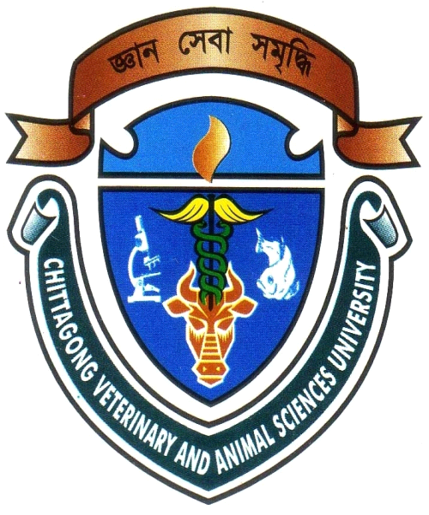
A Report
By

Intern ID : B-09
Roll No. : 2006/11
Reg. No. : 249
Session : 2005-2006.

Submitted in partial of requirement for the fulfillment of the degree of

DOCTOR OF VETERINARY MEDICINE (DVM)

Faculty of Veterinary Medicine,
Chittagong Veterinary and Animal Sciences University
Khulshi, Chittagong - 4202.
May 2012
NUTRITIVE VALUE OF RICE POLISH

A Report
By
Intern ID : B-09
Roll No. : 2006/11
Reg. No. : 249
Session : 2005-2006.

Approved as to style and content by

Signature of Supervisor

NAME: MD. EMRAN HOSSAIN
Assistant Professor
Dept. of Animal Science & Nutrition

Chittagong Veterinary and Animal Sciences University
Khulshi, Chittagong - 4202.
May 2012

ACKNOWLEDGEMENT

All praises are due to Almighty Allah, the creator & supreme authority of the universe; who enabled me to complete this work successfully.
It is deemed as a proud privilege and extra terrestrial pleasure to express author ever indebtedness, deepest sense of gratitude, sincere appreciations, profound regards to reverend and beloved teacher and supervisor Assistant Professor MD. EMRAN HOSSAIN, Dept. of Animal Science & Nutrition , Chittagong Veterinary and Animal Sciences University for his scholastic guidance , sympathetic supervision, valuable advice, constant inspiration, affectionate feeling, radical investigation and constructive criticism in all phases of this study

May 2012
The Author

